Notuul 5: Mr. Rahola
Aanwezig: Jefry, Niels, Niels (Nelis), Levy en (Amin afwezig)
__________________________________________________________________________________
Summary:

__________________________________________________________________________________
Points:
- Introducing Niels the second
- Scrum:
- Every meeting starts with the Trello (Scrum) panel.

- Brian:
- There are a couple of courses that are interesting for your project;
- Time Series (course)
- Put completed Datacamp courses into the completed section on Trello.
- Rahola is the client, he decides if something is done.
- He will decides if something is completed.

- Data Exercise
- The Time Data you get is Unix (Epoch) time. This is in Seconds.
- Look at the most optimal way to load in the data. In the beginning you will probably use pandas to load the data.
- You can use the local option for easier data and faster loading times.

- Showing a already existing datasets and papers.
- Company that makes small systems.
- We’re going to meet Jan Willem.
- The elements inside the box are very small. Their product is mostly plug and play.
Heatpump
- The heat pump has two systems. An inside one and an outside one.
- They extracts the heat from the air into the water, or into the hot water reservoir.
- A heat tank takes a long time to heat. The reservoir has all the hot water to use.
Mechanical ventilation
- The house is so insulated that the warmth can’t escape but there is not enough oxygen.
- The Heatpump module has a oxygen ventilation module.
- The hot CO2 air that goes out heats the cold air coming in.
Solar panels
- The solar panels aren’t made by the factory Zero.
- Only the Transformer (inverter) is being made by Factory Zero.
Thermostat
- The thermostat is a rapberry pi 4 with a screen. This is a control board.
- This is only a local communication system to the server and all the parts of the system.

Sensors
- The sensors are connected to the database.
- Every 300 seconds the data is stored on the server.
- The system doesn’t record the synchronized time data.

- There are some systems that don’t have data for some time.
- The communications system can be offline. (no internet, no data!)
- The Data need to be cleaned!

- First we need to know what the problems are.
Then we are going to take actions how to overcome this problem.

- In the schematic you can see all the elements:

- 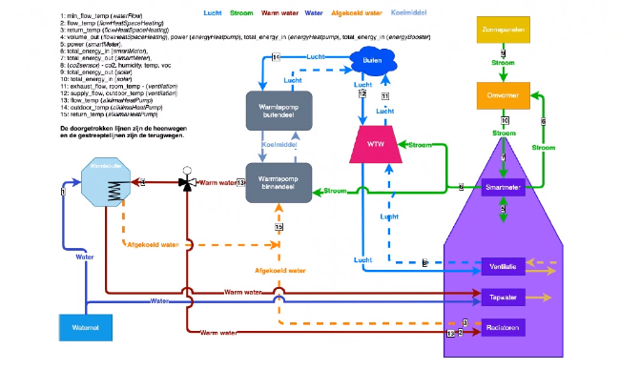

- Houses
- Zoetermeer in Palenstijn.
- Are the houses the same?:
The houses are social houses.
All houses are the same.
Do renovations in a very short time.
They profit from the complete refurbishment of the whole house.
- They need to do it fast and green renovations.
- Everything is prefab made.
- The company needs to ensure 0 demeter.
- The agreement is that you deliver the data and we will guarantee the performance.
- Going to Factory Zero
- Friday at 10:30 to 12:00.
- Travel to Tiel train station.
- The other group has two cars. So we need to contact the other group.
- Rahora will also ride to Tiel and transport people from the station to Factory Zero.
- Tell Rahora who he needs to take from the station.

- The other groups has to compare the performance and efficiency of the new vs the old house.
- Goals for this week
- Get a grasp for the data we have.
- Read Factory Zero paper June. Make the houses performances of the houses. Amount of energy produced by the houses made in one plot.
Energy production (solar), Total production of all houses, Delivered Power of one house (one year), Quality of the data that has been plotted.
- The smart meter is for the whole house (so it is energy taken/put on/from the net). The omvormer shows the data of the energy by the solar panels.
- It is not if we make sense of the data, but if we can make the plots from the paper.
- Questions
- Endgoal.
- Automatic system that can make the maximum profit from the system. No user input for the system. In the morning the energy price is most expensive. Every day the price for the energy is being stated by the electricity companies.
- So… The house needs to store the energy if the price is low and the solar panels generate much. The energy needs to forecast the amount of energy being used.
- If the Energy price is to low you can put the energy in the hot water tank.
- It is possible to buy energy from the grid.

- You have data about all the systems in the house. And we need to know more about the person in the house. There are many parameters used to describe his patterns.

- We need to forecast 24 parameters/values…

- The corona measures
- The corona measures will be send via the mail.
- Do not forget to take masks with you.

- The model
- After a few week we will make a battery.
- All the things needed will be used in the model.

