Notuul 09: Rahola
Present: Niels, Niels (Nelis), Jefry, Levy, Amin.
_____________________________________________________________________________________
Summary:

_____________________________________________________________________________________
Key Points:
- Visiting factory zero:
- 25 september is a go.

- How are we doing?:
- Maybe once a week meet physically.

- Datacamp:
- Cheat sheet: A lot of cheat sheets available online. So search for the topic (or module) you want to know.
JUST Google it!
- Niels and Levy are on schedule.
- Jefry and Nelis are behind.
- Nelis already knows everything, but doesn’t know python. (Advise to go straight to the exercises.)

- Amin (involvement) (enters at 1:15):
- Amin is behind in the datacamp.
- Always be on time, you can’t let the leader wait.

- Document from June:
- How many of the elements of the product are produced by factory zero?
The elements of the system are from different company’s.
The controller is from the company Zero.
The Raspberry pi is the part that communicates with all the systems.
- Can the heat pump heat both systems at the same time?:
The heat pump works or the hot water reservoir works.
- (Done: make some of the graphs of the report.)

- Important:
- It is important to know the background of the system.
Rahola will explain all the systems in the coming weeks.

- Graphs:
- Great graphs!
(sees the code)
- Code looks great.
- But it can be simpler, more efficiënt.
- Devise the programming so that everyone learns from it.
- Nelis can help.

- Upcoming week:
- Target:
energy production and energy use.
Plot the values of these in the upcoming week for the 120 houses.
- In the report the information about calculating this.
- What is the energy of one of the house (dx, time in 5 minutes interval).
- Energy use for five minutes for one year for one house.
- Data cleaning:
Look at the ways the data is unreal. A list of the problems in the data.
For each correction a explaination is needed.
Is interpolation a good aproach? Each question will have to be evaluated.
List of the things that can go wrong.
And the ways this can be prevented.
- The errors of the sensor do have to be considered.
- If we have extra time we can try to use different approaches to work with missing data.

- How do they do it?: Meters
- Energy is the product of power and time.
- The meter reads the amount of energy (in kWh).
- The inverter inverts the DC-power to AC-power.
(Amin goes away, 1:50)
- The inverter meter measures the amount of energy being generated.
- The smart meter measures the amount of energy being put on the net, and put from the net.
- If the solar panels generate more than is being consumed, the energy is being put on the net.
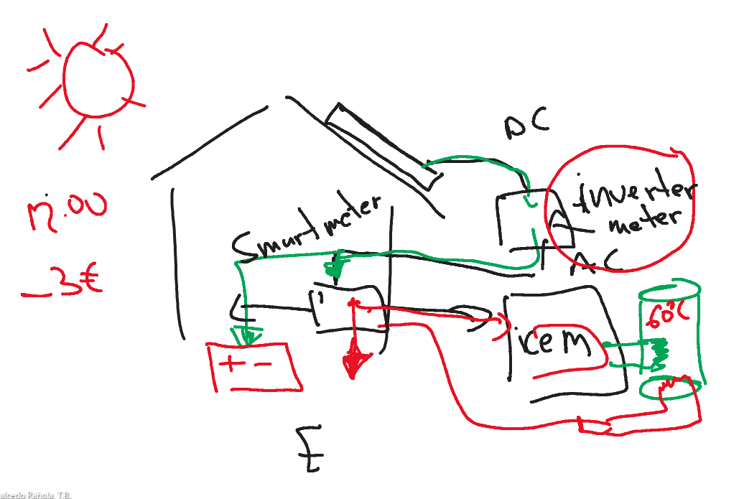
- The energy can have a negative price if put on the wrong time.
- Some of the energy can be out in a battery.
- The hot water reservoir has a temperature of 45 degrees.
- Only at 60 degrees the legionella is killed.
- So doing this once a month will be great.

- GITHUB:
- Code on github isn’t a problem. The problem is the database.
- Let rahola know if we do it and what kind of system of security we have.

- Sumary:
- Going on with DataCamp.
- Deal with the server of the code and data.
- Data plotting: 120 houses in one year energy production, one house energy production/use per five minutes.
- Analyse which problems we can have with the data quality.
- Make a list of the problems of the data quality.
- 25 september at the same time the team will go to Factory Zero.

- Solving the team problem (you can’t dissappear without a notice).
- Sidenote: use local or datascience server

