Company Database Schema
- Create Database using wizard with the following schema then
Create DB Diagram and insert at least 2 rows per table
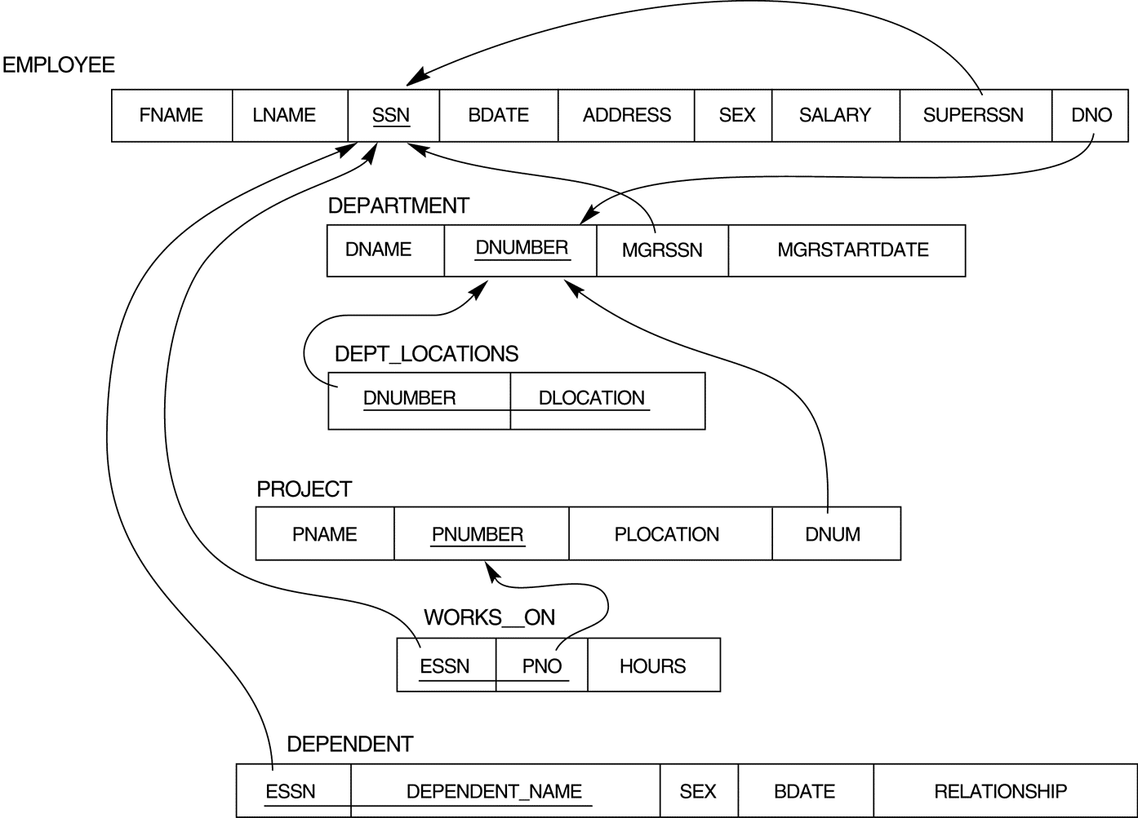

- Restore Company DB then
Try to create the following Queries:

- Display all the employees Data.
- Display the employee First name, last name, Salary and Department number.
- Display all the projects names, locations and the department which is responsible about it.
- If you know that the company policy is to pay an annual commission for each employee with specific percent equals 10% of his/her annual salary .Display each employee full name and his annual commission in an ANNUAL COMM column (alias).
- Display the employees Id, name who earns more than 1000 LE monthly.
- Display the employees Id, name who earns more than 10000 LE annually.
- Display the names and salaries of the female employees
- Display each department id, name which managed by a manager with id equals 968574.
- Dispaly the ids, names and locations of the pojects which controled with department 10.

