# Workshop Specification Document: Indoor Navigation Application for Android

## Introduction

Indoor navigation systems have emerged as a critical technology in large and complex environments such as malls, hospitals, and corporate offices. These systems address challenges posed by GPS limitations in enclosed spaces. This workshop aims to develop an Android-based application that offers seamless navigation within a specific indoor structure. Leveraging building models, RSSI data, and advanced pathfinding algorithms, the application will provide an intuitive navigation experience for users.

## 2. Functional Specification

### 2.1 General Definition

The application is designed to address the challenge of navigating complex indoor structures where GPS signals are unavailable. Initially, the application will focus on a single structure, with the possibility of expanding to additional buildings in the future.

### 2.2 Target Audience

### Potential users include:

### Employees navigating large office spaces.

### Visitors unfamiliar with a building layout.

### Service personnel requiring efficient routes to target locations.

### Emergency responders needing quick access to critical areas.

### 2.3 Main Features

**Building Modeling**

* The system includes a digital representation of the building’s structure, which incorporates details such as room IDs, corridors, and floors.
* The system will support updates to reflect structural changes, ensuring that the model remains accurate over time.

**Route-Finding Algorithm**

* The system will calculate the current coordinate of the user by RSSI and triangulate.
* A* algorithm will be employed to compute optimal paths between the user location and the destination within the building.
* The algorithm recalculates paths in real-time to account for dynamic obstacles or changes in the user’s movement.

**User Interface**

* The system features an intuitive interface that allows users to input their starting point and desired destination.
* The system will have a list of places that the user will choose from it a destination or search bar that can be manually typed a place.
* Navigation routes will be displayed in real-time, overlaid on a detailed building map for easy understanding.

**Points of Interest (POI)**

* The system contains key locations, including elevators, restrooms, meeting rooms, and cafeterias, which will be marked as Points of Interest (POI).
* Safety features, such as bomb shelters and assembly points, are highlighted to assist users in emergency situations.

**RSSI-Based Localization**

* The system integrates with Wi-Fi routers and access points to determine the user’s current position using the Received Signal Strength Indicator (RSSI).
* Accuracy is enhanced through triangulation methods and data smoothing algorithms, providing precise localization for navigation.

### 2.4 User Flow Diagram The complete application workflow is as follows:

1. **Startup Phase:**

* The user opens the application.
* A splash screen is displayed while the app initializes.
* The home screen shows the building map or a "select building" option if multiple maps are available.

1. **User Input Phase:**

* The user starting point is automatically detected via RSSI and KNN algorithm , that working on the app DB to detect the user coordinate or to calculate to which known place the user is closest to.
* The user enters or selects a destination point from a dropdown list or search bar.

1. **Path Calculation Phase:**

* The app sends the input data to the server (if online mode is active) .
* The A* algorithm determines the shortest path based on the building graph.

1. **Navigation Phase:**

* The calculated route is displayed on the map.
* The user receives step-by-step guidance, which includes visual and textual instructions.
* RSSI data is continuously monitored to update the user's location in real time.

1. **Completion Phase:**

* Once the destination is reached, the app provides confirmation.
* The user can choose to navigate to another point or exit the application.

### 2.5 Use Case Scenarios

Navigation from the building entrance to a room:  
- User: Arrived for a meeting and wants to know how to navigate to the designated room.  
- Scenario: The user wants to navigate to a specific meeting room.  
- Flow:  
 1. Open the application.  
 2. Identify the user’s current location.  
 3. Select the destination (e.g., Room 305).  
 4. Follow the displayed route.

## 3. High-Level Design

### 3.1 Architecture

The application will operate in a client-server architecture:  
- Client (Android Application):  
 - User interface  
 - Map display  
 - Handling user input  
- Server:  
 - Storing the building model  
 - Storing for each room all AP RSSI results  
 - Performing route calculations  
 - Map updates

### 3.2 Key Components

- UI Layer: Responsible for displaying the building map, the user selection destination and user interactions.  
- Logic Layer: Handles input validation, communication with the server, and route calculation requests.  
- Data Layer: Responsible for storing the building model and navigation data, including coordinates and RSSI data for each room based on various access points.

### 3.3 Tools and Libraries

- Android Studio for application development.  
- Firebase for real-time database and user authentication (optional).  
- Postgres/MongoDB for storing the data in DB.  
- A* algorithm for calculating the shortest and easiest path.  
- Anyplace: Open-source.  
- OpenStreetMap or a similar tool for integrating base maps (if required).

### 3.4 Database Structure

- Graph: Each vertex represents a room or a passage point (e.g., corner or edge of a corridor), and each edge represents a possible direct transition between rooms.  
- Buildings:  
 - id  
 - name  
 - floors  
- Floors:  
 - id  
 - rooms

- Rooms:  
 - id  
 - floor_id  
 - coordinates (x, y)  
 - frequencies <AP, RSSI>

|  |  |  |  |  |  |  |
| --- | --- | --- | --- | --- | --- | --- |
| ROOM num | AP_1 | AP_2 | AP_3 | AP_4 | AP_5 | … |
| 301 | RSSI frequency | RSSI | RSSI | RSSI | RSSI | …. |
| 301 | RSSI frequency | RSSI | RSSI | RSSI | RSSI | … |
| … | RSSI frequency | RSSI | RSSI | RSSI | RSSI | … |

### 3.5 Route-Finding Algorithm

The graph will represent rooms and corridors as vertices and edges. The shortest path between two points will be calculated using the A* algorithm:  
1. Creating a graphical representation of the structure.  
2. Assigning weights to edges based on distances.  
3. Using the A* algorithm to calculate the shortest path.

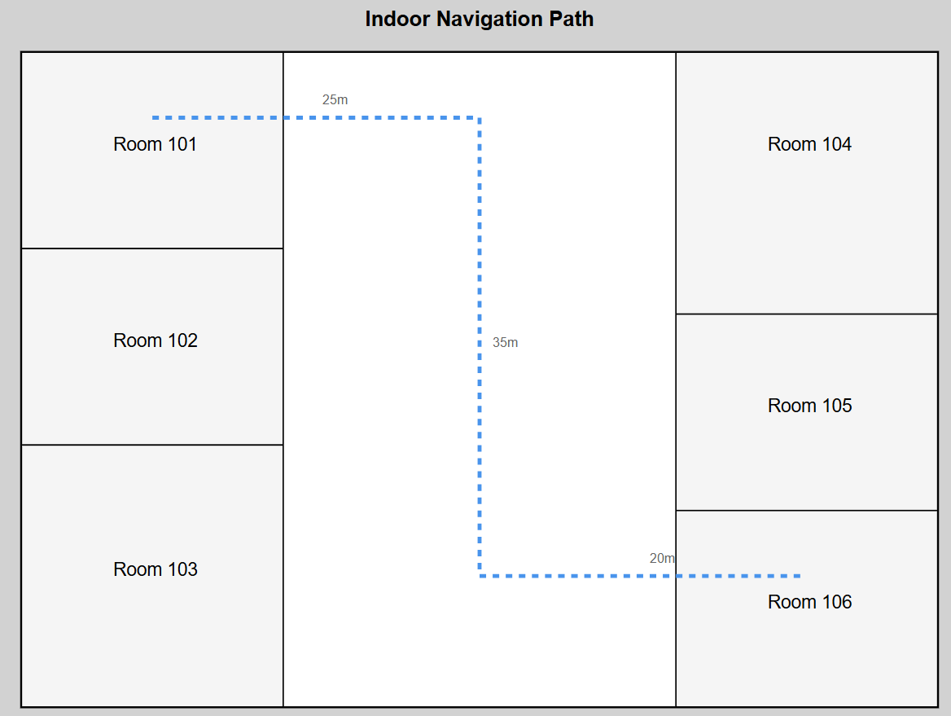

## 4. Building Modeling

Option 1: Using a Pre-existing Physical Map:  
- Use an existing physical map of the building.  
- Map all important locations for navigation (e.g., rooms, corridors, exits).  
- Define each point’s location on the map using coordinates and RSSI signals.  
- Mark walls as lines on the map from the start to the end of each wall.  
- Build a graph based on coordinates and walls, creating edges between points if the connecting line doesn’t cross a wall.  
  
Option 2: Scanning the Building:  
- Conduct a physical scan of the structure and create the map manually.  
- Model points and walls as described in Option 1.  
- Build the graph similarly, connecting points only if no wall obstructs them.  
  
Using RSSI Data:  
- The application will use RSSI (Received Signal Strength Indicator) data from routers or access points in the structure to identify the user's location in real time.  
- It will measure signal strengths from nearby access points and calculate the relative distance to each.  
- With this data, combined with the building’s graph, the exact position will be mapped, and an optimal route will be displayed accordingly.

- Triangulation: With at least three access points, the system can estimate the user’s location by calculating the intersection of three circles centered on each access point, with radii corresponding to the estimated distances. The geometric principle behind triangulation works as follows:

* Each access point provides a signal strength, which is converted to a distance.
* These distances define radii for circles around each access point.
* The point where the three circles intersect represents the user’s location.

## Structure diagram

## תמונה שמכילה טקסט, צילום מסך, גופן התיאור נוצר באופן אוטומטיתמונה שמכילה טקסט, צילום מסך, גופן

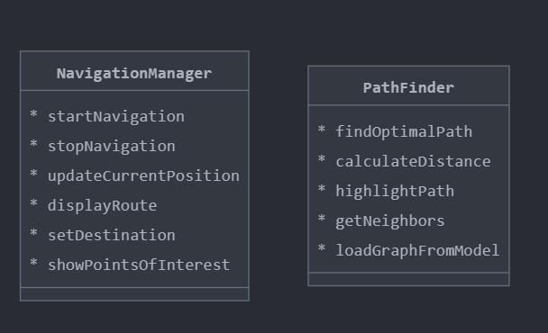

## Flow Chart

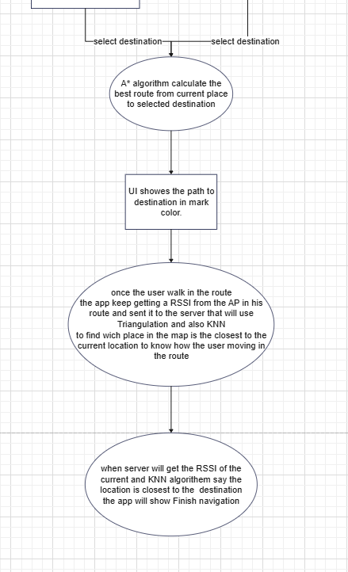

## 5. Open Questions

Here are the additional questions you can add to your list:

* Who will model the classrooms, the user or us?
* Will the walls and obstacles be modeled using an automatic or manual method?
* How will we identify the coordinates of the APs in the space?
* What level of accuracy is required to ensure minimal deviation?

These questions should help refine the planning and implementation of your system's mapping and location accuracy.

## 6. Next Steps

- Complete the building model creation process.  
- Choose the appropriate tools and libraries for implementation.  
- Develop a prototype to gather user feedback.