Game “CombiNation”

Developed by:

Aleksandr Semjonov, Daniils smulko, arturs Kudeika

2021

Contents

General Information 2

Code name 2

Genre 2

USP - Unique Selling Points 2

Description 2

GM – Game Mechanics (main) 2

Main menu 3

Short description 3

Visual Component 3

First mini game 4

Short description 4

Visual Component 4

Game mechanics (secondary) 4

Game description 4

Second mini game 5

Short description 5

Visual component 5

Game mechanics (secondary) 5

Game description 5

Third mini game 6

Short description 6

Visual component 6

Game mechanics (secondary) 6

Game description 6

# General Information

Code name– CombiNation

Genre–Puzzle

USP - Unique Selling Points**:**

The app helps you to understand a certain aspect of combinatorics using life situations as an example.

Availability - Android

Description– the game is a puzzle with elements of progress, variability, and the possibility of losing. The game is an easy understandable, an explanation of the topic provided by a simple and more illustrative example. The game has 3 mini-games (at the moment), with their own characteristics and game mechanics. The player can choose a specific game by reading its rules.

GM – Game Mechanics (main)–

1. **Game variant** – The player can choose 3 different levels; every level has its own game mechanic.
2. **Health bar** –Indicates maximum mistakes you can take (now, by default it is 4 hearts at all levels). If you are lack of hearts, the game is over.
3. **Scale of progress of variability** –The scale gets filled by finding the correct answers. After the scale is filled the player wins.
4. **Exit button** – Small X button to return to the menu.
5. **Game Over panel** – Shows up if player loses. The panel has two options – to restart the level; to return to the menu.
6. **Win panel** – Shows up if player has answered all questions or has found all possible combinations. The panel has two options – to run next level; to return to the menu.

**All used sprites in the game are taken from the site** https://www.freepng.ru, being in the public domain and not subject to copyright. (Quote: "All content on Freepng.ru is either sent to Freepng.ru by email or is available in various locations on the Internet and is considered publicly available. Content posted (including images and videos) is deemed to be posted within your rights under US Law Fair Use of Copyright (17 USC) ")

# Main menu

UI short description – has two buttons:

* **Exit** – quit
* **Levels** – shows up all (at the moment 3) available levels
* **In levels’ menu each level has two options:**
  + Read the rules
  + Play it

Visual Component– A scene with buttons (afore mentioned), levels’ menu, picture and app name.

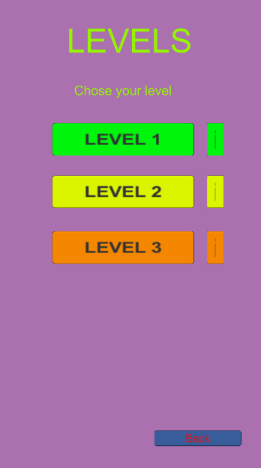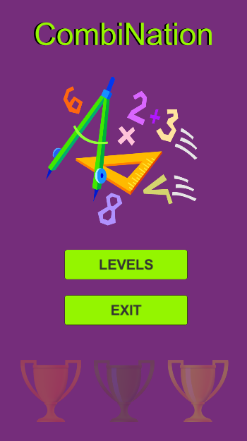

# First mini game

UI short description–The game aims to put the player in a position where the player, having a certain amount of money, must find all possible ways to spend it.

Visual Component– A scene with a cash register and a seller is used to identify the situation, the amount of money left on the counter, to evaluate actions / moves, and the two bottom buttons for choice of purchases.

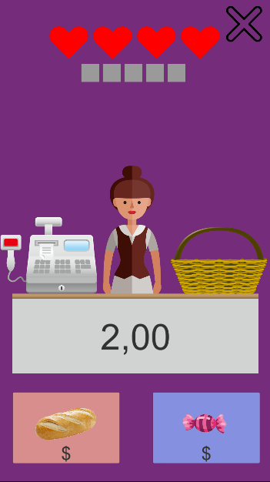Game mechanics (secondary)–the game uses such mechanics as:

1. **Amount of money left** – the number in the middle of the game scene, showing the amount of money available now**.**
2. **Variations (buttons)** – using buttons with different variations, the player can collect all kinds of combinations of spending money, when pressed, the indicated price is considered.

Game description–The game begins with a scene in front of the player with two buttons and a cash register with a sum of money. The player needs to find all possible options for the full spending of this amount, by clicking on the buttons with certain price tags. This amount is fixed - 2.00. Variations in value are abstract, depending on the items themselves and their random value. The player, during the game, must make all possible combinations, filling the variability progress scale*[****GM – main – 3****]*. The player loses hp*[****GM – main – 2****]* if repeats previously collected combination.

# Second mini game

UI short description–the game aims to put the player in a position where the player is obliged to make all possible combinations of the available items.

Visual component –a scene with a child and cubes is used to visualize a problem on the topic of combinatorics, where there are gray areas showing the order of the selected cubes.

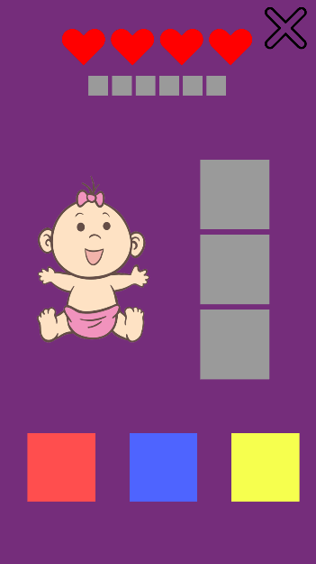Game mechanics (secondary)– the game uses such mechanics as:

1. **Visualization of selected objects -** when a player clicks on a certain cube, he sees what he chose and how to proceed.
2. **Variations (active objects)** - using buttons with different colors, under the game scene, the player can collect all sorts of variations of the construction of all sorts of colors.

Game description –the game begins with the fact that a scene appears in front of the player, with 3 cubes of different colors at the bottom, a child in the middle, to identify the situation, and 3 gray cubes, as an indicator of the progress of the already selected colors. The player needs to find all possible color combinations without using the same color 2 times, by clicking on the colored cubes. The player, during the game, must collect all possible combinations, filling the variability progress scale*[****GM – main – 3****]**.* The player loses hp*[****GM – main – 2****]* if repeats previously collected combination.

# **Third mini game**

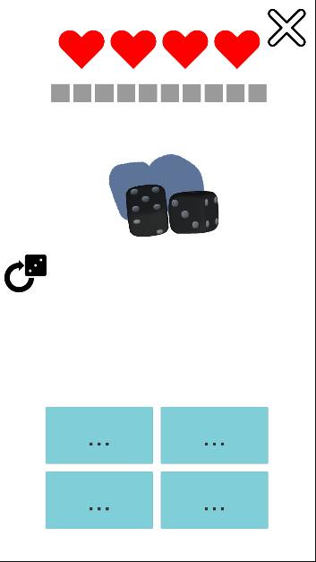UI short description–the game aims to explain variability in combinatorics using dice while working with Game Theory.

Visual component–in front of the player there are cubes and 4 buttons, when the cubes are thrown, the player sees a certain sum of two numbers. Below there are 4 options with 1 correct and 3 incorrect answers.

Game mechanics (secondary)– the game uses such mechanics as:

1. **Re-roll dice** - the ability to throw dices again if they have got stuck for some reason.
2. **Variation of situation** – there are two possible situations (i.e. logics that you will have to use to answer appropriately):
   * Order is important - *it matters which dice what number has rolled. The player has to count all possible dices’ combinations.*
   * 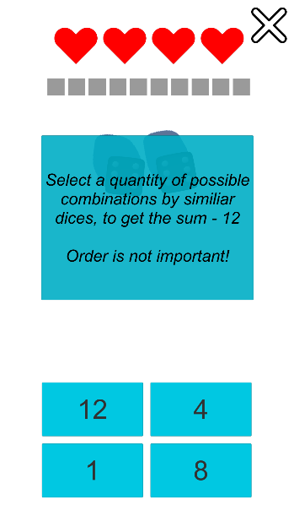Order is not important *– it does not matter which dice what number has rolled. The player has to count only sum of rolled numbers’ combinations.*
3. **Variation of answers** – the player is initially given 4 options for the analysis of the situation.
4. **The question panel** – explains what the situation is*[Third – GM - 2]* and shows the question on screen.

Game description– the game begins with a scene in front of the player with two cubes and 4 disabled answer buttons. Then, dices drop and the player’s device counts a rolled dice’s sum. After that question shows up, the buttons turn on and shows correct answer or random number. The player needs, analyzing the given answers, to choose the correct option. The player, during the game, press the button with the correct answer and fills up the variability progress scale*[****GM – main – 3****]*. The player loses hp*[****GM – main – 2****]* if clicked answer is not correct. Finally, after pressing the answer, the described mechanic reruns.