|  |
| --- |
| **Appointments**  Nairobi +254 (0) 705 700 777  Mombasa +254 (0) 784 700 700 |

** HH NON-SURGICAL HOSPITAL**

**WITHOUT SURGERY, TREAT BODY’S HEALING SYSTEM**



**HOME WHY NON-SURGICAL WHAT BENEFITS INTERGARIVE SERVICES TRAINING TESTIMONIALS INTERNATIONAL CAREERS CONTACT**

**MEDICINE CENTER PATIENTS**

**Why Non-Surgical Treatment**

Human Body has the amazing capacity for Self-Healing.

When we get a cut, sprain, broken bone and many

other cases, our bodies have a remarkable capacity to

heal themselves.

At HH, our treatment modalities are designed to

recover and strengthen your body's natural self-healing ability. Read more… **(Link to the page WHY NON-SURGICAL**)

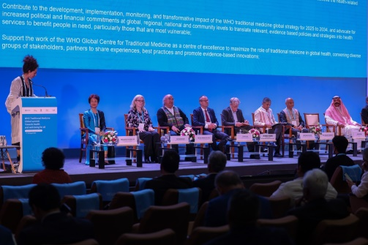

**HOME WHY NON-SURGICAL WHAT BENEFITS INTERGARIVE SERVICES TRAINING TESTIMONIALS INTERNATIONAL CAREERS CONTACT**

**MEDICINE CENTER PATIENTS**

**PATIENTS**

**World Health Organization (WHO)**

**Traditional Medicine Global Summit 2023**

**Global partners commit to advance evidence-based traditional, complementary and Integrative Medicine** Read more**…. Link to ?……**

 **HH NON-SURGICAL HOSPITAL**

 **WITHOUT SURGERY, TREAT BODY’S HEALING SYSTEM**

**HOME WHY NON-SURGICAL WHAT BENEFITS INTEGRATIVE SERVICES TRAINING TESTIMONIALS INTERNATIONAL CAREERS CONTACT**

**MEDICINE CENTER PATIENTS**

**What Benefits:**

**• Less Risky**

**• Short Hospital Stay**

**• Cost-Effective**

**• Less Pain and Discomfort**

**• Quick Recovery Time**

**• Boost the Self-Healing Power of the Body**

**• Less Trauma**

**Read more…(Link to WHAT BENEFIT PAGE)**

 **Discover Alternative Treatment**

Discover an alternative path to healing without

the need for invasive surgery; our non-surgical

treatments provide a safer, more effective

alternative for addressing diseases, promoting

faster recovery, and empowering your body’s

natural self-healing mechanisms.

Read more…**(Link to page INTEGRATIVE MEDICINE)**

|  |
| --- |
| **Integrative Medicine**  Integrative medicine can be described as a practice  that **“Cherry Picks”** the best and scientifically  supported therapies of both systems.  **The ultimate goal:** to treat the patients better, through  the use of safe, effective and **less-invasive** interventions  whenever possible. Read more…  (link to the same page of WHO in the slide photo TOP) |

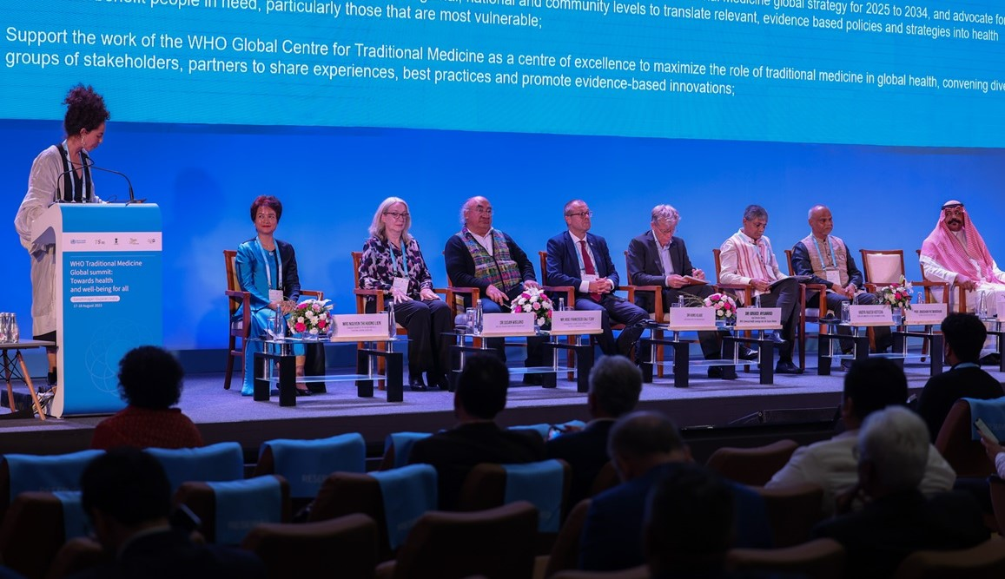

|  |
| --- |
| C:\Users\EyunSoo\Desktop\workplace-wellness-pilates.jpg **Treat Root Cause Not only Symptoms**    At HH Non-Surgical Hospital, we focus on root cause  not only symptoms. We employ techniques that are  carefully curated to complement the body's biological  processes.  These may include targeted interventions, rehabilitative  exercises, and lifestyle modifications designed to support  and amplify the body's natural healing responses. |

|  |
| --- |
| **With Team, Focus on Whole Person**  Integrative Healthcare focuses on the whole person.  Integrative medicine includes all providers of integrative  medicine - working in equal partnership for the better  of the patient - nurses, medical doctors, naturopathic  doctors, chiropractic doctors, acupuncture and oriental  medicine doctors and many more. |

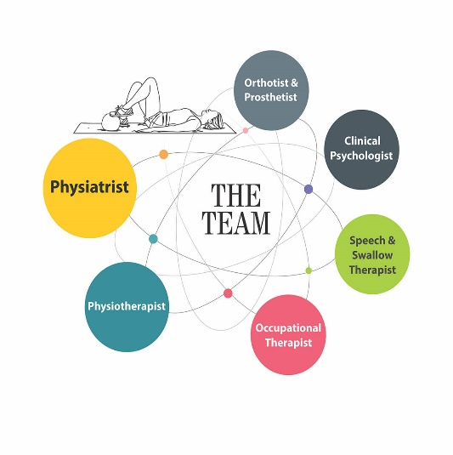

**SOME OF OUR CLIENTS STORIES**



**PHOTO HERE PHOTO HERE NEED TO CHANGE**

|  |  |  |
| --- | --- | --- |
| **Short story here below**  **Detail story in the Read more** | **Short story here below**  **Detail story in the Read more** | **Short story here below**  **Detail story in the Read more** |

**USEFUL LINKS/INFORMATION ABOUT INTEGRATIVE MEDECINE**

|  |  |  |
| --- | --- | --- |
| **C:\Users\Dr. Jong E\Desktop\WHO TCM.jpeg**  **WHO Traditional Medicine Global Summit 2023**  <https://www.who.int/news/item/19-08-2023-g>  lobal-partners-commit-to-advance-evidence-  based-traditional--complementary-and-  integrative-medicine | **C:\Users\EyunSoo\Desktop\W H O.png**    **WHO Integrative Health Services Dept**  **Traditional, Complementary and**  **Integrative Medicine (TCI)**  Link:https://www.who.int/teams/integrated-health-services/traditional-complementary-and-integrative-medicine | C:\Users\Dr. Jong E\Desktop\WHO TCM GROUP.jpg    **WHO Global Traditional Medicine Centre(GTMC)**  Charting an evidence-based roadmap for WHO  Global Traditional Medicine Centre collaborations |
| Related image  Image result for university of integrative medicine | C:\Users\Dr. Jong E\Desktop\download.jpeg  Stanford Integrative Medicine Center  <https://stanfordhealthcare.org/medical-clinics/integrative-medicine-center.html?ecid=glocalsearch-ls-google-clinicpage-all-IntegrativeMedicineCenter> | **C:\Users\Dr. Jong E\Desktop\royal+london+hospital.jpgC:\Users\EyunSoo\Desktop\NIH.jpg** |

|  |  |  |  |
| --- | --- | --- | --- |
| C:\Users\Dr. Jong E\Desktop\H 4.jpg  **HH International Ltd**  Nairobi: +254 (0) 705 700 777  Mombasa: +254 (0) 784 700 700  info@  www. |  |  |  |
| **International Patients Training Center**  **Service**  Join HH Team  Integrative Medicine Job Vacancy  Our Services Newsletter  What Benefits  Testimonials | **About Us**  Partnership  Join Partners  Media Request  Gallery  Contact Us | 2 GOOGLE MAPS here  Nairobi  Mombasa |