1. Screenshot of leader-board accuracy:
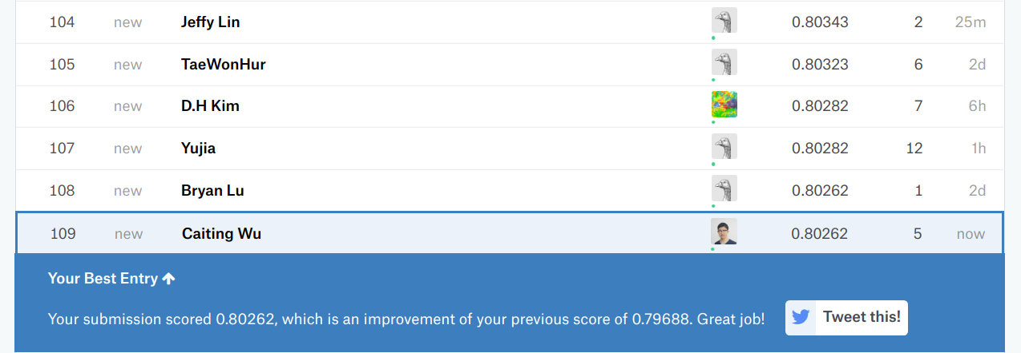
The best test data accuracy that I have obtained on Kaggle is: 0.80262

2. A plot of the accuracy every 30 steps:
(epochs = 50, steps/echo = 300, batch size = 160 [last batch < 160])
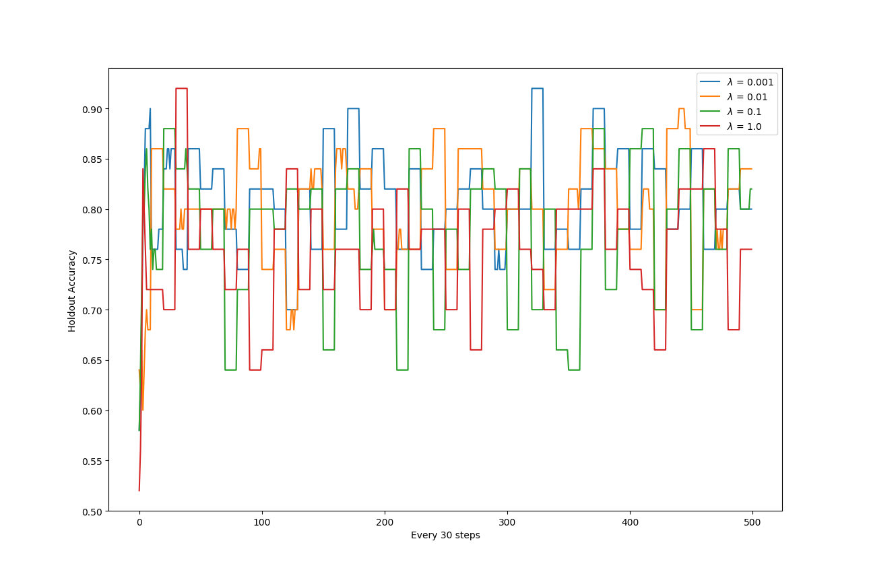
figure1: The plot of Holdout accuracy over every 30 steps with four differentvalues

3. A plot of the magnitude of the coefficient vector every 30 steps:
(epochs = 50, steps/echo = 300, batch size = 160 [last batch < 160])
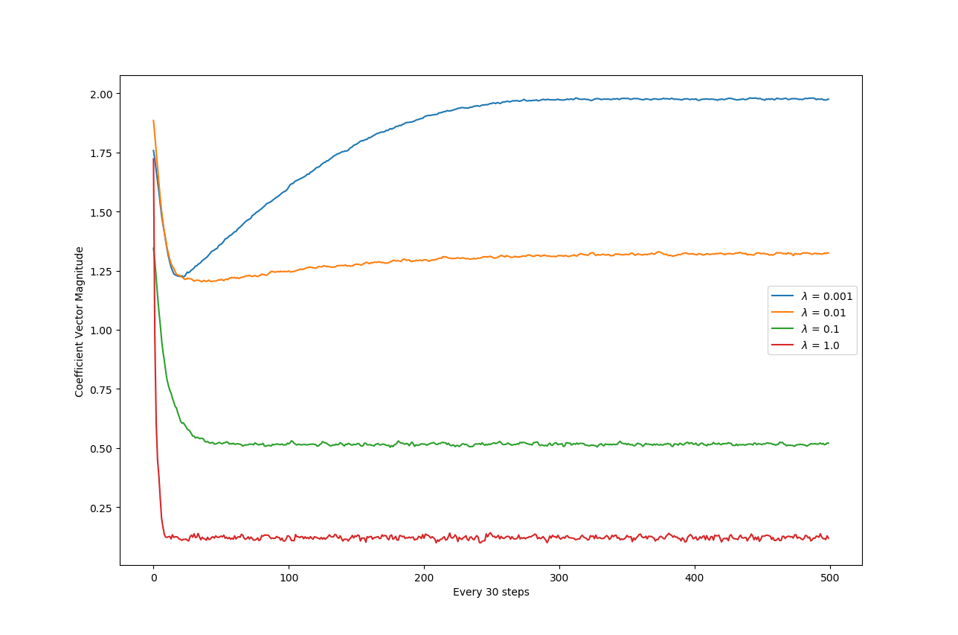
figure2: The plot of coefficient magnitude over every 30 steps with four differentvalues

4. Reasoning the best regularization constant and learning rate:
a. My estimation of the best regularization constant is 0.01:

~ From the accuracy graph, we can conclude that the validation accuracy does not vary too much among different regularization constants. Whenand, we tend to receive good validation results.

~ From the running report, we can see that the best accuracy that the model with these two constants could achieve are no significantly different from each other.
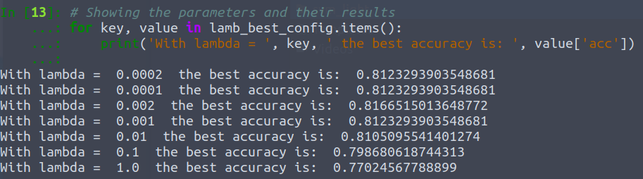
~ During Kaggle course contest submission, yielded the best testing result.

b. My estimation of the learning rate is :
During the training, I found that modifying the learning rate provided in the textbook does not offer significant improvement. The learning rate that I have tried are: ,and. The result confirms with what mentioned in the textbook that the step-length tend to explore large changes in parameters and settle down afterwards.

5. Codes:
