# Image on a paragraph :

Text zone :



Cool !



Inline image :  -> you can write just after

Image with a forced ratio : 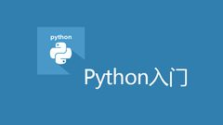

# In a table :

|  |  |
| --- | --- |
| **Image** | **Description** |
|  | The web framework for perfectionists with deadlines |
|  | Zope is a leading Open Source Application Server and Content Management Framework |
|  | Pyramid is a lightweight Python web framework aimed at taking small web apps into big web apps. |
|  | Bottle is a fast, simple and lightweight WSGI micro web-framework for Python |
|  | Tornado is a Python web framework and asynchronous networking library. |