
My English Book
Pupil's Book · Class 1
English Language · Level I · Cameroon
★ EFEDI Schools · Azobe-EFEDI · First edition · 2025/2026
Follows the Class 1 Integrated Scheme of Work — 8 themes · 32 weeks

My English Book
Pupil's Book · Class 1
Class 1 (Primary One) · ages 5–6 · Level I
EFEDI Schools · Azobe-EFEDI
Cameroon
First edition · 2025/2026
Written for the Class 1 Integrated Scheme of Work (EFEDI Schools, 2025/2026)

8 themes · 32 weeks · 127 new words
3 rhymes · 9 chants · 4 songs · 8 dialogues and dramas · 8 presentations
Written for École Azobe (Cameroon). Free to photocopy for the school's pupils; not for sale.
Class 1 Integrated Scheme of Work, EFEDI Schools, Azobe-EFEDI, 2025/2026 (Google Drive: books pro folder, file 1sndXUg8Xq4gkSvzNIC7QEqrhU9ljXNei)

This book belongs to
This book belongs to: ______________________________
Class: ____________________ School: ____________________________
My teacher: ______________________________

Write your name on this page. Draw a sun and colour it yellow.
If you find this book, please return it to the school.

How to use this book
• Every week is one unit. One unit takes five short lessons of 30 minutes.
• Each unit follows the same seven steps, so you learn the routine once: Let's start · Listen and say · Read · Write · New words and grammar · Phonics · Rhyme, song or drama.
• In the middle of the unit you find "I integrate" — a small real-life task where you use everything you have learned that week.
• At the end of the unit there is a mini project. Step by step, the mini projects build the theme strip you present in week 4 of each theme.
• The last box of every unit is "Check yourself". Nobody marks it for you: you decide if you can do it, then colour the star.
• Do not write in the book if the school re-uses copies — say the answers aloud or use an exercise book.

How this book works — learning by doing
This book follows the Competency-Based Approach (CBA) of the Cameroon primary curriculum and the seven domains of your Class 1 Integrated Scheme of Work. A competence is not only what you know: it is what you can do, in a real situation, with what you know.

1. We start from a real situation
Every week opens with "Let's start": a small scene from home, the market, the road, the classroom or the playground. You talk about it before you read or write anything. English must be useful from the first minute.

2. Seven domains, one week
Your scheme gives seven domains: Listening and Speaking, Reading, Writing, Grammar/Vocabulary/Pronunciation, Phonics, Literature and Drama, and the Culminating Project. Each week in this book has one step for each of them, in that order.

3. I integrate
In the middle of each unit, a task asks you to use the week's words, sounds and sentences together — for example, give directions to a visitor, or ask politely to borrow a broom. This is the heart of the CBA.

4. The mini project builds the strip
Each week you add one small thing to a strip: a drawing, a label, a sentence, a polite phrase. After four weeks the strip is complete and you present it — My Home Snapshot Strip, My Village/Town Strip, My School Day Strip, What People Do Strip, How We Travel Strip, Staying Clean Strip, My Game Strip, How We Communicate Strip.

5. You check yourself
Every unit ends with three criteria and three levels: Not yet, Getting there, Yes, I can. Your teacher uses the same criteria. Nobody has to fail: you practise until you can say "Yes, I can".

My strip: what I need
A strip is a long piece of paper or card folded into four parts — one part for each week of the theme. Keep it in your folder. You will present it in the last week of the theme.
What I need  ☐ A strip of paper or card, folded in four  ☐ Crayons or coloured pencils  ☐ Your exercise book for writing labels  ☐ Glue or tape for pictures | How to do it well  · Draw big and clear. Colour inside the lines.  · Write the label under the drawing, in English.  · One part of the strip = one week. Do not jump ahead.  · Keep your spelling neat: copy the words from the book.  · Present your strip standing up, looking at your friends, with a loud clear voice.

Contents — the 32 weeks of Class 1
Each theme lasts four weeks and ends with a culminating project strip.
Wk | Week topic | By the end of the week the pupil can…
THEME 1 · The Home (Weeks 1–4)
1 | Greetings, Letter Sounds and Objects in the Home | recognize and pronounce basic letter sounds and greet others respectfully
2 | Naming Objects and Introducing Family Members | identify common home objects and introduce myself and other people
3 | Polite Expressions and Home Activities | use polite responses and describe simple home routines
4 | Family Routines and Home Description | talk about home routines and describe places and objects
THEME 2 · The Village/Town (Weeks 5–8)
5 | Naming Places and People in the Village | name familiar places and people in my community
6 | Greeting and Describing Community Members | greet people and describe familiar people in my village
7 | Asking About Places and Giving Simple Directions | ask and answer questions about where places and people are
8 | Describing Places and Presenting the Strip | describe places and routines in my village or town
THEME 3 · The School (Weeks 9–12)
9 | Identifying School Places and People | name common places and people in my school
10 | Describing School Tools and Actions | describe the tools we use and the actions we do in class
11 | Greeting, Sharing, and Polite Requests | use polite greetings and requests in the classroom
12 | Classroom Routines and Final Presentation | talk about my school day and present my work
THEME 4 · Occupations (Weeks 13–16)
13 | Naming Occupations and Tools | name common jobs and the tools people use
14 | Describing What People Do | describe what workers do and where they work
15 | Sharing Tools and Speaking Politely | ask politely for tools and talk about duties at work
16 | Reviewing Jobs and Presenting the Strip | talk about jobs and present what people do
THEME 5 · Travelling (Weeks 17–20)
17 | Naming Transport and Movement | name types of transport and describe how we move
18 | Giving Directions and Describing Movement | give directions and describe where things are on the way
19 | Travel Requests and Safety | ask politely and follow the rules for travelling safely
20 | Reviewing Travel and Presenting the Strip | talk about how we travel safely and present my work
THEME 6 · Health (Weeks 21–24)
21 | Naming Body Parts and Hygiene Tools | name parts of my body and the things I use to keep clean
22 | Describing Healthy Routines and Foods | describe healthy habits, clean food and daily routines
23 | Giving Safety Instructions and Requests | give simple health instructions and ask politely about washing
24 | Reviewing Healthy Habits and Final Presentation | talk about keeping clean and present my work
THEME 7 · Games (Weeks 25–28)
25 | Naming and Talking About Games | name indoor and outdoor games and the things we play with
26 | Playing Together and Giving Instructions | give and follow simple instructions when we play
27 | Playing Safely and Using Polite Words | use polite words and rules so that everybody plays safely
28 | Describing Favorite Games and Final Presentation | describe my favourite game and present my work
THEME 8 · Communication (Weeks 29–32)
29 | Naming Communication Forms and Tools | name the ways and tools we use to send messages
30 | Expressing Feelings and Ideas | say how I feel and how other people feel
31 | Asking and Answering Questions Politely | ask and answer questions clearly and politely
32 | Sharing Messages and Final Presentation | give a simple message clearly and present my communication strip

At the end of the book
• Picture dictionary — every new word, by theme and A–Z
• Useful sentences for the classroom (English and French)
• My progress record — all 32 weeks
• Certificate

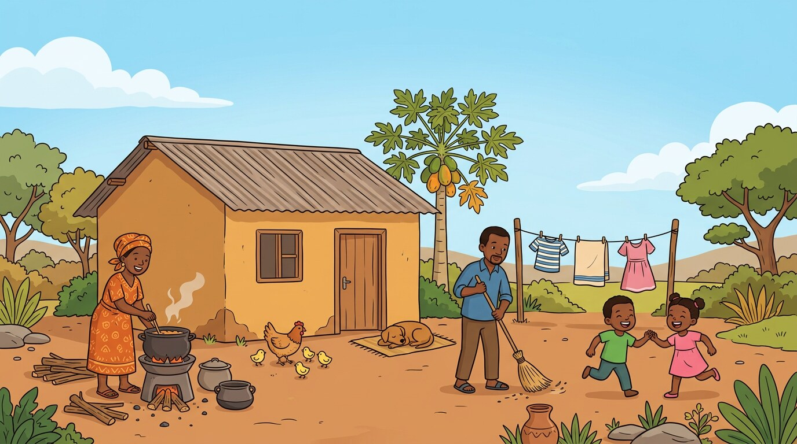
THEME 1 · Weeks 1–4 · weeks 1–4
The Home
At home with Mother, Father, Grandmother and the baby. We greet, name objects, use polite words and describe what we do at home.

By the end of this theme I can…
• Recognize, pronounce, and trace basic letter sounds and common home-related vocabulary
• Demonstrate polite expressions and greetings in home settings
• Identify tools and objects in the home through words, images, and actions
• Decode and spell monosyllabic words connected to routines and spaces
• Compose short oral and written phrases introducing people and places at home
• Participate in storytelling, singing, and simple role-play about life at home

Culminating project
★ My Home Snapshot Strip
☐ 1. Create a strip with a drawing of their home and three labeled items
☐ 2. Add a greeting phrase and polite expression
☐ 3. Include a short sentence introducing one family member
☐ 4. Perform a rhyme or song related to life at home

In this theme — four weeks
Week 1 Greetings, Letter Sounds and Objects in the Home
I can recognize and pronounce basic letter sounds and greet others respectfully.
Week 2 Naming Objects and Introducing Family Members
I can identify common home objects and introduce myself and other people.
Week 3 Polite Expressions and Home Activities
I can use polite responses and describe simple home routines.
Week 4 Family Routines and Home Description
I can talk about home routines and describe places and objects.

WEEK 1 · Theme 1: The Home
Greetings, Letter Sounds and Objects in the Home
COMPETENCE: By the end of this week I can recognize and pronounce basic letter sounds and greet others respectfully.
Knowledge · skills · attitudes: listening, speaking, reading, writing, phonics, drama, and the mini project.

DOMAINS OF THE WEEK: Listening and Speaking · Reading · Writing · Grammar, Vocabulary and Pronunciation · Phonics · Literature and Drama
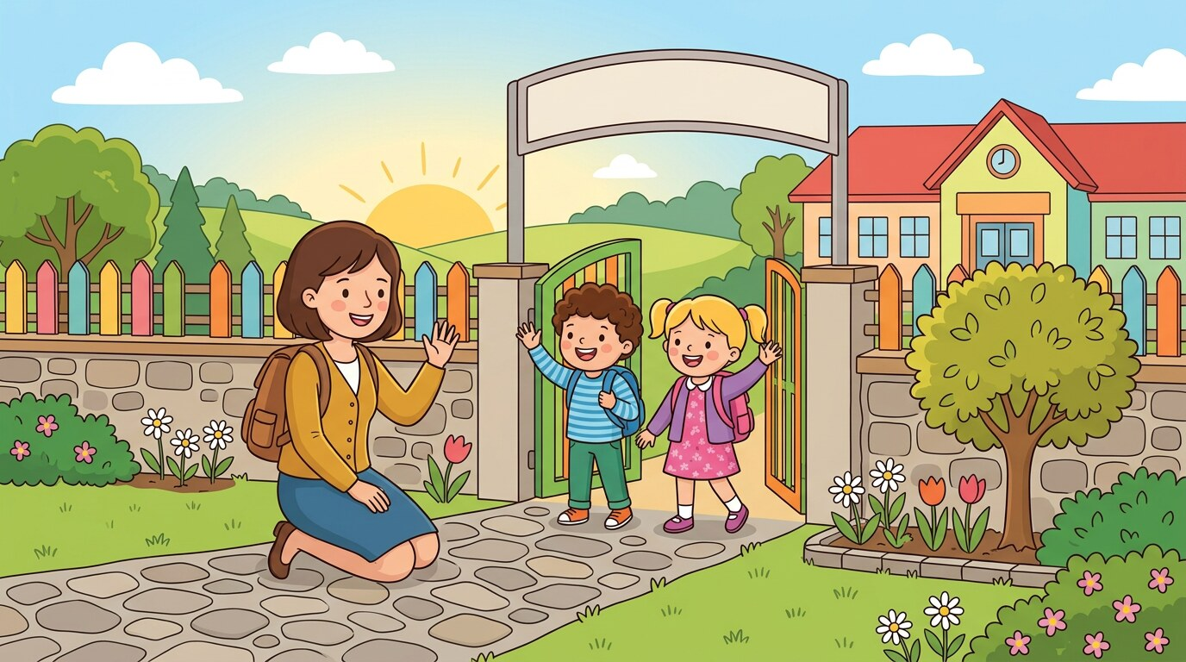
LET'S START It is morning. You come into the house and you see Mother. Your friend Bih is with you.
» What do you say to Mother?
» Which things can you see in the house?

1 Listen and say
LISTENING AND SPEAKING
Listen to your teacher. Then say each line with your teacher.
Saying hello at home
♪ Good morning, Mother.
♪ Hi! I am Bih.
♪ Hello, Bih. You are welcome.
♪ I am happy to see you.
2 Read
READING
Read with your teacher. Point to each word with your finger.
Letter sounds
▸ B b — b for bed
▸ M m — m for mat
▸ S s — s for sun
▸ D d — d for dog
Point to each letter. Say the sound. Then say the word.
3 Write
WRITING
Write in your exercise book. Sit well and hold your pencil well.
Trace the curves, the zigzag lines and the letters B, M, S, D.

4 New words and grammar
GRAMMAR, VOCABULARY AND PRONUNCIATION
Look at the box with your teacher. Then say the examples.
Grammar focus: Interjections; personal pronouns (I, you)
· We say Hi! Hello! Good morning! to greet somebody.
· I am happy. You are kind. — I and you are pronouns.
Say: “Hi!” “Hello!” “I am happy.” “You are kind.”

English | Français | English | Français
mat | la natte | bed | le lit
cup | la tasse | pot | la marmite
mop | le balai à laver
5 Phonics
PHONICS
Say the sound. Then find the sound in each word.
Sound focus: Initial sounds in monosyllabic words: /b/, /m/, /s/, /d/
bed | mat | mop | dog
6 Rhyme: In My Little House
LITERATURE AND DRAMA
Say the rhyme with your teacher. Clap the beat.
In my house, I find my mat,
Where I sit and chat.
In my house, I find my cup,
Where I drink it up.

7 I integrate — I use my English
INTEGRATION — A NEW SITUATION
Work with a friend. Use all the English you have learned this week.
★ Greet three people. Say your name. Name two things you can see in the room.

MINI PROJECT Draw and label one object found in the home (e.g. mat, cup).
Add this to your theme strip.

Check yourself
Tick how you are doing. Colour a star when you can do it alone.
I can… | Not yet | Getting there | Yes, I can
I can greet people at home and at school. | ☐ | ☐ | ☐
I can say the sounds /b/, /m/, /s/, /d/. | ☐ | ☐ | ☐
I can name and label one object in the home. | ☐ | ☐ | ☐

WEEK 2 · Theme 1: The Home
Naming Objects and Introducing Family Members
COMPETENCE: By the end of this week I can identify common home objects and introduce myself and other people.
Knowledge · skills · attitudes: listening, speaking, reading, writing, phonics, drama, and the mini project.

DOMAINS OF THE WEEK: Listening and Speaking · Reading · Writing · Grammar, Vocabulary and Pronunciation · Phonics · Literature and Drama

LET'S START Your friend comes to your house for the first time. Your family is in the yard.
» What do you say to introduce your friend?
» Who is in your family?

1 Listen and say
LISTENING AND SPEAKING
Listen to your teacher. Then say each line with your teacher.
Introducing people at home
♪ I am Anna.
♪ This is Mother.
♪ He is my brother.
♪ This is my friend, Bih.
2 Read
READING
Read with your teacher. Point to each word with your finger.
Reading monosyllabic words
▸ mat
▸ fan
▸ jug
▸ bell
▸ mop
Read each word. Then read it again, quickly.
3 Write
WRITING
Write in your exercise book. Sit well and hold your pencil well.
Write these names and nouns: Sam, Mum, mat, bed.

4 New words and grammar
GRAMMAR, VOCABULARY AND PRONUNCIATION
Look at the box with your teacher. Then say the examples.
Grammar focus: Nouns (common and proper); personal pronouns
· A noun names a person, a place or a thing: mat, cup, Sam.
· Sam and Bih are proper nouns — they start with a capital letter.
Say: “I am Anna.” “This is Mother.” “He is my brother.”

English | Français | English | Français
fan | l'éventail | family | la famille
jug | le pichet | brother | le frère
bell | la cloche
5 Phonics
PHONICS
Say the sound. Then find the sound in each word.
Sound focus: Final sounds in monosyllabic words; building 2–3 letter words
bed | mat | cup | jug
6 Song: Family at Home
LITERATURE AND DRAMA
Sing with your teacher. Add actions.
♪ Mother, Father, Sister too,
♪ All together, me and you.
♪ Brother, baby, Grandma dear,
♪ All my family lives here!

7 I integrate — I use my English
INTEGRATION — A NEW SITUATION
Work with a friend. Use all the English you have learned this week.
★ Introduce three people: "This is Mother. She is kind." Then say your own name.

MINI PROJECT Add a name label and a greeting to one home object in the project strip.
Add this to your theme strip.

Check yourself
Tick how you are doing. Colour a star when you can do it alone.
I can… | Not yet | Getting there | Yes, I can
I can introduce myself and other people. | ☐ | ☐ | ☐
I can read 2–3 letter words. | ☐ | ☐ | ☐
I can write my own name and the names of things at home. | ☐ | ☐ | ☐

WEEK 3 · Theme 1: The Home
Polite Expressions and Home Activities
COMPETENCE: By the end of this week I can use polite responses and describe simple home routines.
Knowledge · skills · attitudes: listening, speaking, reading, writing, phonics, drama, and the mini project.

DOMAINS OF THE WEEK: Listening and Speaking · Reading · Writing · Grammar, Vocabulary and Pronunciation · Phonics · Literature and Drama
LET'S START You are helping Mother. You step on her foot by mistake. Mother is sweeping the floor.
» What do you say to Mother?
» What are you doing in the house?

1 Listen and say
LISTENING AND SPEAKING
Listen to your teacher. Then say each line with your teacher.
Saying polite expressions
♪ Sorry, Sir.
♪ Sorry, Madam.
♪ Thank you.
♪ You are welcome.
2 Read
READING
Read with your teacher. Point to each word with your finger.
Reading polite phrases
▸ Sorry.
▸ Thanks.
▸ Welcome.
▸ Thank you, Madam.
Match each phrase to the right picture in your class.
3 Write
WRITING
Write in your exercise book. Sit well and hold your pencil well.
Trace and write: "Thank you." and "Sorry, Madam."

4 New words and grammar
GRAMMAR, VOCABULARY AND PRONUNCIATION
Look at the box with your teacher. Then say the examples.
Grammar focus: Adjectives; interjections (Sorry, Thank you)
· An adjective tells us more about a noun: a clean cup, a big room.
· Interjections are little words we say with feeling: Oh! Sorry! Thanks!
Say: “This is a clean cup.” “The room is big.” “Sorry, Madam.” “Thank you!”

English | Français | English | Français
sorry | pardon | brush | la brosse
thank you | merci | chair | la chaise
clean | propre
5 Phonics
PHONICS
Say the sound. Then find the sound in each word.
Sound focus: Digraphs ch, sh, th in home words
brush | chair | tooth | bath
6 Drama: Cleaning Together
LITERATURE AND DRAMA
Act it out in pairs. Speak loudly and politely.
Ngo: Mother, may I help you?
Mother: Yes, my child. Please sweep the floor.
Ngo: Thank you, Mother.
Bih: I wash the cups. We clean together!

7 I integrate — I use my English
INTEGRATION — A NEW SITUATION
Work with a friend. Use all the English you have learned this week.
★ Act a small scene. One of you is Mother, one is a child. Greet, help, and say thank you.

MINI PROJECT Add one polite phrase and one home activity to the strip.
Add this to your theme strip.

Check yourself
Tick how you are doing. Colour a star when you can do it alone.
I can… | Not yet | Getting there | Yes, I can
I can say sorry and thank you at the right time. | ☐ | ☐ | ☐
I can read and write the digraphs ch, sh, th. | ☐ | ☐ | ☐
I can describe something with an adjective (a clean cup). | ☐ | ☐ | ☐

WEEK 4 · Theme 1: The Home
Family Routines and Home Description
COMPETENCE: By the end of this week I can talk about home routines and describe places and objects.
Knowledge · skills · attitudes: listening, speaking, reading, writing, phonics, drama, and the mini project.

DOMAINS OF THE WEEK: Listening and Speaking · Reading · Writing · Grammar, Vocabulary and Pronunciation · Phonics · Literature and Drama
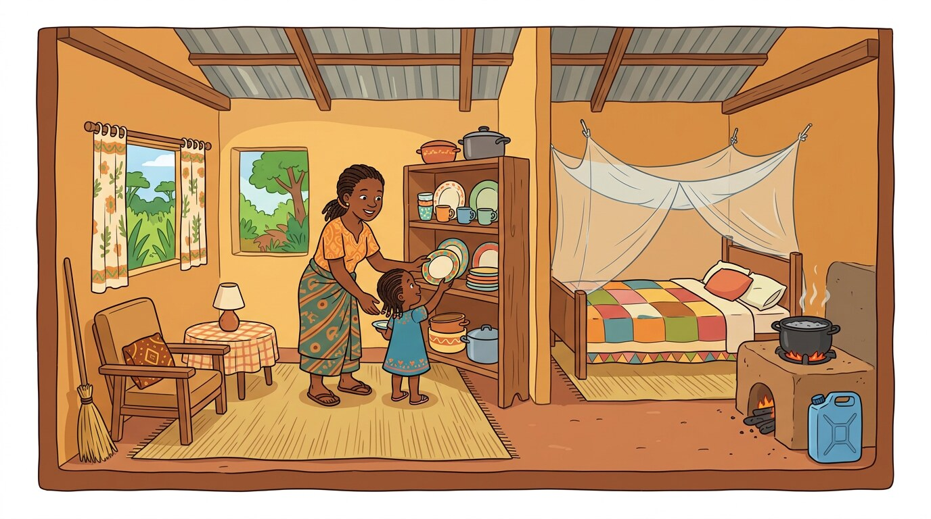
LET'S START A visitor comes to your house. She asks where Mother is and where she can sit.
» What do you say?
» Where is your mother? Show her with your hand.

1 Listen and say
LISTENING AND SPEAKING
Listen to your teacher. Then say each line with your teacher.
Talking about routines
♪ I sleep on the mat.
♪ We eat in the kitchen.
♪ Mother cooks in the kitchen.
♪ The cup is on the table.
2 Read
READING
Read with your teacher. Point to each word with your finger.
Reading short home sentences
▸ Father is in the room.
▸ The cup is on the table.
▸ My bed is soft.
Read the sentence. Then show where the thing is.
3 Write
WRITING
Write in your exercise book. Sit well and hold your pencil well.
Copy and complete: "This is a big ____." "My bed is ____."

4 New words and grammar
GRAMMAR, VOCABULARY AND PRONUNCIATION
Look at the box with your teacher. Then say the examples.
Grammar focus: Prepositions of location; simple sentence construction
· Prepositions tell us where something is: in, on, under, behind.
· A sentence starts with a capital letter and ends with a full stop.
Say: “Father is in the room.” “The cup is on the table.” “The broom is behind the door.”

English | Français | English | Français
room | la chambre | on | sur
kitchen | la cuisine | behind | derrière
table | la table
5 Phonics
PHONICS
Clap the syllables. Then write the word.
Sound focus: Syllable segmentation in home vocabulary
mat-tress | cur-tain | buck-et | kit-chen
6 Performance: My Home Snapshot
LITERATURE AND DRAMA
Present your strip to the class. Speak clearly and smile.
This is my home. (show the strip)
This is my mat. (point)
Thank you, Mother. (smile)
Come in, my friend! (open hand)

7 I integrate — I use my English
INTEGRATION — A NEW SITUATION
Work with a friend. Use all the English you have learned this week.
★ Show your strip to the class. Say where things are: "The pot is on the fire. The broom is behind the door."

MINI PROJECT Finalise the strip with a greeting, an object, a polite phrase and a sentence.
Add this to your theme strip.

Check yourself
Tick how you are doing. Colour a star when you can do it alone.
I can… | Not yet | Getting there | Yes, I can
I can talk about what my family does at home. | ☐ | ☐ | ☐
I can use in, on, under, behind. | ☐ | ☐ | ☐
I can present my Home Strip to the class. | ☐ | ☐ | ☐

THEME 1 · CULMINATING PROJECT
I present my strip
My Home Snapshot Strip
Today you show the class what you have built for four weeks. Take your time. Stand up. Breathe. Smile. Speak loudly.

My strip has…
☐ Create a strip with a drawing of their home and three labeled items
☐ Add a greeting phrase and polite expression
☐ Include a short sentence introducing one family member
☐ Perform a rhyme or song related to life at home

When I present, I…
☐ stand up and look at my friends
☐ speak loudly and slowly
☐ point to my drawing when I speak about it
☐ say at least three English sentences
☐ say "Thank you for listening!" at the end

My project mark
Your teacher uses the same three criteria as you. Tick together and talk about what to improve.
Criterion | Not yet | Getting there | Yes, I can
My strip is complete (all four weeks). | ☐ | ☐ | ☐
My drawings and labels are neat and clear. | ☐ | ☐ | ☐
I spoke in English without reading everything. | ☐ | ☐ | ☐

After the presentation — what next?
Remediation: If you ticked "Not yet" or "Getting there" anywhere, do the practice again with your teacher this week. You do not move on until you can say "Yes, I can".

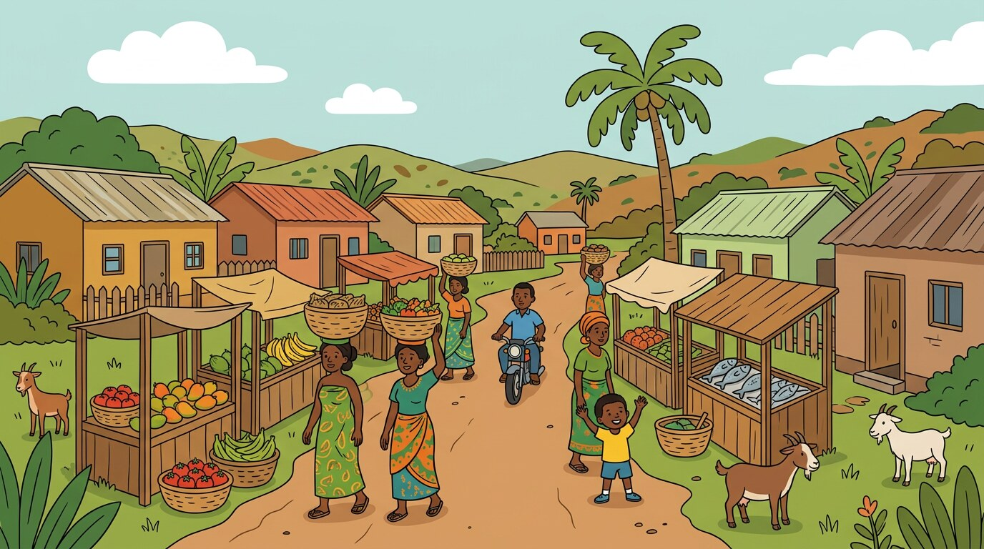
THEME 2 · Weeks 5–8 · weeks 5–8
The Village/Town
In the village and in the town: the market, the well, the clinic, the mosque. We greet our neighbours, ask where places are and give simple directions.

By the end of this theme I can…
• Recognize common places, people, and routines in the village or town
• Use polite expressions to greet and describe people and places in the community
• Read and pronounce simple words related to village and town life
• Identify and write names and locations using basic sentence structure
• Participate in songs, stories, rhymes, and dialogue connected to daily community life

Culminating project
★ My Village/Town Strip
☐ 1. Create a strip showing 3 places in their village/town with drawings and labels
☐ 2. Add short phrases describing one person and place
☐ 3. Include a polite greeting or request related to the community
☐ 4. Recite a rhyme or short chant about daily life in the village or town

In this theme — four weeks
Week 5 Naming Places and People in the Village
I can name familiar places and people in my community.
Week 6 Greeting and Describing Community Members
I can greet people and describe familiar people in my village.
Week 7 Asking About Places and Giving Simple Directions
I can ask and answer questions about where places and people are.
Week 8 Describing Places and Presenting the Strip
I can describe places and routines in my village or town.

WEEK 5 · Theme 2: The Village/Town
Naming Places and People in the Village
COMPETENCE: By the end of this week I can name familiar places and people in my community.
Knowledge · skills · attitudes: listening, speaking, reading, writing, phonics, drama, and the mini project.

DOMAINS OF THE WEEK: Listening and Speaking · Reading · Writing · Grammar, Vocabulary and Pronunciation · Phonics · Literature and Drama
LET'S START You walk to the market with Mother. You see many people and many places.
» What places can you see?
» Who do you greet on the way?

1 Listen and say
LISTENING AND SPEAKING
Listen to your teacher. Then say each line with your teacher.
Saying local place names
♪ This is the market.
♪ That is the hall.
♪ This is the well.
♪ That is the clinic.
2 Read
READING
Read with your teacher. Point to each word with your finger.
Reading place and job names
▸ shop
▸ farm
▸ nurse
▸ school
▸ well
Read the word. Point to the place or the person in the picture.
3 Write
WRITING
Write in your exercise book. Sit well and hold your pencil well.
Trace and write: "shop", "teacher", "nurse".

4 New words and grammar
GRAMMAR, VOCABULARY AND PRONUNCIATION
Look at the box with your teacher. Then say the examples.
Grammar focus: Common nouns; subject pronouns (He, She)
· We use He for a man or a boy, She for a woman or a girl, It for a place or a thing.
· We say capital letters for the names of people: Ngo, Bih.
Say: “He is a farmer.” “She is a nurse.” “It is the clinic.”

English | Français | English | Français
market | le marché | hill | la colline
shop | la boutique | clinic | le dispensaire
well | le puits
5 Phonics
PHONICS
Say the sound. Then find the sound in each word.
Sound focus: Initial sounds in location words
market | school | hill | shop
6 Rhyme: Life in My Village
LITERATURE AND DRAMA
Say the rhyme with your teacher. Clap the beat.
I walk to the well,
I greet and tell.
I walk to the shop,
And there I stop.

7 I integrate — I use my English
INTEGRATION — A NEW SITUATION
Work with a friend. Use all the English you have learned this week.
★ Point to three places in the picture. Say: "This is the ____. That is the ____."

MINI PROJECT Draw and label one place found in the village or town.
Add this to your theme strip.

Check yourself
Tick how you are doing. Colour a star when you can do it alone.
I can… | Not yet | Getting there | Yes, I can
I can name five places in my village or town. | ☐ | ☐ | ☐
I can use He, She and It correctly. | ☐ | ☐ | ☐
I can label a drawing of a place. | ☐ | ☐ | ☐

WEEK 6 · Theme 2: The Village/Town
Greeting and Describing Community Members
COMPETENCE: By the end of this week I can greet people and describe familiar people in my village.
Knowledge · skills · attitudes: listening, speaking, reading, writing, phonics, drama, and the mini project.

DOMAINS OF THE WEEK: Listening and Speaking · Reading · Writing · Grammar, Vocabulary and Pronunciation · Phonics · Literature and Drama
LET'S START An old woman is sitting in front of her house. You pass by with your friend.
» How do you greet her?
» What can you say about her?

1 Listen and say
LISTENING AND SPEAKING
Listen to your teacher. Then say each line with your teacher.
Greeting people politely
♪ Good morning, Sir.
♪ Hello, Madam.
♪ How are you today?
♪ I am fine, thank you.
2 Read
READING
Read with your teacher. Point to each word with your finger.
Reading greetings and traits
▸ She is strong.
▸ He is a child.
▸ The farmer is kind.
Read the sentence. Then say who it is about.
3 Write
WRITING
Write in your exercise book. Sit well and hold your pencil well.
Copy and write: "This is a kind woman." Then write one sentence about your neighbour.

4 New words and grammar
GRAMMAR, VOCABULARY AND PRONUNCIATION
Look at the box with your teacher. Then say the examples.
Grammar focus: Personal pronouns; adjectives (good, kind, strong)
· Adjectives describe people: a kind woman, a strong man, a tall boy.
· He is tall. She is good. They are friendly.
Say: “Good morning, Sir.” “Hello, Madam.” “She is strong.”

English | Français | English | Français
kind | gentil(le) | friendly | aimable
strong | fort(e) | neighbour | le/la voisin(e)
tall | grand(e)
5 Phonics
PHONICS
Say the sound. Then find the sound in each word.
Sound focus: Final sounds in descriptors
kind | strong | tall | good
6 Song: Meet My Neighbours
LITERATURE AND DRAMA
Sing with your teacher. Add actions.
♪ Good morning, teacher,
♪ Hello, farmer,
♪ Good afternoon, nurse,
♪ We greet one another!

7 I integrate — I use my English
INTEGRATION — A NEW SITUATION
Work with a friend. Use all the English you have learned this week.
★ Describe a person you know: "This is my uncle. He is tall and kind."

MINI PROJECT Add a greeting and a short description of a person to the project strip.
Add this to your theme strip.

Check yourself
Tick how you are doing. Colour a star when you can do it alone.
I can… | Not yet | Getting there | Yes, I can
I can greet an adult politely. | ☐ | ☐ | ☐
I can describe a person with one or two adjectives. | ☐ | ☐ | ☐
I can read sentences with He and She. | ☐ | ☐ | ☐

WEEK 7 · Theme 2: The Village/Town
Asking About Places and Giving Simple Directions
COMPETENCE: By the end of this week I can ask and answer questions about where places and people are.
Knowledge · skills · attitudes: listening, speaking, reading, writing, phonics, drama, and the mini project.

DOMAINS OF THE WEEK: Listening and Speaking · Reading · Writing · Grammar, Vocabulary and Pronunciation · Phonics · Literature and Drama
LET'S START A stranger comes to your village. She is looking for the clinic. Your little sister is sick.
» What does the stranger ask you?
» What do you answer?

1 Listen and say
LISTENING AND SPEAKING
Listen to your teacher. Then say each line with your teacher.
Asking for places politely
♪ Excuse me, where is the school?
♪ It is near the tree.
♪ Where is the nurse?
♪ She is in the clinic.
2 Read
READING
Read with your teacher. Point to each word with your finger.
Reading questions and answers
▸ Where is the hill?
▸ It is beside the farm.
▸ Where is the shop?
▸ The shop is behind the mosque.
Read the question. Then read the answer.
3 Write
WRITING
Write in your exercise book. Sit well and hold your pencil well.
Write a question and an answer: "Where is the ____? It is ____."

4 New words and grammar
GRAMMAR, VOCABULARY AND PRONUNCIATION
Look at the box with your teacher. Then say the examples.
Grammar focus: Interrogatives (Where is…?); prepositions in, on, under
· We ask Where is…? to find a place or a person.
· A question ends with a question mark (?).
Say: “Where is the school?” “It is near the tree.” “She is in the clinic.”

English | Français | English | Français
where | où | farm | le champ
near | près de | mosque | la mosquée
village | le village
5 Phonics
PHONICS
Clap the syllables. Then write the word.
Sound focus: Syllables in location words
vil-lage | mar-ket | clin-ic | hall
6 Dialogue: Asking for Directions
LITERATURE AND DRAMA
Act it out in pairs. Speak loudly and politely.
Visitor: Good morning. Where is the shop?
Child: Good morning. The shop is behind the mosque.
Visitor: Thank you very much.
Child: You are welcome.

7 I integrate — I use my English
INTEGRATION — A NEW SITUATION
Work with a friend. Use all the English you have learned this week.
★ Play the visitor and the child. Ask for the school, the market and the clinic. Answer each time.

MINI PROJECT Add a question or a direction sentence to the project strip.
Add this to your theme strip.

Check yourself
Tick how you are doing. Colour a star when you can do it alone.
I can… | Not yet | Getting there | Yes, I can
I can ask Where is…? with a question mark. | ☐ | ☐ | ☐
I can answer with in, on, under, near, behind. | ☐ | ☐ | ☐
I can help a visitor find a place in my village. | ☐ | ☐ | ☐

WEEK 8 · Theme 2: The Village/Town
Describing Places and Presenting the Strip
COMPETENCE: By the end of this week I can describe places and routines in my village or town.
Knowledge · skills · attitudes: listening, speaking, reading, writing, phonics, drama, and the mini project.

DOMAINS OF THE WEEK: Listening and Speaking · Reading · Writing · Grammar, Vocabulary and Pronunciation · Phonics · Literature and Drama
LET'S START Today your class visits the market. Your teacher asks you to describe your village to a visitor.
» What is in your village?
» What do people do there?

1 Listen and say
LISTENING AND SPEAKING
Listen to your teacher. Then say each line with your teacher.
Talking about village life
♪ We sweep near the hall.
♪ Father sells food at the market.
♪ The village is clean.
♪ Children play in the square.
2 Read
READING
Read with your teacher. Point to each word with your finger.
Reading short texts
▸ The shop is small.
▸ The nurse is at the clinic.
▸ Children play in the square.
Read the text. Then answer: Where does the nurse work?
3 Write
WRITING
Write in your exercise book. Sit well and hold your pencil well.
Write three sentences about your village. Correct this one first: "he go to the market".

4 New words and grammar
GRAMMAR, VOCABULARY AND PRONUNCIATION
Look at the box with your teacher. Then say the examples.
Grammar focus: Sentence structure; capitalisation and punctuation
· Start a sentence with a capital letter. End it with a full stop.
· With he, she or it, the verb takes -s: He goes. She walks.
Say: “he go to the market → He goes to the market.” “The shop is small.” “Children play in the square.”

English | Français | English | Français
square | la place | clean | propre
farmer | l'agriculteur | sell | vendre
5 Phonics
PHONICS
Clap the syllables. Then write the word.
Sound focus: Syllable and spelling review
clin-ic | far-mer | vil-lage | mar-ket
6 Performance: My Village/Town Strip
LITERATURE AND DRAMA
Present your strip to the class. Speak clearly and smile.
This is my village. (show the strip)
This is the market. (point)
My uncle is a farmer. He is strong. (smile)
Thank you for listening! (bow)

7 I integrate — I use my English
INTEGRATION — A NEW SITUATION
Work with a friend. Use all the English you have learned this week.
★ Present your strip. Say three places, one person and one thing people do there.

MINI PROJECT Finalise the strip with 3 places, a greeting, a person, a sentence and one illustration.
Add this to your theme strip.

Check yourself
Tick how you are doing. Colour a star when you can do it alone.
I can… | Not yet | Getting there | Yes, I can
I can describe three places in my village or town. | ☐ | ☐ | ☐
I can start sentences with capital letters and end with full stops. | ☐ | ☐ | ☐
I can present my Village/Town Strip. | ☐ | ☐ | ☐

THEME 2 · CULMINATING PROJECT
I present my strip
My Village/Town Strip
Today you show the class what you have built for four weeks. Take your time. Stand up. Breathe. Smile. Speak loudly.

My strip has…
☐ Create a strip showing 3 places in their village/town with drawings and labels
☐ Add short phrases describing one person and place
☐ Include a polite greeting or request related to the community
☐ Recite a rhyme or short chant about daily life in the village or town

When I present, I…
☐ stand up and look at my friends
☐ speak loudly and slowly
☐ point to my drawing when I speak about it
☐ say at least three English sentences
☐ say "Thank you for listening!" at the end

My project mark
Your teacher uses the same three criteria as you. Tick together and talk about what to improve.
Criterion | Not yet | Getting there | Yes, I can
My strip is complete (all four weeks). | ☐ | ☐ | ☐
My drawings and labels are neat and clear. | ☐ | ☐ | ☐
I spoke in English without reading everything. | ☐ | ☐ | ☐

After the presentation — what next?
Remediation: If you ticked "Not yet" or "Getting there" anywhere, do the practice again with your teacher this week. You do not move on until you can say "Yes, I can".

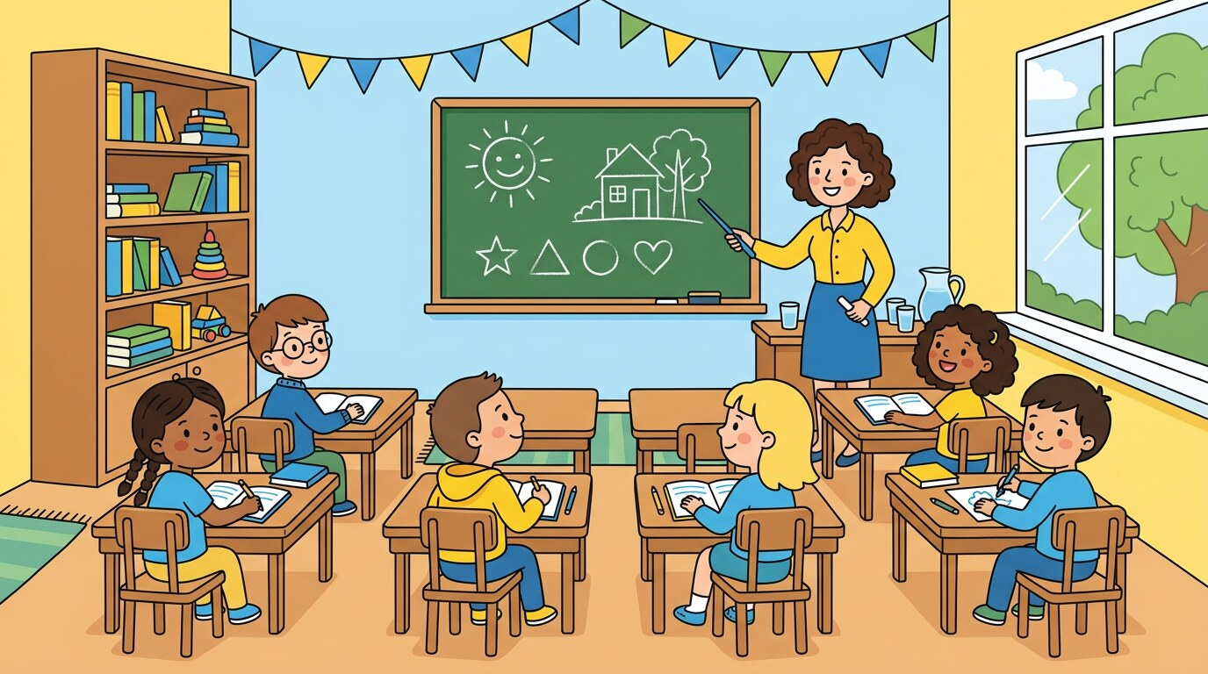
THEME 3 · Weeks 9–12 · weeks 9–12
The School
In our classroom and in the school compound. We name school places and people, describe actions, and ask politely for what we need.

By the end of this theme I can…
• Identify common objects, people, and places within the school environment
• Use greetings and polite phrases in classroom situations
• Decode and spell monosyllabic and simple multisyllabic school-related words
• Write short descriptive and instructional sentences related to school routines
• Apply grammar features such as regular verbs, adjectives, and simple sentence structure
• Participate in songs, chants, sketches, and short dialogues linked to school life

Culminating project
★ My School Day Strip
☐ 1. Create a visual strip showing three classroom or school scenes
☐ 2. Include labels and short phrases for school places, actions, and people
☐ 3. Add one instructional or greeting phrase used at school
☐ 4. Perform a short rhyme or chant describing a school routine

In this theme — four weeks
Week 9 Identifying School Places and People
I can name common places and people in my school.
Week 10 Describing School Tools and Actions
I can describe the tools we use and the actions we do in class.
Week 11 Greeting, Sharing, and Polite Requests
I can use polite greetings and requests in the classroom.
Week 12 Classroom Routines and Final Presentation
I can talk about my school day and present my work.

WEEK 9 · Theme 3: The School
Identifying School Places and People
COMPETENCE: By the end of this week I can name common places and people in my school.
Knowledge · skills · attitudes: listening, speaking, reading, writing, phonics, drama, and the mini project.

DOMAINS OF THE WEEK: Listening and Speaking · Reading · Writing · Grammar, Vocabulary and Pronunciation · Phonics · Literature and Drama
LET'S START It is your first day in Class 1. You stand at the door of the classroom.
» What do you say to the teacher?
» What can you see in the classroom?

1 Listen and say
LISTENING AND SPEAKING
Listen to your teacher. Then say each line with your teacher.
Naming school places and people
♪ This is the classroom.
♪ She is the teacher.
♪ He is at the desk.
♪ It is the school.
2 Read
READING
Read with your teacher. Point to each word with your finger.
Reading school words
▸ desk
▸ mat
▸ pen
▸ bell
▸ chalk
Read each word. Then point to the thing in your classroom.
3 Write
WRITING
Write in your exercise book. Sit well and hold your pencil well.
Trace and write: "teacher", "classroom", "desk".

4 New words and grammar
GRAMMAR, VOCABULARY AND PRONUNCIATION
Look at the box with your teacher. Then say the examples.
Grammar focus: Nouns (common and proper); subject pronouns (He, She)
· A proper noun is the name of one person or place: Ngo, Azobe.
· A common noun names any person or thing: teacher, desk.
Say: “This is the classroom.” “She is the teacher.” “It is the school.”

English | Français | English | Français
classroom | la salle de classe | bell | la cloche
desk | le pupitre | chalk | la craie
bag | le cartable
5 Phonics
PHONICS
Say the sound. Then find the sound in each word.
Sound focus: Initial sounds in school words
bag | desk | mat | board
6 Song: My School
LITERATURE AND DRAMA
Sing with your teacher. Add actions.
♪ Ring the bell,
♪ Enter and tell,
♪ Sit and learn,
♪ Read and spell!

7 I integrate — I use my English
INTEGRATION — A NEW SITUATION
Work with a friend. Use all the English you have learned this week.
★ Walk around the classroom with your teacher. Name five things: "This is a desk. This is the board."

MINI PROJECT Draw and label one school place or person on the strip.
Add this to your theme strip.

Check yourself
Tick how you are doing. Colour a star when you can do it alone.
I can… | Not yet | Getting there | Yes, I can
I can name five things in my classroom. | ☐ | ☐ | ☐
I can use He, She and It for people and things. | ☐ | ☐ | ☐
I can label a drawing of a school place. | ☐ | ☐ | ☐

WEEK 10 · Theme 3: The School
Describing School Tools and Actions
COMPETENCE: By the end of this week I can describe the tools we use and the actions we do in class.
Knowledge · skills · attitudes: listening, speaking, reading, writing, phonics, drama, and the mini project.

DOMAINS OF THE WEEK: Listening and Speaking · Reading · Writing · Grammar, Vocabulary and Pronunciation · Phonics · Literature and Drama
LET'S START Your teacher asks the class: "What do we do in the classroom?"
» What do you do in class?
» Which tools do you use?

1 Listen and say
LISTENING AND SPEAKING
Listen to your teacher. Then say each line with your teacher.
Describing actions
♪ She writes on the board.
♪ He reads the book.
♪ We sit in class.
♪ I write in my book.
2 Read
READING
Read with your teacher. Point to each word with your finger.
Reading action phrases
▸ He reads the book.
▸ We sit in class.
▸ The chair is red.
Read the phrase. Then do the action.
3 Write
WRITING
Write in your exercise book. Sit well and hold your pencil well.
Copy and write: "I write." "We read." Then write one action you do in class.

4 New words and grammar
GRAMMAR, VOCABULARY AND PRONUNCIATION
Look at the box with your teacher. Then say the examples.
Grammar focus: Adjectives; regular verbs in the simple present
· Verbs tell us what somebody does: read, write, sit, mop.
· With he, she, it we add -s: He reads. She writes.
Say: “She writes on the board.” “It is a clean desk.” “He reads the book.”

English | Français | English | Français
board | le tableau | sit | s'asseoir
read | lire | red | rouge
write | écrire
5 Phonics
PHONICS
Say the sound. Then find the sound in each word.
Sound focus: Final sounds in verbs and school items
read | sit | mop | book
6 Chant: In Our Classroom
LITERATURE AND DRAMA
Say the rhyme with your teacher. Clap the beat.
Sit and write,
Pass the light,
Read and speak,
Be polite!

7 I integrate — I use my English
INTEGRATION — A NEW SITUATION
Work with a friend. Use all the English you have learned this week.
★ Play "What am I doing?" Mime an action. Your friend says: "You are reading."

MINI PROJECT Add a short action phrase to the project strip.
Add this to your theme strip.

Check yourself
Tick how you are doing. Colour a star when you can do it alone.
I can… | Not yet | Getting there | Yes, I can
I can name classroom tools. | ☐ | ☐ | ☐
I can say what people do with -s (He reads). | ☐ | ☐ | ☐
I can write one action sentence. | ☐ | ☐ | ☐

WEEK 11 · Theme 3: The School
Greeting, Sharing, and Polite Requests
COMPETENCE: By the end of this week I can use polite greetings and requests in the classroom.
Knowledge · skills · attitudes: listening, speaking, reading, writing, phonics, drama, and the mini project.

DOMAINS OF THE WEEK: Listening and Speaking · Reading · Writing · Grammar, Vocabulary and Pronunciation · Phonics · Literature and Drama
LET'S START Your pencil is broken. You need to sharpen it. The teacher is writing on the board.
» What do you say to the teacher?
» How do you ask your friend for a pencil?

1 Listen and say
LISTENING AND SPEAKING
Listen to your teacher. Then say each line with your teacher.
Using polite requests
♪ May I sharpen my pencil?
♪ Can I sit here?
♪ Please pass the book.
♪ Thank you, teacher.
2 Read
READING
Read with your teacher. Point to each word with your finger.
Reading greetings and requests
▸ Hello, teacher.
▸ Please pass the book.
▸ May I go out?
▸ Can I help?
Read each sentence politely. Use a soft voice.
3 Write
WRITING
Write in your exercise book. Sit well and hold your pencil well.
Write two polite sentences: "Thank you." and "May I go out?"

4 New words and grammar
GRAMMAR, VOCABULARY AND PRONUNCIATION
Look at the box with your teacher. Then say the examples.
Grammar focus: Modal verbs (Can, May); interjections and conjunctions
· We use May I…? and Can I…? to ask politely.
· We use and to join two ideas: I sit and I read.
Say: “May I sharpen my pencil?” “Can I sit here?” “May I go out?”

English | Français | English | Français
please | s'il te plaît | borrow | emprunter
share | partager | pencil | le crayon
5 Phonics
PHONICS
Say the sound. Then find the sound in each word.
Sound focus: Digraphs in social and classroom words
thank | share | chair | this
6 Dialogue: Asking to Borrow a Book
LITERATURE AND DRAMA
Act it out in pairs. Speak loudly and politely.
Bih: Good morning, Ngo.
Ngo: Good morning, Bih. Can I help you?
Bih: May I borrow your book, please?
Ngo: Yes, you may. Here you are.

7 I integrate — I use my English
INTEGRATION — A NEW SITUATION
Work with a friend. Use all the English you have learned this week.
★ Act the dialogue. Then swap. Ask for a book, a pencil and a chair.

MINI PROJECT Add a greeting or a request phrase to the project strip.
Add this to your theme strip.

Check yourself
Tick how you are doing. Colour a star when you can do it alone.
I can… | Not yet | Getting there | Yes, I can
I can ask politely with May I…? and Can I…?. | ☐ | ☐ | ☐
I can read and write the digraphs th, sh, ch. | ☐ | ☐ | ☐
I can share with my friends and say thank you. | ☐ | ☐ | ☐

WEEK 12 · Theme 3: The School
Classroom Routines and Final Presentation
COMPETENCE: By the end of this week I can talk about my school day and present my work.
Knowledge · skills · attitudes: listening, speaking, reading, writing, phonics, drama, and the mini project.

DOMAINS OF THE WEEK: Listening and Speaking · Reading · Writing · Grammar, Vocabulary and Pronunciation · Phonics · Literature and Drama
LET'S START It is the last day of the theme. Your class has visitors. Your teacher asks you to present your School Day Strip.
» What do you do every morning at school?
» What will you show the visitors?

1 Listen and say
LISTENING AND SPEAKING
Listen to your teacher. Then say each line with your teacher.
Talking about my school day
♪ We enter quietly.
♪ I greet the teacher.
♪ The bell rings.
♪ I clean my desk.
2 Read
READING
Read with your teacher. Point to each word with your finger.
Reading about routines
▸ I greet the teacher.
▸ The bell rings.
▸ I clean my desk.
Read the sentences in the right order: bell, greet, clean.
3 Write
WRITING
Write in your exercise book. Sit well and hold your pencil well.
Write three sentences about your school day. Correct this one first: "we sit quiet".

4 New words and grammar
GRAMMAR, VOCABULARY AND PRONUNCIATION
Look at the box with your teacher. Then say the examples.
Grammar focus: Editing simple sentences; punctuation and capitalisation
· Check every sentence: a capital letter first, a full stop at the end.
· With he, she, it, the verb takes -s: She comes.
Say: “we sit quiet → We sit quietly.” “she come → She comes.” “The bell rings.”

English | Français | English | Français
quietly | tranquillement | ring | sonner
morning | le matin | clean | nettoyer
5 Phonics
PHONICS
Clap the syllables. Then write the word.
Sound focus: Syllable and spelling review
clas-sroom | pen-cil | chalk-board | teach-er
6 Performance: My School Day Strip
LITERATURE AND DRAMA
Present your strip to the class. Speak clearly and smile.
This is my school. (show the strip)
I greet my teacher. (wave)
I read my book. (open hands)
I love my school! (smile)

7 I integrate — I use my English
INTEGRATION — A NEW SITUATION
Work with a friend. Use all the English you have learned this week.
★ Present your strip to the class. Say what you do in the morning, at break and at the end of the day.

MINI PROJECT Finalise the strip with labelled drawings and complete phrases.
Add this to your theme strip.

Check yourself
Tick how you are doing. Colour a star when you can do it alone.
I can… | Not yet | Getting there | Yes, I can
I can describe my school day in three sentences. | ☐ | ☐ | ☐
I can correct a sentence with a capital letter and a full stop. | ☐ | ☐ | ☐
I can present my School Day Strip. | ☐ | ☐ | ☐

THEME 3 · CULMINATING PROJECT
I present my strip
My School Day Strip
Today you show the class what you have built for four weeks. Take your time. Stand up. Breathe. Smile. Speak loudly.

My strip has…
☐ Create a visual strip showing three classroom or school scenes
☐ Include labels and short phrases for school places, actions, and people
☐ Add one instructional or greeting phrase used at school
☐ Perform a short rhyme or chant describing a school routine

When I present, I…
☐ stand up and look at my friends
☐ speak loudly and slowly
☐ point to my drawing when I speak about it
☐ say at least three English sentences
☐ say "Thank you for listening!" at the end

My project mark
Your teacher uses the same three criteria as you. Tick together and talk about what to improve.
Criterion | Not yet | Getting there | Yes, I can
My strip is complete (all four weeks). | ☐ | ☐ | ☐
My drawings and labels are neat and clear. | ☐ | ☐ | ☐
I spoke in English without reading everything. | ☐ | ☐ | ☐

After the presentation — what next?
Remediation: If you ticked "Not yet" or "Getting there" anywhere, do the practice again with your teacher this week. You do not move on until you can say "Yes, I can".

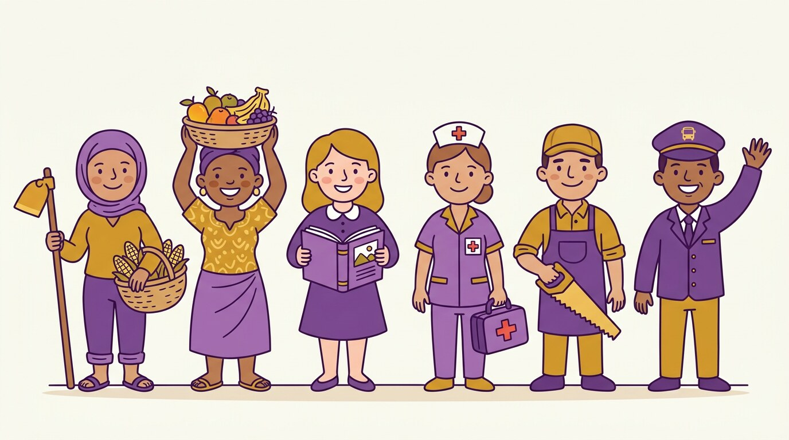
THEME 4 · Weeks 13–16 · weeks 13–16
Occupations
The people who work around us: the farmer, the nurse, the cook, the carpenter, the market woman. We name their work, their tools and what they do.

By the end of this theme I can…
• Identify common jobs, tools, and responsibilities in the community
• Use polite language and correct sentence structure to describe work routines
• Read and write monosyllabic and simple multisyllabic job-related words
• Apply grammar features such as noun-verb agreement, pronouns, and adjectives
• Participate in role-play, chants, songs, and descriptive writing based on community work
• Create a visual strip featuring drawings and labels of two occupations

Culminating project
★ What People Do Strip
☐ 1. Create a visual strip featuring drawings and labels of two occupations
☐ 2. Include a short greeting and one action sentence for each job
☐ 3. Add one polite request or work-related phrase
☐ 4. Perform a chant, rhyme, or short scene about people and the work they do

In this theme — four weeks
Week 13 Naming Occupations and Tools
I can name common jobs and the tools people use.
Week 14 Describing What People Do
I can describe what workers do and where they work.
Week 15 Sharing Tools and Speaking Politely
I can ask politely for tools and talk about duties at work.
Week 16 Reviewing Jobs and Presenting the Strip
I can talk about jobs and present what people do.

WEEK 13 · Theme 4: Occupations
Naming Occupations and Tools
COMPETENCE: By the end of this week I can name common jobs and the tools people use.
Knowledge · skills · attitudes: listening, speaking, reading, writing, phonics, drama, and the mini project.

DOMAINS OF THE WEEK: Listening and Speaking · Reading · Writing · Grammar, Vocabulary and Pronunciation · Phonics · Literature and Drama

LET'S START You are ill. Mother takes you to the health centre. A woman in a white uniform helps you.
» Who is she? What is her work?
» Which tool does she use?

1 Listen and say
LISTENING AND SPEAKING
Listen to your teacher. Then say each line with your teacher.
Naming jobs
♪ She is a teacher.
♪ He is a farmer.
♪ She is a nurse.
♪ The cook stirs the pot.
2 Read
READING
Read with your teacher. Point to each word with your finger.
Reading job and tool words
▸ nurse
▸ cook
▸ chalk
▸ doctor
▸ broom
Read the word. Then say the job and its tool.
3 Write
WRITING
Write in your exercise book. Sit well and hold your pencil well.
Write: "The cook stirs." "The driver drives." Then write one job you know.

4 New words and grammar
GRAMMAR, VOCABULARY AND PRONUNCIATION
Look at the box with your teacher. Then say the examples.
Grammar focus: Common nouns; present tense verbs
· We say: She is a teacher. He is a farmer.
· The verb tells the work: The cook stirs. The driver drives.
Say: “She is a teacher.” “He is a farmer.” “The cook stirs.”

English | Français | English | Français
teacher | l'enseignant(e) | cook | le cuisinier
farmer | l'agriculteur | driver | le chauffeur
nurse | l'infirmier(ère)
5 Phonics
PHONICS
Say the sound. Then find the sound in each word.
Sound focus: Initial sounds in job and tool words
teacher | farmer | nurse | cook
6 Chant: What People Do
LITERATURE AND DRAMA
Say the rhyme with your teacher. Clap the beat.
Cook, cook — cooks!
Driver, drive — drives!
Teacher, teach — teaches!
Farmer, farm — farms!

7 I integrate — I use my English
INTEGRATION — A NEW SITUATION
Work with a friend. Use all the English you have learned this week.
★ Play a mime game. Your friend acts a job with a tool. The class says: "She is a nurse. She helps the sick."

MINI PROJECT Draw and label one occupation and one tool.
Add this to your theme strip.

Check yourself
Tick how you are doing. Colour a star when you can do it alone.
I can… | Not yet | Getting there | Yes, I can
I can name six jobs. | ☐ | ☐ | ☐
I can say what job a person does. | ☐ | ☐ | ☐
I can label a job and its tool. | ☐ | ☐ | ☐

WEEK 14 · Theme 4: Occupations
Describing What People Do
COMPETENCE: By the end of this week I can describe what workers do and where they work.
Knowledge · skills · attitudes: listening, speaking, reading, writing, phonics, drama, and the mini project.

DOMAINS OF THE WEEK: Listening and Speaking · Reading · Writing · Grammar, Vocabulary and Pronunciation · Phonics · Literature and Drama
LET'S START Your aunt sells tomatoes in the market. She works from morning to evening.
» What is her work?
» What does she do every day?

1 Listen and say
LISTENING AND SPEAKING
Listen to your teacher. Then say each line with your teacher.
Describing work
♪ The tailor sews.
♪ The nurse helps.
♪ The cook works in the kitchen.
♪ The cleaner sweeps.
2 Read
READING
Read with your teacher. Point to each word with your finger.
Reading action sentences
▸ The nurse works in the clinic.
▸ He sells books.
▸ She teaches well.
Read the sentence. Then say where the person works.
3 Write
WRITING
Write in your exercise book. Sit well and hold your pencil well.
Write two sentences: "The nurse works in the ____." "The driver is on the ____."

4 New words and grammar
GRAMMAR, VOCABULARY AND PRONUNCIATION
Look at the box with your teacher. Then say the examples.
Grammar focus: Simple present verbs; prepositions of place
· The nurse works in the clinic. The driver is on the road.
· in, on, at tell us where the work happens.
Say: “The tailor sews.” “The cook works in the kitchen.” “The driver is on the road.”

English | Français | English | Français
sew | coudre | sell | vendre
sweep | balayer | work | travailler
help | aider
5 Phonics
PHONICS
Say the sound. Then find the sound in each word.
Sound focus: Final sounds in job and action words
cook | sweep | help | sell
6 Chant: Where They Work
LITERATURE AND DRAMA
Say the rhyme with your teacher. Clap the beat.
Doctor helps,
Tailor sews,
Driver moves,
Cleaner mops!

7 I integrate — I use my English
INTEGRATION — A NEW SITUATION
Work with a friend. Use all the English you have learned this week.
★ Describe two workers: what they do and where they work. "My father is a farmer. He works in the field."

MINI PROJECT Add one action sentence about a worker.
Add this to your theme strip.

Check yourself
Tick how you are doing. Colour a star when you can do it alone.
I can… | Not yet | Getting there | Yes, I can
I can say what a worker does. | ☐ | ☐ | ☐
I can use in, on, at to say where. | ☐ | ☐ | ☐
I can write two sentences about work. | ☐ | ☐ | ☐

WEEK 15 · Theme 4: Occupations
Sharing Tools and Speaking Politely
COMPETENCE: By the end of this week I can ask politely for tools and talk about duties at work.
Knowledge · skills · attitudes: listening, speaking, reading, writing, phonics, drama, and the mini project.

DOMAINS OF THE WEEK: Listening and Speaking · Reading · Writing · Grammar, Vocabulary and Pronunciation · Phonics · Literature and Drama
LET'S START The cleaner wants to sweep the classroom. She needs the broom, but you are holding it.
» What does she say to you?
» What do you answer?

1 Listen and say
LISTENING AND SPEAKING
Listen to your teacher. Then say each line with your teacher.
Sharing tools politely
♪ May I borrow the broom?
♪ Can I use the chalk?
♪ Please give the book.
♪ Here you are.
2 Read
READING
Read with your teacher. Point to each word with your finger.
Reading requests
▸ May I help?
▸ Can I clean the desk?
▸ The mop is clean.
Read the request politely. Then answer: "Yes, you may."
3 Write
WRITING
Write in your exercise book. Sit well and hold your pencil well.
Write two polite sentences asking to borrow a broom and a pencil.

4 New words and grammar
GRAMMAR, VOCABULARY AND PRONUNCIATION
Look at the box with your teacher. Then say the examples.
Grammar focus: Modal verbs (Can, May); nouns and adjectives
· May I borrow the broom? — Yes, you may.
· We can describe tools too: a clean mop, an old book.
Say: “May I borrow the broom?” “Can I use the chalk?” “The mop is clean.”

English | Français | English | Français
broom | le balai | chalk | la craie
mop | le balai à laver | old | vieux / ancien
5 Phonics
PHONICS
Say the sound. Then find the sound in each word.
Sound focus: Digraphs in tool words
shop | chalk | path | brush
6 Drama: Asking for a Tool
LITERATURE AND DRAMA
Act it out in pairs. Speak loudly and politely.
Cleaner: May I borrow the broom, please?
Child: Yes, you may. Here you are.
Cleaner: Thank you very much.
Child: You are welcome.

7 I integrate — I use my English
INTEGRATION — A NEW SITUATION
Work with a friend. Use all the English you have learned this week.
★ Act the scene with the cleaner, the carpenter and the cook. Ask for their tools politely.

MINI PROJECT Add one polite request or greeting related to work.
Add this to your theme strip.

Check yourself
Tick how you are doing. Colour a star when you can do it alone.
I can… | Not yet | Getting there | Yes, I can
I can ask for a tool politely. | ☐ | ☐ | ☐
I can use Can and May correctly. | ☐ | ☐ | ☐
I can describe a tool with an adjective. | ☐ | ☐ | ☐

WEEK 16 · Theme 4: Occupations
Reviewing Jobs and Presenting the Strip
COMPETENCE: By the end of this week I can talk about jobs and present what people do.
Knowledge · skills · attitudes: listening, speaking, reading, writing, phonics, drama, and the mini project.

DOMAINS OF THE WEEK: Listening and Speaking · Reading · Writing · Grammar, Vocabulary and Pronunciation · Phonics · Literature and Drama
LET'S START Your class makes a "jobs wall". Each pupil says what work they want to do when they are big.
» What work do you want to do?
» Why do you like that work?

1 Listen and say
LISTENING AND SPEAKING
Listen to your teacher. Then say each line with your teacher.
Talking about the work we want
♪ I want to be a nurse.
♪ He dreams of farming.
♪ The tailor makes clothes.
♪ The doctor helps the sick.
2 Read
READING
Read with your teacher. Point to each word with your finger.
Reading about work
▸ The tailor makes clothes.
▸ The doctor helps the sick.
▸ My father is a farmer.
Read the text. Then answer: Who helps the sick?
3 Write
WRITING
Write in your exercise book. Sit well and hold your pencil well.
Write three sentences about a worker in your family. Correct this one first: "she sells food".

4 New words and grammar
GRAMMAR, VOCABULARY AND PRONUNCIATION
Look at the box with your teacher. Then say the examples.
Grammar focus: Sentence editing; punctuation and pronoun review
· Check: capital letter, verb with -s, full stop.
· she sells food → She sells food. they clean → They clean.
Say: “She sells food.” “They clean.” “My father is a farmer.”

English | Français | English | Français
tailor | le tailleur | dream | rêver
hospital | l'hôpital | clothes | les vêtements
5 Phonics
PHONICS
Clap the syllables. Then write the word.
Sound focus: Syllable and spelling review
teach-er | mar-ket | hos-pi-tal | tail-or
6 Performance: What People Do Strip
LITERATURE AND DRAMA
Present your strip to the class. Speak clearly and smile.
This is a farmer. He plants crops. (show the strip)
This is a nurse. She helps the sick. (point)
I want to be a teacher. (raise hand)
Thank you! (bow)

7 I integrate — I use my English
INTEGRATION — A NEW SITUATION
Work with a friend. Use all the English you have learned this week.
★ Present your strip with a partner. Each of you describes one job, then answer one question from the class.

MINI PROJECT Present the full strip with drawings, phrases and a chant.
Add this to your theme strip.

Check yourself
Tick how you are doing. Colour a star when you can do it alone.
I can… | Not yet | Getting there | Yes, I can
I can describe two jobs and their tools. | ☐ | ☐ | ☐
I can correct sentences with capital letters and full stops. | ☐ | ☐ | ☐
I can present my What People Do Strip. | ☐ | ☐ | ☐

THEME 4 · CULMINATING PROJECT
I present my strip
What People Do Strip
Today you show the class what you have built for four weeks. Take your time. Stand up. Breathe. Smile. Speak loudly.

My strip has…
☐ Create a visual strip featuring drawings and labels of two occupations
☐ Include a short greeting and one action sentence for each job
☐ Add one polite request or work-related phrase
☐ Perform a chant, rhyme, or short scene about people and the work they do

When I present, I…
☐ stand up and look at my friends
☐ speak loudly and slowly
☐ point to my drawing when I speak about it
☐ say at least three English sentences
☐ say "Thank you for listening!" at the end

My project mark
Your teacher uses the same three criteria as you. Tick together and talk about what to improve.
Criterion | Not yet | Getting there | Yes, I can
My strip is complete (all four weeks). | ☐ | ☐ | ☐
My drawings and labels are neat and clear. | ☐ | ☐ | ☐
I spoke in English without reading everything. | ☐ | ☐ | ☐

After the presentation — what next?
Remediation: If you ticked "Not yet" or "Getting there" anywhere, do the practice again with your teacher this week. You do not move on until you can say "Yes, I can".


THEME 5 · Weeks 17–20 · weeks 17–20
Travelling
How we move from place to place: on foot, by bike, by bus. We give directions, ask politely and learn the rules for travelling safely.

By the end of this theme I can…
• Recognize common forms of transport and travel-related vocabulary
• Use directional words, location prepositions, and polite expressions when speaking about movement
• Read, spell, and segment simple travel words and safety expressions
• Write short instructions and descriptive phrases about going from place to place
• Engage in role-play, chants, and conversations about safe and polite travel

Culminating project
★ How We Travel Strip
☐ 1. Create a strip with drawings of two travel methods and labels
☐ 2. Add one directional phrase and one polite request related to travel
☐ 3. Include one chant or short rhyme about movement or safety
☐ 4. Present the strip through speech or a short dramatized scene

In this theme — four weeks
Week 17 Naming Transport and Movement
I can name types of transport and describe how we move.
Week 18 Giving Directions and Describing Movement
I can give directions and describe where things are on the way.
Week 19 Travel Requests and Safety
I can ask politely and follow the rules for travelling safely.
Week 20 Reviewing Travel and Presenting the Strip
I can talk about how we travel safely and present my work.

WEEK 17 · Theme 5: Travelling
Naming Transport and Movement
COMPETENCE: By the end of this week I can name types of transport and describe how we move.
Knowledge · skills · attitudes: listening, speaking, reading, writing, phonics, drama, and the mini project.

DOMAINS OF THE WEEK: Listening and Speaking · Reading · Writing · Grammar, Vocabulary and Pronunciation · Phonics · Literature and Drama
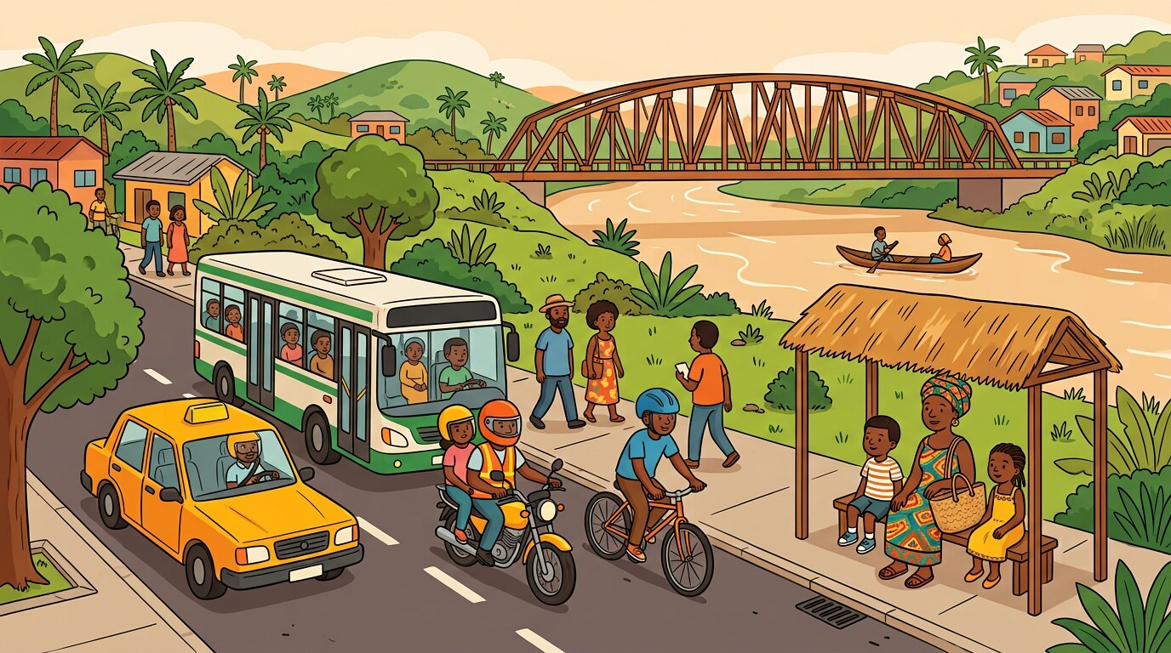
LET'S START Morning. You must go to school. Your house is far from the school.
» How do you go to school?
» Who goes with you?

1 Listen and say
LISTENING AND SPEAKING
Listen to your teacher. Then say each line with your teacher.
Naming transport
♪ We walk.
♪ He rides.
♪ This is a bus.
♪ The driver drives the bus.
2 Read
READING
Read with your teacher. Point to each word with your finger.
Reading transport words
▸ bus
▸ bike
▸ walk
▸ car
Read each word. Then say how many wheels it has.
3 Write
WRITING
Write in your exercise book. Sit well and hold your pencil well.
Write: "I walk to school." "He rides the bike." Then draw your transport.

4 New words and grammar
GRAMMAR, VOCABULARY AND PRONUNCIATION
Look at the box with your teacher. Then say the examples.
Grammar focus: Common nouns; action verbs in the present
· We use ride for a bike, drive for a car or bus, walk for our feet.
· He rides. She drives. We walk.
Say: “This is a bus.” “He rides the bike.” “I walk.”

English | Français | English | Français
bus | le bus | walk | marcher
bike | le vélo | ride | monter / rouler
car | la voiture
5 Phonics
PHONICS
Say the sound. Then find the sound in each word.
Sound focus: Initial sounds in transport and movement words
bus | bike | walk | ride
6 Chant: Move with Care
LITERATURE AND DRAMA
Say the rhyme with your teacher. Clap the beat.
Move with care,
Stop and stare,
Check both ways,
Travel fair!

7 I integrate — I use my English
INTEGRATION — A NEW SITUATION
Work with a friend. Use all the English you have learned this week.
★ Ask three friends: "How do you come to school?" Answer for them: "Bih walks. Ngo rides a bike."

MINI PROJECT Draw and label one type of transport.
Add this to your theme strip.

Check yourself
Tick how you are doing. Colour a star when you can do it alone.
I can… | Not yet | Getting there | Yes, I can
I can name four types of transport. | ☐ | ☐ | ☐
I can say how I come to school. | ☐ | ☐ | ☐
I can label a drawing of transport. | ☐ | ☐ | ☐

WEEK 18 · Theme 5: Travelling
Giving Directions and Describing Movement
COMPETENCE: By the end of this week I can give directions and describe where things are on the way.
Knowledge · skills · attitudes: listening, speaking, reading, writing, phonics, drama, and the mini project.

DOMAINS OF THE WEEK: Listening and Speaking · Reading · Writing · Grammar, Vocabulary and Pronunciation · Phonics · Literature and Drama
LET'S START A taxi driver stops and asks you the way to the market. You know the village very well.
» What does the driver ask?
» What do you tell him?

1 Listen and say
LISTENING AND SPEAKING
Listen to your teacher. Then say each line with your teacher.
Giving directions
♪ Go straight.
♪ Turn left.
♪ It is near the shop.
♪ Walk beside the road.
2 Read
READING
Read with your teacher. Point to each word with your finger.
Reading directions
▸ The shop is near the mosque.
▸ Walk under the bridge.
▸ Turn left at the school.
Read the direction. Then show it with your hand.
3 Write
WRITING
Write in your exercise book. Sit well and hold your pencil well.
Write directions from your class to the school gate.

4 New words and grammar
GRAMMAR, VOCABULARY AND PRONUNCIATION
Look at the box with your teacher. Then say the examples.
Grammar focus: Prepositions on, behind, near, in front; sentence structure
· We use on for a road, behind for the back, near for close, in front for the front.
· Go straight. Turn left. Walk beside the road.
Say: “It is near the shop.” “The bus is behind the tree.” “I walk on the road.”

English | Français | English | Français
near | près de | straight | tout droit
behind | derrière | left | à gauche
in front | devant
5 Phonics
PHONICS
Clap the syllables. Then write the word.
Sound focus: Syllable segmentation in travel words
mar-ket | trav-el | cross-ing | school
6 Dialogue: Finding the School
LITERATURE AND DRAMA
Act it out in pairs. Speak loudly and politely.
Driver: Excuse me, where is the school?
Child: Go straight, then turn left.
Driver: Is it far?
Child: No, it is near the big tree.

7 I integrate — I use my English
INTEGRATION — A NEW SITUATION
Work with a friend. Use all the English you have learned this week.
★ Draw a simple map. Give your friend directions to the market, the clinic and the school.

MINI PROJECT Add one directional sentence to the strip.
Add this to your theme strip.

Check yourself
Tick how you are doing. Colour a star when you can do it alone.
I can… | Not yet | Getting there | Yes, I can
I can give directions with straight, left, near. | ☐ | ☐ | ☐
I can use on, behind, near, in front. | ☐ | ☐ | ☐
I can say where a place is on my map. | ☐ | ☐ | ☐

WEEK 19 · Theme 5: Travelling
Travel Requests and Safety
COMPETENCE: By the end of this week I can ask politely and follow the rules for travelling safely.
Knowledge · skills · attitudes: listening, speaking, reading, writing, phonics, drama, and the mini project.

DOMAINS OF THE WEEK: Listening and Speaking · Reading · Writing · Grammar, Vocabulary and Pronunciation · Phonics · Literature and Drama
LET'S START You are standing at the side of a busy road with Mother. Cars and motorbikes pass fast.
» What must you do before crossing?
» What do you say to Mother?

1 Listen and say
LISTENING AND SPEAKING
Listen to your teacher. Then say each line with your teacher.
Asking and warning
♪ Can I cross here?
♪ May I sit near the window?
♪ Look both ways.
♪ Stop and wait.
2 Read
READING
Read with your teacher. Point to each word with your finger.
Reading safety rules
▸ Look both ways.
▸ Walk after the light.
▸ Stop and wait.
Read the rule. Then show the class what to do.
3 Write
WRITING
Write in your exercise book. Sit well and hold your pencil well.
Write two safety rules for the road. Start with "Look…" and "Stop…".

4 New words and grammar
GRAMMAR, VOCABULARY AND PRONUNCIATION
Look at the box with your teacher. Then say the examples.
Grammar focus: Modal verbs (Can, May); conjunctions and, then
· Can I cross here? May I sit near the window?
· We use then for the second action: Stop, then look.
Say: “Can I cross here?” “Look both ways.” “Cross, then walk.”

English | Français | English | Français
cross | traverser | stop | s'arrêter
wait | attendre | look | regarder
5 Phonics
PHONICS
Say the sound. Then find the sound in each word.
Sound focus: Digraphs and blends in safety words
path | stop | check | dash
6 Chant: Wait and Look
LITERATURE AND DRAMA
Say the rhyme with your teacher. Clap the beat.
Wait and look,
Stop and think,
Use the road,
Safe and sound!

7 I integrate — I use my English
INTEGRATION — A NEW SITUATION
Work with a friend. Use all the English you have learned this week.
★ Act a road scene in the classroom. One pupil is a driver, others are children. Use the safety words.

MINI PROJECT Add one polite travel-related request to the strip.
Add this to your theme strip.

Check yourself
Tick how you are doing. Colour a star when you can do it alone.
I can… | Not yet | Getting there | Yes, I can
I can ask politely before crossing or sitting. | ☐ | ☐ | ☐
I can say three road-safety rules. | ☐ | ☐ | ☐
I can read safety signs and words. | ☐ | ☐ | ☐

WEEK 20 · Theme 5: Travelling
Reviewing Travel and Presenting the Strip
COMPETENCE: By the end of this week I can talk about how we travel safely and present my work.
Knowledge · skills · attitudes: listening, speaking, reading, writing, phonics, drama, and the mini project.

DOMAINS OF THE WEEK: Listening and Speaking · Reading · Writing · Grammar, Vocabulary and Pronunciation · Phonics · Literature and Drama
LET'S START Your class makes a road-safety corner. Each pupil presents their travel strip and one safety rule.
» How do you travel to school?
» Which safety rule is the most important?

1 Listen and say
LISTENING AND SPEAKING
Listen to your teacher. Then say each line with your teacher.
Talking about travel habits
♪ I walk with Mother.
♪ We cross after the light.
♪ Children sit quietly.
♪ Drivers stop at signs.
2 Read
READING
Read with your teacher. Point to each word with your finger.
Reading about safety
▸ We stop and look before crossing.
▸ Children sit quietly.
▸ Drivers stop at signs.
Read the text. Then answer: What do drivers do at signs?
3 Write
WRITING
Write in your exercise book. Sit well and hold your pencil well.
Write three sentences about travelling safely. Correct this one first: "they go road".

4 New words and grammar
GRAMMAR, VOCABULARY AND PRONUNCIATION
Look at the box with your teacher. Then say the examples.
Grammar focus: Sentence editing; punctuation and capital letters
· they go road → They go on the road. she walk → She walks.
· Check every sentence before you present it.
Say: “They go on the road.” “She walks.” “We stop and look before crossing.”

English | Français | English | Français
safety | la sécurité | careful | prudent
motor | le moteur | sign | le panneau
5 Phonics
PHONICS
Clap the syllables. Then write the word.
Sound focus: Syllable and spelling review
walk-ing | mo-tor | sa-fe-ty | cross-ing
6 Performance: How We Travel Strip
LITERATURE AND DRAMA
Present your strip to the class. Speak clearly and smile.
This is a bus. (show the strip)
I walk to school with Mother. (point)
Stop and look before you cross! (raise hand)
Thank you! (bow)

7 I integrate — I use my English
INTEGRATION — A NEW SITUATION
Work with a friend. Use all the English you have learned this week.
★ Present your strip. Say how you travel, one direction and one safety rule.

MINI PROJECT Present the completed travel strip with labels, phrases and a chant.
Add this to your theme strip.

Check yourself
Tick how you are doing. Colour a star when you can do it alone.
I can… | Not yet | Getting there | Yes, I can
I can describe how I travel to school. | ☐ | ☐ | ☐
I can say and write safety rules. | ☐ | ☐ | ☐
I can present my How We Travel Strip. | ☐ | ☐ | ☐

THEME 5 · CULMINATING PROJECT
I present my strip
How We Travel Strip
Today you show the class what you have built for four weeks. Take your time. Stand up. Breathe. Smile. Speak loudly.

My strip has…
☐ Create a strip with drawings of two travel methods and labels
☐ Add one directional phrase and one polite request related to travel
☐ Include one chant or short rhyme about movement or safety
☐ Present the strip through speech or a short dramatized scene

When I present, I…
☐ stand up and look at my friends
☐ speak loudly and slowly
☐ point to my drawing when I speak about it
☐ say at least three English sentences
☐ say "Thank you for listening!" at the end

My project mark
Your teacher uses the same three criteria as you. Tick together and talk about what to improve.
Criterion | Not yet | Getting there | Yes, I can
My strip is complete (all four weeks). | ☐ | ☐ | ☐
My drawings and labels are neat and clear. | ☐ | ☐ | ☐
I spoke in English without reading everything. | ☐ | ☐ | ☐

After the presentation — what next?
Remediation: If you ticked "Not yet" or "Getting there" anywhere, do the practice again with your teacher this week. You do not move on until you can say "Yes, I can".

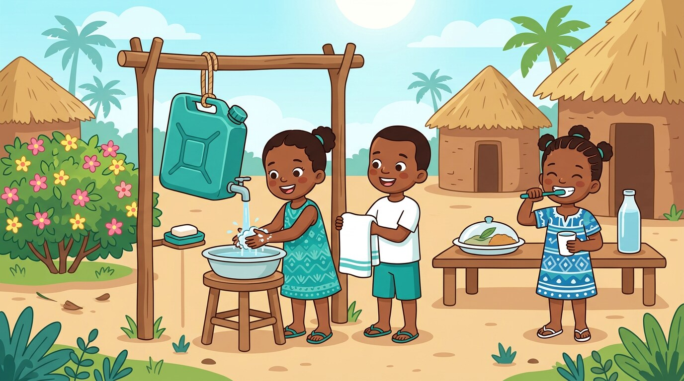
THEME 6 · Weeks 21–24 · weeks 21–24
Health
Keeping our body clean and strong: soap, water, toothbrush, clean food. We give simple health instructions and polite requests.

By the end of this theme I can…
• Identify good hygiene habits, body parts, and personal care items
• Demonstrate polite responses, greetings, and health-related instructions
• Read and write simple health vocabulary and descriptive phrases
• Segment and spell monosyllabic and multisyllabic health-related words
• Participate in chants, sketches, and rhymes about health and well-being

Culminating project
★ Staying Clean Strip
☐ 1. Create a strip with drawings of two hygiene or health tools and their labels
☐ 2. Include a polite health request or instruction
☐ 3. Add one short chant, rhyme, or sentence promoting good habits
☐ 4. Present the strip orally, using vocabulary from the theme

In this theme — four weeks
Week 21 Naming Body Parts and Hygiene Tools
I can name parts of my body and the things I use to keep clean.
Week 22 Describing Healthy Routines and Foods
I can describe healthy habits, clean food and daily routines.
Week 23 Giving Safety Instructions and Requests
I can give simple health instructions and ask politely about washing.
Week 24 Reviewing Healthy Habits and Final Presentation
I can talk about keeping clean and present my work.

WEEK 21 · Theme 6: Health
Naming Body Parts and Hygiene Tools
COMPETENCE: By the end of this week I can name parts of my body and the things I use to keep clean.
Knowledge · skills · attitudes: listening, speaking, reading, writing, phonics, drama, and the mini project.

DOMAINS OF THE WEEK: Listening and Speaking · Reading · Writing · Grammar, Vocabulary and Pronunciation · Phonics · Literature and Drama
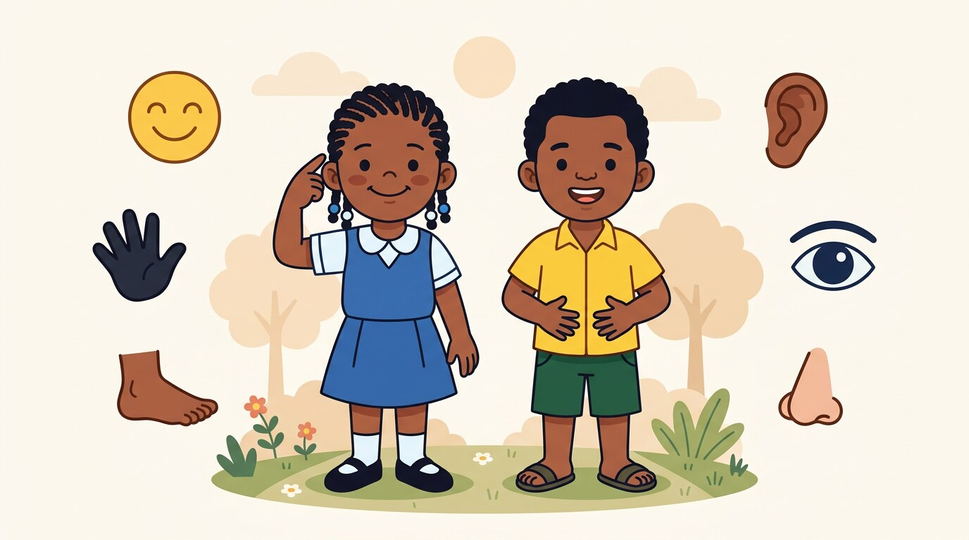
LET'S START It is morning. You are going to school. Mother calls you to wash before you eat.
» What do you use to wash?
» Which parts of your body do you wash?

1 Listen and say
LISTENING AND SPEAKING
Listen to your teacher. Then say each line with your teacher.
Naming body parts and tools
♪ This is a hand.
♪ That is soap.
♪ My hands are clean.
♪ This is a soft towel.
2 Read
READING
Read with your teacher. Point to each word with your finger.
Reading health words
▸ tooth
▸ hair
▸ soap
▸ towel
▸ brush
Read the word. Then point to the thing or the body part.
3 Write
WRITING
Write in your exercise book. Sit well and hold your pencil well.
Trace and write: "soap", "hand", "tooth". Then label your drawing.

4 New words and grammar
GRAMMAR, VOCABULARY AND PRONUNCIATION
Look at the box with your teacher. Then say the examples.
Grammar focus: Common nouns; adjectives for size and condition
· Nouns name the things we use: soap, towel, brush, tooth.
· Adjectives describe them: a soft towel, a new brush, clean hands.
Say: “This is a hand.” “That is soap.” “This is a soft towel.”

English | Français | English | Français
hand | la main | soap | le savon
tooth | la dent | towel | la serviette
hair | les cheveux
5 Phonics
PHONICS
Say the sound. Then find the sound in each word.
Sound focus: Initial sounds in health words
soap | tooth | hair | towel
6 Chant: Soap and Brush
LITERATURE AND DRAMA
Say the rhyme with your teacher. Clap the beat.
Soap — clean!
Brush — hair!
Towel — dry!
Water — everywhere!

7 I integrate — I use my English
INTEGRATION — A NEW SITUATION
Work with a friend. Use all the English you have learned this week.
★ Play "Simon says". Touch your nose, your hand, your tooth. Then name the tool you use for each.

MINI PROJECT Draw and label one hygiene tool or body part.
Add this to your theme strip.

Check yourself
Tick how you are doing. Colour a star when you can do it alone.
I can… | Not yet | Getting there | Yes, I can
I can name six body parts and hygiene tools. | ☐ | ☐ | ☐
I can describe a tool with an adjective. | ☐ | ☐ | ☐
I can label a drawing of a hygiene tool. | ☐ | ☐ | ☐

WEEK 22 · Theme 6: Health
Describing Healthy Routines and Foods
COMPETENCE: By the end of this week I can describe healthy habits, clean food and daily routines.
Knowledge · skills · attitudes: listening, speaking, reading, writing, phonics, drama, and the mini project.

DOMAINS OF THE WEEK: Listening and Speaking · Reading · Writing · Grammar, Vocabulary and Pronunciation · Phonics · Literature and Drama
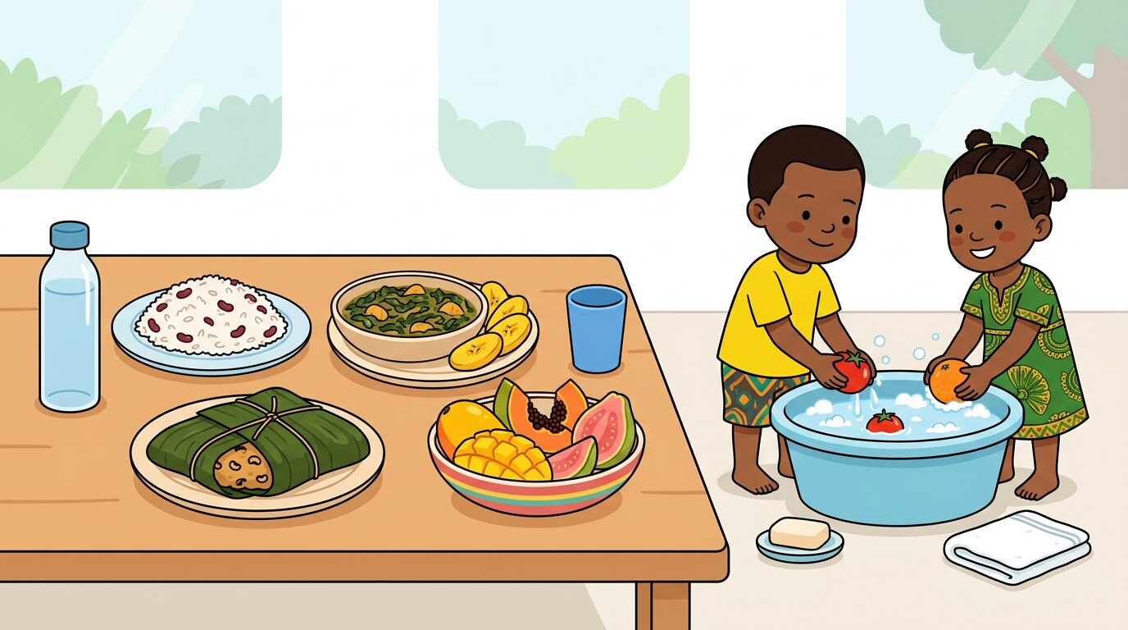
LET'S START At break time your friend eats a mango from the ground and drinks water from a dirty cup.
» What do you say to your friend?
» What is good food and clean water?

1 Listen and say
LISTENING AND SPEAKING
Listen to your teacher. Then say each line with your teacher.
Talking about healthy habits
♪ I bathe every morning.
♪ We eat fruits.
♪ Drink clean water.
♪ Sleep early.
2 Read
READING
Read with your teacher. Point to each word with your finger.
Reading healthy phrases
▸ We eat sweet fruit.
▸ He drinks clean water.
▸ Clean hands. Good food.
Read the phrase. Then tick the healthy one.
3 Write
WRITING
Write in your exercise book. Sit well and hold your pencil well.
Write two healthy habits: "I ____ every day." "I drink ____ water."

4 New words and grammar
GRAMMAR, VOCABULARY AND PRONUNCIATION
Look at the box with your teacher. Then say the examples.
Grammar focus: Verbs in the present; simple sentences with adjectives
· We bathe every morning. He drinks clean water.
· Adjectives go before the noun: clean water, sweet fruit.
Say: “I bathe every morning.” “We eat fruits.” “He drinks clean water.”

English | Français | English | Français
bathe | se laver | water | l'eau
drink | boire | sleep | dormir
fruit | le fruit
5 Phonics
PHONICS
Clap the syllables. Then write the word.
Sound focus: Final sounds and syllables in health and food words
veg-e-ta-ble | wa-ter | bath-ing | fruit
6 Song: I Take Care of Me
LITERATURE AND DRAMA
Sing with your teacher. Add actions.
♪ Wash and eat,
♪ Rest and play,
♪ Brush my teeth,
♪ Every day!

7 I integrate — I use my English
INTEGRATION — A NEW SITUATION
Work with a friend. Use all the English you have learned this week.
★ Make a healthy plate with your friend. Say: "This is rice. This is fruit. This is clean water."

MINI PROJECT Add one healthy habit or food phrase to the strip.
Add this to your theme strip.

Check yourself
Tick how you are doing. Colour a star when you can do it alone.
I can… | Not yet | Getting there | Yes, I can
I can describe three healthy habits. | ☐ | ☐ | ☐
I can say what I eat and drink. | ☐ | ☐ | ☐
I can read and spell water, fruit, bathing. | ☐ | ☐ | ☐

WEEK 23 · Theme 6: Health
Giving Safety Instructions and Requests
COMPETENCE: By the end of this week I can give simple health instructions and ask politely about washing.
Knowledge · skills · attitudes: listening, speaking, reading, writing, phonics, drama, and the mini project.

DOMAINS OF THE WEEK: Listening and Speaking · Reading · Writing · Grammar, Vocabulary and Pronunciation · Phonics · Literature and Drama
LET'S START Your little brother comes from playing in the dust. He wants to eat bread.
» What do you tell him to do first?
» How do you ask for the towel?

1 Listen and say
LISTENING AND SPEAKING
Listen to your teacher. Then say each line with your teacher.
Giving health instructions
♪ Wash your hands.
♪ Brush your teeth.
♪ Please comb your hair.
♪ Don't eat dirt.
2 Read
READING
Read with your teacher. Point to each word with your finger.
Reading health instructions
▸ Wash your hands.
▸ Brush before bed.
▸ Can I wash now?
Read the instruction. Then do it with your hands.
3 Write
WRITING
Write in your exercise book. Sit well and hold your pencil well.
Write two instructions for your brother. Start with "Wash…" and "Brush…".

4 New words and grammar
GRAMMAR, VOCABULARY AND PRONUNCIATION
Look at the box with your teacher. Then say the examples.
Grammar focus: Modal verbs (May, Can); imperative verbs
· An instruction tells somebody what to do: Wash your hands. Brush your teeth.
· We ask politely with May I…? and Can I…?
Say: “Wash your hands.” “Brush before bed.” “May I use the towel?”

English | Français | English | Français
wash | laver | comb | peigner
brush | brosser | dirt | la saleté
5 Phonics
PHONICS
Say the sound. Then find the sound in each word.
Sound focus: Digraphs in hygiene actions and objects
brush | chair | bath | wash
6 Drama: Asking About Washing
LITERATURE AND DRAMA
Act it out in pairs. Speak loudly and politely.
Child: May I use the towel?
Mother: Yes, you may.
Child: Can I wash now?
Mother: Wash your hands first, then eat.

7 I integrate — I use my English
INTEGRATION — A NEW SITUATION
Work with a friend. Use all the English you have learned this week.
★ Give three instructions to a friend: wash, brush, comb. Your friend does the actions.

MINI PROJECT Add one polite health-related request or warning.
Add this to your theme strip.

Check yourself
Tick how you are doing. Colour a star when you can do it alone.
I can… | Not yet | Getting there | Yes, I can
I can give three health instructions. | ☐ | ☐ | ☐
I can ask politely about washing. | ☐ | ☐ | ☐
I can read and spell brush, bath, wash. | ☐ | ☐ | ☐

WEEK 24 · Theme 6: Health
Reviewing Healthy Habits and Final Presentation
COMPETENCE: By the end of this week I can talk about keeping clean and present my work.
Knowledge · skills · attitudes: listening, speaking, reading, writing, phonics, drama, and the mini project.

DOMAINS OF THE WEEK: Listening and Speaking · Reading · Writing · Grammar, Vocabulary and Pronunciation · Phonics · Literature and Drama
LET'S START Your class is preparing a clean-hands corner for the school. The teacher asks each pupil to present their Staying Clean Strip.
» What do you do to stay clean?
» Which habit will you show the class?

1 Listen and say
LISTENING AND SPEAKING
Listen to your teacher. Then say each line with your teacher.
Sharing what keeps us clean
♪ I clean my teeth.
♪ We wash our hands before eating.
♪ She bathes daily.
♪ He drinks clean water.
2 Read
READING
Read with your teacher. Point to each word with your finger.
Reviewing health sentences
▸ She bathes daily.
▸ He drinks clean water.
▸ We wash our hands before eating.
Read the sentences. Then say which one you do every day.
3 Write
WRITING
Write in your exercise book. Sit well and hold your pencil well.
Write three sentences: "To stay clean, I ____, ____ and ____." Correct "he brush" first.

4 New words and grammar
GRAMMAR, VOCABULARY AND PRONUNCIATION
Look at the box with your teacher. Then say the examples.
Grammar focus: Sentence editing and verb tense review
· he brush → He brushes. we drink water → We drink water.
· With he, she, it the verb takes -s.
Say: “He brushes.” “She bathes daily.” “We drink clean water.”

English | Français | English | Français
clean | propre / nettoyer | daily | chaque jour
teeth | les dents | well | bien
5 Phonics
PHONICS
Clap the syllables. Then write the word.
Sound focus: Syllable review and spelling
bath-ing | clea-ning | tooth-brush | com-bing
6 Performance: Staying Clean Strip
LITERATURE AND DRAMA
Present your strip to the class. Speak clearly and smile.
This is soap. (show the strip)
I wash my hands before I eat. (rub hands)
I brush my teeth every day. (brush motion)
Clean and strong! (smile)

7 I integrate — I use my English
INTEGRATION — A NEW SITUATION
Work with a friend. Use all the English you have learned this week.
★ Present your strip in a group. Each pupil says one habit, then the group chants "Clean and strong!".

MINI PROJECT Finalise the strip with tools, phrases, a chant and one drawing.
Add this to your theme strip.

Check yourself
Tick how you are doing. Colour a star when you can do it alone.
I can… | Not yet | Getting there | Yes, I can
I can describe what I do to stay clean. | ☐ | ☐ | ☐
I can correct a sentence with the verb -s. | ☐ | ☐ | ☐
I can present my Staying Clean Strip. | ☐ | ☐ | ☐

THEME 6 · CULMINATING PROJECT
I present my strip
Staying Clean Strip
Today you show the class what you have built for four weeks. Take your time. Stand up. Breathe. Smile. Speak loudly.

My strip has…
☐ Create a strip with drawings of two hygiene or health tools and their labels
☐ Include a polite health request or instruction
☐ Add one short chant, rhyme, or sentence promoting good habits
☐ Present the strip orally, using vocabulary from the theme

When I present, I…
☐ stand up and look at my friends
☐ speak loudly and slowly
☐ point to my drawing when I speak about it
☐ say at least three English sentences
☐ say "Thank you for listening!" at the end

My project mark
Your teacher uses the same three criteria as you. Tick together and talk about what to improve.
Criterion | Not yet | Getting there | Yes, I can
My strip is complete (all four weeks). | ☐ | ☐ | ☐
My drawings and labels are neat and clear. | ☐ | ☐ | ☐
I spoke in English without reading everything. | ☐ | ☐ | ☐

After the presentation — what next?
Remediation: If you ticked "Not yet" or "Getting there" anywhere, do the practice again with your teacher this week. You do not move on until you can say "Yes, I can".

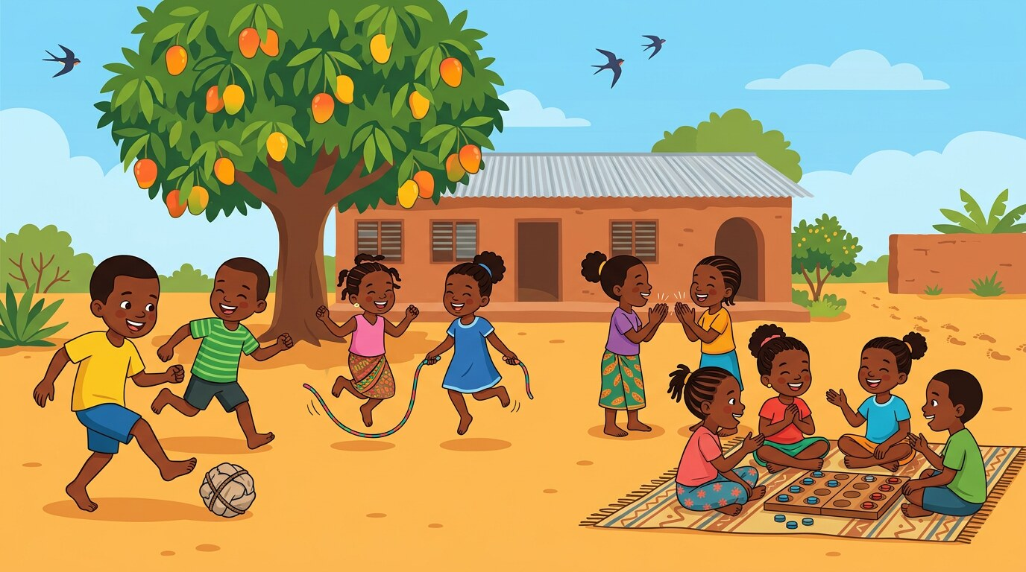
THEME 7 · Weeks 25–28 · weeks 25–28
Games
The games we play inside and outside: ball, rope, chalk, tag. We give instructions, play fairly and use polite words on the field.

By the end of this theme I can…
• Identify common games and play tools used indoors and outdoors
• Use polite expressions and instructions when participating in games
• Read and write simple words, phrases, and rules related to play
• Apply grammar features including verbs, prepositions, and conjunctions
• Decode, spell, and segment play-related vocabulary
• Participate in rhymes, dialogues, sketches, and structured play activities

Culminating project
★ My Game Strip
☐ 1. Create a strip with drawings and labels of one indoor and one outdoor game
☐ 2. Include short sentences describing each game and its tools
☐ 3. Add one polite phrase or instruction used during play
☐ 4. Perform a rhyme or short scene that reflects the spirit of friendly play

In this theme — four weeks
Week 25 Naming and Talking About Games
I can name indoor and outdoor games and the things we play with.
Week 26 Playing Together and Giving Instructions
I can give and follow simple instructions when we play.
Week 27 Playing Safely and Using Polite Words
I can use polite words and rules so that everybody plays safely.
Week 28 Describing Favorite Games and Final Presentation
I can describe my favourite game and present my work.

WEEK 25 · Theme 7: Games
Naming and Talking About Games
COMPETENCE: By the end of this week I can name indoor and outdoor games and the things we play with.
Knowledge · skills · attitudes: listening, speaking, reading, writing, phonics, drama, and the mini project.

DOMAINS OF THE WEEK: Listening and Speaking · Reading · Writing · Grammar, Vocabulary and Pronunciation · Phonics · Literature and Drama
LET'S START Break time. Some pupils play outside, some play inside the classroom because it is raining.
» Which games do you play outside?
» Which games do you play inside?

1 Listen and say
LISTENING AND SPEAKING
Listen to your teacher. Then say each line with your teacher.
Naming games
♪ We play ball.
♪ She skips.
♪ This is chalk.
♪ They jump the rope.
2 Read
READING
Read with your teacher. Point to each word with your finger.
Reading game names
▸ ball
▸ rope
▸ chalk
▸ tag
▸ swing
Read the word. Then show how you play with it.
3 Write
WRITING
Write in your exercise book. Sit well and hold your pencil well.
Write: "ball", "rope", "skip". Then write one sentence: "I like ____."

4 New words and grammar
GRAMMAR, VOCABULARY AND PRONUNCIATION
Look at the box with your teacher. Then say the examples.
Grammar focus: Common nouns; present tense verbs
· Nouns name the game and the tool: ball, rope, chalk, swing.
· Verbs tell the action: throw, jump, skip, play.
Say: “We play ball.” “She skips.” “This is chalk.”

English | Français | English | Français
ball | le ballon | skip | sauter à la corde
rope | la corde | game | le jeu
chalk | la craie
5 Phonics
PHONICS
Say the sound. Then find the sound in each word.
Sound focus: Initial sounds in game words
skip | tag | ball | rope
6 Chant: Throw and Catch
LITERATURE AND DRAMA
Say the rhyme with your teacher. Clap the beat.
Throw and catch,
Jump and skip,
Let's play fair,
And never trip!

7 I integrate — I use my English
INTEGRATION — A NEW SITUATION
Work with a friend. Use all the English you have learned this week.
★ Tell your friend your favourite game and its tool: "I like skipping. I use a rope."

MINI PROJECT Draw and label one game and its tool.
Add this to your theme strip.

Check yourself
Tick how you are doing. Colour a star when you can do it alone.
I can… | Not yet | Getting there | Yes, I can
I can name five games and their tools. | ☐ | ☐ | ☐
I can say what I do with a ball and a rope. | ☐ | ☐ | ☐
I can label a drawing of a game. | ☐ | ☐ | ☐

WEEK 26 · Theme 7: Games
Playing Together and Giving Instructions
COMPETENCE: By the end of this week I can give and follow simple instructions when we play.
Knowledge · skills · attitudes: listening, speaking, reading, writing, phonics, drama, and the mini project.

DOMAINS OF THE WEEK: Listening and Speaking · Reading · Writing · Grammar, Vocabulary and Pronunciation · Phonics · Literature and Drama
LET'S START You are the captain of your team. Your friends do not know the game. You must explain it.
» What do you say first?
» How do you explain the next action?

1 Listen and say
LISTENING AND SPEAKING
Listen to your teacher. Then say each line with your teacher.
Giving and following instructions
♪ Throw the ball.
♪ Jump and clap.
♪ Sit, then stand.
♪ Run and tap.
2 Read
READING
Read with your teacher. Point to each word with your finger.
Reading action sentences
▸ Run and tap.
▸ Roll the ball.
▸ Skip together.
Read the instruction. Then do it.
3 Write
WRITING
Write in your exercise book. Sit well and hold your pencil well.
Write two instructions for a game. Use and or then.

4 New words and grammar
GRAMMAR, VOCABULARY AND PRONUNCIATION
Look at the box with your teacher. Then say the examples.
Grammar focus: Imperative verbs; conjunctions and, then
· An instruction starts with a verb: Throw the ball. Jump now.
· We use then for the next action: Sit, then stand.
Say: “Throw the ball.” “Jump and clap.” “Sit, then stand.”

English | Français | English | Français
throw | lancer | clap | frapper des mains
jump | sauter | roll | faire rouler
5 Phonics
PHONICS
Say the sound. Then find the sound in each word.
Sound focus: Final sounds in game and action words
skip | roll | drum | jump
6 Chant: Play With Me
LITERATURE AND DRAMA
Say the rhyme with your teacher. Clap the beat.
Clap and spin,
Tap then win,
Sit and smile,
Let's begin!

7 I integrate — I use my English
INTEGRATION — A NEW SITUATION
Work with a friend. Use all the English you have learned this week.
★ Be the captain. Give three instructions. Your team follows them correctly.

MINI PROJECT Add one instruction or game-related request to the strip.
Add this to your theme strip.

Check yourself
Tick how you are doing. Colour a star when you can do it alone.
I can… | Not yet | Getting there | Yes, I can
I can give three clear play instructions. | ☐ | ☐ | ☐
I can use and and then. | ☐ | ☐ | ☐
I can follow my friend's instructions. | ☐ | ☐ | ☐

WEEK 27 · Theme 7: Games
Playing Safely and Using Polite Words
COMPETENCE: By the end of this week I can use polite words and rules so that everybody plays safely.
Knowledge · skills · attitudes: listening, speaking, reading, writing, phonics, drama, and the mini project.

DOMAINS OF THE WEEK: Listening and Speaking · Reading · Writing · Grammar, Vocabulary and Pronunciation · Phonics · Literature and Drama
LET'S START Two pupils are playing with the only rope. You also want to play, but you must ask politely.
» What do you say to them?
» What rules keep the game safe?

1 Listen and say
LISTENING AND SPEAKING
Listen to your teacher. Then say each line with your teacher.
Saying polite words at play
♪ Can I join?
♪ May I use the chalk?
♪ Please wait your turn.
♪ Sit before you play.
2 Read
READING
Read with your teacher. Point to each word with your finger.
Reading play rules
▸ Sit before you play.
▸ May I use the rope?
▸ Can I skip now?
Read each rule. Then say if it is polite or not.
3 Write
WRITING
Write in your exercise book. Sit well and hold your pencil well.
Write two polite sentences for the playground.

4 New words and grammar
GRAMMAR, VOCABULARY AND PRONUNCIATION
Look at the box with your teacher. Then say the examples.
Grammar focus: Modal verbs (Can, May); sentence punctuation
· Can I join? May I use the chalk?
· Polite questions end with a question mark.
Say: “Can I join?” “May I use the chalk?” “Please wait your turn.”

English | Français | English | Français
join | se joindre | shout | crier
turn | le tour | wait | attendre
5 Phonics
PHONICS
Say the sound. Then find the sound in each word.
Sound focus: Digraphs in polite and play words
chalk | shout | this | chair
6 Dialogue: Playing Together Politely
LITERATURE AND DRAMA
Act it out in pairs. Speak loudly and politely.
Bih: Can I join your game?
Ngo: Yes, you can. Wait your turn.
Bih: May I use the rope first?
Ngo: Please do. Let's play!

7 I integrate — I use my English
INTEGRATION — A NEW SITUATION
Work with a friend. Use all the English you have learned this week.
★ Act the dialogue. Then make one rule for your class playground and say it politely.

MINI PROJECT Add a polite request or a rule to the strip.
Add this to your theme strip.

Check yourself
Tick how you are doing. Colour a star when you can do it alone.
I can… | Not yet | Getting there | Yes, I can
I can ask to join a game politely. | ☐ | ☐ | ☐
I can say three rules for safe play. | ☐ | ☐ | ☐
I can read and spell chalk, shout, chair. | ☐ | ☐ | ☐

WEEK 28 · Theme 7: Games
Describing Favorite Games and Final Presentation
COMPETENCE: By the end of this week I can describe my favourite game and present my work.
Knowledge · skills · attitudes: listening, speaking, reading, writing, phonics, drama, and the mini project.

DOMAINS OF THE WEEK: Listening and Speaking · Reading · Writing · Grammar, Vocabulary and Pronunciation · Phonics · Literature and Drama
LET'S START Your teacher asks: "What is your favourite game, and why?"
» What is your favourite game?
» Who do you play it with?

1 Listen and say
LISTENING AND SPEAKING
Listen to your teacher. Then say each line with your teacher.
Talking about favourite games
♪ I like skipping.
♪ My best game is catch.
♪ We sit before the game.
♪ She jumps with the rope.
2 Read
READING
Read with your teacher. Point to each word with your finger.
Reviewing play sentences
▸ We sit before the game.
▸ She jumps with the rope.
▸ I play every day.
Read the sentences. Then say which game you like.
3 Write
WRITING
Write in your exercise book. Sit well and hold your pencil well.
Write three sentences about your favourite game. Correct "she like jump" first.

4 New words and grammar
GRAMMAR, VOCABULARY AND PRONUNCIATION
Look at the box with your teacher. Then say the examples.
Grammar focus: Sentence editing; adjectives and capitalisation
· she like jump → She likes to jump. he play game → He plays a fun game.
· Add -s with he, she, it.
Say: “She likes to jump.” “He plays a fun game.” “We sit before the game.”

English | Français | English | Français
skip | sauter à la corde | friend | l'ami(e)
catch | attraper | fun | amusant
5 Phonics
PHONICS
Clap the syllables. Then write the word.
Sound focus: Syllable review in game words
jump-ing | sit-ting | throw-ing | play-ing
6 Performance: My Game Strip
LITERATURE AND DRAMA
Present your strip to the class. Speak clearly and smile.
This is my game. (show the strip)
I jump the rope with my friend. (jump)
We play fair and we are polite. (smile)
Let's play! (clap)

7 I integrate — I use my English
INTEGRATION — A NEW SITUATION
Work with a friend. Use all the English you have learned this week.
★ Present your strip and teach the class one game in English, using instructions.

MINI PROJECT Finalise the strip with drawings, instructions and a chant.
Add this to your theme strip.

Check yourself
Tick how you are doing. Colour a star when you can do it alone.
I can… | Not yet | Getting there | Yes, I can
I can describe my favourite game. | ☐ | ☐ | ☐
I can correct a sentence with the verb -s. | ☐ | ☐ | ☐
I can present my My Game Strip and teach a game. | ☐ | ☐ | ☐

THEME 7 · CULMINATING PROJECT
I present my strip
My Game Strip
Today you show the class what you have built for four weeks. Take your time. Stand up. Breathe. Smile. Speak loudly.

My strip has…
☐ Create a strip with drawings and labels of one indoor and one outdoor game
☐ Include short sentences describing each game and its tools
☐ Add one polite phrase or instruction used during play
☐ Perform a rhyme or short scene that reflects the spirit of friendly play

When I present, I…
☐ stand up and look at my friends
☐ speak loudly and slowly
☐ point to my drawing when I speak about it
☐ say at least three English sentences
☐ say "Thank you for listening!" at the end

My project mark
Your teacher uses the same three criteria as you. Tick together and talk about what to improve.
Criterion | Not yet | Getting there | Yes, I can
My strip is complete (all four weeks). | ☐ | ☐ | ☐
My drawings and labels are neat and clear. | ☐ | ☐ | ☐
I spoke in English without reading everything. | ☐ | ☐ | ☐

After the presentation — what next?
Remediation: If you ticked "Not yet" or "Getting there" anywhere, do the practice again with your teacher this week. You do not move on until you can say "Yes, I can".

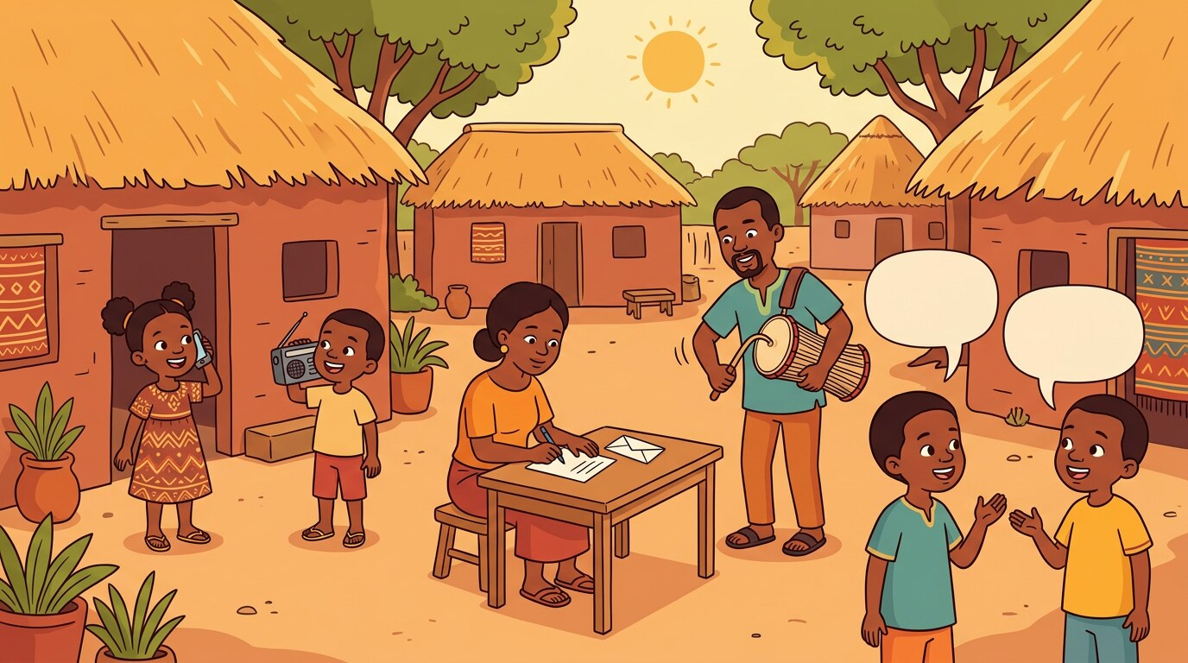
THEME 8 · Weeks 29–32 · weeks 29–32
Communication
How we send and receive messages: talking, a letter, the radio, the phone. We say how we feel, ask politely and share a message.

By the end of this theme I can…
• Identify common communication methods and tools (verbal, non-verbal, digital, and traditional)
• Use appropriate greetings, expressions, and descriptive vocabulary during communication
• Read, write, and decode basic words related to expressing ideas, messages, and feelings
• Apply grammar structures including sentence types, pronouns, and punctuation for clarity
• Engage in dialogue, chant, storytelling, and role-play about exchanging messages and feelings

Culminating project
★ How We Communicate Strip
☐ 1. Create a strip showing two forms of communication (e.g., talking and messaging) with drawings and labels
☐ 2. Add greeting and expression phrases for sharing ideas politely
☐ 3. Include one chant or short role-play about giving and receiving a message
☐ 4. Present the strip with clear explanation and oral performance

In this theme — four weeks
Week 29 Naming Communication Forms and Tools
I can name the ways and tools we use to send messages.
Week 30 Expressing Feelings and Ideas
I can say how I feel and how other people feel.
Week 31 Asking and Answering Questions Politely
I can ask and answer questions clearly and politely.
Week 32 Sharing Messages and Final Presentation
I can give a simple message clearly and present my communication strip.

WEEK 29 · Theme 8: Communication
Naming Communication Forms and Tools
COMPETENCE: By the end of this week I can name the ways and tools we use to send messages.
Knowledge · skills · attitudes: listening, speaking, reading, writing, phonics, drama, and the mini project.

DOMAINS OF THE WEEK: Listening and Speaking · Reading · Writing · Grammar, Vocabulary and Pronunciation · Phonics · Literature and Drama
LET'S START Your father is in Douala. You want to tell him about your school prize.
» How can you send him a message?
» What do you say to him?

1 Listen and say
LISTENING AND SPEAKING
Listen to your teacher. Then say each line with your teacher.
Naming communication tools
♪ This is a phone.
♪ She writes a letter.
♪ She calls her father.
♪ I talk to my friend.
2 Read
READING
Read with your teacher. Point to each word with your finger.
Reading communication words
▸ phone
▸ talk
▸ call
▸ letter
▸ radio
Read the word. Then say how you use it.
3 Write
WRITING
Write in your exercise book. Sit well and hold your pencil well.
Write: "She calls." "He writes." Then label your drawing.

4 New words and grammar
GRAMMAR, VOCABULARY AND PRONUNCIATION
Look at the box with your teacher. Then say the examples.
Grammar focus: Common nouns; personal pronouns
· Nouns name the tools: phone, letter, radio, drum.
· Pronouns replace names: She calls. He writes. I talk.
Say: “This is a phone.” “She writes a letter.” “I talk.”

English | Français | English | Français
phone | le téléphone | talk | parler
letter | la lettre | write | écrire
radio | la radio
5 Phonics
PHONICS
Say the sound. Then find the sound in each word.
Sound focus: Initial sounds in communication words
call | talk | radio | letter
6 Chant: Say It Right
LITERATURE AND DRAMA
Say the rhyme with your teacher. Clap the beat.
Talk with care,
Speak and share,
Hear and write,
Be polite!

7 I integrate — I use my English
INTEGRATION — A NEW SITUATION
Work with a friend. Use all the English you have learned this week.
★ Show three ways to send a message without words: a wave, a smile, a drum. Say what each one means.

MINI PROJECT Draw and label one form of communication (phone, letter or speech).
Add this to your theme strip.

Check yourself
Tick how you are doing. Colour a star when you can do it alone.
I can… | Not yet | Getting there | Yes, I can
I can name four communication tools. | ☐ | ☐ | ☐
I can say how I send a message. | ☐ | ☐ | ☐
I can label a drawing of a communication tool. | ☐ | ☐ | ☐

WEEK 30 · Theme 8: Communication
Expressing Feelings and Ideas
COMPETENCE: By the end of this week I can say how I feel and how other people feel.
Knowledge · skills · attitudes: listening, speaking, reading, writing, phonics, drama, and the mini project.

DOMAINS OF THE WEEK: Listening and Speaking · Reading · Writing · Grammar, Vocabulary and Pronunciation · Phonics · Literature and Drama
LET'S START Your friend lost her pen. She is looking at the ground and she is quiet.
» How does she feel?
» What do you say to her?

1 Listen and say
LISTENING AND SPEAKING
Listen to your teacher. Then say each line with your teacher.
Saying how we feel
♪ I am happy.
♪ He is sad.
♪ She is kind.
♪ I feel fine.
2 Read
READING
Read with your teacher. Point to each word with your finger.
Reading feeling words
▸ She is kind.
▸ I feel fine.
▸ The boy is happy.
Read the sentence. Then show the feeling on your face.
3 Write
WRITING
Write in your exercise book. Sit well and hold your pencil well.
Write two sentences: "I am ____ today." "My friend is ____."

4 New words and grammar
GRAMMAR, VOCABULARY AND PRONUNCIATION
Look at the box with your teacher. Then say the examples.
Grammar focus: Interjections and adjectives
· Interjections show feeling: Oh! Wow! Sorry!
· Adjectives tell how somebody is: happy, sad, kind, calm.
Say: “I am happy.” “He is sad.” “Wow! Thank you!”

English | Français | English | Français
happy | heureux | calm | calme
sad | triste | quiet | silencieux
kind | gentil
5 Phonics
PHONICS
Say the sound. Then find the sound in each word.
Sound focus: Final sounds in feeling words
sad | calm | quiet | happy
6 Rhyme: How I Feel
LITERATURE AND DRAMA
Say the rhyme with your teacher. Clap the beat.
Happy and proud,
Say it aloud.
Sad and still,
Calm and chill.

7 I integrate — I use my English
INTEGRATION — A NEW SITUATION
Work with a friend. Use all the English you have learned this week.
★ Make a feelings face. Your friend looks at it and says: "You are happy!" or "You are sad."

MINI PROJECT Add one feeling or expression phrase to the strip.
Add this to your theme strip.

Check yourself
Tick how you are doing. Colour a star when you can do it alone.
I can… | Not yet | Getting there | Yes, I can
I can say how I feel. | ☐ | ☐ | ☐
I can describe how a friend feels. | ☐ | ☐ | ☐
I can use Wow!, Oh! and Sorry! correctly. | ☐ | ☐ | ☐

WEEK 31 · Theme 8: Communication
Asking and Answering Questions Politely
COMPETENCE: By the end of this week I can ask and answer questions clearly and politely.
Knowledge · skills · attitudes: listening, speaking, reading, writing, phonics, drama, and the mini project.

DOMAINS OF THE WEEK: Listening and Speaking · Reading · Writing · Grammar, Vocabulary and Pronunciation · Phonics · Literature and Drama
LET'S START A new pupil comes into your class. She does not know anybody.
» What do you ask her?
» How do you answer her questions?

1 Listen and say
LISTENING AND SPEAKING
Listen to your teacher. Then say each line with your teacher.
Asking polite questions
♪ What is your name?
♪ Where are you going?
♪ Who is he?
♪ Where is the teacher?
2 Read
READING
Read with your teacher. Point to each word with your finger.
Reading questions and answers
▸ Who are you? I am Sam.
▸ What is this? It is a book.
▸ Where is the teacher? He is in the class.
Read the question, then read the answer.
3 Write
WRITING
Write in your exercise book. Sit well and hold your pencil well.
Write two questions and two answers. Remember the question mark.

4 New words and grammar
GRAMMAR, VOCABULARY AND PRONUNCIATION
Look at the box with your teacher. Then say the examples.
Grammar focus: Question words who, what, where; punctuation
· We ask with Who…? What…? Where…?
· Every question ends with a question mark (?).
Say: “What is your name?” “Where are you going?” “Who is he?”

English | Français | English | Français
who | qui | where | où
what | quoi | name | le nom
5 Phonics
PHONICS
Say the sound. Then find the sound in each word.
Sound focus: Digraphs in question and answer words
what | she | this | where
6 Dialogue: Asking and Answering
LITERATURE AND DRAMA
Act it out in pairs. Speak loudly and politely.
Bih: What is your name?
Ngo: My name is Ngo. Who are you?
Bih: I am Bih. Where do you live?
Ngo: I live near the school.

7 I integrate — I use my English
INTEGRATION — A NEW SITUATION
Work with a friend. Use all the English you have learned this week.
★ Interview a friend with three questions. Then tell the class about your friend.

MINI PROJECT Add a question or an answer sentence to the strip.
Add this to your theme strip.

Check yourself
Tick how you are doing. Colour a star when you can do it alone.
I can… | Not yet | Getting there | Yes, I can
I can ask questions with who, what, where. | ☐ | ☐ | ☐
I can answer questions in a full sentence. | ☐ | ☐ | ☐
I can read and spell what, she, where. | ☐ | ☐ | ☐

WEEK 32 · Theme 8: Communication
Sharing Messages and Final Presentation
COMPETENCE: By the end of this week I can give a simple message clearly and present my communication strip.
Knowledge · skills · attitudes: listening, speaking, reading, writing, phonics, drama, and the mini project.

DOMAINS OF THE WEEK: Listening and Speaking · Reading · Writing · Grammar, Vocabulary and Pronunciation · Phonics · Literature and Drama
LET'S START You must take a message to your neighbour: his son is coming home today.
» What is your message?
» How do you say it politely?

1 Listen and say
LISTENING AND SPEAKING
Listen to your teacher. Then say each line with your teacher.
Sharing a message
♪ I have a message.
♪ We want to talk.
♪ He said hello.
♪ Call me, please.
2 Read
READING
Read with your teacher. Point to each word with your finger.
Reading message sentences
▸ Call me.
▸ She writes a letter.
▸ They send a message.
Read the message. Then say who it is for.
3 Write
WRITING
Write in your exercise book. Sit well and hold your pencil well.
Write a short message to a friend. Correct "they write letter" first.

4 New words and grammar
GRAMMAR, VOCABULARY AND PRONUNCIATION
Look at the box with your teacher. Then say the examples.
Grammar focus: Editing messages; review of sentence types and punctuation
· she call him → She called him. they write letter → They write a letter.
· Check: capital letter, verb, full stop or question mark.
Say: “She called him.” “They write a letter.” “I have a message.”

English | Français | English | Français
message | le message | call | appeler
send | envoyer | share | partager
5 Phonics
PHONICS
Clap the syllables. Then write the word.
Sound focus: Syllable segmentation and spelling review
mes-sage | writ-ing | ra-di-o | talk-ing
6 Performance: How We Communicate Strip
LITERATURE AND DRAMA
Present your strip to the class. Speak clearly and smile.
This is a phone. I call my father. (show the strip)
This is a letter. I write a message. (write motion)
Talk with care and be polite. (smile)
Thank you for listening! (bow)

7 I integrate — I use my English
INTEGRATION — A NEW SITUATION
Work with a friend. Use all the English you have learned this week.
★ Present your strip to the class. Give your message clearly, then answer two questions.

MINI PROJECT Finalise and present the communication strip with tools, phrases and a chant.
Add this to your theme strip.

Check yourself
Tick how you are doing. Colour a star when you can do it alone.
I can… | Not yet | Getting there | Yes, I can
I can give a message clearly. | ☐ | ☐ | ☐
I can correct a message sentence. | ☐ | ☐ | ☐
I can present my How We Communicate Strip. | ☐ | ☐ | ☐

THEME 8 · CULMINATING PROJECT
I present my strip
How We Communicate Strip
Today you show the class what you have built for four weeks. Take your time. Stand up. Breathe. Smile. Speak loudly.

My strip has…
☐ Create a strip showing two forms of communication (e.g., talking and messaging) with drawings and labels
☐ Add greeting and expression phrases for sharing ideas politely
☐ Include one chant or short role-play about giving and receiving a message
☐ Present the strip with clear explanation and oral performance

When I present, I…
☐ stand up and look at my friends
☐ speak loudly and slowly
☐ point to my drawing when I speak about it
☐ say at least three English sentences
☐ say "Thank you for listening!" at the end

My project mark
Your teacher uses the same three criteria as you. Tick together and talk about what to improve.
Criterion | Not yet | Getting there | Yes, I can
My strip is complete (all four weeks). | ☐ | ☐ | ☐
My drawings and labels are neat and clear. | ☐ | ☐ | ☐
I spoke in English without reading everything. | ☐ | ☐ | ☐

After the presentation — what next?
Remediation: If you ticked "Not yet" or "Getting there" anywhere, do the practice again with your teacher this week. You do not move on until you can say "Yes, I can".

Picture dictionary
Every new word in this book, by theme. Point, say the word, then write it in your exercise book.

Theme 1 — The Home
☐ mat | ☐ cup | ☐ mop
☐ bed | ☐ pot | ☐ fan
☐ jug | ☐ bell | ☐ family
☐ brother | ☐ sorry | ☐ thank you
☐ clean | ☐ brush | ☐ chair
☐ room | ☐ kitchen | ☐ table
☐ on | ☐ behind

Theme 2 — The Village/Town
☐ market | ☐ shop | ☐ well
☐ hill | ☐ clinic | ☐ kind
☐ strong | ☐ tall | ☐ friendly
☐ neighbour | ☐ where | ☐ near
☐ village | ☐ farm | ☐ mosque
☐ square | ☐ farmer | ☐ sell

Theme 3 — The School
☐ classroom | ☐ desk | ☐ bag
☐ chalk | ☐ board | ☐ read
☐ write | ☐ sit | ☐ red
☐ please | ☐ share | ☐ borrow
☐ pencil | ☐ quietly | ☐ morning
☐ ring

Theme 4 — Occupations
☐ teacher | ☐ nurse | ☐ cook
☐ driver | ☐ sew | ☐ sweep
☐ help | ☐ work | ☐ broom
☐ old | ☐ tailor | ☐ hospital
☐ dream | ☐ clothes

Theme 5 — Travelling
☐ bus | ☐ bike | ☐ car
☐ walk | ☐ ride | ☐ in front
☐ straight | ☐ left | ☐ cross
☐ wait | ☐ stop | ☐ look
☐ safety | ☐ motor | ☐ careful
☐ sign

Theme 6 — Health
☐ hand | ☐ tooth | ☐ hair
☐ soap | ☐ towel | ☐ bathe
☐ drink | ☐ fruit | ☐ water
☐ sleep | ☐ wash | ☐ comb
☐ dirt | ☐ teeth | ☐ daily

Theme 7 — Games
☐ ball | ☐ rope | ☐ skip
☐ game | ☐ throw | ☐ jump
☐ clap | ☐ roll | ☐ join
☐ turn | ☐ shout | ☐ catch
☐ friend | ☐ fun

Theme 8 — Communication
☐ phone | ☐ letter | ☐ radio
☐ talk | ☐ happy | ☐ sad
☐ calm | ☐ quiet | ☐ who
☐ what | ☐ name | ☐ message
☐ send | ☐ call

All my words, A to Z
The number after each word is the week where you learn it.
☐ bag 9 | ☐ ball 25 | ☐ bathe 22
☐ bed 1 | ☐ behind 4, 18 | ☐ bell 2, 9
☐ bike 17 | ☐ board 10 | ☐ borrow 11
☐ broom 15 | ☐ brother 2 | ☐ brush 3, 23
☐ bus 17 | ☐ call 32 | ☐ calm 30
☐ car 17 | ☐ careful 20 | ☐ catch 28
☐ chair 3 | ☐ chalk 9, 15, 25 | ☐ clap 26
☐ classroom 9 | ☐ clean 3, 8, 12, 24 | ☐ clinic 5
☐ clothes 16 | ☐ comb 23 | ☐ cook 13
☐ cross 19 | ☐ cup 1 | ☐ daily 24
☐ desk 9 | ☐ dirt 23 | ☐ dream 16
☐ drink 22 | ☐ driver 13 | ☐ family 2
☐ fan 2 | ☐ farm 7 | ☐ farmer 8, 13
☐ friend 28 | ☐ friendly 6 | ☐ fruit 22
☐ fun 28 | ☐ game 25 | ☐ hair 21
☐ hand 21 | ☐ happy 30 | ☐ help 14
☐ hill 5 | ☐ hospital 16 | ☐ in front 18
☐ join 27 | ☐ jug 2 | ☐ jump 26
☐ kind 6, 30 | ☐ kitchen 4 | ☐ left 18
☐ letter 29 | ☐ look 19 | ☐ market 5
☐ mat 1 | ☐ message 32 | ☐ mop 1, 15
☐ morning 12 | ☐ mosque 7 | ☐ motor 20
☐ name 31 | ☐ near 7, 18 | ☐ neighbour 6
☐ nurse 13 | ☐ old 15 | ☐ on 4
☐ pencil 11 | ☐ phone 29 | ☐ please 11
☐ pot 1 | ☐ quiet 30 | ☐ quietly 12
☐ radio 29 | ☐ read 10 | ☐ red 10
☐ ride 17 | ☐ ring 12 | ☐ roll 26
☐ room 4 | ☐ rope 25 | ☐ sad 30
☐ safety 20 | ☐ sell 8, 14 | ☐ send 32
☐ sew 14 | ☐ share 11, 32 | ☐ shop 5
☐ shout 27 | ☐ sign 20 | ☐ sit 10
☐ skip 25, 28 | ☐ sleep 22 | ☐ soap 21
☐ sorry 3 | ☐ square 8 | ☐ stop 19
☐ straight 18 | ☐ strong 6 | ☐ sweep 14
☐ table 4 | ☐ tailor 16 | ☐ talk 29
☐ tall 6 | ☐ teacher 13 | ☐ teeth 24
☐ thank you 3 | ☐ throw 26 | ☐ tooth 21
☐ towel 21 | ☐ turn 27 | ☐ village 7
☐ wait 19, 27 | ☐ walk 17 | ☐ wash 23
☐ water 22 | ☐ well 5, 24 | ☐ what 31
☐ where 7, 31 | ☐ who 31 | ☐ work 14
☐ write 10, 29

Useful sentences
Say these every day in class. Your teacher will help you.
In English | En français
Good morning, teacher. | Bonjour, maîtresse / maître.
May I come in, please? | Puis-je entrer, s'il vous plaît ?
May I go out, please? | Puis-je sortir, s'il vous plaît ?
May I borrow your pencil, please? | Puis-je emprunter ton crayon ?
I am sorry, Madam. | Je suis désolé(e), Madame.
Thank you very much. | Merci beaucoup.
What is this? — It is a ______. | Qu'est-ce que c'est ? — C'est un(e) ______.
Where is the ______? — It is near the ______. | Où est le ______ ? — Il est près de ______.
What is your name? — My name is ______. | Comment t'appelles-tu ? — Je m'appelle ______.
Can I play with you? | Puis-je jouer avec vous ?
Water, please. | De l'eau, s'il vous plaît.
I can do it! | Je peux le faire !

My progress record
Your teacher ticks a box when you finish a week. Colour the star when you presented your strip.
Wk | Week topic | Done | Date | Star
1 | Greetings, Letter Sounds and Objects in the Home | ☐ | ________ | ☆
2 | Naming Objects and Introducing Family Members | ☐ | ________ | ☆
3 | Polite Expressions and Home Activities | ☐ | ________ | ☆
4 | Family Routines and Home Description | ☐ | ________ | ☆
5 | Naming Places and People in the Village | ☐ | ________ | ☆
6 | Greeting and Describing Community Members | ☐ | ________ | ☆
7 | Asking About Places and Giving Simple Directions | ☐ | ________ | ☆
8 | Describing Places and Presenting the Strip | ☐ | ________ | ☆
9 | Identifying School Places and People | ☐ | ________ | ☆
10 | Describing School Tools and Actions | ☐ | ________ | ☆
11 | Greeting, Sharing, and Polite Requests | ☐ | ________ | ☆
12 | Classroom Routines and Final Presentation | ☐ | ________ | ☆
13 | Naming Occupations and Tools | ☐ | ________ | ☆
14 | Describing What People Do | ☐ | ________ | ☆
15 | Sharing Tools and Speaking Politely | ☐ | ________ | ☆
16 | Reviewing Jobs and Presenting the Strip | ☐ | ________ | ☆
17 | Naming Transport and Movement | ☐ | ________ | ☆
18 | Giving Directions and Describing Movement | ☐ | ________ | ☆
19 | Travel Requests and Safety | ☐ | ________ | ☆
20 | Reviewing Travel and Presenting the Strip | ☐ | ________ | ☆
21 | Naming Body Parts and Hygiene Tools | ☐ | ________ | ☆
22 | Describing Healthy Routines and Foods | ☐ | ________ | ☆
23 | Giving Safety Instructions and Requests | ☐ | ________ | ☆
24 | Reviewing Healthy Habits and Final Presentation | ☐ | ________ | ☆
25 | Naming and Talking About Games | ☐ | ________ | ☆
26 | Playing Together and Giving Instructions | ☐ | ________ | ☆
27 | Playing Safely and Using Polite Words | ☐ | ________ | ☆
28 | Describing Favorite Games and Final Presentation | ☐ | ________ | ☆
29 | Naming Communication Forms and Tools | ☐ | ________ | ☆
30 | Expressing Feelings and Ideas | ☐ | ________ | ☆
31 | Asking and Answering Questions Politely | ☐ | ________ | ☆
32 | Sharing Messages and Final Presentation | ☐ | ________ | ☆

Certificate


This is to certify that

has completed My English Book — Class 1: 8 themes and 32 weeks, with 8 project strips presented.
This pupil can speak, read and write English in Class 1. Teacher: ______________ Date: ____________

Well done! ★ Bravo !
EFEDI Schools · Azobe-EFEDI · First edition · 2025/2026

