DAY 11: STATIC ROUTING

What I have learned:

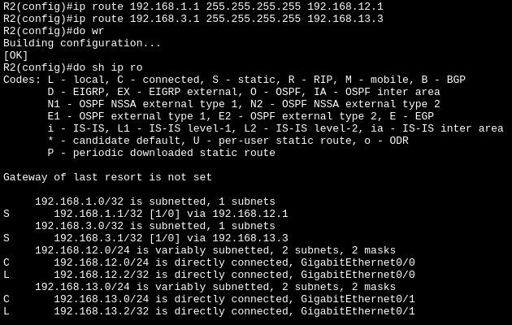
1. How to configure add static route in Cisco router
Example:
The R2 act like a bridge for R1 and R3 to send and received ICMP Echo request/reply (ping).
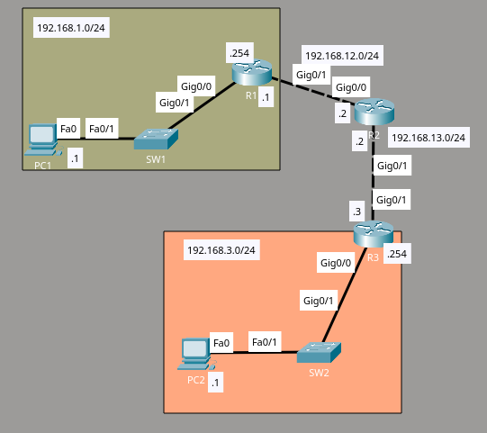
R2

