DAY 19 LAB: DTP & VTP

What I have learned:
1.) What is DTP? What is the importance of it?
→ DTP stands for Dynamic Trunking Protocol which automates the creation of trunks links between switches.

→ DTP is used to automaticall “negotiate” wheter a switch port should become a trunk link or remain as access link
→ Trunk link means carrying multiple VLANs
→ Access link means carrying single VLAN

2.) What are the common DTP modes?
→ switchport mode trunk: Puts the port in permanent trunking mode and actively sends DTP packets to other side

→ switchport mode dynamic desirable: The port actively tries to form a trunk by sending DTP packets. It becomes a trunk if other side is set to trunk, dynamic desirable, dynamic auto.

→ switchport mode dynamic auto: The port passive “waits” to receive DTP packets to form a trunk. It onlly becomes a trunk if other side is set to trunk, dynamic desirable. dynamic auto.

→ switchport mode access: Puts the port in permanent access mode, disabling trunk. No DTP negotiation happen.

→ switchport nonegotiate: Used with switchport mode trunk to make the port a trunk without sending any DTP packets
3.) What is VTP? What is the importance of it?
→ VTP stands for VLAN Trunking Protocol while synchronizes VLAN databases across multiple switches.

→ You have to create a VLAN on one VTP server and it will be automatically used by all other switches within the same VTP domain which ensures VLAN consistency and reducing configuration errors.

4.) What are the common VTP modes?

→ Server: The default mode. You can create, modify, and dlete VLANs. Changes are broadcast to the rest of VTP domain. (This is the policy maker, I think)

→ Client: Recieves VTP updates from servers and applies them to its local VLAN database but you cannot create, modify, or delete VLANs on client switch. (This is for client only since they only have to use it).

→ Transparent: Ignores VTP updates for its own database, but forwards them to other switches. You can create, modify, and delete VLANs locally, but these changes are not applicable to the rest of the domain. (This one will be used for special occasion).

5.) How to disable DTP on the port/s in cisco packet tracer?

Example: If we want to disable the DTP when trunking, the command are “switch mode trunk” and “switch nonegotiation”. Both of them are important to use the command “switch nonegotiation” which stops sending the DTP.

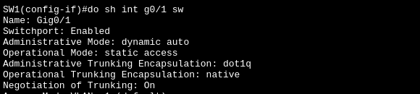
Before:
During:
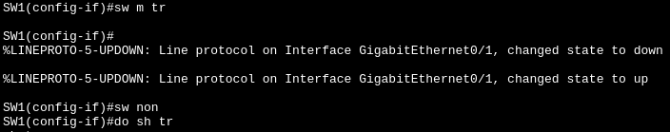
After: Just check the Mode it should “on” meaning nonegotiation work and Status should be “trunking” meaning operational mode is trunk.
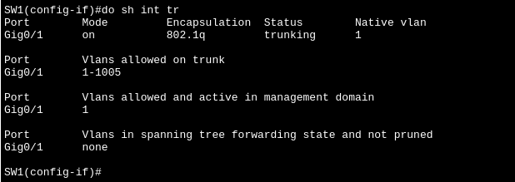

To disable the access ports (PCs, Printers, IP Phones) and unused ports:

Example: Just use the command “switch mode access” if “in-use” access ports. For unused ports, just “switch mode access” and “shutdown” command, even if attackers manage to use that port it will be useless since that port is set “administratively down” = no connection at all.

Before:

This example (above) is a security risk since attackers can “act as switch” and give access on trunk and manipulate it.
After:
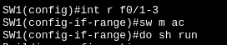
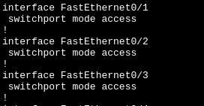
Using the “switchport mode access” automatically deny sending DTP.
6.) How to check if I disable DTP on the port/s already? What is the command for it?

Example: Type “do sh int [interface you want to check] sw”
(do switch interface g0/1 switchport)
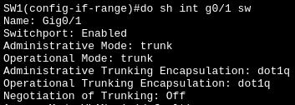

In this picture (above) only look on this 3 which are Administrative Mode, Operational Mode, Negotiation of Trunking. The proper config for each of them are trunk, trunk, and off.
7.) (yung #2 to #5 nalang yung gagawin ko bukas kasi matutulog na ako hahaha)
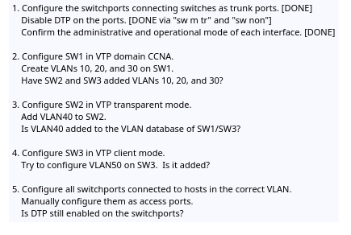
Bukas ko aralin yang VTP

