TASK:
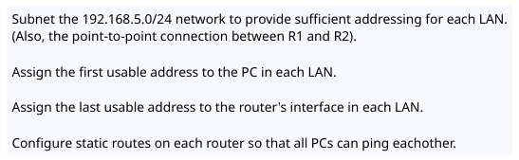
TOPOLOGY :
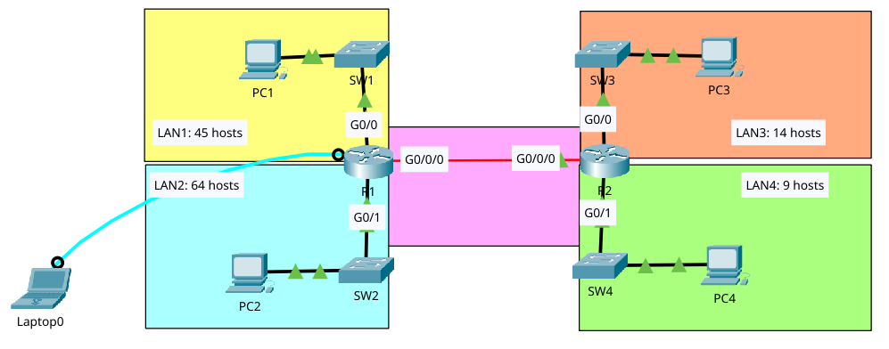

PROBLEM ENCOUNTER:

1. What is VLSM?
2. How to do VLSM?
3. Significance of VLSM?
4. Proper calculating the subnet mask
5. How to determine the following:
- Network address?
- First usable address?
- Last usable address?
- Broadcast address?

ANSWER TO THE PROBLEM:

1.) What is VLSM?

VLSM stands for Variable Length Subnet Mask. VLSM allows you take a single network (like 192.168.1.0/34) and subnet it into different sized chunks based on how many host each department or VLAN actually needs.

Example: If Sales needs 60 hosts and HR needs 10 hosts, VLSM lets you give Sales a /26 (62 usable hosts) and HR a /28 (14 usable hosts). You don’t waste 50 IP addresses by giving HR a /26 too.

2.) What is the significance of using VLSM?
- Efficient use of IP space (Conservation) which VLSM prevents wasting thousands of addresses by allowing us to allocate exactly what is needed.
- Reduces routing table table size used with classless routing protocols (like OSPF, EIGRP, or RIPv2), VLSM allows for route summarization, keeping routing table small and fast.
- Control since it allow network engineer to design logical network which giving more addresses to a large server and fewer for guest WI-FI network.

3.) How to do VLSM?

The Scenario:
Your company has been assigned the network block 192.168.10.0/24. You have 4 departments:
- Management (needs 50 hosts)
- Sales (needs 25 hosts)
- IT (needs 12 hosts)
- HR (needs 6 hosts)
- WAN (router-to-router, if there is which needs 2 hosts)

The golden rule of VLSM: Always start with the largest subnet first. Subnet from largest to smallest to avoid overlapping addresses spaces.

Step 1: Subnet for Management (50 hosts)
- To find the 50 usable hosts, use the formula: 2^n – 2 >= 50 (where n is the number of hosts bits)

