Day 17 Lab – VLANs (Part 2)

What I have learned:

1.) Configuring the SW1 and SW2 as trunk

Example (SW1):
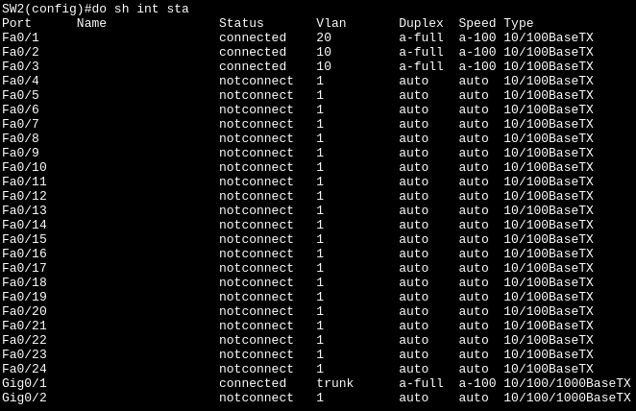
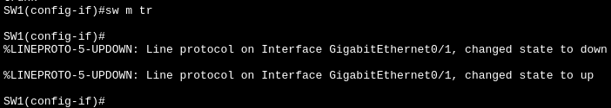
Note: You don’t have to configure the interface (g0/1) of SW2 since SW1 and SW2 have connection which trunk the other)

2.) Configure an unused VLAN as the native VLAN.

Example (SW1):
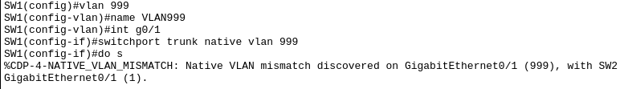
The error mismatch will be fixed after you create the VLAN 999 and native VLAN it in SW2.

(SW2):
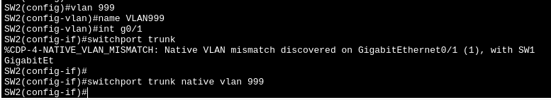

Note: SW1 and SW2 should have a VLAN that is unused or create a VLAN like VLAN 999 that will not be use by any like end hosts. This VLAN will be use only SW1 to SW2.

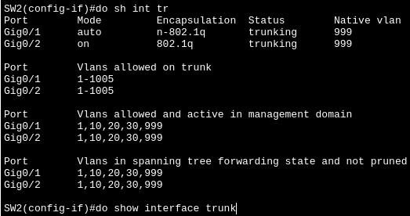
3.) How to check the trunk status in switch, which used to verify if we successfully or forgot to native the unused VLAN we created earlier.
Example:
The command is “do sh int tr” (do show interface trunk) where you can see the status “trunking” and what’s the Native VLAN of the interface.

4.) What’s the purpose of an unused native VLAN?

Answer:
To prevent the double tagging attack, when the outer tag (the native VLAN, VLAN 999) is removed, the inner tag (for example, VLAN 20) cannot simply hop to a different VLAN (such as VLAN 30). The switch will not allow it because it still remembers where the frame came from (VLAN 10). The switch has no clue what to do with the remaining inner tag, so the frame is dropped.

Second, even if the outer and inner tags are the same, the switch will treat it like an untagged frame, so it still will not hop. For a double tagging attack to work, the inner tag must be different from the outer tag. It is similar to IP routing, where the target IP address determines the next hop router, not the source router.

TL;DR: Double-tagging is impersonation—the attacker pretends to be from VLAN 20, but the switch catches the lie because the source port says VLAN 10. The normal process is having one VLAN tag not two VLAN tags at once.

5.) Configure the router as “Router in a stick” aka ROAS.

Step 1: Open the interface port of R1 to SW2
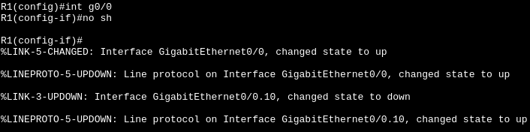
The command use is “int g0/0” (interface gigabitethernet0/0) and “no sh” (no shutdown).

Step 2: Create the sub-interface by typing interface we used in step 1 (g0/0) with “.10” I would like to treat the decimal as VLAN id.

Example:
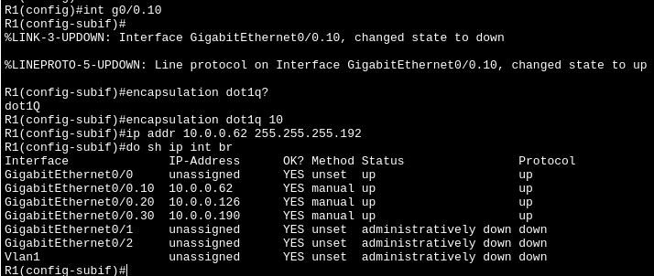
NOTE: We have to encapsulate the sub-interface by “encapsulation dot1q 10”, where did I get the 10? The 10 I use here is the .10 since it acts as VLAN id (I think). After the encapsulate, we can set the IP address of the sub-interface “g0/0.10” it will act as VLAN 10.
I set the IP address of the in “last usable address” and subnet mask given the task problem I’m solving. Did you notice that I did not “exit” after any command since you can edit other interface in the global configuration mode.

Step 3: Just repeat the process to other VLAN like VLAN 20 and VLAN 30.

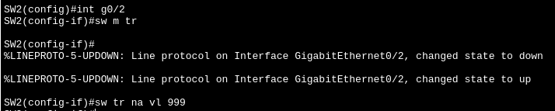
Step 4: Go to SW2 (router that connected to your main switch) and set the access ports into “trunk” so it can access other VLAN. Also, switch the native VLAN into 999 (the VLAN we used between switches)
6.) Don’t forget (Aston Machan) to add in SW2 the VLAN 30 since SW2 only have wired connection to R1 which SW2 must include VLAN 30 so it knows where to pass the ICMP Echo request (it will pass to trunk interface g0/1 of SW2).

Example:
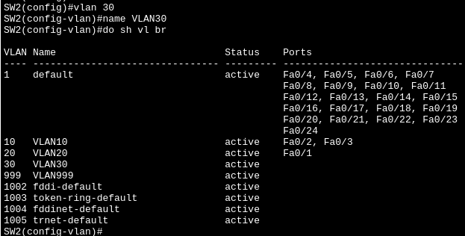

7.) To check if we really trunk the gigabit interface in switch, use the command “do sh run” (do show run) where you can see the configuration we do since step 1.

Example: NOTE: Its very long I just cut the part where it matters in this screenshot.
