DAY 22 LAB: RAPID STP

TASKS:

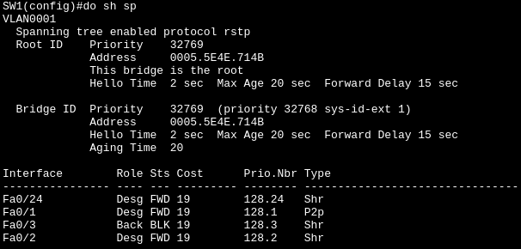
1.) Which switch is the root bridge?
Answer: SW1 is the root bridge
Use the CLI to examine the port role/state of each interface on the root. What appears different than what you have learned about the root bridge?
Answer: All ports in the SW1 should have a FWD (Forward) status not a single BLK (Block) and Alt (Alternative). However, Fa0/3 in SW1 interface have a role of “Back” and “BLK” (Block) status. In addition, all roles of interface in SW1 should be Desg (Designated), the type also change from “p2p” to “Shr”.
What is the cause of this?
Answer: The cause is Hub since it broadcast messages to the ports except where it came from then switch manage to prevent broadcast storm by switching the role of Fa0/3 to become “Back”? And status of BLK (Block).
2.) Without using the CLI, determine the port role/state of each remaining switch interface. Use the CLI to confirm.
Answer:
3.) Manually configure the appropriate RSTP link type on each interface. What do you think is
the correct link type for SW1's F0/24?
Answer:
TRIVIA:
1.) Hub is a device that connects multiple computers within Local Area Network (LAN) using broadcast that message out of every single port except the one it came from.

- Hub has Half-Duplex, where it can either send or receive data at one time, not simultaneously.
- Hub can cause collisions, if two devices send broadcast at exact same second their messages crash into each (collision) other and both have to resend.
- Hub also shared bandwidth, if you have 100 Mbps Hub with 4 devices, they share all that 100 Mpbs. If a device using it heavily, it slows down for everyone.

2.) Switch is the upgrade version Hub where its modern and smarter.

- Switch have full-duplex, where devices can send and receive data the exact same time (like a real phone call)

- Switch have no zero collision, since messages are delivered directly (unicast), they never crash into each other.

- Switch have a dedicated bandwidth for everyone, for example, if you have 100 Mbps switch with 4 devices, each device gets its own dedicated 100 Mbps path.

3.) The “Type” column in that switch have “P2p” (Point-to-point) meaning directly connected (operating in full-duplex mode). While “Shr” (Shared) meaning they are connected to a Hub (they are operating in half-duplex mode)

