Day 16 Lab – VLANs (Part 1)

What I have learn :

1.) Create a vlan using the “vlan 50” command and naming it in global configuration.

Example:
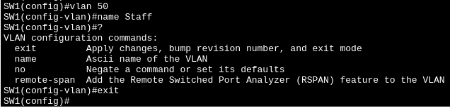

2.) Switch access port the interface of end hosts (so end hosts can use the vlan and isolate each other unless its allowed).

Example:
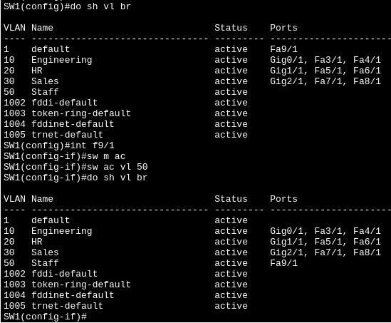

3.) When you ping the broadcast address especially in VLAN 10, the PC that will receive the request is PC2 and provide ICMP Echo reply. Since its a broadcast meant to be talk to anyone within its network and subnet (PC2).

Example:
