DAY 18 LAB – MULTI-LAYER SWITCHING

What I learn during the lab:

(I-type ko lang yung mga nagawa ko based sa number at ayusin ko lang bukas kung pano tinapos yung project na to)
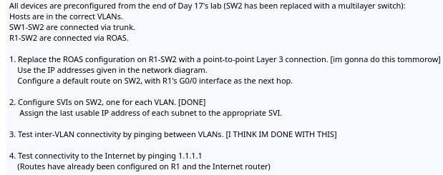
yung #2 at #3 natapos ko na ata kasi co-configure lang yung SVI ng each vlan at t-test yung inter-VLAN kung gumagana

1.) How “point-to-point Layer 3 connection” between R1 and SW2

Example: Configure the interface g1/0/2 in SW2 to become “routed port” (Layer 3). In every ports in switch operates in Layer 2 only means forward frames based on MAC addresses.

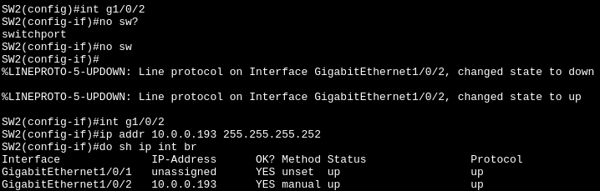
NOTE: Its important to “no swtichport” the interface to become “Routed port”. If you try to put ip addresses in interface skipping the command “no switchport” It will be “unrecognized command.”
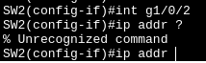

2.) How to IP route L3 SW2 to Internet?

Example: The command is "ip route". The first "0.0.0.0" is the destination network, and the second "0.0.0.0" is the subnet mask of that network. The "10.0.0.194" is the next-hop router IP address, which is R1. R1 will act like an ISP and figure out where to send the packet based on the destination network and subnet mask.
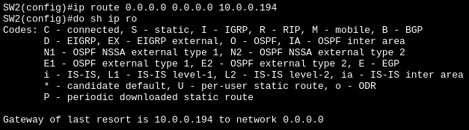

Before the command “gateway of last resort is not set”:
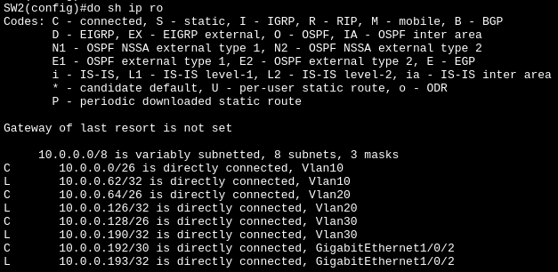
3.) How to enable in L3 switch where VLANs can talk to each other?
Example: The command is “ip routing” (in global configuration mode)
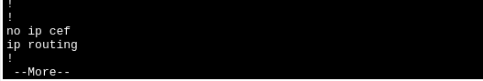

NOTE: By default its “no ip routing” but now there’s “no” now.

4.) How to create SVI (Swtich Virtual Interface) on L3 SW2, one for each VLAN?
Example: Creating SVI 99
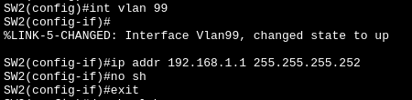
To check if the ip address we put works:

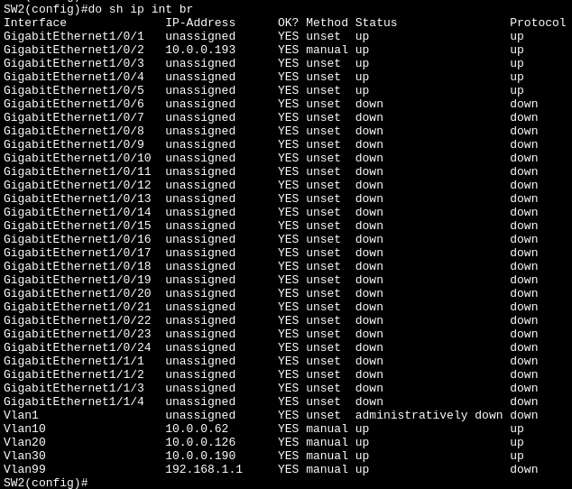
We can see in the bottom “Vlan99” with 192.168.1.1 IP address
To remove it, just “no int vlan 99” and check it again using “do sh ip int br”:

