DAY 19 LAB: DTP & VTP

What I have learned:
1.) What is DTP? What is the importance of it?
→ DTP stands for Dynamic Trunking Protocol which automates the creation of trunks links between switches.

→ DTP is used to automaticall “negotiate” wheter a switch port should become a trunk link or remain as access link
→ Trunk link means carrying multiple VLANs
→ Access link means carrying single VLAN

2.) What are the common DTP modes?
→ switchport mode trunk: Puts the port in permanent trunking mode and actively sends DTP packets to other side

→ switchport mode dynamic desirable: The port actively tries to form a trunk by sending DTP packets. It becomes a trunk if other side is set to trunk, dynamic desirable, dynamic auto.

→ switchport mode dynamic auto: The port passive “waits” to receive DTP packets to form a trunk. It onlly becomes a trunk if other side is set to trunk, dynamic desirable. dynamic auto.

→ switchport mode access: Puts the port in permanent access mode, disabling trunk. No DTP negotiation happen.

→ switchport nonegotiate: Used with switchport mode trunk to make the port a trunk without sending any DTP packets
3.) What is VTP? What is the importance of it?
→ VTP stands for VLAN Trunking Protocol, it synchronizes VLAN databases across multiple switches.

→ You have to create a VLAN on one VTP server and it will be automatically used by all other switches within the same VTP domain which ensures VLAN consistency and reducing configuration errors.

4.) What are the common VTP modes?

→ Server: The default mode. You can create, modify, and dlete VLANs. Changes are broadcast to the rest of VTP domain. (This is the policy maker, I think)

→ Client: Recieves VTP updates from servers and applies them to its local VLAN database but you cannot create, modify, or delete VLANs on client switch. (This is for client only since they only have to use it).

→ Transparent: Ignores VTP updates for its own database, but forwards them to other switches. You can create, modify, and delete VLANs locally, but these changes are not applicable to the rest of the domain. (This one will be used for special occasion).

5.) How to disable DTP on the port/s in cisco packet tracer?

Example: If we want to disable the DTP when trunking, the command are “switch mode trunk” and “switch nonegotiation”. Both of them are important to use the command “switch nonegotiation” which stops sending the DTP.

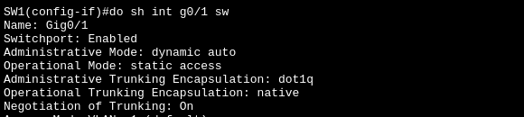
Before:
During:
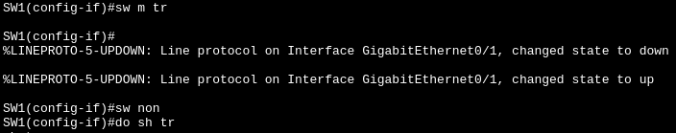
After: Just check the Mode it should “on” meaning nonegotiation work and Status should be “trunking” meaning operational mode is trunk.
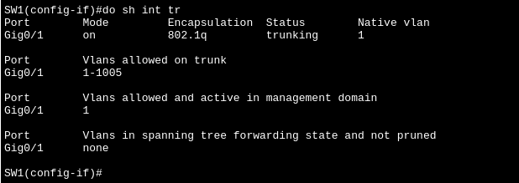

To disable the access ports (PCs, Printers, IP Phones) and unused ports:

Example: Just use the command “switch mode access” if “in-use” access ports. For unused ports, just “switch mode access” and “shutdown” command, even if attackers manage to use that port it will be useless since that port is set “administratively down” = no connection at all.

Before:
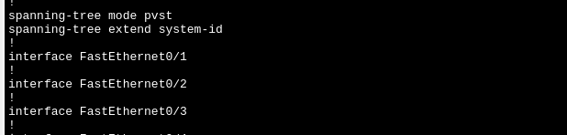
This example (above) is a security risk since attackers can “act as switch” and give access on trunk and manipulate it.
After:
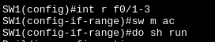
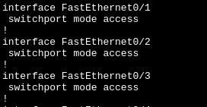
Using the “switchport mode access” automatically deny sending DTP.
6.) How to check if I disable DTP on the port/s already? What is the command for it?

Example: Type “do sh int [interface you want to check] sw”
(do switch interface g0/1 switchport)
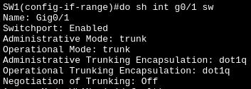

In this picture (above) only look on this 3 which are Administrative Mode, Operational Mode, Negotiation of Trunking. The proper config for each of them are trunk, trunk, and off.
7.) How to configure SW1 as VTP Server?

Example: The command is “vtp domain [domain name you want]”
We can change the domain name if you want by typing the same command
8.) How can we tell if its a server?

Example: The command to check wether it becomes a server is “do show vtp status”
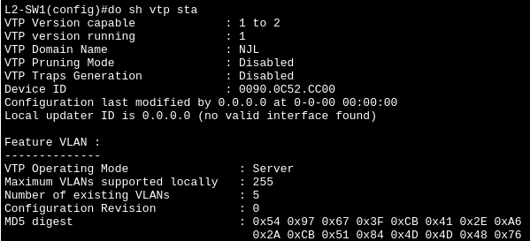
Just look at Feature VLAN and look below it you can see the VTP Operating Mode: Server.
9.) Let’s create VLANs and check L2-SW2 and L2-SW3 if it synchronized the VLAN database across the entire domain:
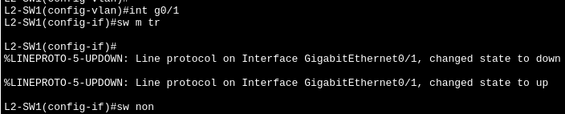
NOTE: Make sure to TRUNK THE PORTS BETWEEN SWITCHES using the command “switch mode trunk”, disable the DTP using the command “switchport nonegation”, and laslty, set a native VLAN for security (like VLAN 999, the command is “switchport trunk native vlan 999”.
L2-SW1:
If Mode is on meaning the nonegation work, if Status is trunking then “switchport mode tr” work. Do the same to other switches
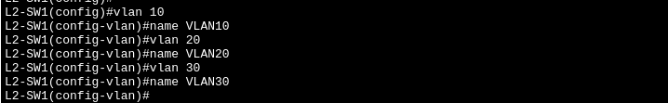
Then we create 3 different VLANs 10, 20, and 30.

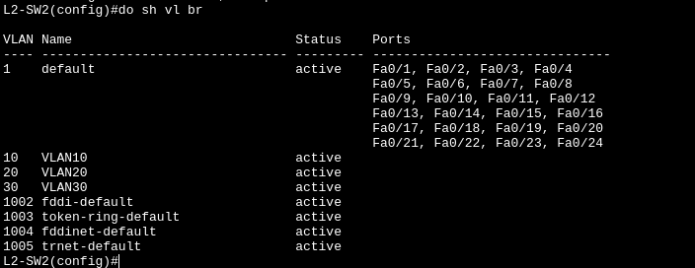
Let’s check the other switch if synchronized works.
L2-SW2:
L2-SW3:
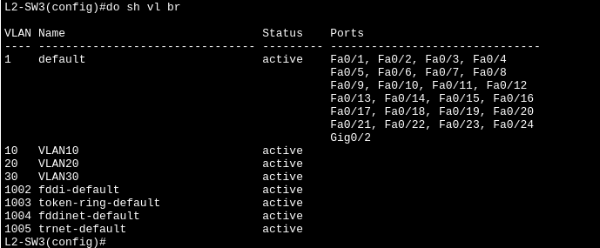
We can see the synchronized works which VLAN 10, 20, and 30 exist in SW2 and SW3.
10.) How to configure SW2 into Client mode?

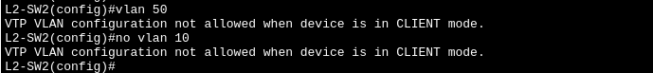
Example: In CLIENT mode, the switch cannot modify and delete the VLAN database on it. It automatically update its VLAN database based on SERVER switch.
If we try to create a VLAN or delete a VLAN, this is the result:
11.) How to configure SW3 into Transparent mode?

Example: In Transparent mode, the switch can ignore the update but the pass the update (server) to other switches. Additionally, it can modify and delete its VLAN database without affecting other switch (it cannot be pass-on, it will stay locally).
L2-SW3:
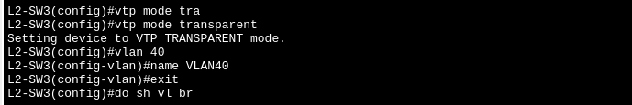
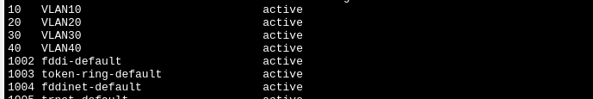
Let’s add VLAN 50 in the server and check SW3 again if it add the VLAN 50.
L2-SW1 (Server mode):
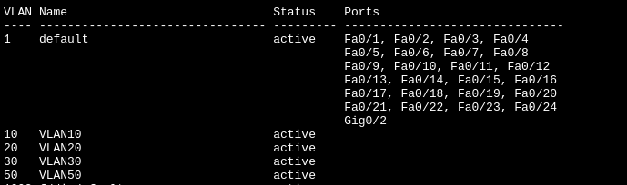
L2-SW2 (Client mode):
L2-SW3 (Transparent mode): It works!
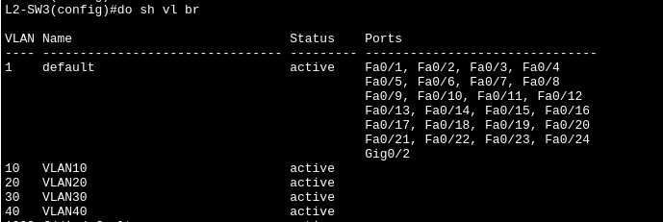

ALWAYS DO THE FOLLOWING:

1.) Create a unused VLAN and use it as native VLAN between SWITCHES when doing a trunk (for security purpose, anti-VLAN hopping).
2.) Always check the PCs if they have an IP Address and Default gateway, sometimes its the source of the problem where ping doesn’t work.

3.) Change the access ports of clients/end hosts (PCs, Printers, Servers) to their respective VLANs (doing “switchport mode access” and “switchport access vlan vlan-id”.

4.) Disable the DTP when trunking between SWITCHES.
5.) Change into “access mode” and “shutdown” the unused interfaces.

