DAY 20 LAB: ANALYZING STP

What I have learned:

1.) What is STP? What’s the importance of Spanning Tree Protocol?
→ STP stands for Spanning Tree Protocol which primary job is to stop broadcast storms (network loop) that can paralyze a network (Prevent network loops by blocking one port.)

→ Broadcast storms is the cause when there’s a network loop between switches which consume the all available bandwidth.

→ STP is used to create backup paths (redundant links) in-case one of link fails, traffic can automatically take another path.
→ STP also prevent “flapping” where MAC address table becomes unstable when seeing the same source MAC address on different ports (overwhelmed)
2.) How do I know which switch is the “root bridge”?

Example: Using the command “do show spanning-tree” in global config mode.
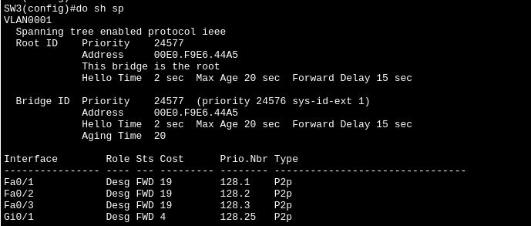
Look at Root ID part where “This bridge is the root” you can also knoiw it by its lower priority number to other switch.
3.) How do I know the designated and non-designated between switches port?
Example: Using the command “do show spanning-tree”.

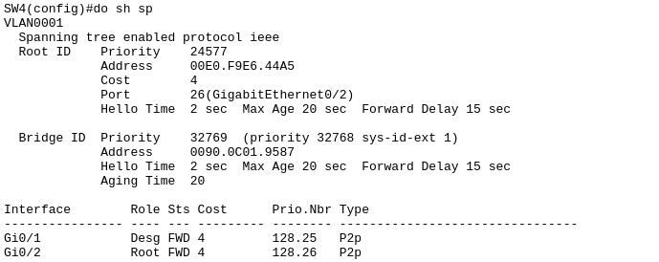
SW4:
Check the Role which interface have Desg (g0/1) and Root (g0/2).
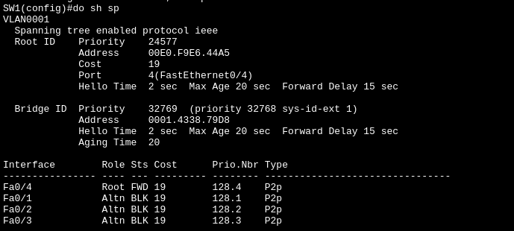
4.) How do I know if my answer are correct using the CLI in cisco packet tracer.
Example: Using the command “do show spanning-tree”.
SW1:
You can easily know the Role, Sts (Status), Cost, Prio.Nbr (Priority Number).
5.) What are the STP Features?
→ Rapid STP (RSTP): Significantly speeds up network convergence when a failure occurs.

→ Multiple STP (MSTP): Allows grouping multiple VLANs into a single STP, which can provide better load balancing and efficient use of network resources.

→ Root Guard: A security feature that prevents a rogue switch from forcefully taking over as the root bridge and disrupting the network topology. (used when switch-to-switch)

→ BPDU Guard: A security feature that disables a port if it receives STP information, protecting access ports that should be connected only to end-hosts devices.

→ The command “spanning-tree portfast” by pass the listening and learning states and immediately puts the port into forwarding mode.
6.) How to set “BDPU Guard ” to prevent unauthorized switches becoming the root

Example:
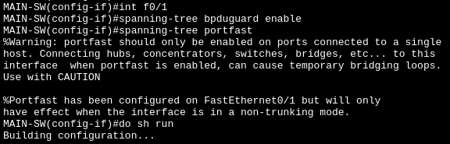

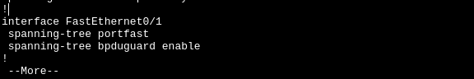

We run “spanning-tree portfast” to forward state which immediately provide internet access for PCs. While we use the command “spanning-tree bpduguard enable”, If someone try to plug a switch in access ports (ports connected to PCs) it will shut the port down (errdisable state) to stop the rouge switch instantly.

7.) How to set “Root Guard” to prevent inter-switch becoming the Root Bridge?
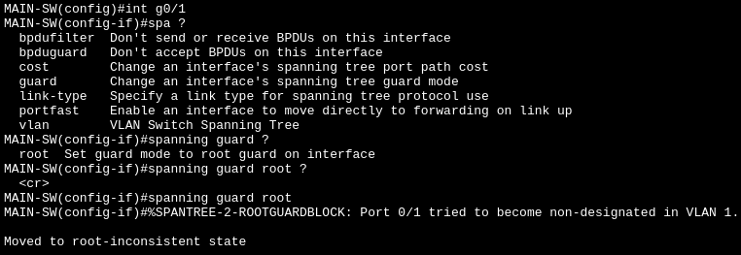
Example: Always use the “?” symbol when you are unsure what command next.
I set the main switch as the root bridge then configure the interface where inter-switch links (switch to switch interface), I use the command “spanning-tree guard root” to block the port when it receives a “superior” BPDU from that switch (trying to be root bridge).
7.) What will happen if PC doesn’t get a DHCP reply?
Answer: It assigns it self an Automatic Private IP Address (APIPA) in the 169.254.x.x range, which means it has no internet connectivity.

8.) How to know the “role” of the interface in SPT using CLI?
Answer: Check on the “Prior.Nbr” (priority number) where the higher value will become Root.

Additional:
→ All ports in the “Root Bridge” switch are all have a “designated” role since they are the “Boss” (Big Boss?!). All other switches determine their best path based on this switch.

→ The Root Port is the best path, or cheapest path (based on lower cost when checking the spanning-tree in CLI)

→ The Designated Port is usually the root’s ports, or the closer switch. Its responsible for forwarding the traffic toward the Root Bridge

→ Non-designated (Blocking) is the backup and prevents the loop (block one port in the switch).

→ Port States transition through Blocking → Listening → Learning → Forwarding. This process takes 30-50 seconds (using the “portfast” can skip the process).

→ Priority is a configurable value (in multiple of 4096) to determine which switch becomes the Root Bridge. A lower priority value means a higher change of being elected.

