DAY 21 LAB: CONFIGURING SPANNING TREE

Tasks based on lab topology:

1.) Use the CLI to check the current STP topology:
1.1) What is the current root bridge?
Answer: SW2
1.2)What is the STP role/state of each port on each switch?
Switch | Interface | Role | State
SW1 | F0/1 | Alternative (Altn) | Block (BLK)
SW1 | F0/2 | Designated (Desg) | Forward (FWD)
SW1 | F03 | Root | Forward (FWD)
SW2 (Root bridge) | F0/1 | Designated (Desg) | Forward (FWD)
SW2 (Root bridge) | F0/2 | Designated (Desg) | Forward (FWD)
SW2 (Root bridge) | F03 | Designated (Desg) | Forward (FWD)
SW3 | F0/1 | Designated (Desg) | Forward (FWD)
SW3 | F0/2 | Root | Forward (FWD)
SW3 | F03 | Designated (Desg) | Forward (FWD)
SW4 | F0/1 | Root | Forward (FWD)
SW4 | F0/2 | Alternative (Altn) | Block (BLK)

2.) Configure SW1 as the primary root for VLAN1 and the secondary root for VLAN2.
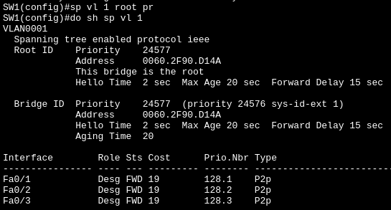
Primary root for VLAN 1: I use the command “sp vl 1 ro pr” and “do sh sp vl 1”

Secondary root for VLAN 2:
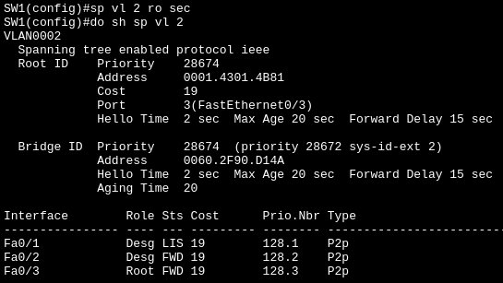
I use the command “do sh sp vl 2” to see different vlan spanning-tree config. We can know how it become the secondary by looking in priority where using the command “spanning-tree vlan 2 root secondary” automatically sets a priority of 28672.
2.1) Configure SW2 and the primary root for VLAN2 and the secondary root for VLAN1.

Primary Root for VLAN 2:
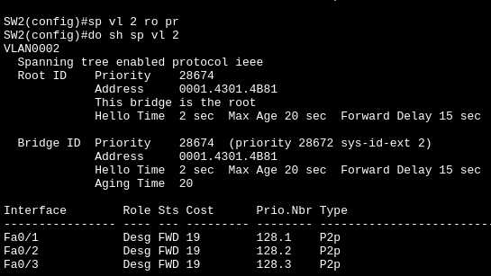

If we see “This bridge is the root” then the command “spanning-tree vlan 2 root primary” work!
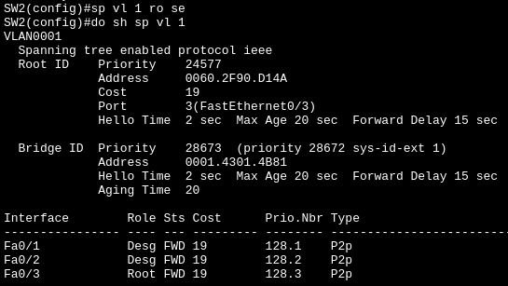
Secondary root for VLAN 1:
We can know how it become the secondary by looking in priority where using the command “spanning-tree vlan 1 root secondary” automatically sets a priority of 28672.
2.2) What is the STP role/state of each port on each switch now?

Switch | Vlan | Interface | Role | State
SW1 | 1  (Primary Root) | F0/1 | Designated (Desg) | Forward (FWD)
SW1 | 1  (Primary Root) | F0/2 | Designated (Desg) | Forward (FWD)
SW1 | 1  (Primary Root) | F03 | Designated (Desg) | Forward (FWD)
SW1 | 2  (Secondary Root) | F0/1 | Designated (Desg) | Forward (FWD)
SW1 | 2  (Secondary Root) | F0/2 | Designated (Desg) | Forward (FWD)
SW1 | 2  (Secondary Root) | F03 | Root | Forward (FWD)
SW2 | 1  (Secondary Root) | F0/1 | Designated (Desg) | Forward (FWD)
SW2 | 1  (Secondary Root) | F0/2 | Designated (Desg) | Forward (FWD)
SW2 | 1  (Secondary Root) | F03 | Root | Forward (FWD)
SW2 | 2  (Primary Root) | F0/1 | Designated (Desg) | Forward (FWD)
SW2 | 2  (Primary Root) | F0/2 | Designated (Desg) | Forward (FWD)
SW2 | 2  (Primary Root) | F03 | Designated (Desg) | Forward (FWD)

3. Increase the VLAN1 cost of SW4's F0/2 interface to 100.

Before:
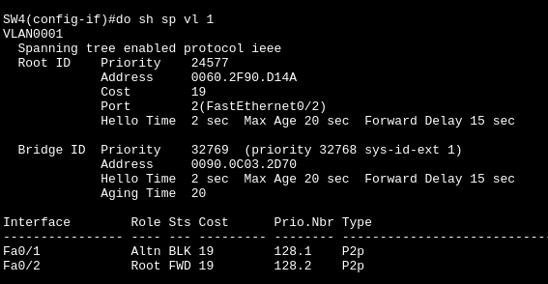

The role is Root and Status is FWD (Forward).

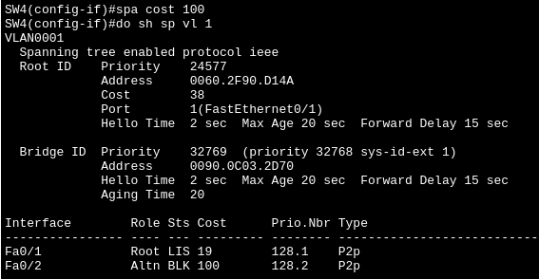
After:
The role become Altn (Alternative) and status become BLK after increasing the cost to 100
Does SW4 select a different root port? Why/why not?

Answer: Yes, it select Fa0/1 interface since it has cheaper cost which is important to become a root port in SW4.

4. Increase the VLAN1 port priority of SW1's F0/1 to 240.
Before:

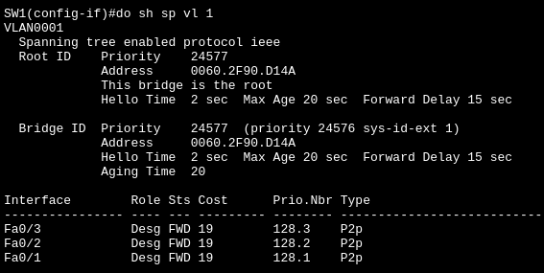

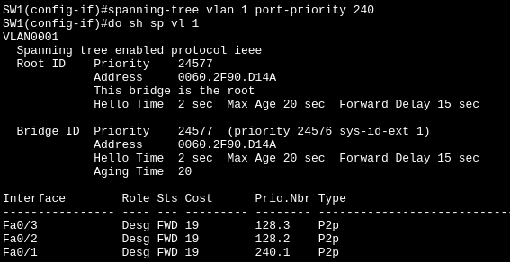
After:
Does SW3 select a different root port? Why/why not?

Before:
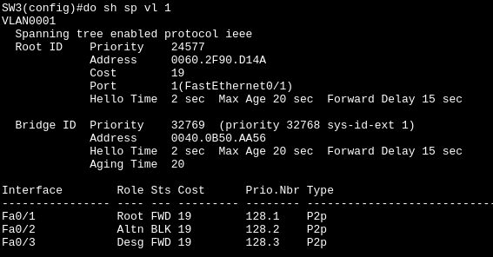

After:
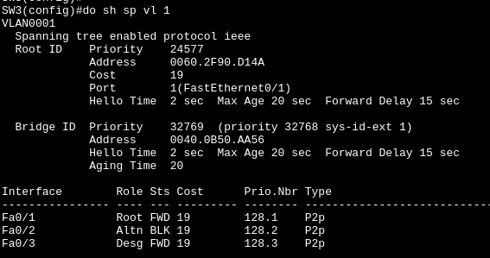
Answer: No, I guess it only matters to “cost” when selecting different port (I’m referring to SW4 scenario where the role of an interface change because of a higher “cost”).
5. Configure PortFast and BPDU Guard on the F0/3 interfaces of SW3/SW4.
SW3, Before:
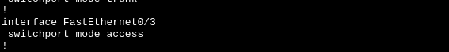
SW3, After:
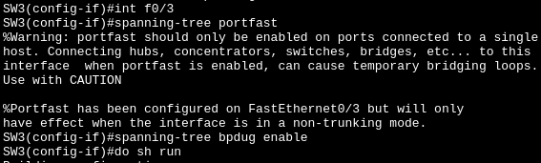
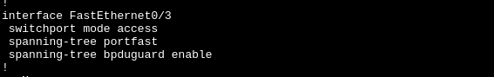

SW4, Before:
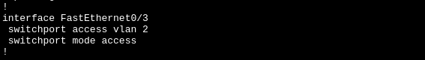
SW4, After:
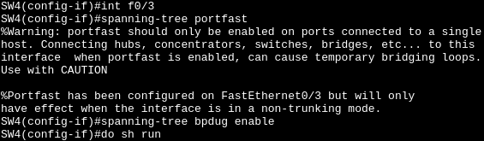
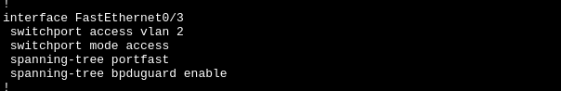
Lesson learned: We enable PortFast for end hosts like PC where it provide (forward) connection immediately (if disable, it takes 30-50 seconds to forward connection since its listening and learning status).
NOTE: Use this to one single end device NOT to a switch since it will cause layer 2 loop (broadcast storm)

On another hand, we enable bpduguard to secure only end hosts device such as PC to be able to use the access port, If anyone try to connect a switch to an access port it will immediately shutdown that port entirely (err-disable state) to stop a loop forming.

In addition, it prevent a rogue switch by shutdown the port before it can reach the switch that has a bpdu guard where it can mess up our topology we did earlier (some rogue switch have lower bridge priority (0) where it can take over our selected switch “bridge root”).

TRIVIA:
1. Pag mataas yung cost ng isang interface sa switch yung status niya ay automatically BLK (Block)

2. After mo mag configure sa isang interface yung status niya ay nagiging LIS (Listening) later mag change rin siya into something else like FWD (Forward) or BLK (Block) situational btw

