DAY 22 LAB: RAPID STP

TASKS:

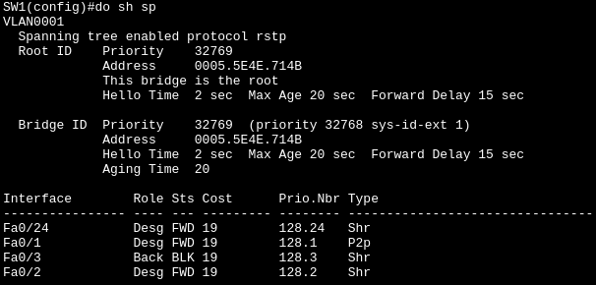
1.) Which switch is the root bridge?
Answer: SW1 is the root bridge
Use the CLI to examine the port role/state of each interface on the root. What appears different than what you have learned about the root bridge?
Answer: All ports in the SW1 should have a FWD (Forward) status not a single BLK (Block) and Alt (Alternative). However, Fa0/3 in SW1 interface have a role of “Back” and “BLK” (Block) status. In addition, all roles of interface in SW1 should be Desg (Designated), the type also change from “p2p” to “Shr”.
What is the cause of this?
Answer: I guess, its because of the “Hub” I’m not sure how but
2.) Without using the CLI, determine the port role/state of each remaining switch interface. Use the CLI to confirm.
Answer:
3.) Manually configure the appropriate RSTP link type on each interface. What do you think is
the correct link type for SW1's F0/24?
Answer:
TRIVIA:
1. Hub is a device that connects multiple computers within Local Area Network (LAN) using broadcast that message out of every single port except the one it came from.

- Hub can either send or receive data at one time, not simultaneously.
- Hub can cause collisions, if two devices send broadcast at exact same second their messages crash into each (collision) other and both have to resend.
- Hub also shared bandwidth, if you have 100 Mbps Hub with 4 devices, they share all that 100 Mpbs. If a device using it heavily, it slows down for everyone.

