Video Game Library and Sales Website Documentation

Authors: Brenda Beach and Jonathan Hardwick

**Consider creating a batch file to run perform the necessary tasks for the user to install the webpage.

**Add pictures to illustrate the installation process.

**Create a mock folder for demonstration purposes

**Disclaimer: These screenshots are placeholders until the website is finalized. All screenshots will be updated as the website is updated.

# Installation:

**The following instructions explain how to install and launch the website from a folder on the desktop (maybe use a different folder, like directly on the c:/ drive to limit the amount of personal information and simplify the process)

1. Install required software to run this website:
   1. Install the latest Python version (python.org)
2. Clone the Github repo CSC289 to an empty folder on your computer or download the zip file and unzip the file to an empty folder on your computer.
   1. Github repository (<https://github.com/MrChiff/CSC289>)
   2. For zip file:
      1. Click the green code button and select download zip from the drop down menu.

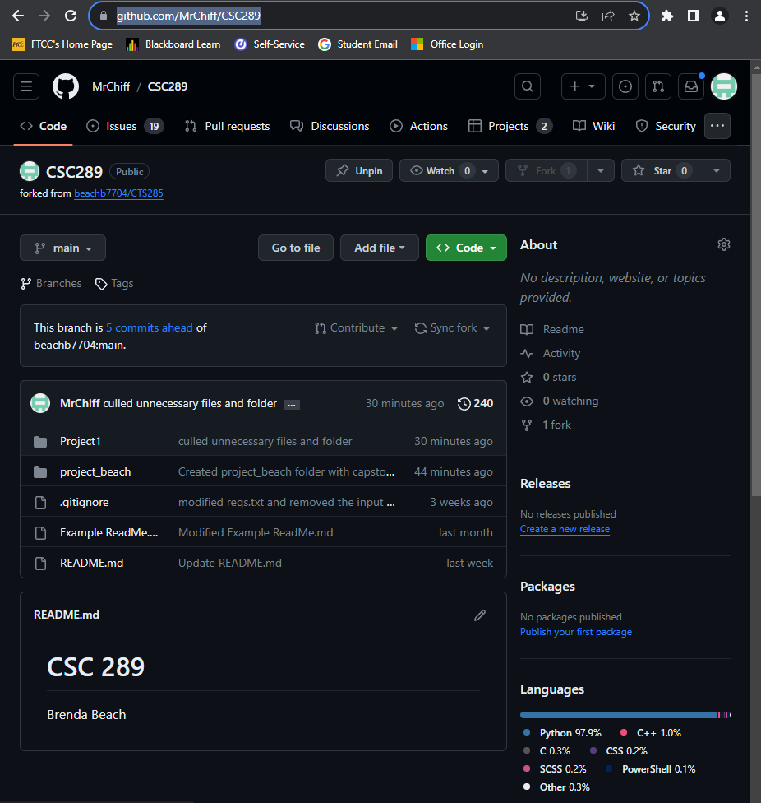

**Update github to have both of our names

1. Open command prompt on windows. (press the windows key and type cmd and select command prompt)
2. In the Command Prompt window,
   1. Navigate to the new folder.
      1. Use the command: cd “path to new folder”
   2. Create a Python virtual environment.
      1. Use the command: python -m virtualenv “your env name”
   3. Activate the virtual environment.
      1. Use the command: .\”your env name”\Scripts\activate
   4. Install the necessary modules.
      1. Use the command: pip install -r reqs.text
   5. Uninstall werkzeug.
      1. Use the command: pip uninstall werkzeug
      2. Enter Y to uninstall the module.
   6. Install werkzeug v2.3.7.
      1. Use the command: pip install werkzeug==2.3.7
   7. Change directory to the project folder.
      1. Use the command: cd project_beach
   8. Initialize the website.
      1. Use the command: python run.py
3. Go to the website <http://127.0.0.1:5000> in your web browser
4. Congratulations! You have launched the Video Game Library and Sales (VGLS) website.

Welcome Page

(placeholder)

# Using the Website:

1. View/Search for video games without logging in.
   1. The website if fully searchable for users that do not have an account.
   2. An account allows the user to create a video game/console/accessory library and add items to this library.

Welcome Page

(placeholder)

1. Registration
   1. In order to create an account click “Create Account” button
   2. Choose a username and password, and enter these items into the webpage.

Registration

(placeholder)

1. Login
   1. Navigate to the login screen (explain this after have test site available)
   2. Enter your username and password into the appropriate boxes.

Login Page

(placeholder)

1. Change Password
   1. How to get to this page? (look at mathmaticus)
   2. Enter username and new password.

Change Password Page

(placeholder)

1. Reset password
   1. If you have forgotten your password you and reset the password.
   2. Navigate to the appropriate webpage. (explain once I can get the website running)
   3. Enter username and new password

Reset Password Page

(placeholder)

1. Select/search for specific video game.
   1. Click into the search box and type the desired video game/console/accessory
      1. What happens if the person types in the incorrect spelling of a item in inventory?
   2. Use the buttons to select the desired category. (video games/console/accessories)

Primary Category Page

(placeholder)

Secondary Category Page

(placeholder)

* 1. Choose from the alphabetized list of games/consoles/accessories to find the

List of Specific Items Page

(placeholder)

1. Select video game

List of Specific Items Page

(placeholder)

1. Add video game to list connected to account=> like view cart/checkout
   1. Only one of each item can be added to the library.
   2. To view the your library select the “Library” button in the navbar at the top of the page.

Library Page

(placeholder)

1. Admin portal
   1. Reset user’s password.
   2. View/edit databases

Admin Portal