Criterion Crawler Installation

The program that finds the requested details about the items in the VGLS database.

# Installation:

1. Install required software to run this website:
   1. Install the latest Python version (python.org)
2. Clone the Github repo CSC289 to an empty folder on your computer
   1. Github repository: https://github.com/MrChiff/CSC289

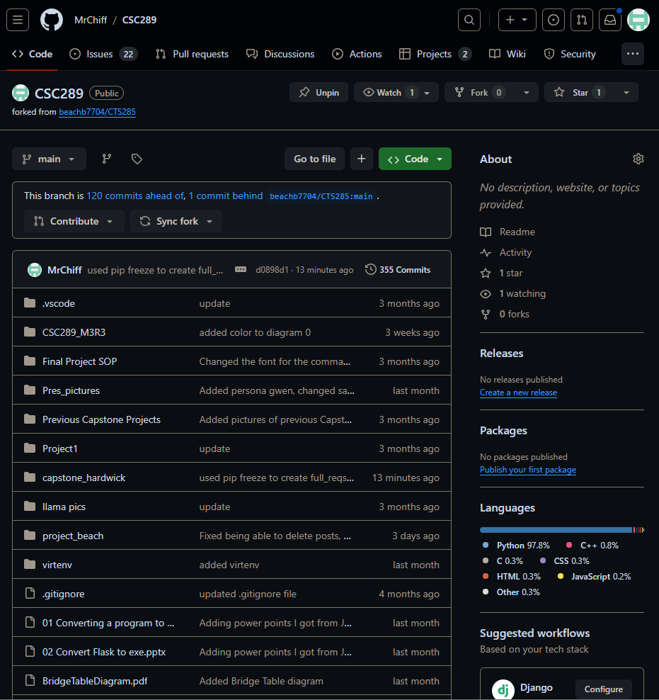

1. Open command prompt on windows. (press the windows key and type cmd and select command prompt)
2. In the Command Prompt window,
   1. Navigate to the new folder.
      1. Use the command: cd “path to new folder”
   2. Create a Python virtual environment.
      1. Use the command: python -m virtualenv “your env name”
   3. Activate the virtual environment.
      1. Use the command: .\”your env name”\Scripts\activate
   4. Install the necessary modules.
      1. Use the command: pip install -r criterion_crawler_reqs.text
   5. Uninstall werkzeug.
      1. Use the command: pip uninstall werkzeug
      2. Enter Y to uninstall the module.
   6. Install werkzeug v2.3.7.
      1. Use the command: pip install werkzeug==2.3.7
   7. Initialize the website.
      1. Use the command: python -m criterion_crawler
3. Congratulations! You have launched the criterion crawler.