# **MIDI Lighter: Skip Note Off Implementation Measurement and Characterization**

## Measurement 1: Single MIDI Signal and Event Timing

This meausurement shows the timing of Note Event (Note On and Note Off) and the implemented “Skip Note Off” feature . For this test, only one MIDI Signal has been sent as shown was follows:

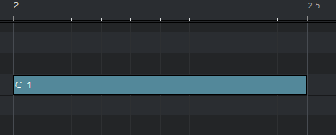

Figure : MIDI Signal in Studio One 3

Duration of the MIDI Signal is 500 ms. At the beginning a “Note On” Event is sent and at the end a “Note Off” Event. Oin each event, a single character has been outputted with a frequency of 4 MHz. This frequency is much higher than the MIDI baud rate, which is 31250 (Factor 128). The SPI data has been captured with Logic Analyzer. The following charcters have been emitted on the corresponding event:

* Event “Note On”: N
* Event “Note Off”: F (Event has been recevied and marked for execution)
* “Note Off” Execution: A (Received “Note Off” Event has been executed)

The timings are shown in the figure below:

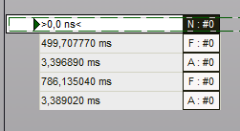

Figure : Event table with relative timing measured by the Logic Analyzer

The initial of the “Note On” Event is shown as time 0,0 ns. The “Note Off” Event has been received ~500 ms later (expected result). The “Note Off” Event has been executed about 3,4 ms later. This is an implemented delay and to be expected as well. The “Note Off” Event at the second last row was caused by stopping the playback manually.

## Measurement 2: Faster MIDI Signal Sequence Timing

As subsequent test, multiple MIDI signals on the same note has been sent out in a faster sequence. Each signal had a different velocity, shown by the infilling of each signal. The velocity takes no part in this measurement, only the timing is relevant.

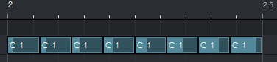

Figure : MIDI Signals in faster sequence on same note

In Figure 3 eight signals are sent within 500 ms 🡪 New signal every 62,5 ms. Two signals are directly subsequent to each other with no break in between. The measurements by the Logic Analyzer are shown in the following figure:

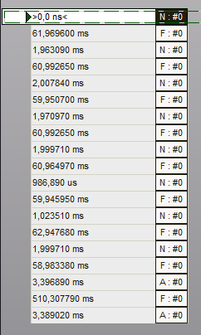

Figure : Event timing of the faster MIDI signal sequence

The very first “Note On” Event is shown at 0,0 ns. In total eight “Note On” Events (N) are have been received, which was expected. For eacht “Note On” Event, a “Note Off” Event (F) has been received and marked for execution. But only the very last “Note Off” Event has been executed (A). The delta timing here shows, that after a “Note Off” event, the following “Note On” Event has been sent out in about 1~2 ms. This time is shorter than the ~3,4 ms, which Characterisation the “Note Off” Event execution is delayed. If within these 3,4 ms, a “Note On” Event is received, the execution of the previous received “Note Off” Event will be skipped.

The very last “Note Off” Event at the second last row was caused by stopping the playback manually and has no relevance by for this test.