Tile Map Editor

Introduction
Tile map editor is an application which let's you design your tile maps visually and easily. On internet, there are a lot of tile map editors. However, they have some disadvantages. So, in our project, we design tile map editor:
It has 2 main functions:
- Create resource map: It contain 2 files: png image and “.rmp” binary file. These are used in “Tiled” application to design tile map and in our game to provide images exactly.
- Complete tile maps: We will add some information (example: items, images…) and after that, the application will export them to binary files with extension “.map”.

Files’ structure

“.MAP” file structure
This is a binary file. It’s created by Tile Map Converter. It contains following information
Field | Bytes | Description
MapWidth | 2 | The map width or number of tile columns.
MapHeight | 2 | The map height or number of tile rows.
TileWidth | 2 | The width of a tile in pixels
TileHeight | 2 | The height of a tile in pixels
ByteNum | 1 | The number of byte is used in Map data field
MapData | x | The actual map data. Read from top to bottom, left to right.
BackGroundRed | 1 | The value of red color in background color
BackGroundGreen | 1 | The value of green color in background color
BackGroundBlue | 1 | The value of blue color in background color
DecorationNum | 1 | The number of decorative images (characters can’t interact to it)
DecorativeData | y | Include DecorationNum set: ID, x, y (byte)
ItemsNum | 1 | The number of Items images (characters can interact to it)
ItemsData | z | Include ItemsNum set: ID, x, y (byte)

“.RMP” file structure
This is a binary file. It’s created by Tile Map Converter. It contains n sets include following fields:
Field | Bytes | Description
X | 2 | Location x of image “i” in png resource map
Y | 2 | Location y of image “i” in png resource map
Width | 1 | The width of image “i” in png resource map
Height | 1 | The height of image “i” in png resource map

How to use
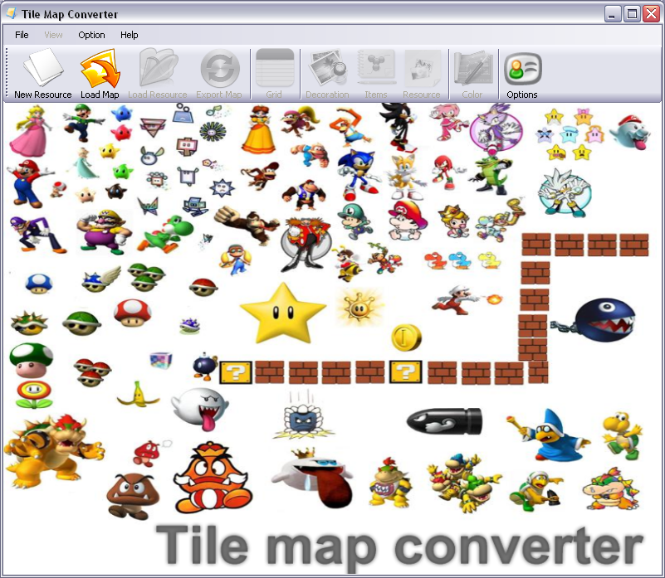
Figure 1 - Tile map converter
To load “.tmx” map, we can click “Load Map” on Toolbar or File → Load Map → Playing Map. A dialog will appear, choice paths and click OK (in textbox binary file we can choice path to .map file to open old file or blank)
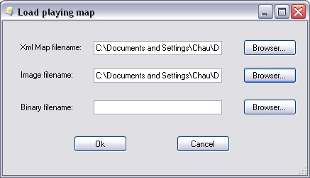
Figure 2 - Load playing map Dialog
Now, we can add some items or decorative images into map by using toolbar or menu. Beside, we can choice background’s color and view on grid mode. To create .map file, we click “Export Map” on toolbar or File → Export Map → Playing map
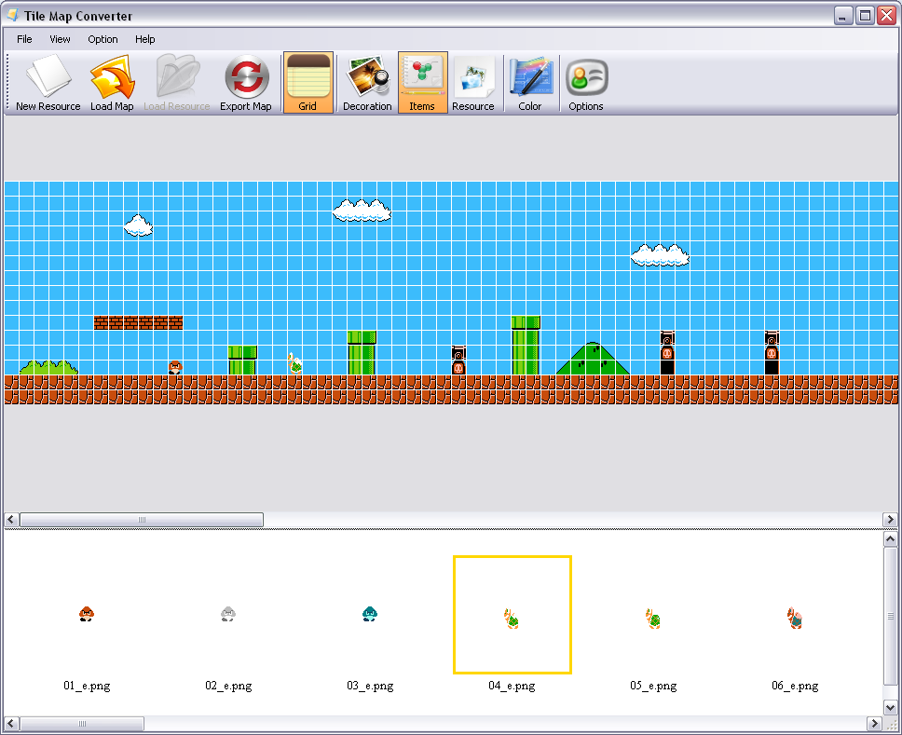
Figure 3 - Design map with Tile Map Converter
To create resource map, we click on “New Resource” on toolbar or File → Create new map → resource map. A dialog will appear and we’ll modify some values and click OK.
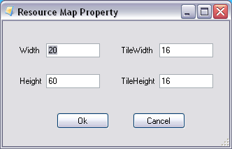
Figure 4 - Create new resource map Dialog
Next step, we can choice a saved file and open it to continue design by clicking on “Load Resource” or File → Load Map → Resource map. Now, we can begin to design resource map and after finishing, click Export Map or File → Export map → Resource map.
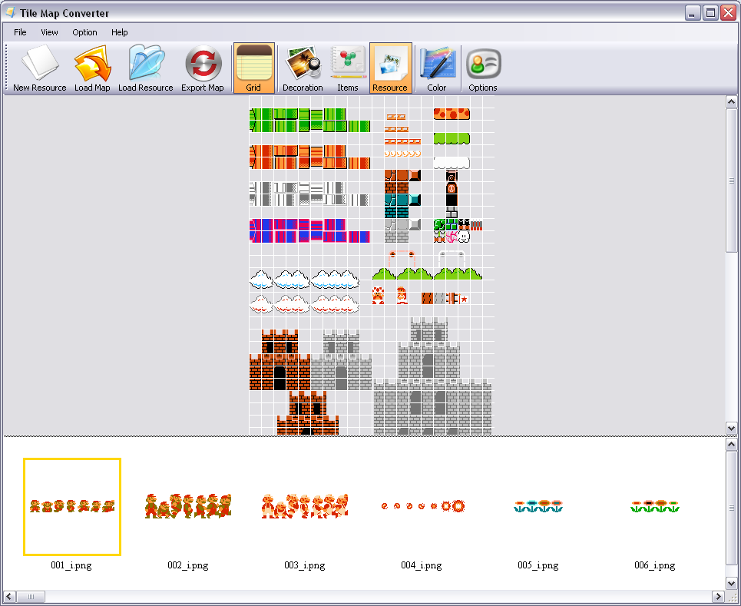
Figure 5 - Design resource map with Tile Map Converter

