**Maintenance Report**

**01/26/2020 – 8:20 PM**

**Eduardo D.**

Note: The original larger-size higher-quality JPGs of the stations’ historical data is available within this file’s current working directory.

**Station 1 (Phase 1) - 300234067638620@rockblock.rock7.com**

Status: Deployed, Idle (Non-functioning properly)

Last Email Received Datetime: 01/08/2020 – 10:31 PM (Website values agree)

Last Weight Value: 6 gallons

Historical Data:

Diagnosis:

The high concentration of data points at the end of this plot implies that a reset was attempted. The reset is recognized to have occurred on late 1/07/2020. After the reset, there is a small amount of stability for the sensor and weight values, implying that the station was functional after the reset. However, this station has stopped transmitting the information. The most likely cause of this discontinued of service can be the following (of decreasing likeability:

* Software Fault after automatic reset (the case was not tested during development)
* Wiring Disconnection during water station deployment
* Faulty redeployment
* RockBLOCK communication failure
* Arduino Long Operation failure (memory issues ?)

**Station 2 (Phase 1) - 300234067639570@rockblock.rock7.com**

Status: Deployed, Idle (Non-functioning properly)

Last Email Received Datetime: 01/08/2020 – 7:58 PM (Website values agree)

Last Weight Value: 12 gallons

Historical Data:

Diagnosis:

This station was deployed on 12/23/2019 (based on what our data says, not what the user says), which is then placed where the graph spikes up in value. This is mostly due to the changing value of the weight sensors during setup. Then the station stagnates for a period of time, mostly at around 100 lbs (≈12 gallons) for the weight. This agrees with the most up-to-date value in the southtexashrc.com website, it reported 12 gallons. This water station is much more difficult to diagnosis as the station just suddenly stopped transmitting the information. The fact that it stopped transmitting information the same day Station 1 failed implies that an external force is the cause of the problem.

**Station 3 (Phase 1) - 300234067431270@rockblock.rock7.com**

Status: Unknown, Idle (Unknown – Possibly not powered)

Last Email Received Datetime: 09/12/20219 – 7:29 PM

Last Weight Value: 2 gallons (Website values agree)

Historical Data:

Diagnosis:

The trip to change Phase 1 stations occurred on October 12, 2019. During this trip, we realized that station 3 had a different electrical layout where the Arduino microcontroller was connected to the batteries through its 9V input port instead of being connected to the solar charger via a USB connector. We tried to make this station conform with the other water stations' circuit layout. However, we realized that the USB port of the solar charger in station 3 was faulty and could not be used. The electrical box was returned to on-site personnel. We are waiting for them to place the electrical box to its designated compartment and initiate the station's service.

**Station 4 (Phase 1) - 300234067638500@rockblock.rock7.com**

Status: Unknown, Idle (Definitely Non-functioning properly)

Last Email Received Datetime: 09/12/2019 – 6:53 PM

Last Weight Value: 3 gallons (Website values agree)

Historical Data:

Diagnosis:

During the 09/12/19 trip, station 4 was modified, calibrated, setup, and confirm to have transmitted its first email. Once the engineering team returned to San Antonio, station 4 stopped transmitting the information. The cause remains unknown. We have not received any additional information regarding the station; therefore, communication with on-site personnel is needed to properly diagnose.

Possible Causes:

* Faulty Setup
* Faulty Calibration
* ???

**Station 5 (Phase 1) - 300234067638200@rockblock.rock7.com**

Status: Deployed, Idle (Non-functioning properly)

Last Email Received Datetime: 01/08/2020 – 5:02 PM

Last Weight Value: 6 gallons (Website values agree)

Historical Data:

Diagnosis:

When the weight of the station is 0, or just very low, it implies that the barrel was removed. We can see in the far right of the plot that the barrel was repetitively removed and replaced. The transmission of data ended on 01/08/2020, which is also the same time as stations 1 and 2 failed, implying that the problem is linked together and related to a shared external force.

**Station 6 (Phase 2) - 300234067929930@rockblock.rock7.com**

Status: Dead

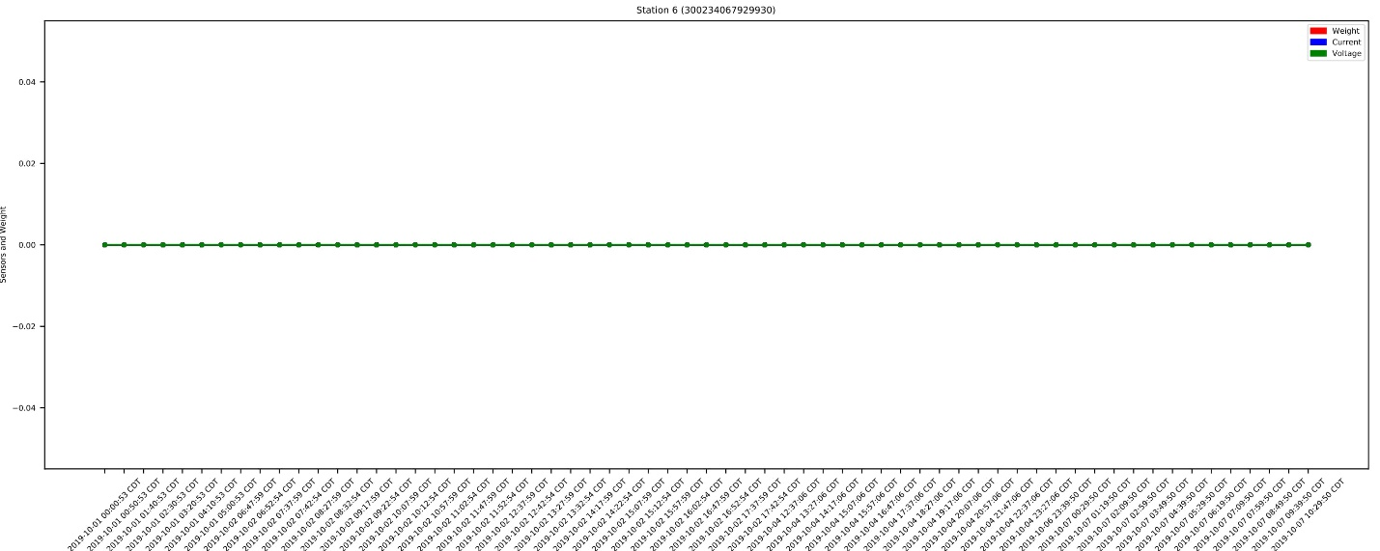

Diagnosis:

Discontinued station – the station was broken and tossed in the trash.