SKORE (Smart Keyboard Operated by Robotic Educator)

By

Ashkan Aminian, Zachary Bosker,

and Eduardo Davalos Anaya

An Electrical Engineering Senior Design Proposal

submitted for project approval for Senior Design Project.

St. Mary’s University

San Antonio, Texas

September 15th, 2018

**ABSTRACT**

SKORE: Smart Keyboard Operated by Robotic Educator

Learning music is a hobby that many people avoid because of the time and effort required to learn music sheet notation. Additionally, experienced piano players face often the issue of not finding the music sheet of their liking, making them unmotivated to practice. The SKORE intends to solve these issues, for both the amateur and expert pianist. By utilizing open-source software, SKORE provides LED-guided tutoring with the user’s input of an audio file (.mp3) and music sheet (.pdf). With the LED array placed above the keys of the piano, the user can practice by following SKORE’s guided tutoring. SKORE’s multiple levels of tutoring allow continuous growth with a healthy balance between instruction and autonomy. The LED array will be modular and made to be functional with multiple piano keyboards and the SKORE application can be utilized by any Windows 10 machine. Additionally, the project provides experienced players the added feature of instant music sheet transcribing of their own recording or of a .mp3 files. For all intended purposes, this project is a proof of concept.

**TABLE OF CONTENTS**

**ABSTRACT**………………………………………………………………………………………i

**TABLE OF CONTENTS**………………………………………………………………………..ii

**LIST OF FIGURES AND TABLES** …….…………………………………………………….iii

CHAPTERS

CHAPTER I: INTRODUCTION…………………………………………………………1

CHAPTER II: DESIGN OBJECTIVES………………………………...………………...1

CHAPTER III: PRODUCT AND SYSTEM DEFINITION…………..………………….2

CHAPTER IV: DIVISION OF RESPONSIBILITY………..…………………………….6

CHAPTER V: PROJECT’S SCHEDULE AND BUDGET…………...………………….7

CHAPTER VI: STUDENT’S RESUMES…………..…………………………………….8

REFERENCES…………………………………………………………………………………..11

**LIST OF FIGURES AND TABLES**

3.1 An overall concept of the communications between the user, PC (windows 10 machine), Arduino, and Piano. The communications will be complex and interconnected. The arrows specify the directionality between major components of the system. …………………………....2

3.2 Visualization of the application utilization within the software of the project. …………..3

3.3 Concept mechanical model of the LED rod…………………………………………….3-4

3.4 Demonstration of completed project appearance………………………………………….4

4.1 A visual aid to see the division of responsibilities. For the completion of the group tasks, each student must complete their personal task. ………………………………………………….6

5.1 Gantt Chart of the expected completion dates for each member’s task. …………….……7

5.2 A budget that offers a list of expenses necessary for the completion of the project and provides the items to be purchased with a small description. ......…………………...……………7

**CHAPTER I**

**INTRODUCTION**

Learning an instrument is a beneficial skill that improves our quality of life[1]. However, the majority of the people quit playing instruments, about more than 50% quit within 3 years[2]. There are multiple reasons why people stop playing instruments, such as lack of time, general loss of interest, and tutor discomfort or inconvenience. The latter is the issue we are trying to ease, in particular for the piano. Our project, SKORE, intends to address this issue by granting the user complete control of their music lessons. The SKORE provides the user with the tools to learn any song without the need for the music sheet.

**CHAPTER II**

**DESIGN OBJECTIVES**

Requirements

Basic requirements for the project with regards to the customer/consumer is ease of use, complete functionality, and multi-keyboard compatibility. Additionally, the SKORE’s installation and usage should be simple and straightforward. The SKORE should provide the possibility for the user to learn any song of their choice given an audio file (.mp3) or the music sheet (.pdf).

Design Constraints

Design boundaries present for this project mostly regard its economical liability and its complexity. Since some of the applications and features present in the SKORE already exist on the market, our design and construction of the SKORE should consider the prices of the components. The goal of the project, with respect to economics, is to develop an illuminated tutoring piano that is lower-cost and higher-functionality than the readily available products on-the-market. To reduce the cost of the project for the user, the computer system for the project can be any windows 10 machine.

Design Criteria

With the most important consideration of this project being cost, it was imperative that we find alternative designs that had no effect on performance at a cheaper price. Another crucial factor was to make this design compatible with most keyboards. Originally SKORE was meant to enhance the qualities of an existing keyboard by tampering with the electronics of a Casio WK-500 piano and adding features aimed for tutoring purposes. However, this design leads to many issues concerning cost and efficiency. Therefore, we chose to create a universal rod that will be capable of being installed on all pianos. This rod will offer all functionalities listed previously while it allows the user to utilize their own piano.

**CHAPTER III**

**PRODUCT AND SYSTEM DEFINITION**

Essential background: MIDI files (.mid) are the intermediate data file that connects the user to the computer. It is similar to the digitalization of an .mp3. The user inputs a .mp3 or .pdf file since most songs and audio user-friendly information are stored in these formats. For the computer to be able to use the music data files, they must be converted to .mid format. Once the .mid file is generated, it can be sent to a speaker driver to be played with synthesizers. The utilization of multiple open-source software is needed for this project to convert files into .mid format.

A screenshot of a social media post

Description generated with very high confidence

Figure 3.1: Communication Flow Diagram of Project

User Interaction

When referring to a PC, its implied that it is a windows 10 machine. The user would be allowed to place the SKORE’s LED array above their piano keys, power the tablet with a docking system with a wall outlet, download the SKORE application, input the song of their choice, and begin learning how to play that song. The overall project includes an Arduino microcontroller, LED array, charging dock for a tablet and power supply for the LED array. The project will develop a functional windows 10 tablet system, but the user can provide their own PC to run the SKORE application.

The user’s PC with the SKORE application will act as the brain of the system, transmitting data and receiving data from both the piano and Arduino microcontroller. The Arduino will be following the directions of the user’s PC and turning on the appropriate LED(s) to help the user learn. Additionally, a mobile charging dock for the tablet will be manufactured to ensure that the user can practice whenever they would like, without interruptions. The LED array will have a power system to utilize the power from the outlet to remove the need for additional batteries.

To provide the user with the tutoring services with the input of audio .mp3 files and music sheet .pdf files, multiple open-source programs will be used to perform the file conversions. The following open-source programs are the ones that will be utilized in this project (possibly subject to change): AmazingMIDI, Red Dot Forever, Xenoplay, Audiverius, MidiMusicSheet, Audacity, and PianoBooster. However, due to the unfriendly nature of open-source software to new users, a user interface (UI) will be programmed to aid the user’s operation of the SKORE. The UI will provide means for the user to enter their song’s information and allow the user to choose what tutoring mode they would like to utilize.

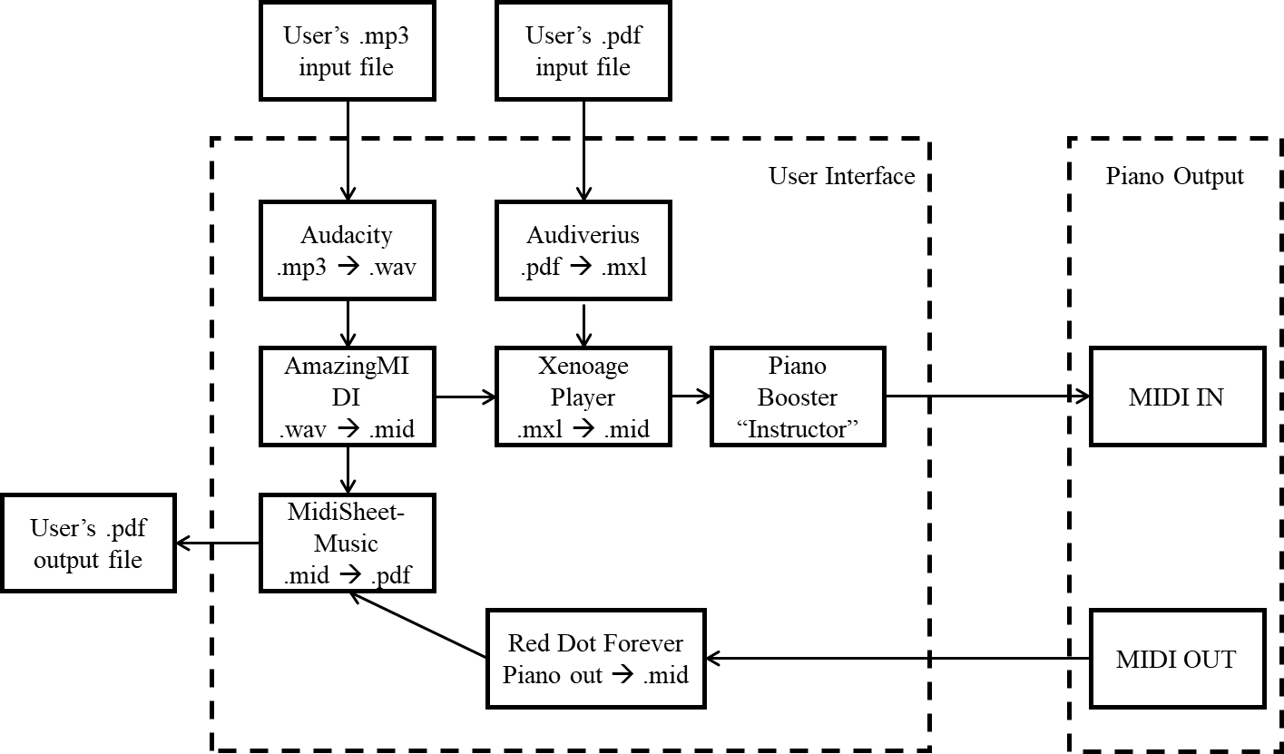

Figure 3.2: UI Flow Diagram of the project.

The tutoring program will be designed by the group, making it functional with the LED strip. Three tutoring modes, with incremental difficulty, will be provided for the user to choose from in the UI. The first tutoring mode, ‘Beginner mode’, will guide the user through note progression by waiting for the user to play the correct note. The second tutoring mode, ‘Intermediate mode’, will be a non-stop tempo-adjustable play along with the piano and LED strip. In the third tutoring mode, ‘Expert mode’, the SKORE will only light an LED(s) if the user incorrectly plays the note(s), this is meant to test the user’s knowledge of the song.

LED Rod

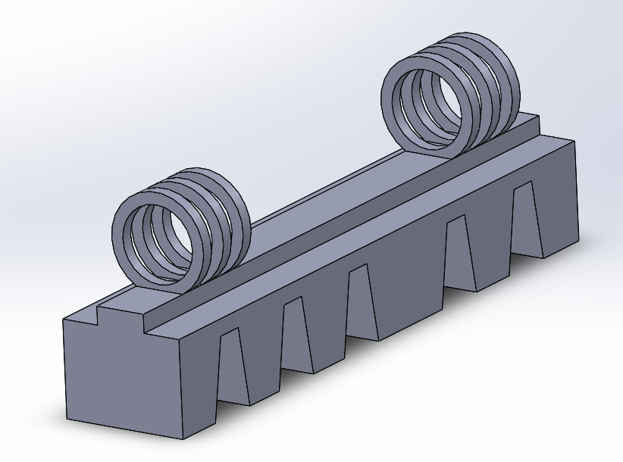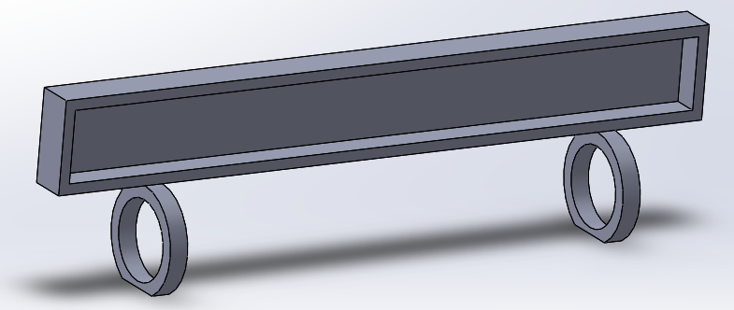

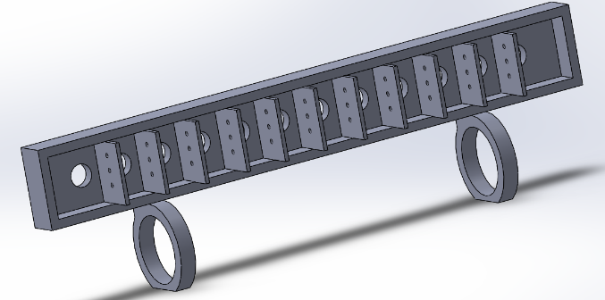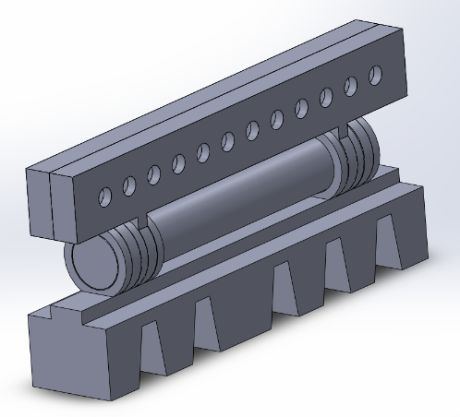

Figure 3.3: 3D concept model of LED rod design. Only one octave of notes displayed. Pictures display all elements in the rod, as well as the rod itself (top left: base, top right: rear, bottom left: front, bottom right: LED rod).

The LED rod will consist of multiple parts (base, front, pole, and rear). Once all parts are connected as shown above, we will link many in series to create the complete LED rod. The base contains teeth that allow it to fit snugly on the piano. A hinge design is utilized to join all elements of the design together. The rear and front have cavities where the LEDs can rest, and walls between each chamber reduce the amount of light radiating into the adjacent LED cubbyhole. Moreover, small holes in the wall allow for necessary wiring between each LED. Holes on the front of the rod allow the light from the LED to illuminate and signal to the user what action was taken place by the system (depending on the selected mode).

Deliverables

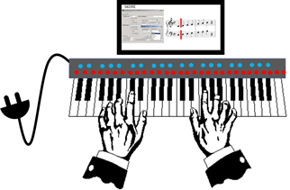

Figure 3.4: Illustration of Completed Project.

By the end of this project, our group will deliver three major co-systems: *software/communication*, *electrical-hardware*, and *mechanical-hardware.*

In the *software/communication* category, we will deliver a Pythonic application that, when installed on a Windows 10 machine of the user’s choosing (tablet or computer), it manipulates the input the user offers from the UI, instructs the Arduino which LEDs to illuminate, and establishes seamless and continuous communications between itself, the Arduino and the piano. In specific, the software installed on the user’s PC will offer a proper user interface that enables simple and quick control of the entire system. The shell script will combine a multitude of programs seamlessly, which will allow smooth back end conversions from one kind of file to the next. Additionally, the backend script will allow the transmission to and reception from the piano of MIDI data.

In the *electrical-hardware* category, we will deliver an Arduino that lights up the correct LED on the strip just prior to when that note in the song is to be played and hold the light until the note is struck (for beginner tutoring mode). Furthermore, a power supply system will be delivered that will provide enough power for each electrical component of the project. This power supply system includes a tablet charging dock that allows simultaneous power to the tablet and the charging of the internal battery, enabling portability and convenience.

In the *mechanical-hardware* category, we will deliver an LED array casing which has the flexibility to fit on standard piano keyboards and a safe housing for the user’s tablet.

Design Specifications

For many, learning any instrument can be challenging and intimidating. With no assistance as to how and what to practice, most users give up and completely stop playing that instrument. SKORE is designed to be the assistant needed to keep the user satisfied and driven. This is done by a system that will keep track of how the user performs during their session, while also teaching them how to play. A scoring system may be applied that will allow the user to see their improvements after each tutoring session is completed.

Testing Procedures

The most significant problem our product is trying to solve is helping a beginner pianist learn a piece of music as effortlessly as possible. Having a machine tell you exactly what keys are to be pressed allows very little mental or physical strain from the user besides following the LED array. The loss of a potentially ill-tempered human tutor will lessen the anxiety the user faces which can prevent the user from becoming adversely conditioned to the piano.

We will measure how long is required for a beginner pianist to increase their skill from zero experience to playing a piece at a recognizable level and see how that fairs against the average beginner pianist learning from a tutor or online. Going directly to what the user wants to do (learning a desired piece of music) and not having any uncomfortable interactions with a piano tutor may very well ensure continuity of the user’s practices.

**CHAPTER IV**

**DIVISION OF RESPONSIBILITY**

To improve the efficiency of our group, we decided to split the responsibilities of the project into systems: Computer, Communication, Power. We also included a shared responsibilities category to ensure that the most complex component of the project is equally contributed by each member.

A screenshot of a social media post

Description generated with very high confidence

Figure 4.1: Responsibility Diagram by Individual and Overall Group.

Eduardo Davalos will create the majority of the software that the user will interact and manage the overall functionality of the computer systems. Zachary Bosker will be responsible for the communications systems between the piano, PC, and Arduino. Ashkan Aminian will manufacture the circuitry that provides power to the user’s tablet, Arduino and LED. Additionally, Mr. Aminian will be designing and constructing the modular LED bar. To ensure that tutoring sessions are not cut short by dead battery, the powering system will allow a simple way to keep the tablet charged (if the user decides to user a tablet). For the group component of the work to be realized, each person must complete their part of the project first. The project’s design and development phase will follow an iterative design process to improve the quality of project.

**CHAPTER V**

**PROJECT SCHEDULE AND BUDGET**

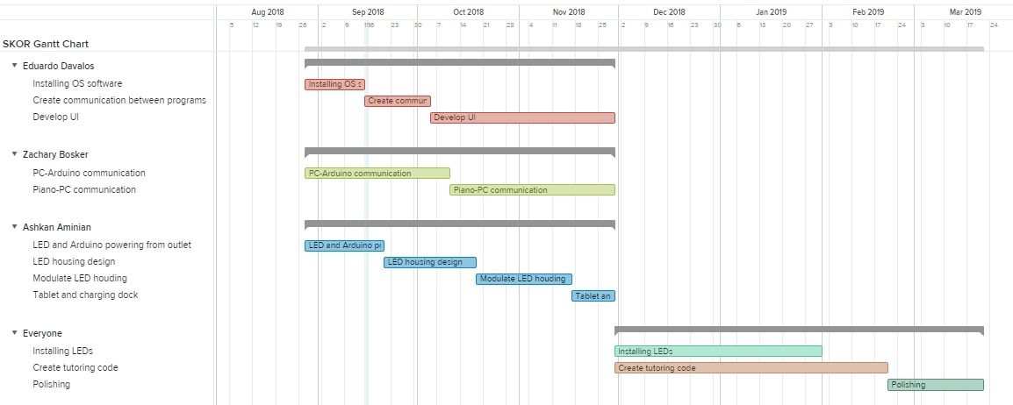

Figure 5.1: Gantt Chart of the Project.

Each member will contribute their own money into this project towards what is felt to be most necessary. In the table below all products that must be purchased will be sorted by value. It is important to note that these items are subject to change as the project advances.

|  |  |  |
| --- | --- | --- |
| **Item** | **Cost** | **Description** |
| BTF-Lighting (LEDs) | $17.88 | Individual addressable RGB LED strip. |
| Arduino Uno Mega | $38.50 | Microcontroller that will be responsible for LEDs and other signals necessary for operation. |
| Windows 10 Tablet | $80 - $150 | Computer that will manage all software. (Optional: user might already have a Windows 10 computer or tablet) |
| Anthem Score | $39.00 | Audio file to Sheet music software. (Optional)  *Note: this software will not be necessary for the SKORE application to function, but it will enhance its .mp3 to .mid file conversion. * |
| Casio WK-500 piano | $150 | Piano that will be used for testing. This will not necessarily be the only model functional with this project. Other piano models will be considered. |
| Total | $56  $95  $325-$395 | The cost if the user already has a windows 10 machine and a piano.  The cost if the user desires Anthem Score’s enhance file conversion.  The cost if the user desires the entire system. |

Table 5.2: The Project’s Budget.

**CHAPTER VI**

**STUDENT’S RESUMES**

**Ashkan A. Aminian**

402 Salado Mist, San Antonio, TX 78258 ♦ (210) 542-7482 ♦ aaminian3@gmail.com

**SUMMARY OF QUALIFICATIONS**  
• Works diligently both independently and within teams.  
• Motivated to succeed and passionate about technological solutions.  
• Programming Languages: C, Motorola Assembly.  
• Application Software: Proficient in MATLAB, SolidWorks 3D/2D CAD, MultiSIM.  
• Microcontrollers: Freescale HCS12.  
  
**EDUCATION**  
**Bachelor of Science in Electrical Engineering Expected: May 2019**  
St. Mary’s University, San Antonio, TX, ABET Accredited  
• GPA: 3.72  
• Relevant Coursework: Electronics, Signals and Systems, Circuit Analysis and Design, Logic Design, Microprocessors, Digital Signal Processing, and Electromagnetic Theory.   
  
**EXPERIENCE  
Lab Assistant  August 2016 to May 2017**• Helped in setting up and taking down lab equipment.  
• Assisted lab instructor in aiding students through the lab.   
**Machine Learning Research Assistant May 2017 to August 2017**  
• Helped assemble deep neural networks codes using Matlab.   
**Peer Lead Group Tutor    January 2017 to Present**• Coached and guided students in solving Physics problems.  
• Helped students to develop knowledge of physics and learn how to apply concepts to different problems.  
**Cashier/Runner        July 2016 to Present**  
• Served as a cashier for the Soccer Factory for San Antonio Football Club equipment.

**Samsung Austin Semiconductors Intern     May 2018 to August 2018**

• Worked in PI 28A-2 department with mostly Samsung created programs to optimize daily monitoring of critical and non-critical ET parameters for 28, 32, and 45nm and CIS products.  
   
**ACCOMPLISHMENTS  
Dean’s List**   
• Highest Honors Fall 2016, Fall 2017  
• High Honors Spring 2016  
• Honors Spring 2017  
  
**LEADERSHIP**  
Member, Institute of Electrical and Electronic Engineers, St. Mary’s University January 2018 to Present

**Zachary J Bosker**

**7612 Linkmeadow, San Antonio, TX 78240♦(210) 779-7725♦**[**Boskerzach@gmail.com**](mailto:Boskerzach@gmail.com)

**SUMMARY OF QUALIFICATIONS**

·       Works diligently both independently and within teams.

·       Motivated to succeed and passionate about technological solutions.

·       *Operating Systems*: Advanced knowledge of Windows, Linux, and Android.

·       *Programming Languages*: C/C++, Python, and Motorola Assembly.

·       *Application Software*: Proficient in MATLAB, SolidWorks 3D/2D CAD, MultiSIM, Microsoft Office Suite.

·       *Microcontrollers:* Arduino, Raspberry Pi, and Freescale HCS12.

**EDUCATION**

**Bachelor of Science in Electrical Engineering                                                                 Expected: May 2019**

*St. Mary’s University, San Antonio, TX, ABET Accredited*

·       **GPA: 3.2**

**EXPERIENCE**

**Computer/Electronic Repair Service                                                                   August 2013 to Present**

*Owner/Technician*

·    Built and coordinated a computer and electronic service that repaired damaged or insufficient software and hardware of Windows based PCs and other electronics, such as mobile devices. Head owner and overseer of operations.

·    Specialized in the removal and prevention of malicious applications (Trojans, spyware, backdoors) gaining insight for discovering and tracking down unwanted processes in a system.

·    Manage clients’ requests and met self-directed deadlines resulting in satisfactory feedback.

**American Red Cross Intern.                                                                                     July 2018 to August 2018**

*Student Engineer*

·    Worked with a team of engineers to originally design a multipurpose water barrel capable of measuring quantity of remaining water and have data uploaded to a private server (powered by solar panel and lithium batteries).

·    Responsible for setting up efficient communication between server and water station using an Arduino and GSM module.

·    Designed a weatherproof base responsible for holding a twenty-foot flag pole, Solar Panel, and all other electronics required for functionality**.**

**Machine Learning Summer Research                                                                               May 2018 to August 2018**

*Student Research*

·    Translated neural network designed to find faulty electronic components originally coded in MATLAB to python environment using NumPy and TensorFlow.

·    Tested Code in Python environment to compare results with MATLAB’s simulated data.

**Personal Tutor                                                                                              August 2015 to April 2018**

*Mathematics*

·       Aided high school students in the learning of various mathematical subjects through lectures and calibrated exercises I created. Subjects included Algebra, Trigonometry and Calculus.

·       Planned a structured study course that increased learning performance and established strong study habits.

·       Grew motivation through encouragement, nurturing a positive and cooperative environment.

·       Taught technical concepts to a non-technical audience.

**Veterans Affair                                                                                        May 2015 to August 2015**

*Engineering Assistant*

·       Responsible for troubleshooting malfunctioning hospital equipment.

·       Worked with team of technicians on projects aimed to aid hospital work.

**Eduardo Davalos Anaya**

1540 Clementson ● San Antonio, TX 78260 ● (210) 412-5589 ● davalosaeduardo@gmail.com

**SUMMARY OF SKILLS**

·        *Programming Languages:* Intermediate experience with C, Python and Assembly.

·        *Design Programs:* Intermediate experience with SolidWorks and MultiSIM; Beginner skills with Matlab.

·        *Languages:* English and Spanish (Written and Verbal).

**EDUCATION**

**Bachelor of Science in Electrical Engineering and Bachelor of Arts in Physics           Expected: May 2020**

*St. Mary’s University – San Antonio, TX*

·        Cumulative GPA 3.91; Electrical Engineering Major: 3.9; Physics Major: 4.00

·        Scholarships*:* Honor’s Program (August 2016 – May 2020) , Presidential Scholarship (August 2015 – May 2020), Dr. Ozan Scholarship (August 2016 – December 2016)     

**RELEVANT PROJECTS**

**Quantum Dot (QD) Matrices Research                                                        June 2016 - December 2017**

*St. Mary’s University, San Antonio, TX*

·        Researched, performed, and examined the production of QD matrices on a surface to gradually develop solar cells.

·        Investigated the chemistry of QDs and the fabrication processes of QD matrices.

**WORK EXPERIENCE**

**Semiconductor REU at Dayton University                                                                          2018 Summer**

*Dept. of Physics and Optoelectronics of University of Dayton, in Dayton, OH*

·        Investigated the photolithographic fabrication process of laser waveguides.

·        Conducted metrology inspections on the fabricated semiconductors with SEM.

**Summer Robotics Teaching Assistant                                                                       May 2016 – July 2016**

*St. Mary’s Robotics Summer Camp, San Antonio, TX*

·        Taught 80+ middle and high school students throughout the summer the core principles of robotics and the connection between hardware and software.

·        Mentored students during the development of their own robots and introduced them to the field of robotics and engineering.

**LEADERSHIP EXPERIENCE**

**Robotics Team for IEEE Robotics Competition                                              September 2015 – April 2017**

*2016 R5 Conference in Kansas City, MI*

·        Organized, motivated, and worked with two teammates to create an autonomous robot that collected and transported color designated objects back to their color coordinated locations within time restriction.

·        Competed on April 7, 2016 in Kansas City, Missouri and won third place overall.

*2017 R5 Conference in Denver, CO*

·        Designed, built, machined, and assembled the drive train, circuits, and implemented the electronics for the upcoming robotics competition this 2017.

·        Programmed software in both python and Arduino platforms for the robots’ communication systems between an Arduino and a Raspberry Pi.

·        Competed on April 1, 2017 in Denver, Colorado and placed 8th place.

**REFERENCES**

[1] Cremaschi, Alejandro, Students who quit music lessons: recent research and recommendations for teachers, MTNA e-Journal, MTNA, Colorado, February 2015.

[2] Groves, Olivia, 15 Benefits of Learning Piano (Backed by Science), Lindeblad Piano Restoration, Pine Brook, New Jersey, Feb 21, 2018.