Security Project Demo Explanation
First off, make sure both the Attacker (Kali VM) and the Victim (Metasploitable VM) are in a NAT network.
Then, list the IP address for both the Attacker and Victim:
Victim IP
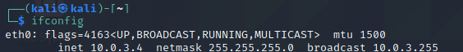
Attacker IP

Then, scan the Victim’s IP for open ports, mainly we are looking for the NSF protocol:

-A is for an aggressive scan to find the OS and other details
Here are the results of the scan:
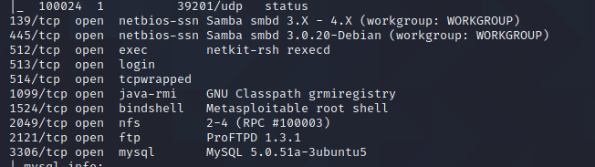
We locate NFS as the weakly configured NFS share (Metasploitable) and then escalating privileges via a local exploit.

Then, we list the exported or shared directories on the remote host (victim) via NFS:
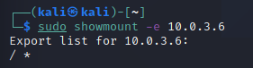
This indicates that / directory is accessible to any host and the /home directory can also be modified by mounting it remotely

Then, we mount the /home directory into our device in the /tmp directory:
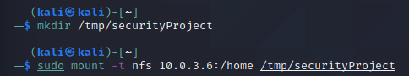

Here, we can list the contents of the /home directory of the victim in our Kali machine:
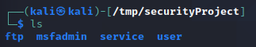

Next, we need to add our own public key to the victim’s authorized_keys so that we can SSH as msfadmin without knowing the user’s real password, so first we create our own SSH key pair on Kali:
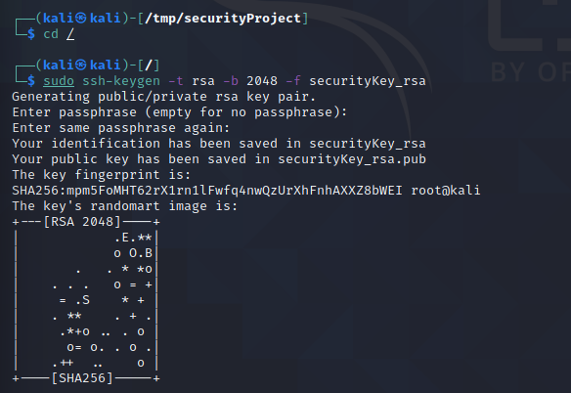
Then we append the public key to the authorized_keys in msfadmin:
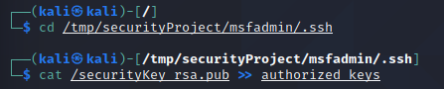

After appending the public key, now we can attempt to SSH using our private key:
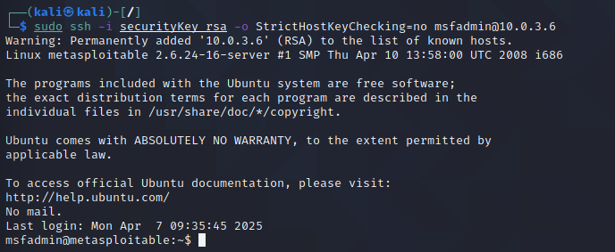

Here, we have access to msfadmin (non-root), so we need to escalate privileges to become the root. Metasploitable is intentionally vulnerable, so we’ll exploit a know udev vulnerability.
So we need to download the exploit on Kali:
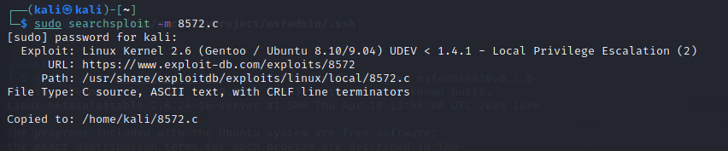

Then we prepare the web server and reverse shell script:
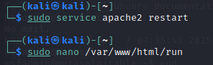
Inside nano, write this, then ctrl +o, enter, then ctrl+x:

The purpose of this bash script is to use nc (netcat) to connect back to our Kali machine on port 1234 and ttaches /bin/bash to that connection, giving remote root shell if the exploit is successful
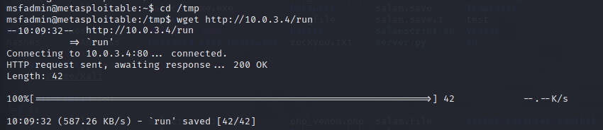
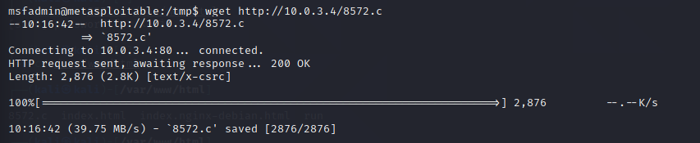
Make sure the 8572.c is in the /var/www/html directory

Then we get the udevd PID, which is non zero:
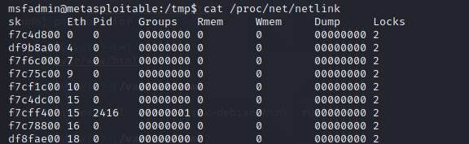

Then, on Kali, setup a listener:

Then execute the exploit on the other terminal (msfadmin):

Now we have root privileges on the other terminal

