

DEPARTMENT OF ARABIC AND TRANSLATION STUDIES

The representation of the Islamic prayer between the Quran and Hadith Final Project Report
Introduction to Arabic digital humanities ARA 250- Spring 2023
Name : Kareem Mahmoud – b00097349
Instructor : Dr.May Zaki

Introduction:
This project analyzes both the Holy Quran and the book Sahih Al-Albani, which serve as the primary datasets for this study. Provided by the instructor, these texts were utilized to explore the representation of Islamic prayer "الصلاة" within them. The primary research questions guiding this study are: How is "الصلاة" represented in the Holy Quran? And how is it represented in the Hadith?
To address these questions, a combination of textual analysis, which is focused on analyzing the frequency and occurrences of the word and its variations. As well as contextual analysis, which is focused on analyzing the context of each occurrence of the words and the collocations. The analysis employed digital tools such as Ayat, AntConc, Excel, and Quran.com. Ayat and Quran.com provided access to both the textual and contextual elements of the analysis. AntConc facilitated the textual analysis by identifying patterns and frequencies of terms related to prayer in all its variations and forms. Excel was used for data organization, graphing, plotting, and further analysis.
The significance of this research lies in its innovative use of digital tools to enhance the understanding of Islam's two primary sources of legislation. By systematically analyzing how prayer is portrayed in both the Quran and Hadith, this study aims to contribute to the digital humanities by demonstrating the value of technology in religious and textual studies. The findings from this project offer insights into the centrality of prayer in Islam, highlighting its unique representation, textual patterns, and various meanings compared to other pillars of Islam.
Ultimately, this research serves as a starting point for international digital humanities projects and broader projects that could benefit the Islamic world. It seeks to deepen the knowledge of Muslim communities about the importance of prayer and how its significance is uniquely reflected in the Quran and Hadith.

Dataset Description:
Two main datasets were used in this analysis:
1-The Quran: This central religious text is believed by Muslims to be the literal word of God (Allah), revealed to the Prophet Muhammad by the archangel Gabriel. Written in classical Arabic, it consists of 114 chapters (surahs) covering theology, law, morality, and guidance. The Quran is the ultimate authority in Islam, shaping beliefs and practices. The corpus used in this analysis was provided by the instructor in a text format (.txt), containing 77,880 words with a size of 763 Kb. Each verse (ayah) is formatted on a single line with no additional characters except the surah and ayah number, separated by vertical lines. No OCR process was conducted on this dataset since it was already devoid of diacritics, extra characters, and punctuation marks. It was sampled, cleaned, and prepared for analysis (Britannica, 2024).

2-Hadith (Sahih Al-Albani): Referring to compilations of authenticated hadiths by Muhammad Nasiruddin al-Albani, this collection provides the sayings and actions of the Prophet Muhammad. Sahih Al-Albani is not a single work but rather a collection of hadith compilations authenticated by the Albanian Islamic scholar Muhammad Nasiruddin al-Albani (Salafism in Jordan, 2016). The corpus used in this analysis was also provided by the instructor in a text format (.txt), containing 69,178 words with a size of 611 Kb. Each hadith is formatted on a single line with no additional characters or strings. No OCR process was conducted on this dataset as it had already been preprocessed to remove diacritics, extra characters, and punctuation marks.

Several limitations were imposed on this analysis to streamline the process and enhance efficiency. For instance, certain words such as “ركوع” and “سجود” were excluded from the analysis of the Quran dataset, and words such as “صلى الله عليه وسلم” were excluded from the analysis of the hadith corpus. The complexity of the Arabic language and the large word count for both datasets presented challenges in the analysis process, such as dealing with words containing multiple meanings and finding reliable online sources to distinguish between Makki and Madani surahs. Which was later overcome by finding the “Quran.com” website.
Furthermore, the careful curation of the datasets not only facilitated efficient analysis but also minimized potential biases, enhancing the credibility and validity of the research outcomes. This methodical approach underscores the importance of rigorous data preparation in ensuring the integrity of scholarly investigations in the field of digital humanities.

Methodology:
There are 4 main tools used in this project :
AntConc is a versatile corpus analysis tool designed to assist researchers in analyzing and exploring large bodies of text, known as corpora. It offers a wide range of functionalities, including concordance, word frequency analysis, keyword analysis, and collocation analysis. With its user-friendly interface and powerful features, it enables users to gain valuable insights into linguistic patterns, trends, and relationships within their textual data. Whether used for language teaching, literary analysis, or linguistic research. Due to these powerful textual features, this app was mainly used for textual analysis and frequency counting in this project. However, this tool was only used for the Quran corps and not the Hadith since it only analyses the Quran and not the Hadith.

Ayat.apk is a mobile application designed to facilitate the study and understanding of the Quran on Android devices. It offers a comprehensive set of features, including access to the full text of the Quran in multiple translations and recitations, search capabilities, bookmarking, and verse-by-verse audio playback. Additionally, it provides users with tools for studying and analyzing the Quran, such as word-by-word translations, tafsir (exegesis), and thematic categorization of verses. With its user-friendly interface and extensive functionality. The features of tafsir (tafsir al-Saadi) and the contextual description provided by this app were the main sources of the contextual analysis in this project. However, this tool was only used for the Quran corps and not the Hadith since it only analyzes the Quran and not the Hadith.

An Excel sheet, or spreadsheet, is a digital document created using Microsoft Excel or similar software. It consists of rows and columns where users can input, organize, and analyze data. Excel sheets offer a wide range of functionalities, including mathematical calculations, data visualization through charts and graphs, sorting and filtering capabilities, and collaboration features. They are commonly used for various purposes such as budgeting, financial analysis, project management, data tracking, and reporting. This app was mainly used for data collection and visualizations.

Quran.com is a comprehensive online platform providing access to the Quran in multiple languages and translations. It offers a user-friendly interface that allows users to read, listen to, and study the Quran with ease. Quran.com features various translations and interpretations of the Quran, along with audio recitations by renowned reciters. Additionally, it provides tools for searching, bookmarking, and sharing specific verses or chapters. The platform also includes supplementary resources such as tafsir (exegesis), hadith collections, and educational articles to aid in understanding the Quranic text. The main feature of this website was distinguishing between Makki and Madani surahs, which was used for the comparison in the Quranic corpse.

The approach used for this analysis was divided into the following steps :
- Gathering the keywords and variations used for the analysis.
2-Grouping the keywords into larger groups that contain different variations.
3- Using the tools to analyze the frequency of each group and comparing it with Makki and Madani surahs.
4- Finalizing the Quran data and comparing it with the data gathered from Hadith and finding the similarities and differences between the Quran and hadith. As well as interpreting the data
5- Concluding a few facts about both the Holy Quran and Hadith based on the analysis done. As well as generating charts and visualizations.
The used approach Step-by-step :
First of all, before analyzing the data, collecting the keywords was mandatory to start the analysis process for both the Quran and hadith corps. Starting by trying all the variations of the words “الصلاة” using the star operator on AntConc and the keywords section that gives all the forms that have similar characters to the input words. With a total of 23 variations.
*figure(1): shows the process of getting all the variations and forms of the word using the Keyword feature.
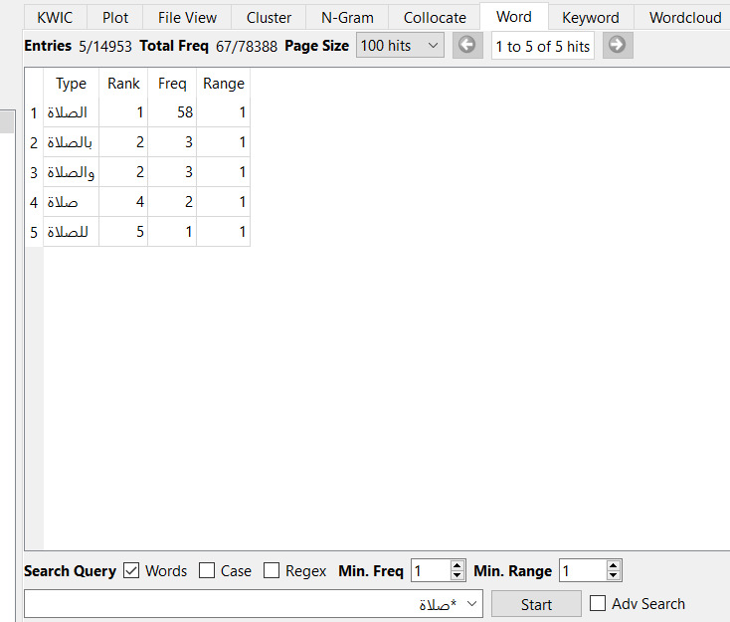
Secondly, the huge number of variations and forms of the same word was one of the challenges that interrupted the process. Grouping was the best method to narrow down the complexity of searching for the frequency of each word. And it was the easiest way to overcome to problem of variations in diversity. 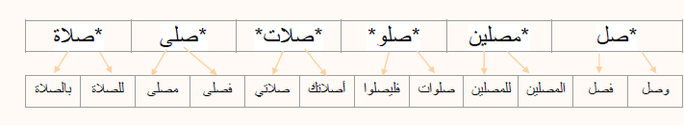*figure(2): it shows the groups that were used as keywords for searching and analyzing, using the star operator to ease the process, there are also examples of each group with the words it contains.
Furthermore, the process of the textual and contextual analysis (including collocations) started by using the groups as keywords and distinguishing between Makki and Madani surahs in the Quran Corps, while in the Hadith Corps, the same groups of keywords were used too, this step was done using the two tools: Ayat.apk and Quran.com
Moreover, after finalizing the data gathered from both types of analysis, the comparison process started by finding the similarities and differences of both sides and interpreting the data.
Lastly, the facts about the two datasets are based on analyzed data and the comparison process. As well as Generating charts and visualizations using Excel.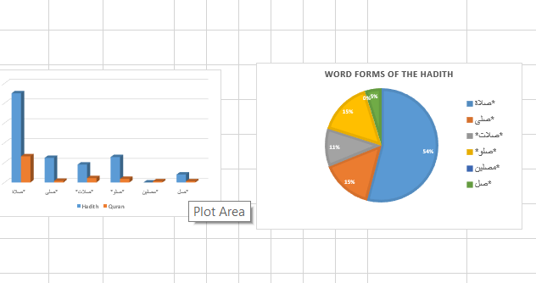
*figure(3): shows how the visualizations are done using the Excell sheet.
Results and Interpretation:
1-Textual Analysis :
Through the analysis of both the Holy Quran and the book of Sahih Al-Albani, several key findings emerged regarding the representation of Islamic prayer "الصلاة."
In the Quran, textual analysis revealed that the word "الصلاة" appears prominently across various chapters and contexts. The frequency analysis indicated that it is frequently mentioned in the Quran, mainly in Madani surah underscoring its significance in Islamic teachings.
The keyword: | Frequency : | Madani | Maki | Hadith
*صلاة | 66 | 43 | 23 | 225
*صلى | 4 | 1 | 3 | 62
*صلات* | 11 | 3 | 8 | 45
*صلو* | 9 | 7 | 2 | 64
*مصلين | 3 | 0 | 3 | 0
*صل | 3 | 2 | 1 | 20
Total Freq | 96 | 56 | 40 | 416
*Table(1): it shows the frequency of each group of keywords aligned with the hadith as well.

It is clearly shown that the majority of the occurrences of the word and its variations are mostly in Madani surah, mostly in the form of “صلاة*” in both the Quran and Hadith As well as it is obvious that the frequency of the same keywords in hadith is huge compared to the Holy Quran. There is an interesting result that must be mentioned which is the fact that there are no occurrences in any Madani surah nor the hadith of the form “مصلين*”.

*Chart(1): shows the percentage of each keyword based on the frequency in the Quran corps
The form “*صلاة”, which contains words such as “صلاة” and “الصلاة”, was the most frequent in the Quran with a burden of 69% of the total occurrences. The least forms of occurrences are the forms “*صلات*” and “*مصلين” with a burden of 3% each.

The form “*صلاة”, which contains words such as “صلاة” and “الصلاة”, was the most frequent in the Hadith too with a burden of 54% which is surprisingly less than the percentage in the Quran corpse. However, this is due to the low frequency and large word count of the Quran Corpse compared to Hadith. The last form of occurrences is the form “*مصلين” with a burden of 0%.
*Chart(2) : shows the percentage of each keyword based on the frequency in the Hadith corps

*Chart(3) : shows the Maki to madani ratio of the Frequency of the keywords in the Quran.

The word "الصلاة" was mentioned more frequently in Madani surahs compared to Makki surahs, to interpret this fact, I had to analyze and understand the meanings of Maki and Madani surah.

Makki surahs are those chapters revealed to the Prophet Muhammad before he migrates to Medina, whereas Madani surahs are revealed after he migrates to Medina. The context of revelation often influences the themes and subject matter of the surahs. Makki surahs typically focus more on theological concepts, belief in one God, prophethood, and moral teachings, while Madani surahs often address legal and social matters, including the establishment of a Muslim community and governance.

Given the emphasis on community and governance in Madani surahs, it is likely that the word "الصلاة" would be mentioned more frequently in this context. Prayer (salah) is not only a spiritual act of worship but also a communal and social practice in Islam. In Madani surahs, there may be more references to the establishment of prayer as a communal obligation, the regulations surrounding prayer, and its role in the life of the Muslim community.

Conversely, in Makki surahs, where the focus is primarily on foundational beliefs and spiritual guidance, the mention of specific rituals and practices like prayer may be comparatively fewer. The emphasis in Makki surahs may be more on building faith, moral principles, and the relationship between individuals and God.

2- Contextual Analysis:
In the contextual analysis, the collocations and the meanings of the keywords were analyzed using the tools AntConc and Ayat.com (for the Quran corps). However, in the collocations analysis only the word “الصلاة” was used and not any other form or group to ease the process of the analysis.
Collocate | Rank | FreqLR | FreqR | FreqL
وآتوا | 1 | 12 | 0 | 12
وأقيموا | 2 | 8 | 8 | 0
وأقاموا | 2 | 8 | 8 | 0
يقيمون | 4 | 4 | 4 | 0
ويؤتون | 4 | 4 | 0 | 4
فأقيموا | 6 | 3 | 3 | 0
وأقم | 6 | 3 | 3 | 0
*Table (2): this table shows the most frequent collocations of the word “الصلاة” in the Quran with a range of 1 word from left and right.
Collocate | Rank | FreqLR | FreqR | FreqL
في | 1 | 24 | 22 | 2
إلى | 2 | 9 | 9 | 0
وإيتاء | 3 | 3 | 0 | 3
وإقام | 4 | 2 | 2 | 0
ويؤخرون | 4 | 2 | 2 | 0
وأقام | 4 | 2 | 2 | 0
أقيمت | 4 | 2 | 2 | 0
*Table (3): this table shows the most frequent collocations of the word “الصلاة” in the Hadith with a range of 1 word from left and right.
However, there are nine different meanings for the same word mentioned in the Quran, while in the Hadith the word “الصلاة” mainly refers to all types of Islamic prayer.
- The prayer | (وَيُقِيمُونَ الصَّلَاةَ)
2. Prayer for | (وَصَلِّ عَلَيهِم إِنَّ صَلاتَكَ سَكَنٌ لَهُم)
3. Asking for forgiveness | (وَصَلَواتِ الرَّسولِ)
4. Forgiveness | (إِنَّ اللَّـهَ وَمَلَائِكَتَهُ يُصَلُّونَ عَلَى النَّبِيِّ)
5. Mercy | (أُولَـٰئِكَ عَلَيْهِمْ صَلَوَاتٌ مِّن رَّبِّهِمْ وَرَحْمَةٌ)
6. The houses of worship | (وَلَوْلَا دَفْعُ اللَّـهِ النَّاسَ بَعْضَهُم بِبَعْضٍ لَّهُدِّمَتْ صَوَامِعُ وَبِيَعٌ وَصَلَوَاتٌ وَمَسَاجِدُ يُذْكَرُ فِيهَا اسْمُ اللَّـهِ)
7. Islam | (فَلَا صَدَّقَ وَلَا صَلَّى)
8. Religion | (أَصَلاتُكَ تَأمُرُكَ)
9. Recitation | (وَلا تَجهَر بِصَلاتِكَ)
*Table (4): this table shows the nine different meanings that the word “الصلاة” was referring to and an example.
3- Interpretations:
- The Quran:
- The word “الصلاة” with all its variations is mostly mentioned in Madani surah which indicates that after the prayer was revealed to the prophet Mohammed, it was a reminder for believers to pray.
- The prayer was mentioned less in the Quran since it was mainly a reminder but in hadith, it had more details.
- “الصلاة” was mostly linked with “الزكاة” in the Quran which shows the importance of both of them as they are the second and third pillars of Islam.

- The Hadith:
- The word “الصلاة” with all its variations are mentioned with a very high frequency compared to word count difference, mainly because the hadith dives deep into things that were not mentioned in the Quran such as the timings, steps, types of the prayer.
- “الصلاة” has only one meaning mostly in the hadith which refers to the Islamic prayers ( any type of prayer not just the 5 prayers). Excepts for the “صلى الله عليه وسلم” which is excluded from the research.
- “الصلاة” was linked with “الزكاة” too but mostly with the word “في” which shows how the hadith is focusing more on things inside the prayer which may not be mentioned in the Quran.

The analysis boasts several strengths, including systematic approaches, accurate data grouping, and the precise handling of pre-processed datasets, ensuring reliability and depth in uncovering patterns of "الصلاة" across texts. However, limitations exist, such as the lack of contextual analysis that may overlook the nuanced meanings of "الصلاة." The exclusion of related terms like “ركوع” (ruku') and “سجود” (sujud) limits comprehensiveness. Additionally, reliance on digital tools introduces potential biases and may not fully capture the socio-historical context, leading to an oversimplified interpretation of complex theological concepts.

Conclusion:
Summary of Key Findings:
This analysis examined the representation of "الصلاة" (prayer) in the Holy Quran and Sahih Al-Albani using digital tools such as Ayat, AntConc, Excel, and Quran.com. Key findings revealed that "الصلاة" appears frequently in both texts, underscoring its centrality in Islamic practice and theology. The word was mentioned more often in Madani surahs compared to Makki surahs, reflecting the shift towards community-focused practices post-migration to Medina. In Sahih Al-Albani, prayer-related hadiths provided detailed guidance on the rituals and significance of prayer, illustrating its practical importance in daily Muslim life. These insights highlight the multifaceted nature of "الصلاة" and its integral role in Islamic teachings.

Implications for Future Research:
The findings of this project open avenues for future research in several ways. Further studies could extend the analysis to include additional variations and related terms such as “ركوع” (ruku') and “سجود” (sujud) to provide a more comprehensive understanding of prayer in Islamic texts. Additionally, incorporating qualitative methods, such as historical contextualization and expert consultations, could enrich the analysis by capturing the socio-historical nuances that digital tools may overlook. Refinements in digital humanities methodologies could also address potential biases inherent in algorithm-based analysis, ensuring a more balanced and accurate interpretation of textual data.

Broader Impact on the Field:
This project contributes significantly to the field of Arabic digital humanities by demonstrating the value of integrating digital tools for textual analysis in religious studies. By systematically analyzing the representation of "الصلاة" in primary Islamic texts, the research provides a model for future studies on other key concepts in the Quran and Hadith. The use of digital tools in this context facilitates a more efficient and thorough exploration of large textual corpora, offering new insights and fostering a deeper understanding of Islamic teachings.

Furthermore, the project's findings can benefit educators, researchers, and practitioners in the Islamic world by enhancing their knowledge of the theological and practical aspects of prayer. It underscores the potential of digital humanities to bridge traditional scholarship and modern technology, making religious texts more accessible and comprehensible to a broader audience. Ultimately, this work lays the groundwork for a more extensive exploration of Islamic texts, promoting a nuanced appreciation of their complexity and depth in the digital age.

References

Qur’an | Description, Meaning, History, & Facts | Britannica. (2024). In Encyclopædia Britannica. https://www.britannica.com/topic/Quran

Salafism in Jordan. (2016). Google Books. https://books.google.ae/books?id=L13WDAAAQBAJ&redir_esc=y

