CSRF Token Task 1

1. Task Description

Built a Django view and form that allows saving data to the database without using CSRF token.
Key Requirements:
- Create a form to add a student with fields: name, dept, city.
- Save the submitted data to the database.
- Do not include {% csrf_token %} in the form.
- Handle POST requests successfully using Django.
Note: Disabling CSRF is generally unsafe for public-facing forms and should only be used in controlled environments or testing.

2. Task Output Screenshot
Screenshot Description:
- Form Page:
  - Input fields for Name, Department, and City.
  - Submit button to save the data.
- After Submission:
  - Redirected to the student list page or success page.
  - New student entry successfully stored in the database.
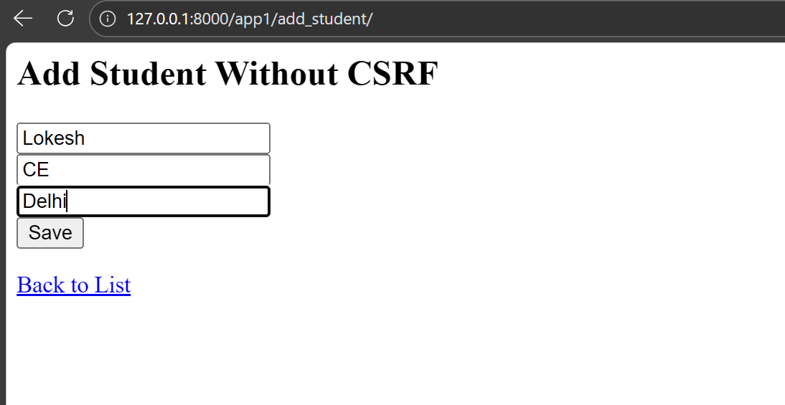
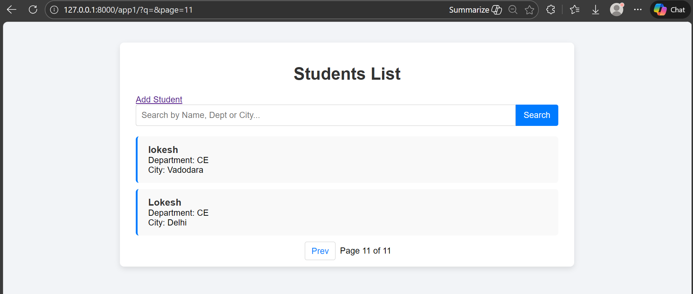

3. Widgets / Algorithms / Concepts Used

• Django View with @csrf_exempt
- Disables CSRF verification for a specific view:
from django.views.decorators.csrf import csrf_exempt

@csrf_exempt
def add_student_no_csrf(request):
if request.method == "POST":
name = request.POST.get("name")
dept = request.POST.get("dept")
city = request.POST.get("city")
Student.objects.create(name=name, dept=dept, city=city)
return redirect('student_list')
return render(request, "add_student.html")

• HTML Form Without CSRF Token
- Form fields for student data:
<form method="POST">
<input type="text" name="name" placeholder="Name" required><br>
<input type="text" name="dept" placeholder="Department" required><br>
<input type="text" name="city" placeholder="City" required><br>
<button type="submit">Save</button>
</form>
- No {% csrf_token %} used.

• Database Save
- Data submitted via POST is saved using Django ORM:
Student.objects.create(name=name, dept=dept, city=city)

4. URL Configuration
from django.urls import path
from .views import add_student_no_csrf

urlpatterns = [
path("add-no-csrf/", add_student_no_csrf, name="add_student_no_csrf"),
]

