ORM Query Task_5
1. Task Description
Build a Django web page that allows:
- Fetching Student objects with even IDs using Django ORM.
- Displaying student details in a list or form.
- Allowing editing only for students with even IDs.
- Showing an error message or preventing editing if the student has an odd ID.
Key Requirements:
- Use ORM query to filter even IDs.
- Conditional rendering for editing in the template.
- Proper messages for invalid edit attempts.

2. Task Output Screenshot

Screenshot Description:
- List Page:
  - Shows students’ name, department, and city.
  - For even ID students, “Edit” button/link is available.
  - For odd ID students, “Cannot Edit” is displayed in red.

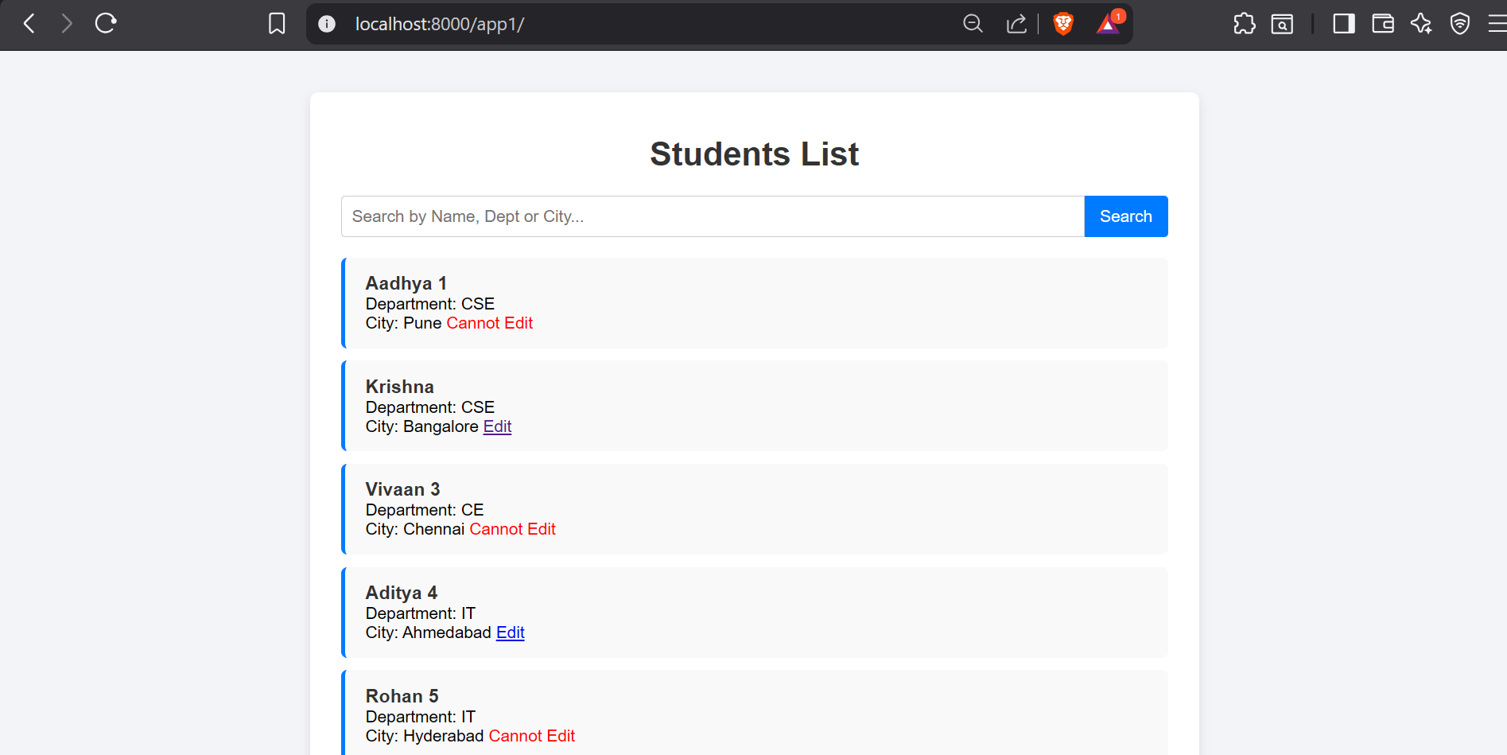
- Edit Page (Even ID Student):
  - Form pre-filled with student details.
  - Allows editing and saving changes.
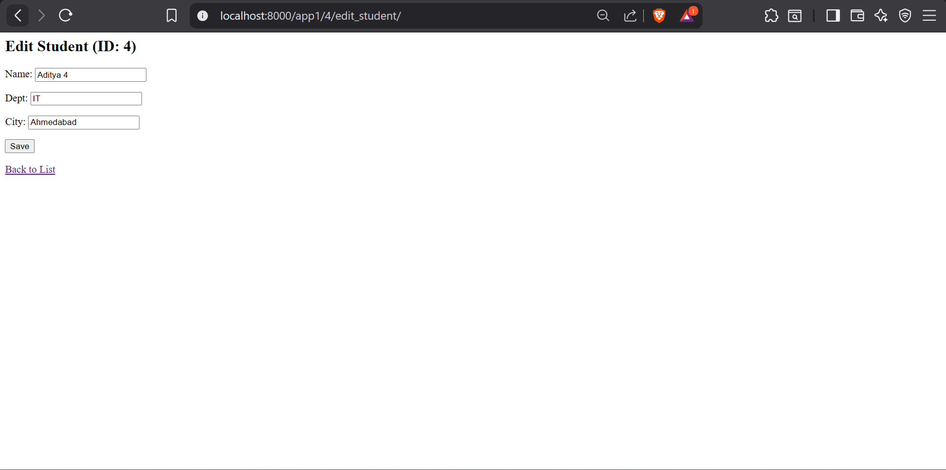

3. Widgets / Algorithms / Concepts Used

• Django ORM Query for Even IDs
even_students = Student.objects.filter(id__mod=(2, 0))
- id__mod=(2, 0) selects only rows where id % 2 == 0.

• Django ModelForm
Used to render a form for student objects:
class StudentForm(forms.ModelForm):
class Meta:
model = Student
fields = ['name', 'dept', 'city']

• Conditional Editing in Views
- Check ID before allowing edit:
if student.id % 2 != 0:
messages.error(request, "You can only edit students with even ID!")
return redirect('student_list')

• Template Conditional Rendering
- Edit link only shown for even IDs:
{% if std.id|divisibleby:2 %}
<a href="{% url 'edit_student' std.id %}">Edit</a>
{% else %}
<span style="color: red;">Cannot Edit</span>
{% endif %}
- |divisibleby:2 → Django template filter for even numbers.

• Django Messages Framework
- Displays success or error messages when editing or invalid access occurs.
from django.contrib import messages
messages.error(request, "You can only edit students with even ID!")

4. Code Snippets

View (views.py):
def edit_student(request, student_id):
student = get_object_or_404(Student, id=student_id)
if student.id % 2 != 0:
messages.error(request, "You can only edit students with even ID!")
return redirect('student_list')

if request.method == "POST":
form = StudentForm(request.POST, instance=student)
if form.is_valid():
form.save()
messages.success(request, "Student updated successfully!")
return redirect('student_list')
else:
form = StudentForm(instance=student)

return render(request, "edit_student.html", {"form": form, "student": student})

