Project: Assignment 4.2
Course: CSD 380 DevOps
Description: Sample test cases for Todo site (Daniel Preller)
Date: 2026/01/14
To complete the test case plan, fill out the information for Project, Course, Description and Date in the header below.

TABLE OF CONTENTS
Create a new todo task item 2
Delete a todo task item 2
For invalid URLs, provide users with a custom 404 error page 3
Prevent users from submitting a task form with without entering a todo item 3
Prevent users from submitting the edit form without entering a todo item 4

For each test, the developer should: provide a test description, a test objective, the developer name and date tested. For each step, fill out the actions to be taken and describe the expected results, and indicate yes or no for each step depending upon the result. The peer tester should provide their name, date tested, indicate yes or no for each step depending upon the result, and a screenshot (thumbnail) of the result.

Test 1 | Create a new todo task item
 | Test Objective: Verifies ability to add tasks | Developer: Daniel Preller  Date tested: 2026/01/14 | Peer tester: Hugo Ramirez  Date tested: 2026/01/18
Step | Action | Expected results: | Developer pass/fail | Tester pass/fail  + Screenshot
1 | Visit https://buwebdev.github.io/todo/ | Page will load without errors | Yes | Yes  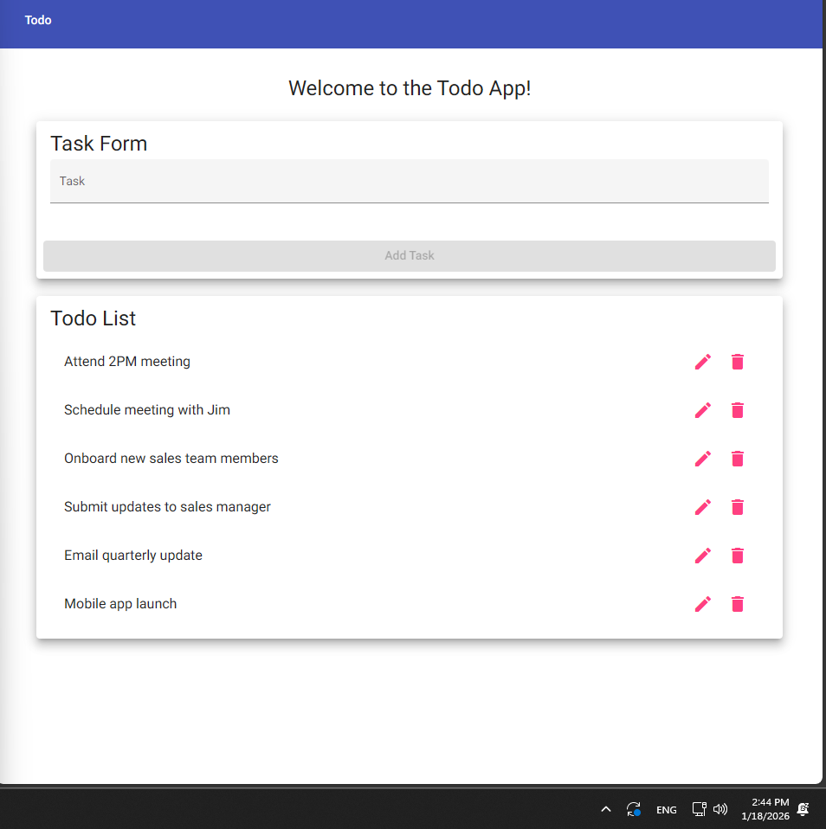
2 | Enter an item in the task form | Text will appear in the form | Yes | Yes  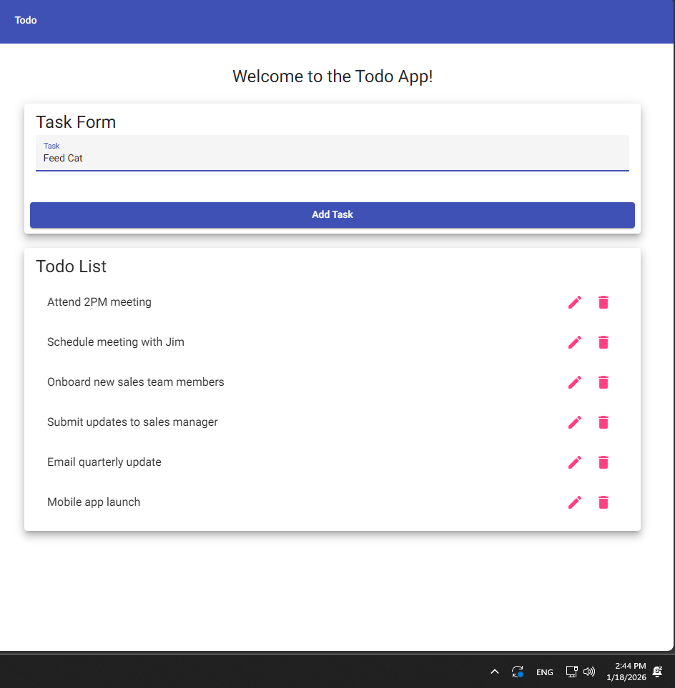
3 | Click the “Add Task” button | Task form will be cleared | Yes | Yes  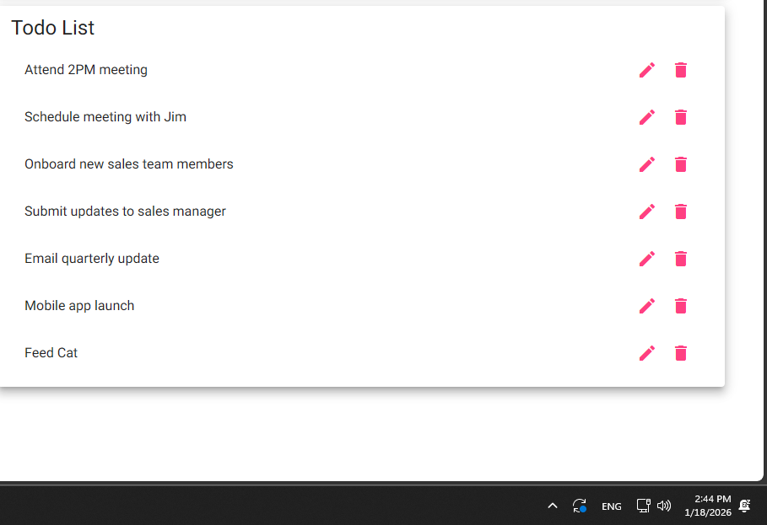
4 | Confirm new task appears in the list | Task will appear in the task list | Yes | Yes  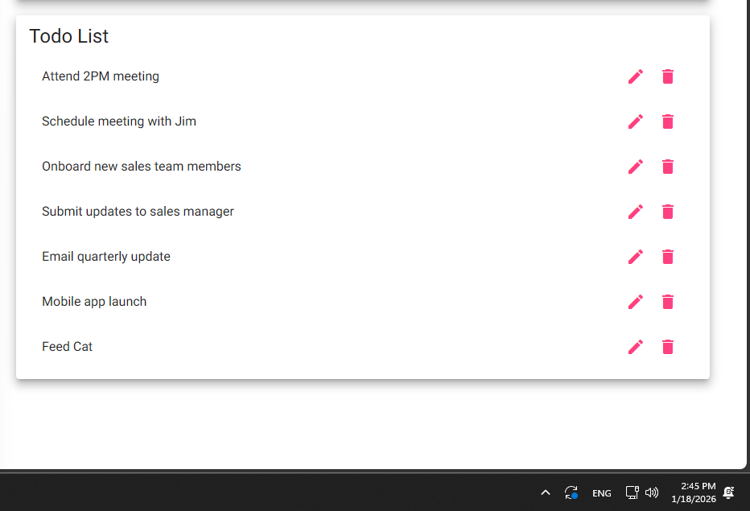
Comments | The Test is specific and simple, which leads to clear actions and results for each step. This helps keep a tester from misinterpreting the instructions leading to incorrect testing. The only issue is that steps 3 and 4 could have been combined into one step.

Test 2 | Delete a todo task item
 | Test Objective: Verifies ability to delete tasks | Developer: Daniel Preller  Date tested: 2026/01/14 | Peer tester: Hugo Ramirez  Date tested: 2026/01/18
Step | Action | Expected results: | Developer pass/fail | Tester pass/fail
1 | Visit https://buwebdev.github.io/todo/ | Page will load without errors | Yes | Yes
2 | Click a delete button (trashcan icon) | Task will be deleted | Yes | Yes
3 | Confirm matching task is deleted | Task will be removed from list | Yes | Yes
Comments | I personally think that having the Todo App link as step 1 is redundant after Test 1 because the tester should still be on the Todo App website. I like that you specified that the delete button is a trashcan icon.

Test 3 | For invalid URLs, provide users with a custom 404 error page
 | Test Objective: Verifies invalid URLs are properly handled | Developer: Daniel Preller  Date tested: 2026/01/14 | Peer tester:  Date tested: <yyyy/mm/dd>
Step | Action | Expected results: | Developer pass/fail | Tester pass/fail
1 | Enter buwebdev.github.io/todo/ with text appended in browser and press enter | Error page displays | Yes | Yes  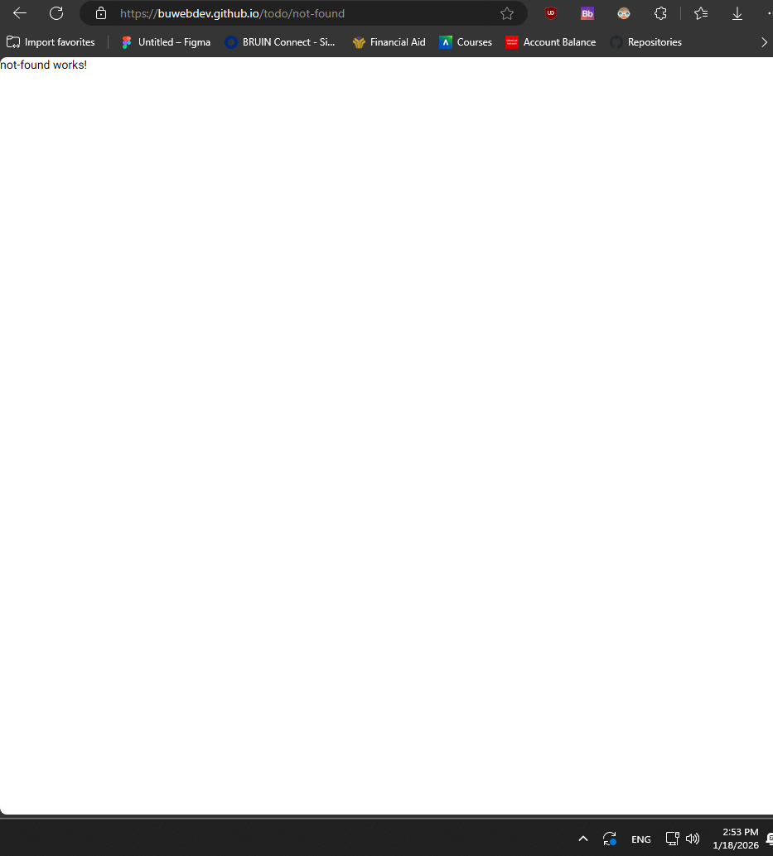
2 | Confirm 404 page displays | Custom, readable 404 page displays | No | Yes
3 | Confirm URL changes to https://buwebdev.github.io/todo/not-found | URL changes to not found URL | Yes | Yes
Comments | Step 1 should have been more specific as to where the tester should append that extra text. Step 1 should have said to append the extra text after the last forward slash because if the appended text is anywhere expect after the forward slash it will not take the tester to the not-found page.

Test 4 | Prevent users from submitting a task form with without entering a todo item
 | Test Objective: Verifies that a task name is required | Developer: Daniel Preller  Date tested: 2026/01/14 | Peer tester: Hugo Ramirez  Date tested: 2026/01/18
Step | Action | Expected results: | Developer pass/fail | Tester pass/fail
1 | Visit https://buwebdev.github.io/todo/ | Page will load without errors | Yes | Yes  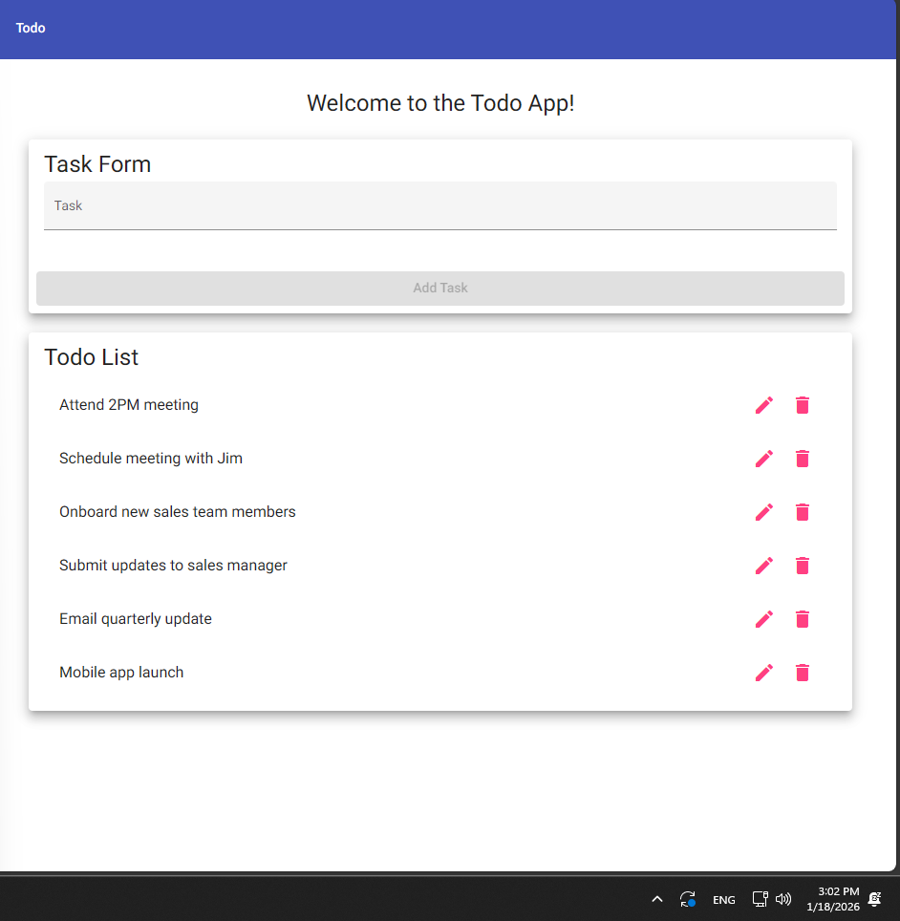
2 | Click “Add Task” | Nothing will happen | Yes | Yes  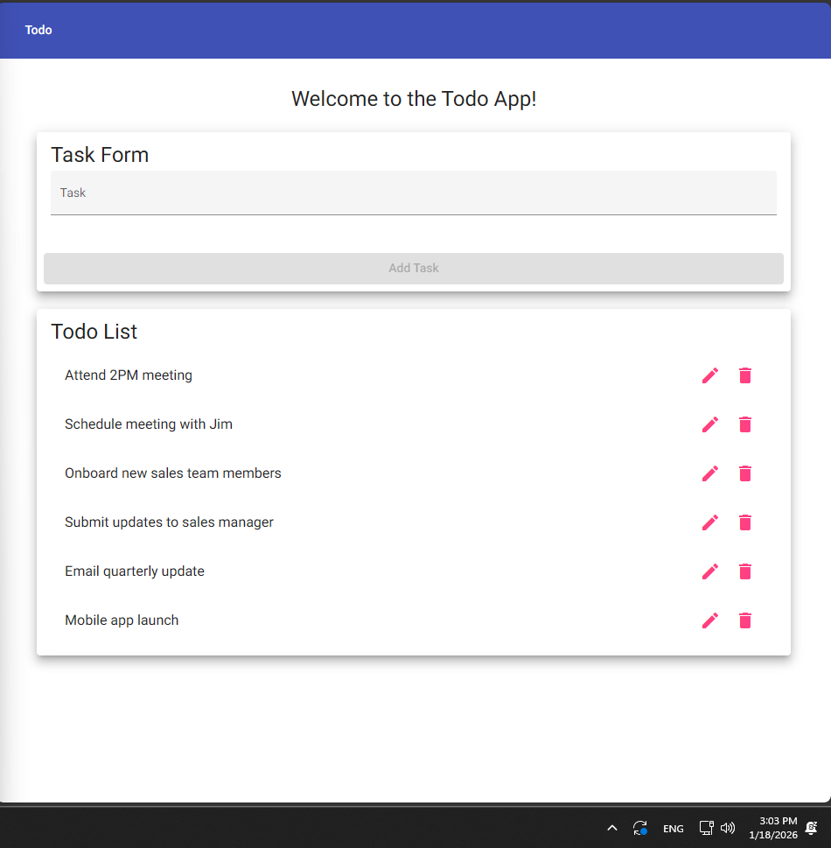
3 | Verify the list does not change | The list will not change | Yes | Yes
4 | Enter an item in the task form | Text will appear in form | Yes | Yes  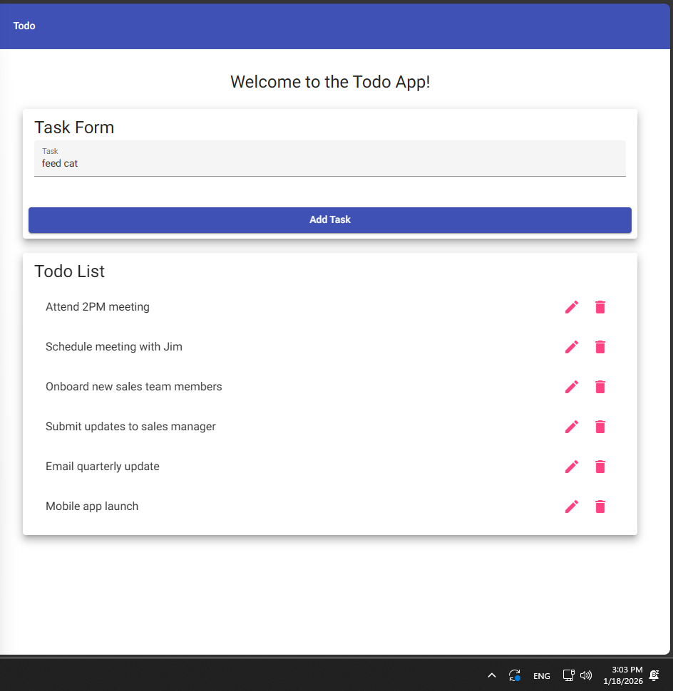
5 | Delete text from the task form | Text will be removed from form; Form will become red | Yes | Yes  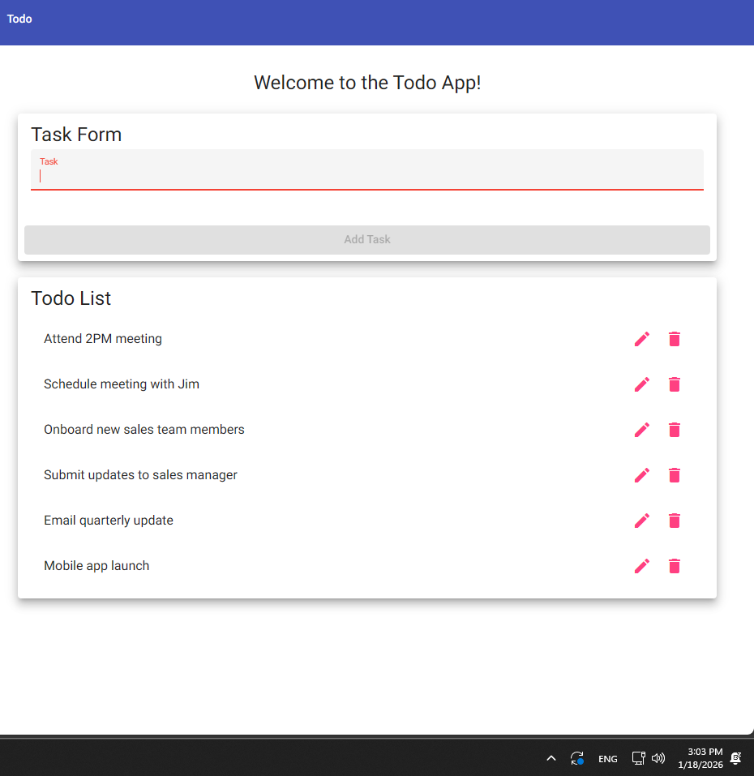
6 | Click “Add Task” | Nothing will happen | Yes | Yes  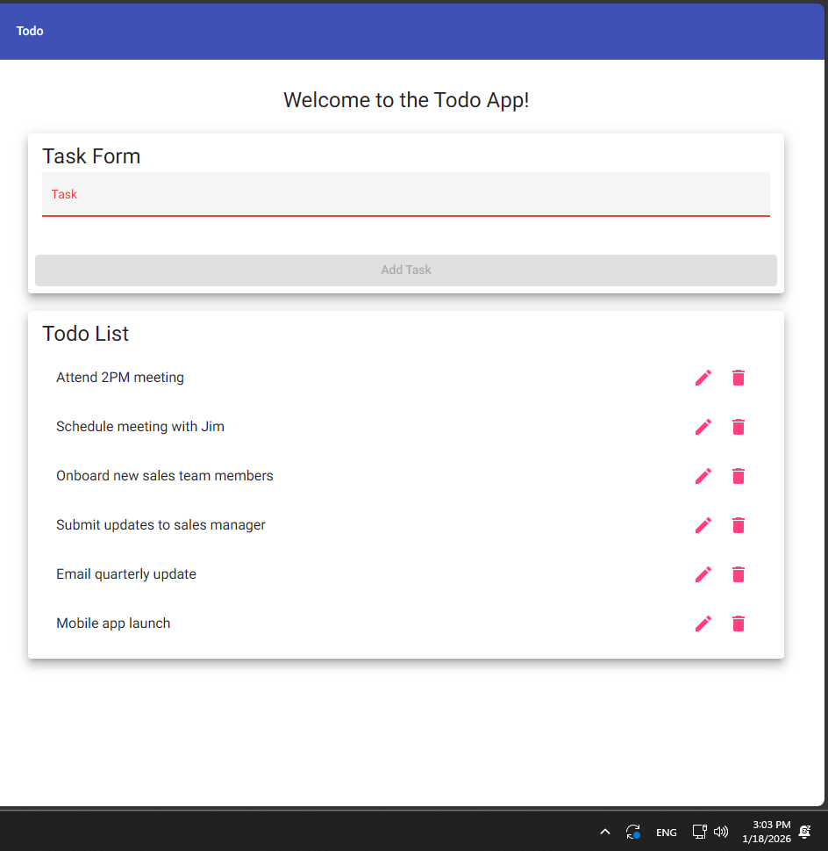
7 | Verify the list does not change | The list will not change | Yes | Yes
Comments | I once again think that you could remove step 1 because the tester should already be on the Todo App website do to the previous test. But I also think although there a 7 steps and some of the steps are just repeating each other I think almost all of the steps are necessary to get accurate and good results.

Test 5 | Prevent users from submitting the edit form without entering a todo item
 | Test Objective: Verifies that a task name is required | Developer: Daniel Preller  Date tested: 2026/01/14 | Peer tester: Hugo Ramirez  Date tested: 2026/01/18
Step | Action | Expected results: | Developer pass/fail | Tester pass/fail
1 | Visit https://buwebdev.github.io/todo/ | Page will load without errors | Yes | Yes  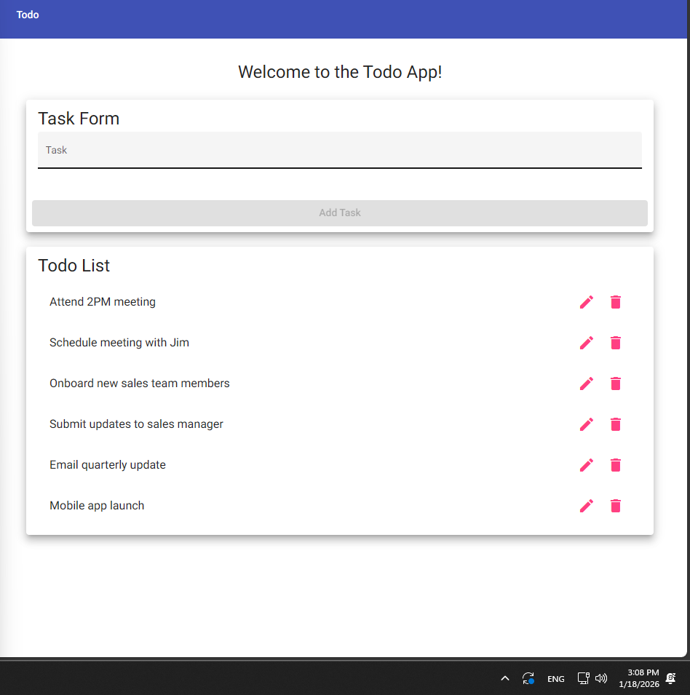
2 | Click an edit button (pencil) | Edit form will open | Yes | Yes  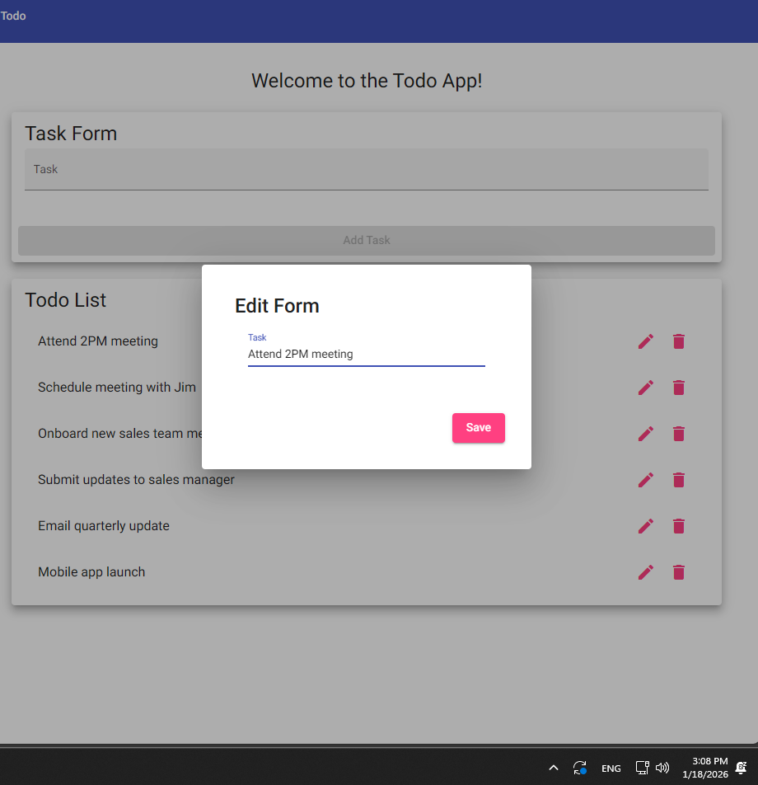
3 | Delete text in edit field | Text will be removed from edit field | Yes | Yes  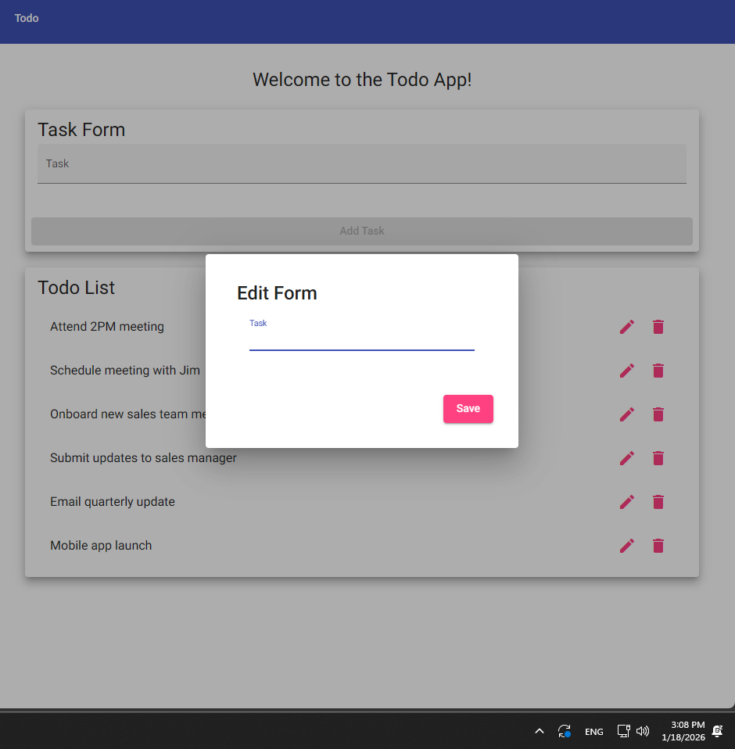
4 | Click “Save” | Edit field will close | Yes | Yes  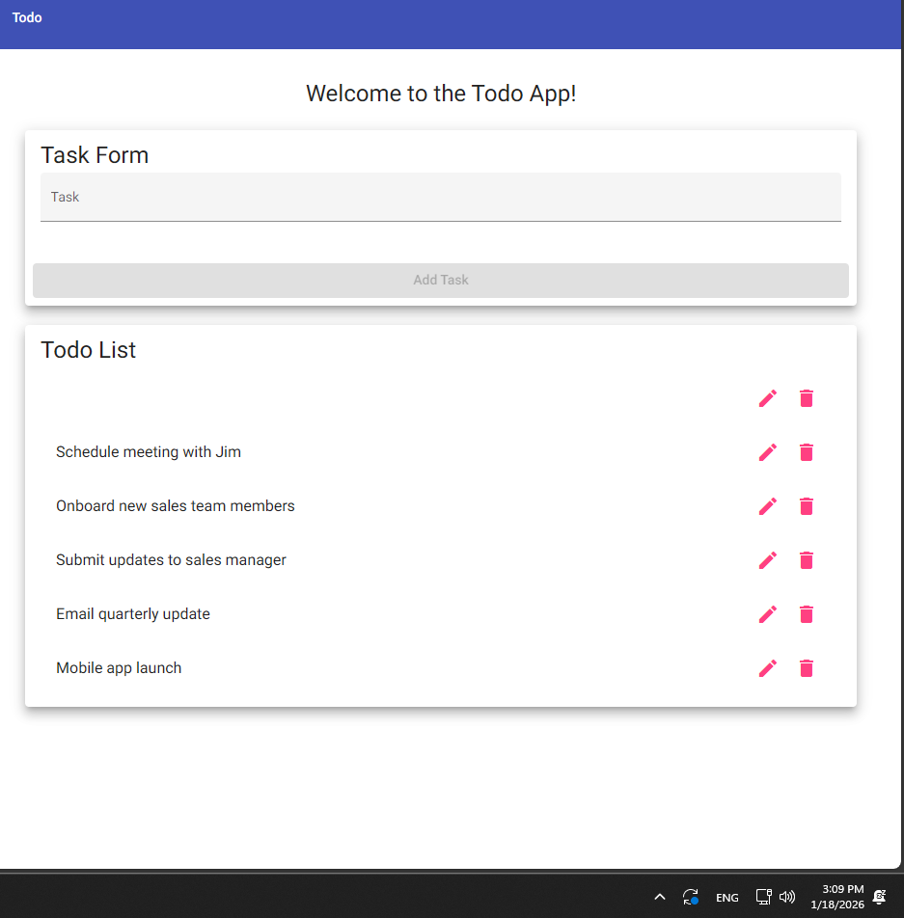
5 | Verify the task still has a name | Task will still have original name | No | No
Comments | Similar to Test 2 I think that specifying that the edit button is the pencil icon was a good choice.

