Project: Module 4.2 Assignment – Test Plan
Course: CSD380 DevOps
Description: For this assignment, you will be drafting a test plan based on the business requirements presented in the “Todo Business Requirements” document (linked below). The test plan must include at least 5 functional tests and those tests must encompass the requirements in the document.
Date: 2026/01/11
To complete the test case plan, fill out the information for Project, Course, Description and Date in the header below.
.
TABLE OF CONTENTS
Test Plan 1 2
Test Plan 2 3
Test Plan 3 3
Test Plan 4 4
Test Plan 5 4

For each test, the developer should: provide a test description, a test objective, the developer name and date tested. For each step, fill out the actions to be taken and describe the expected results, and indicate yes or no for each step depending upon the result. The peer tester should provide their name, date tested, indicate yes or no for each step depending upon the result, and a screenshot (thumbnail) of the result.

Test 1 | Access Website Using Standard URL
 | Test Objective: Allow users to visit the website through https://buwebdev.github.io/todo/ | Developer:  Date tested: Jackson<2026/01/11> | Peer tester: Hugo Ramirez  Date tested: 2026/01/18
Step | Action | Expected results: | Developer pass/fail | Tester pass/fail  + Screenshot
1 | Open a web browser | Browser open | yes | Yes  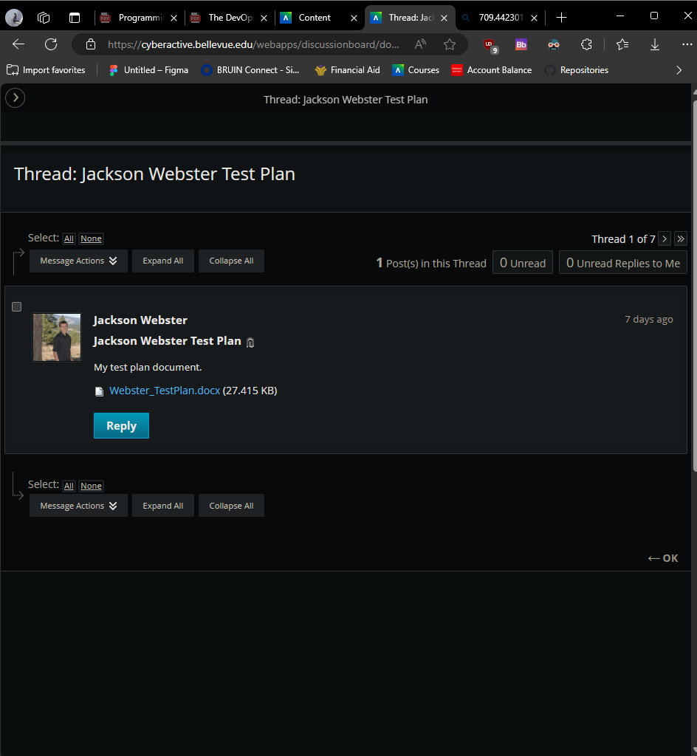
2 | Go to https://buwebdev.github.io/todo/ | Link works | yes | Yes  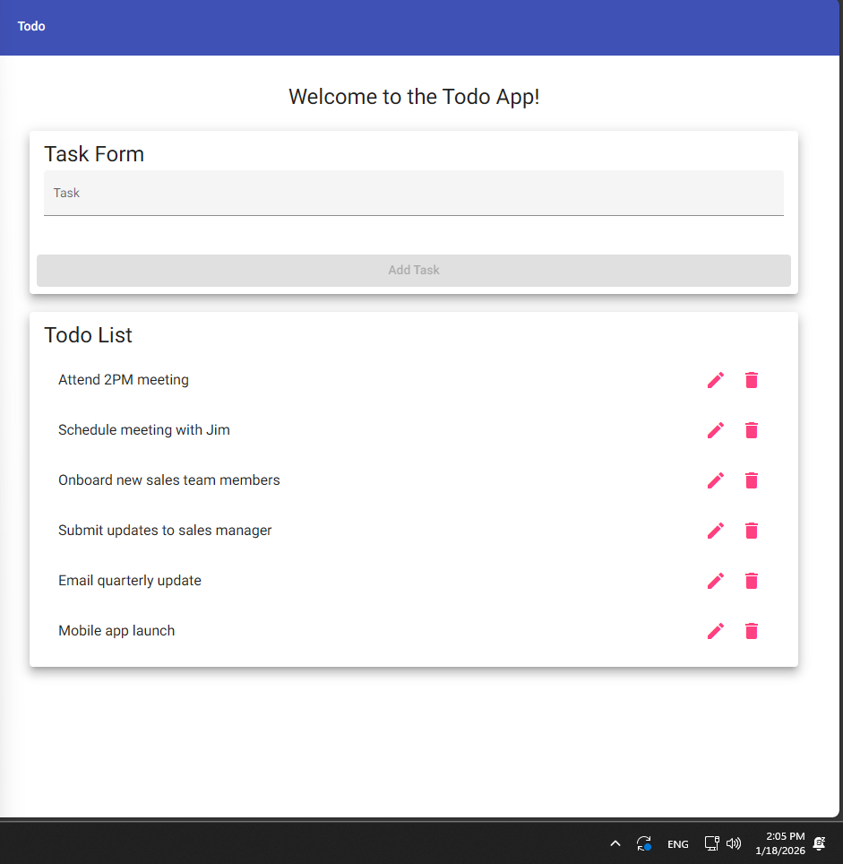
3 | Confirm pages load | Page loads correctly | yes | Yes  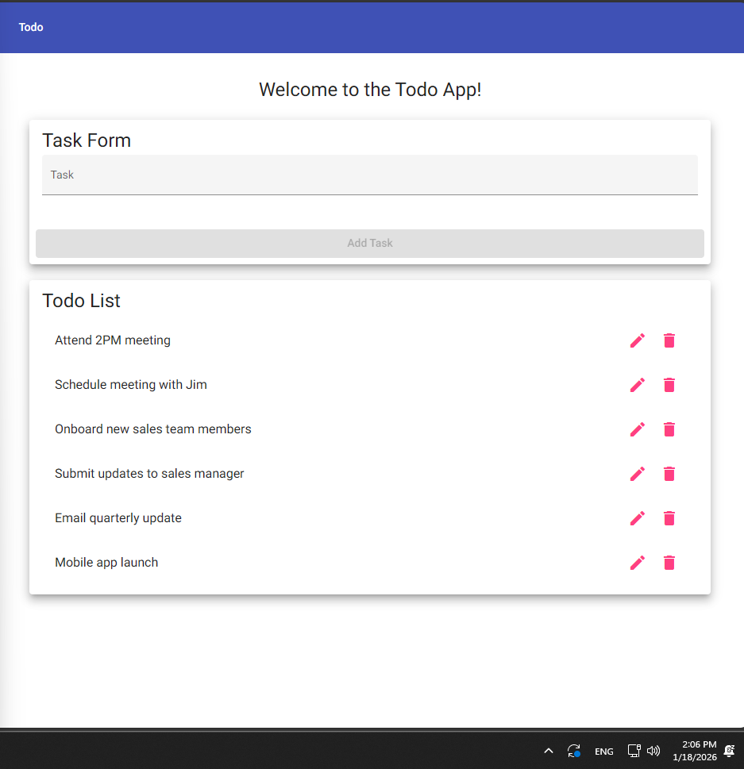
4 | Refresh the window | Page continues to work | yes | Yes  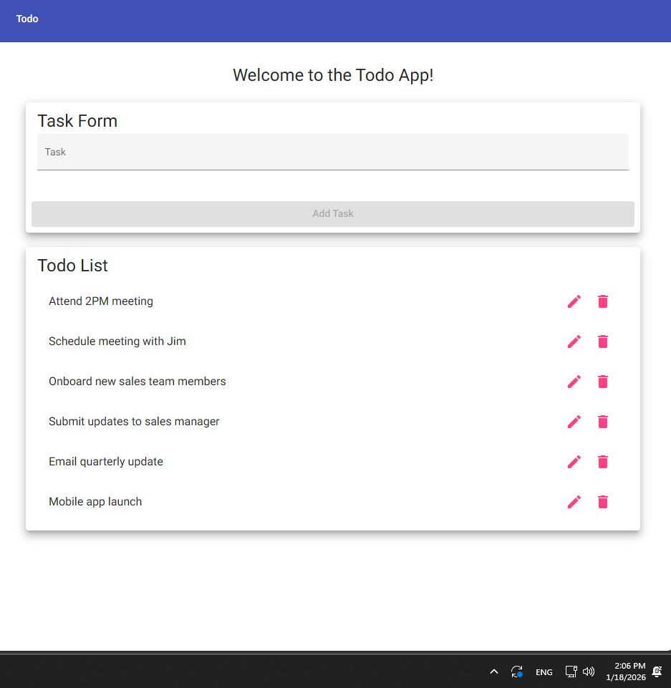
Comments | The page of the Todo App loaded correctly when I was told to got to the Todo App URL. Refreshing the window did not cause the Todo App to load incorrectly or crash.

Test 2 | View List of ToDo Items
 | Test Objective: View a list of todo tasks | Developer:  Date tested: Jackson <2026/01/11> | Peer tester: Hugo Ramirez  Date tested: 2026/01/18
Step | Action | Expected results: | Developer pass/fail | Tester pass/fail
1 | Load the Todo homepage | Homepage loads and displays | yes | Yes  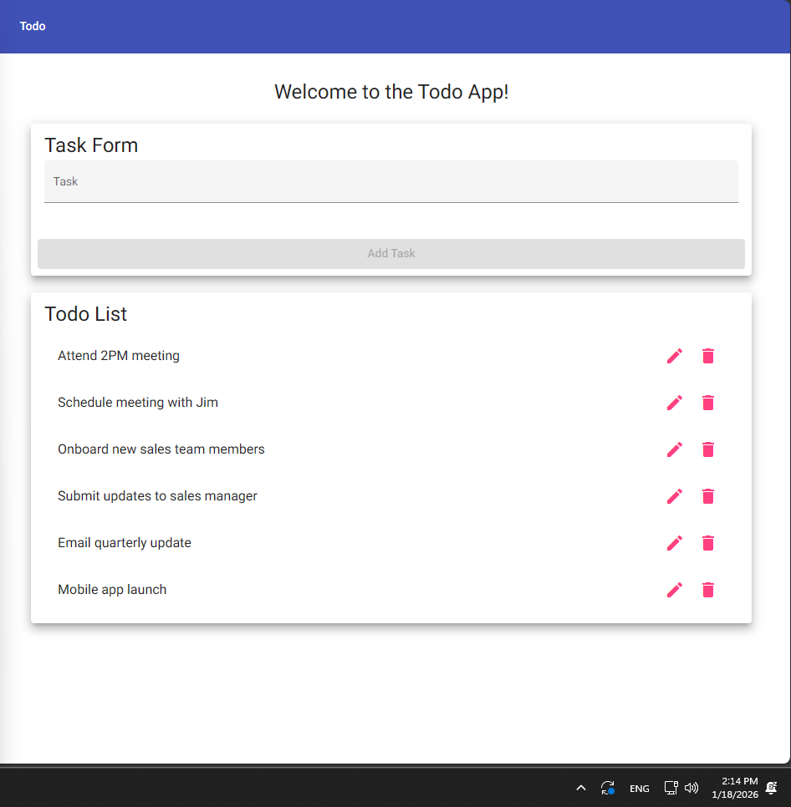
2 | Observe the todo list | List is visible and easy to access | yes | Yes  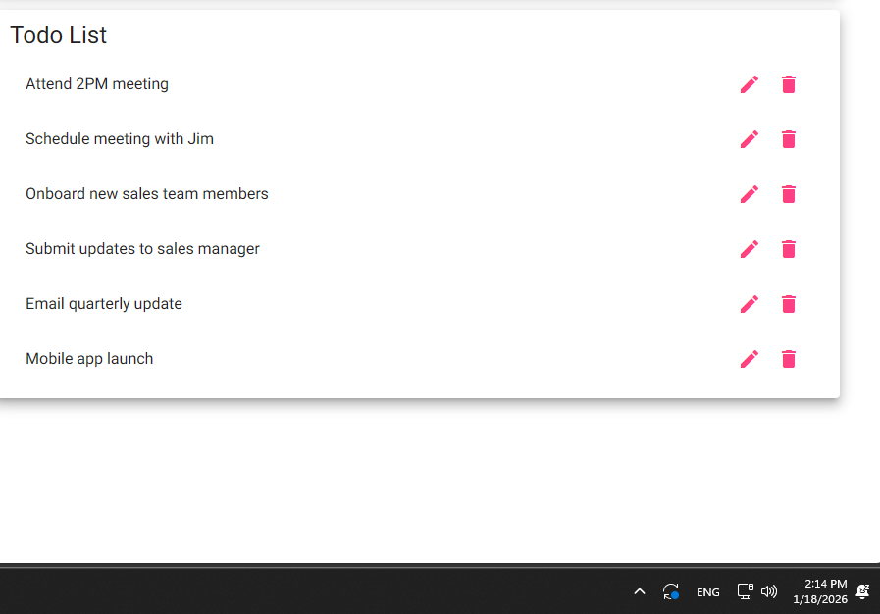
Comments | Test 2 felt redundant and could have been included with test 1. Step 1 could have been the same step as step 3 in Test 1 and there could have just been an extra step in Test 1 that asked the tester to make sure that the Todo List is visible and easily assessed.

Test 3 | Create a New Todo Item
 | Test Objective: | Developer:  Date tested: Jackson <2026/01/11> | Peer tester: Hugo Ramirez  Date tested: 2026/01/18
Step | Action | Expected results: | Developer pass/fail | Tester pass/fail
1 | Click inside the Todo input field | Allows for typing | yes | Yes  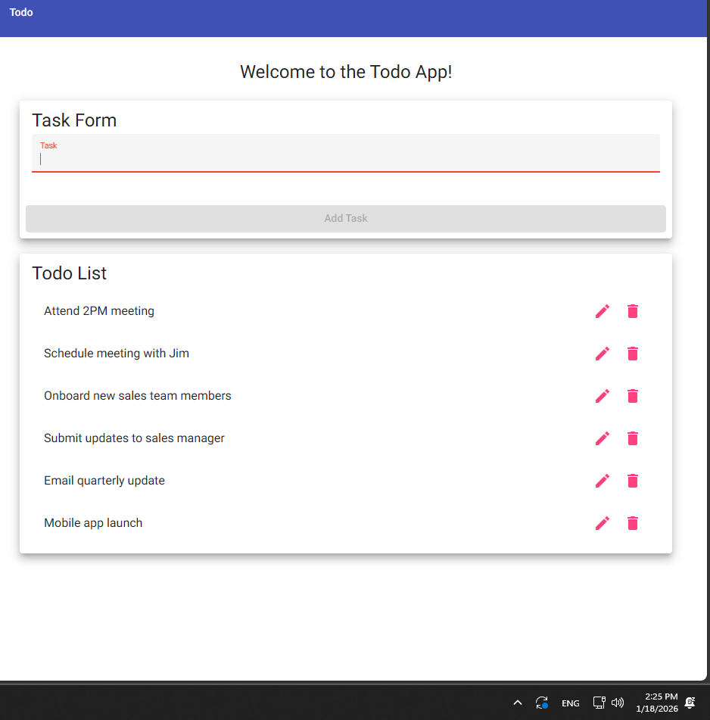
2 | Enter a task | Text is taken | yes | Yes  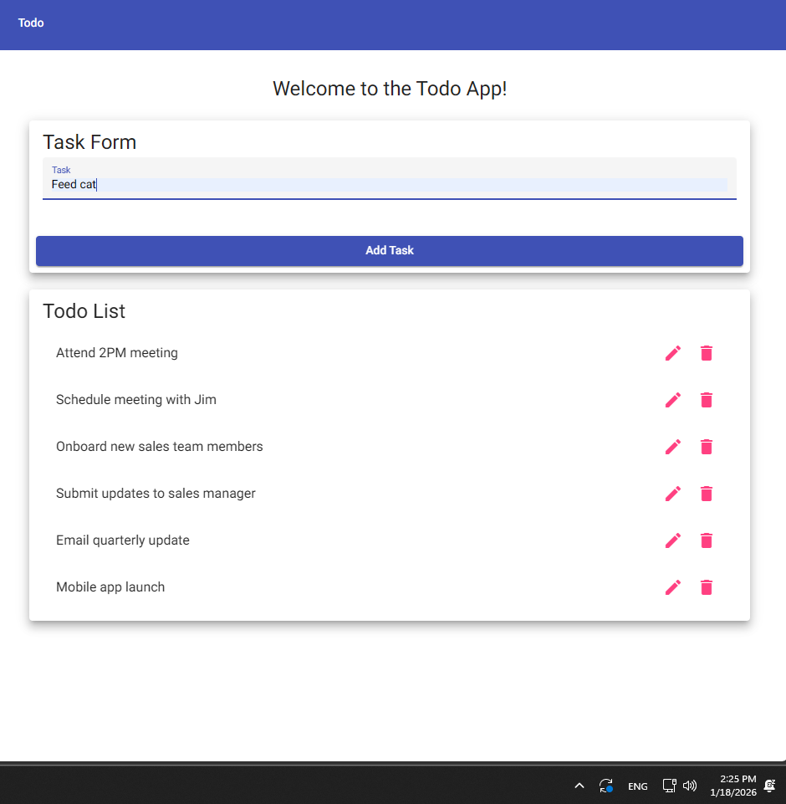
3 | Press Add Task | New item is created | yes | Yes  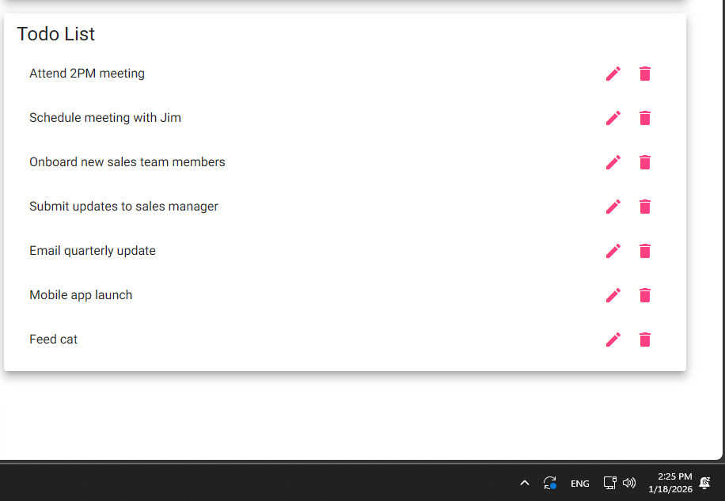
Comments | Test 3 was missing a test objective which can be confusing for another tester. Being a bit more specific about clicking the Task Form input field instead of asking “click inside the Todo input field” could reduce the amount of variables a test could have leading to better results.

Test 4 | Prevent Empty Todo Submission
 | Test Objective: Prevent users from submitting a task form without entering a todo item | Developer:  Date tested: Jackson <2026/01/11> | Peer tester: Hugo Ramirez  Date tested: 2026/01/18
Step | Action | Expected results: | Developer pass/fail | Tester pass/fail
1 | Click inside the Todo input field | Allows for typing | yes | Yes  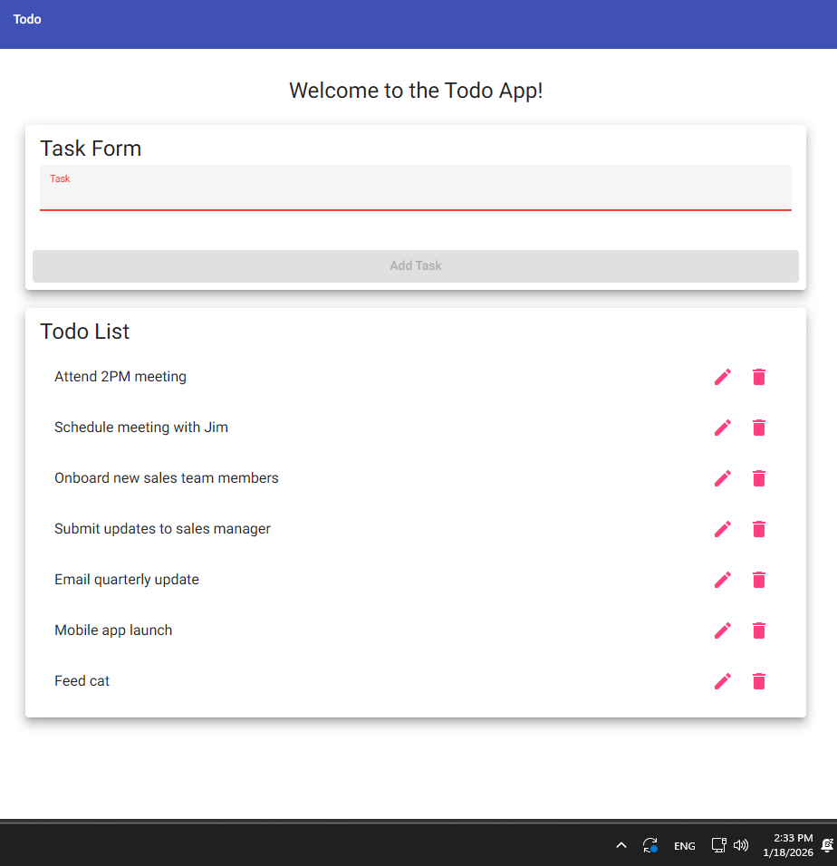
2 | Leave the input field empty | Input field empty | yes | Yes  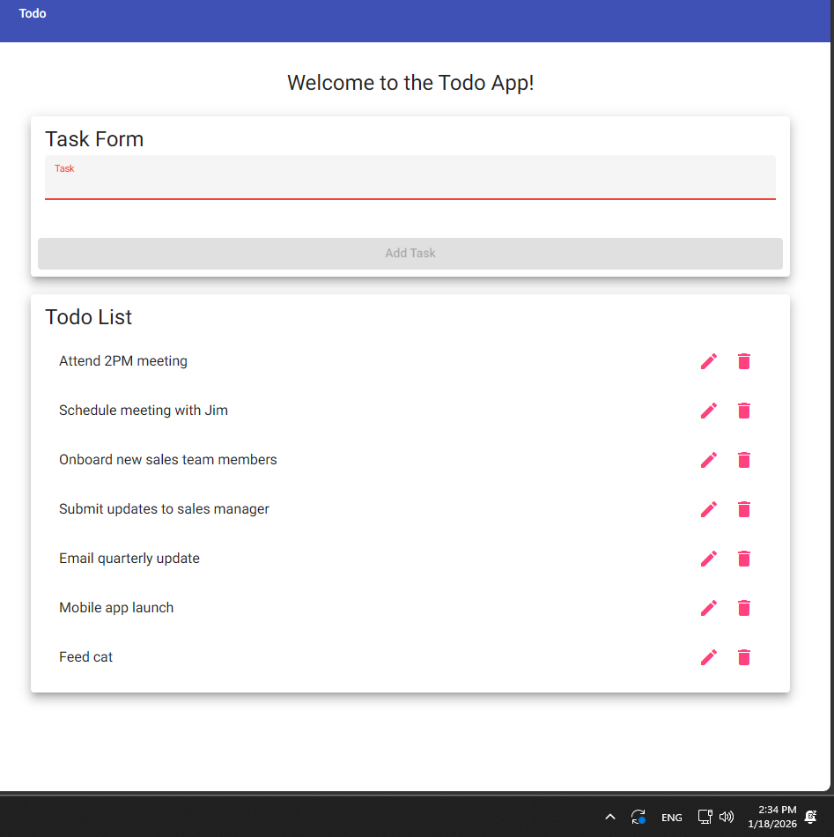
3 | Try to Add Task | Doesn’t let you press the button | yes | Yes  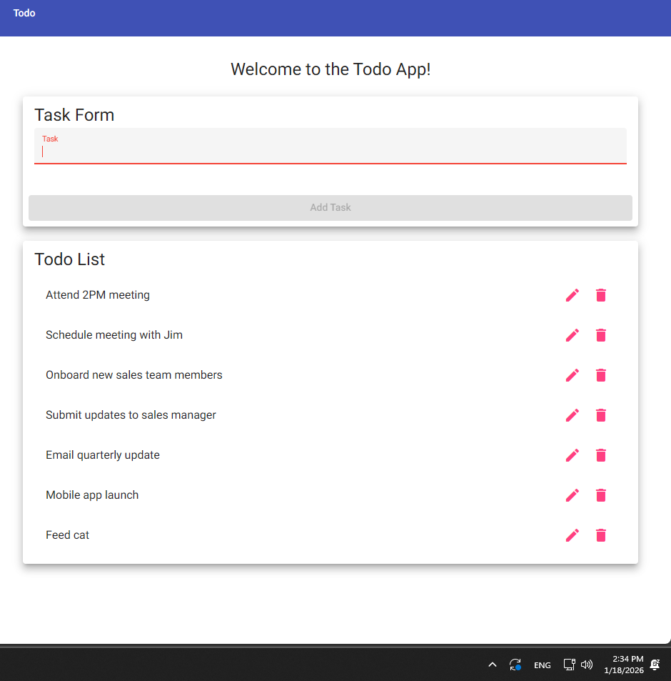
Comments | Have a more detailed action for step 1 could help get better results similar to Test 3. I also think that instead of “Dosen’t let you press the button” for expected result in step 3, saying “add task button stays grayed out” this is more specific and helps get better results.

Test 5 | Delete a Todo Item
 | Test Objective: Delete todo task item | Developer:  Date tested: Jackson <2026/01/11> | Peer tester: Hugo Ramirez  Date tested: 2026/01/18
Step | Action | Expected results: | Developer pass/fail | Tester pass/fail
1 | Locate an existing Todo item | Find items on list | yes | Yes  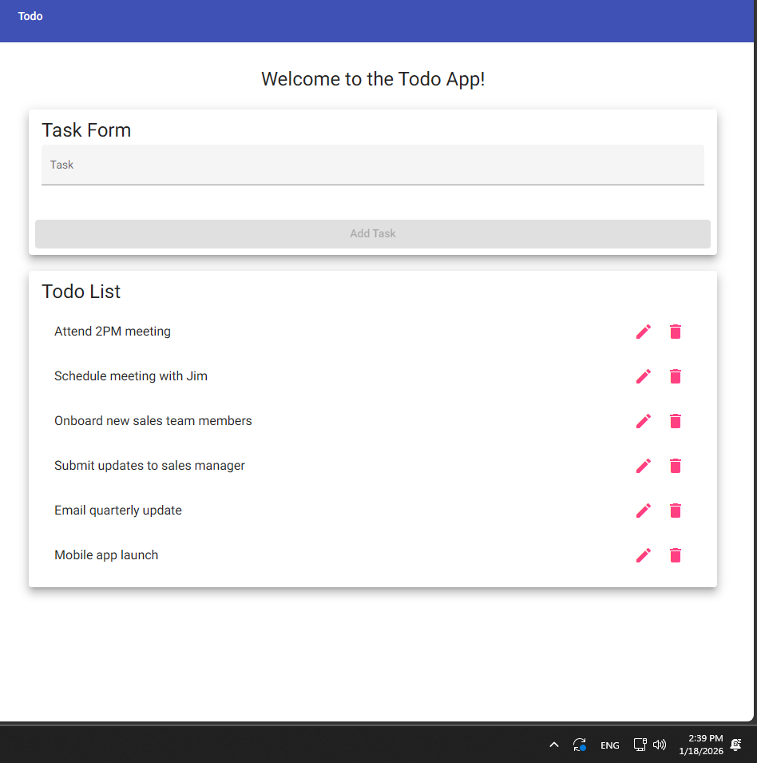
2 | Click the delete (X) button | Todo item is deleted | yes | No
Comments | I failed step 2 because there was no (X) anywhere on the Todo App. I understand that to delete a task I need to click on the trash can icon to delete the task but the directions ask to look for a (X).

