Hugo Ramirez Jr
3/17/2026
Module 1
Assignment 1.3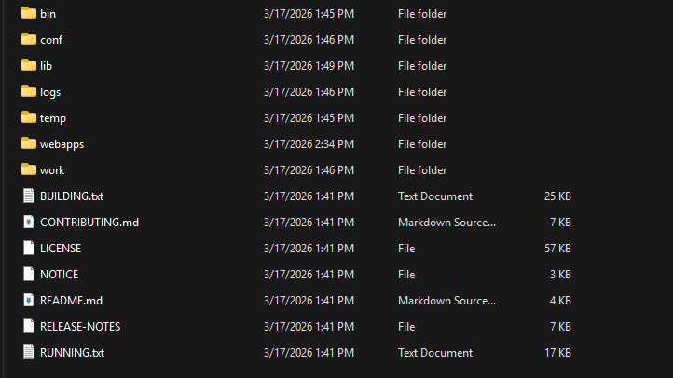
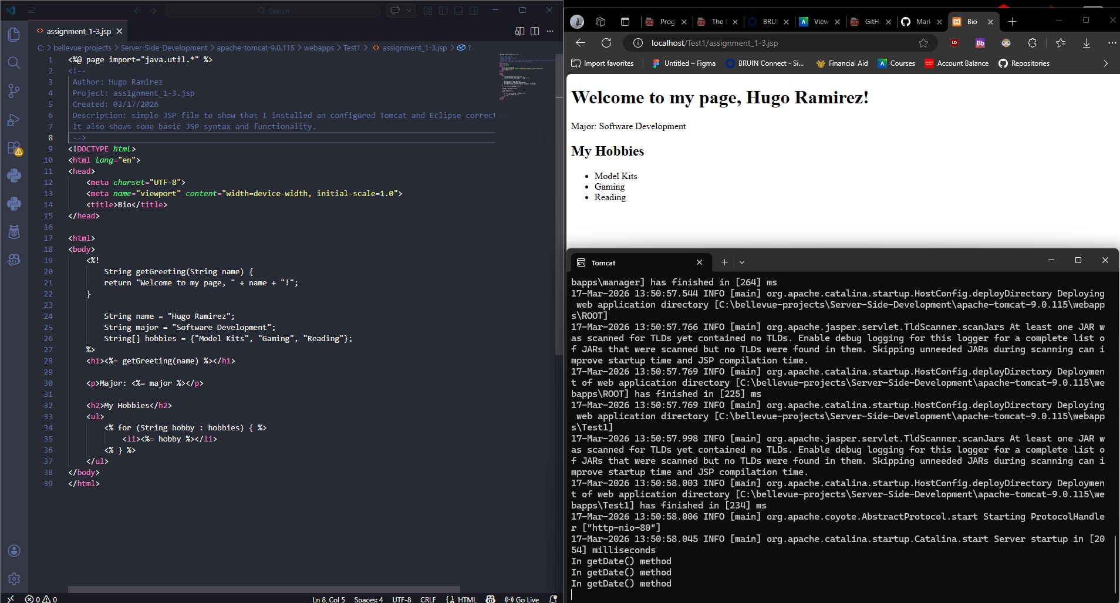
GitHub Repo: https://github.com/MrDangos/csd-430

