Hugo Ramirez Jr
3/28/2026
Module 2
Assignment 2.2
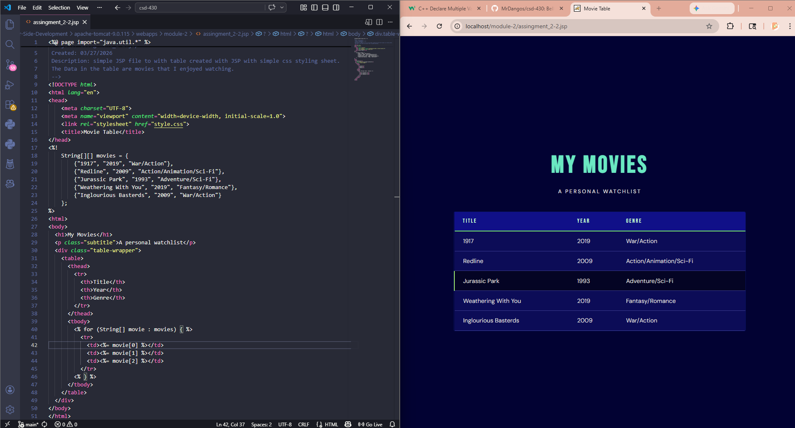

GitHub:

