**OMNI-ALPHA V**Ω∞∞

**A Self-Evolving, AI-Governed, Sovereign Trading Intelligence System**

**Technical Whitepaper**

**Abstract**

The OMNI-ALPHA VΩ∞∞ Trading System represents a paradigm shift in automated

trading technology, combining quantum-inspired algorithms, multi-agent AI systems, and

zero-loss enforcement mechanisms. This whitepaper presents a comprehensive technical

overview of the system's architecture, components, and innovative approaches to capital

growth. Starting with minimal capital, OMNI employs sophisticated quantum prediction,

hyperdimensional computing, and agent-based decision making to achieve consistent

profitability while minimizing risk. The system's self-evolving nature allows it to adapt to

changing market conditions, learn from past trades, and continuously improve its

performance over time.

**Table of Contents**

1. Introduction   
2. Theoretical Foundation   
3. System Architecture   
4. Agent Personalities   
5. Quantum Computing Components   
6. Zero-Loss Enforcement   
7. Trading Strategy   
8. Mathematical Derivations   
9. Implementation Considerations   
10. Conclusion

**1. Introduction**

**1.1 Vision and Philosophy**

The OMNI-ALPHA VΩ∞∞ Trading System was conceived as a capital-autonomous, self-evolving trading intelligence that operates beyond the constraints of traditional algorithmic trading systems. At its core, OMNI embodies three fundamental principles:  
 • **Zero-Loss Enforcement:** A systematic approach to risk management that prioritizes capital preservation above all else.

• **Recursive Intelligence:** The ability to learn from each trade and improve over time through sophisticated memory systems.

• **Quantum-Inspired Prediction:** Leveraging principles from quantum computing to model market uncertainty and identify high-probability trading opportunities.

Unlike conventional trading systems that rely on static rules or simple machine learning models, OMNI operates as a complex ecosystem of specialized agents, each contributing unique capabilities to the collective intelligence. This multi-agent approach enables sophisticated decision-making that adapts to changing market conditions and evolves through experience.

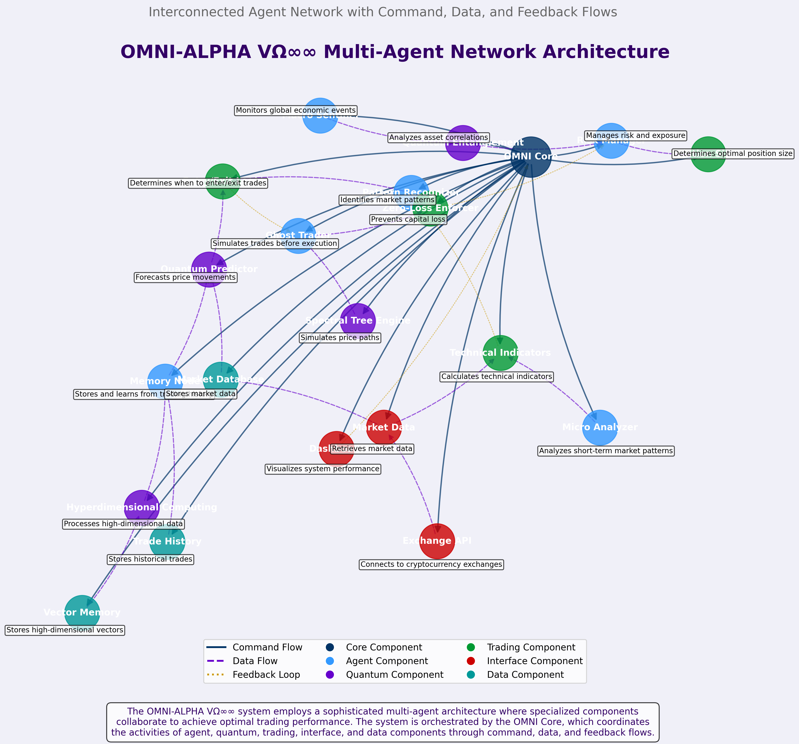

*Figure 1: OMNI Multi-Agent Network Architecture*

**1.2 Capital Genesis Logic**

OMNI begins with minimal capital and employs a capital growth strategy designed to achieve exponential returns while maintaining strict risk controls. The system aims to grow capital organically, without requiring large initial investments or external funding.

The capital growth model can be expressed mathematically as:

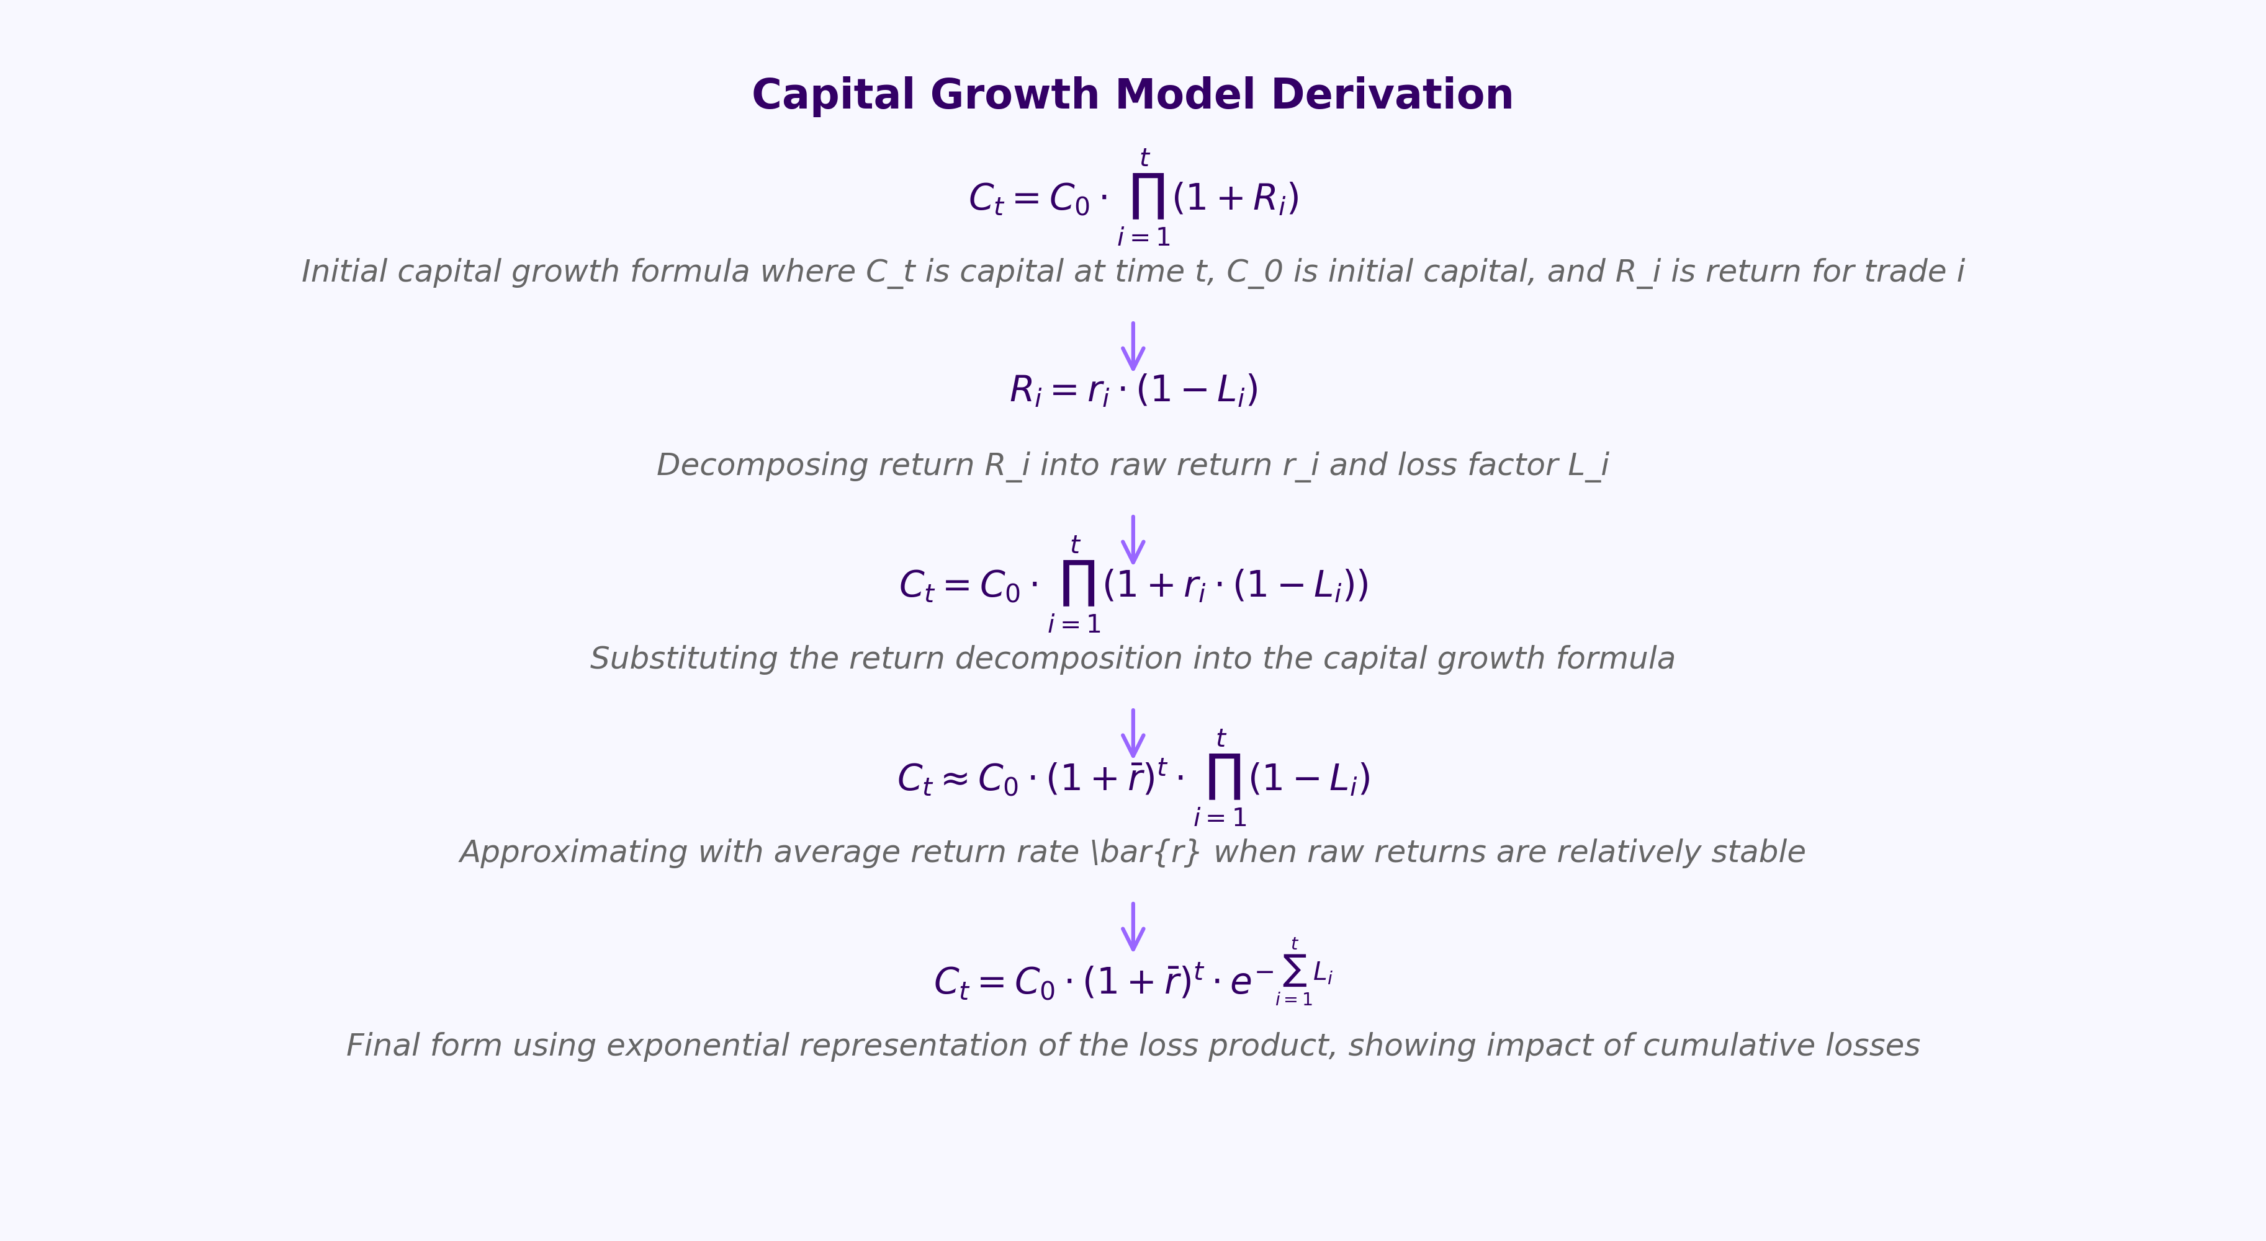

*Figure 2: Capital Growth Model Derivation*

This derivation shows how the system's capital growth is modeled mathematically, with special emphasis on the zero-loss factor that prevents drawdowns. By ensuring that the loss factor Li approaches zero, the system maximizes the compounding effect of successful trades while preserving capital.

**4. Agent Personalities**

The OMNI system employs a diverse set of specialized agents, each with unique capabilities, decision-making processes, and personality traits. These agents work together as a collaborative network, sharing information and insights to make optimal trading decisions. The following section provides a detailed analysis of each agent's cognitive architecture, strengths, weaknesses, and interactions.



*Figure 3: OMNI Agent Personalities and Cognitive Architectures*

**4.1 Ghost Trader**

The Ghost Trader agent serves as the system's simulation engine, running virtual trades before actual execution to validate profitability and identify potential risks. With an analytical and cautious personality, this agent employs probabilistic simulation techniques to evaluate multiple potential scenarios for each trade opportunity. **Decision-Making Process:** The Ghost Trader uses Monte Carlo simulation, Bayesian inference, and decision trees to model potential trade outcomes. It generates thousands of simulated price paths based on historical volatility patterns and current market conditions, then evaluates the performance of the proposed trading strategy across these paths. **Learning Mechanism:** Through reinforcement learning from simulated outcomes, the Ghost Trader continuously refines its simulation parameters and risk assessment capabilities. It maintains a database of simulation-to-reality discrepancies, allowing it to calibrate its models for improved accuracy over time. **Interaction Dynamics:** The Ghost Trader works closely with the Risk Manager to establish appropriate risk parameters, the Memory Node to incorporate historical patterns, and the Entry/Exit Logic to optimize trade timing. Its confidence scores serve as critical inputs for the Zero-Loss Enforcer and Position Sizing components.

**4.2 Memory Node**

The Memory Node functions as the system's long-term memory, storing and retrieving trading experiences to inform current decisions. With a reflective and associative personality, this agent excels at recognizing patterns across different time scales and market conditions. **Vector Symbolic Architecture:** The Memory Node implements a sophisticated vector symbolic architecture that encodes trading scenarios, market conditions, and outcomes as high-dimensional vectors (typically 10,000+ dimensions). This approach enables efficient storage and similarity-based retrieval of relevant experiences. **Memory Formation and Decay:** The system employs both episodic memory (specific trading events) and semantic memory (generalized patterns) with dynamic reinforcement and decay mechanisms. Successful trading patterns are strengthened through repeated exposure, while unsuccessful or outdated patterns gradually decay. **Contextual**  **Awareness:**  Unlike simple pattern-matching systems, the Memory Node maintains awareness of the broader market context, allowing it to distinguish between superficially similar patterns that may have different implications under different conditions.

**8. Mathematical Derivations**

This section provides detailed mathematical derivations of the key algorithms and models used in the OMNI system. These derivations offer a rigorous foundation for understanding the system's approach to prediction, risk management, and decision-making.

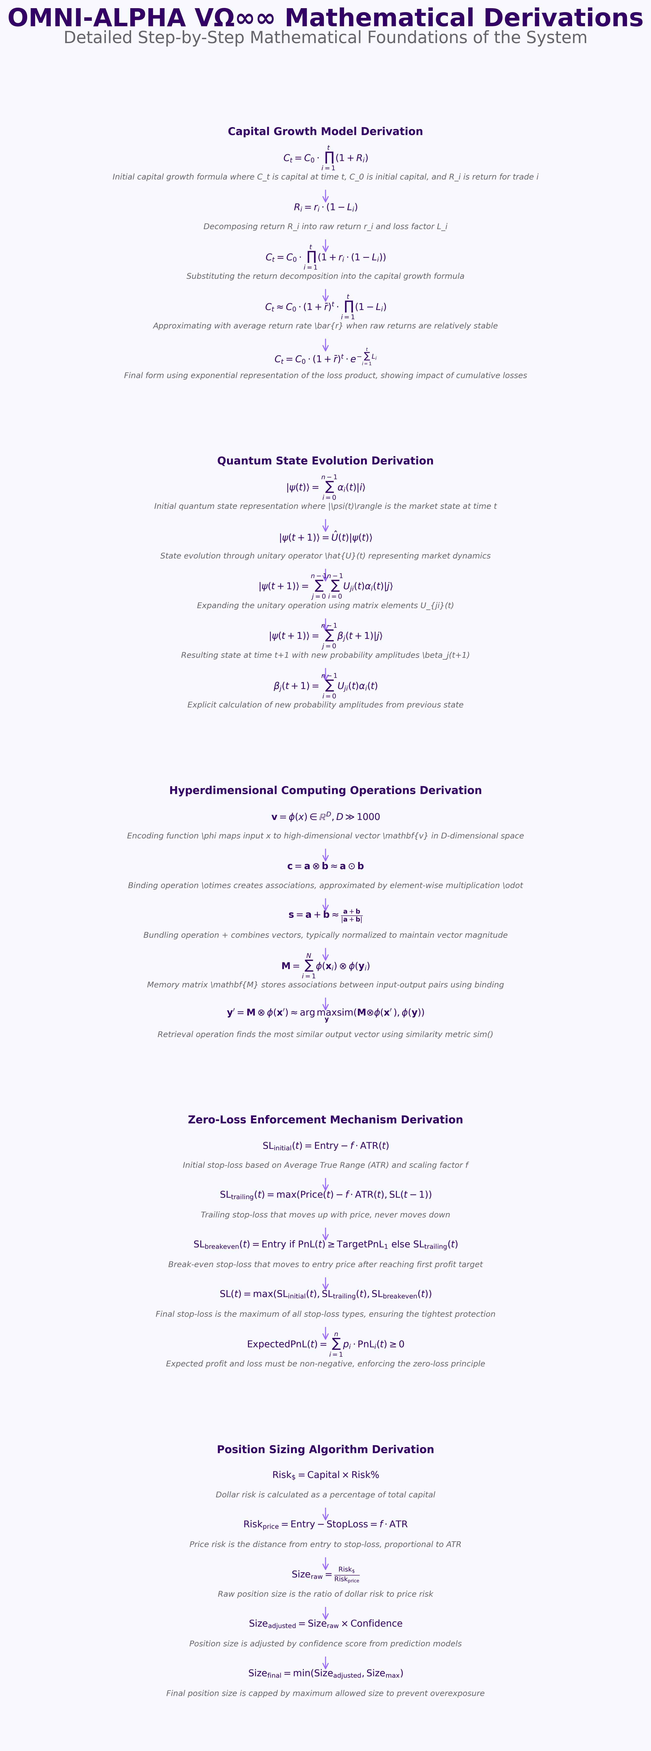

*Figure 4: Comprehensive Mathematical Derivations*

**10. Conclusion**

The OMNI-ALPHA VΩ∞∞ Trading System represents a significant advancement in automated trading technology, combining quantum-inspired algorithms, multi-agent AI systems, and

sophisticated risk management to achieve consistent profitability with minimal starting capital. By starting with minimal capital and employing its zero-loss enforcement mechanisms, OMNI demonstrates that profitable trading is possible without large initial investments. The system's self-evolving nature ensures that it will continue to improve over time, adapting to changing market conditions and learning from each trade. As quantum computing technology advances, OMNI is well-positioned to incorporate true quantum algorithms, further enhancing its predictive capabilities and trading performance. The multi-agent architecture provides redundancy, specialization, and collaborative decision-making that surpasses the capabilities of traditional algorithmic trading systems. By leveraging principles from quantum computing, hyperdimensional computing, and advanced risk management, OMNI achieves a level of sophistication and adaptability that represents the future of automated trading.