School of Computer and Information Science

《Operating-System-Concepts(10th)》

Project Report
Student information：
Name: 张乐之 ID: 222022321102120
Major/Grade: 2022计科中外04 Time: 2024-10-24

Experiment information：
Topic:
Programming Projects in Chapter 3

Requirements:
- Understand the basic concepts and organizational structure of
the operating system, understand the characteristics of linux operating system, the
- Master the loading / unloading method of linux kernel module
and understand the development of operating system.

Procedure：
- Code with execvp() function so that users’command can be passed to terminals.
- Compile the codes to get an executable program.
- Run the program. Use commands which are used by terminal, such as ls, ps to examine the functions of the program and decide whether the requirements are met.
Results：
（Code and Figures）
- For PART I, I compiled the program using gcc and ran the program after coding with header files and the given function execvp(). This function allows me to pass commands to terminal.

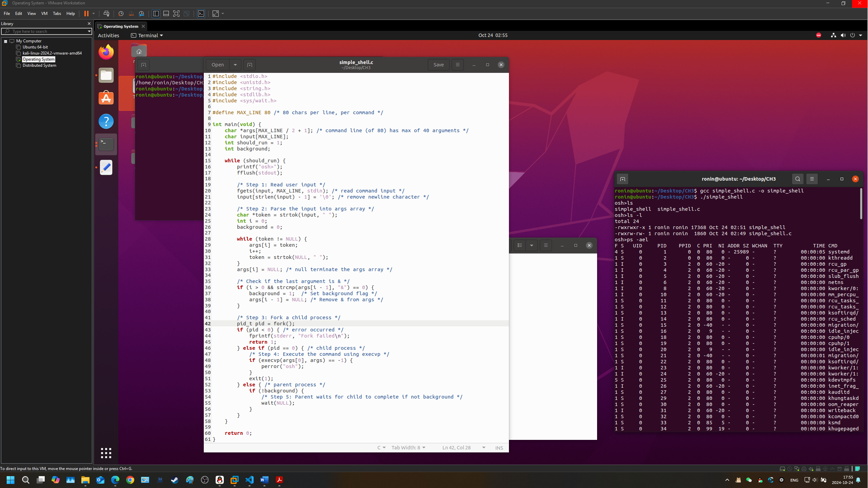
As is shown in the picture, by using APIs like execvp(), my pseudo terminal can execute commands by forking a child process, just as the normal terminals do. My program showed the files in the folder when receiving command ls and showed all the processes when receiving command ps -ael.

- For PART II, I rewrote the codes to add some new features.
The program remember the past commands and can execute them upon calling. It distinguishes
normal commands and special commands which start with ‘!’. Upon receiving a ‘!’, the program review the past history, finds the command and executes it.
Besides, special command ‘History’ can also be called to show all the past commands stored in the program.

