School of Computer and Information Science

《Operating-System-Concepts(10th)》

Project Report
Student information：
Name: 张乐之 ID: 222022321102120
Major/Grade: 2022计科中外04 Time: 2024-10-31

Experiment information：
Topic:
Programming Project 4
Requirements:
- Master the basic concepts, design ideas and status of the process.
Understanding the basic principles and ideas of process synchronization and
mutual exclusion. Use the basic means of realizing process synchronization and mutual
exclusion to analyze and solve the basic problems of process synchronization
and mutual exclusion.
- Master the basic concepts and design ideas of the computer file system. Have the ability to write simple codes to read or write a file.

Procedure：
- Choose the algorithm and code.
- Compile the codes and link with the Linux library so that some functions like creating threads can work properly.
- Run the program and check whether it meet the requirements.
Results：
（Code and Figures）
Codes are as follows:
- /**
- * Multithread solution for checking a Sudoku puzzle
- * Solution to project 1
- *
- * Operating System Concepts - Ninth Edition
- * Copyright John Wiley & Sons - 2013.
- */

- #include <pthread.h>
- #include <stdio.h>
- #include <stdlib.h>

- #define NUMBER_OF_THREADS 11
- #define PUZZLE_SIZE 9

- // Function declarations
- void *column_worker(void *param); /* thread that checks columns */
- void *row_worker(void *param); /* thread that checks rows */
- void *subfield_worker(void *param); /* thread that checks subfields */

- // Shared result array
- int status_map[NUMBER_OF_THREADS] = {0};

- // Data structure for passing data to threads
- typedef struct {
- int thread_number;
- int x;
- int y;
- } parameters;

- // Sudoku puzzle array
- int puzzle[PUZZLE_SIZE][PUZZLE_SIZE];

- int load_puzzle_from_file(const char *filename) {
- FILE *file = fopen(filename, "r");
- if (file == NULL) {
- perror("Error opening puzzle file");
- return -1;
- }

- for (int i = 0; i < PUZZLE_SIZE; i++) {
- for (int j = 0; j < PUZZLE_SIZE; j++) {
- if (fscanf(file, "%d,", &puzzle[i][j]) != 1) {
- perror("Error reading puzzle data");
- fclose(file);
- return -1;
- }
- }
- }

- fclose(file);
- return 0;
- }

- int main(int argc, char *argv[]) {
- pthread_t workers[NUMBER_OF_THREADS];
- int i;

- // Load the Sudoku puzzle from file
- if (load_puzzle_from_file("puzzle.txt") != 0) {
- fprintf(stderr, "Failed to load puzzle\n");
- return 1;
- }

- // Create thread for row check
- parameters *row_data = (parameters *) malloc(sizeof(parameters));
- row_data->thread_number = 0;
- pthread_create(&workers[0], NULL, row_worker, row_data);

- // Create thread for column check
- parameters *col_data = (parameters *) malloc(sizeof(parameters));
- col_data->thread_number = 1;
- pthread_create(&workers[1], NULL, column_worker, col_data);

- // Create threads for each 3x3 subgrid
- for (i = 0; i < PUZZLE_SIZE; i++) {
- parameters *subfield_data = (parameters *) malloc(sizeof(parameters));
- subfield_data->thread_number = i + 2;
- subfield_data->x = (i / 3) * 3;
- subfield_data->y = (i % 3) * 3;
- pthread_create(&workers[i + 2], NULL, subfield_worker, subfield_data);
- }

- // Wait for all threads to complete
- for (i = 0; i < NUMBER_OF_THREADS; i++) {
- pthread_join(workers[i], NULL);
- }

- // Check final result
- for (i = 0; i < NUMBER_OF_THREADS; i++) {
- if (status_map[i] == 0) {
- printf("Sudoku puzzle is invalid.\n");
- return 0;
- }
- }

- printf("Sudoku puzzle is valid.\n");
- return 0;
- }

- void *row_worker(void *params) {
- int found[PUZZLE_SIZE + 1] = {0};
- for (int row = 0; row < PUZZLE_SIZE; row++) {
- for (int i = 0; i <= PUZZLE_SIZE; i++) found[i] = 0; // reset for each row
- for (int col = 0; col < PUZZLE_SIZE; col++) {
- int num = puzzle[row][col];
- if (num < 1 || num > 9 || found[num]) {
- pthread_exit(0);
- }
- found[num] = 1;
- }
- }
- status_map[((parameters *) params)->thread_number] = 1;
- pthread_exit(0);
- }

- void *column_worker(void *params) {
- int found[PUZZLE_SIZE + 1] = {0};
- for (int col = 0; col < PUZZLE_SIZE; col++) {
- for (int i = 0; i <= PUZZLE_SIZE; i++) found[i] = 0; // reset for each column
- for (int row = 0; row < PUZZLE_SIZE; row++) {
- int num = puzzle[row][col];
- if (num < 1 || num > 9 || found[num]) {
- pthread_exit(0);
- }
- found[num] = 1;
- }
- }
- status_map[((parameters *) params)->thread_number] = 1;
- pthread_exit(0);
- }

- void *subfield_worker(void *params) {
- parameters *data = (parameters *) params;
- int found[PUZZLE_SIZE + 1] = {0};
- for (int i = 0; i < 3; i++) {
- for (int j = 0; j < 3; j++) {
- int num = puzzle[data->x + i][data->y + j];
- if (num < 1 || num > 9 || found[num]) {
- pthread_exit(0);
- }
- found[num] = 1;
- }
- }
- status_map[data->thread_number] = 1;
- pthread_exit(0);
- }
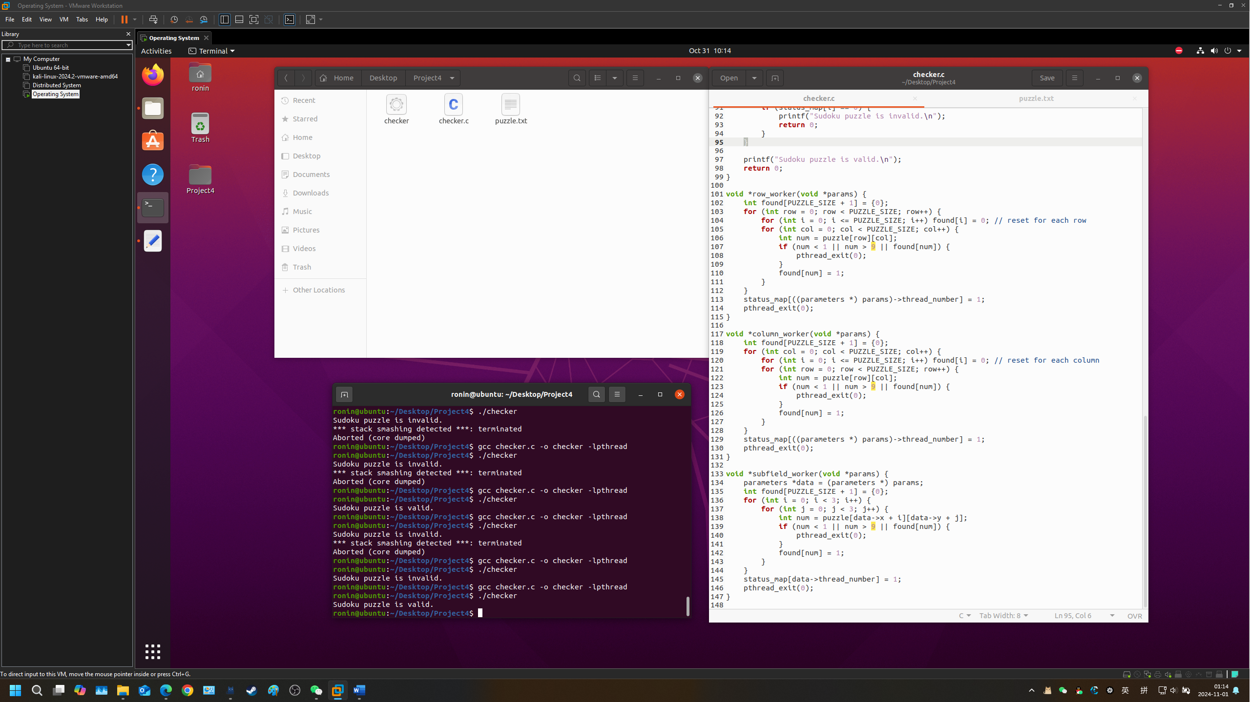
As is shown in the picture, we can see that the checker can identify whether the matrix meet the requirements of a Sudoku puzzle or not and print the result.

