计算机与信息科学学院 软件学院
课程过程性考核命题记录表
（适用于平时作业等过程性考核）

（ 2023 － 2024 学年第 2 学期）

课程名称 | 操作系统原理 | 任课教师 | 赵恒军
年级/专业 /班级 | 2022级软件工程1-4班 | 考核时间 | 2024.4.16
考核点对应教学内容（如章/节编号、名称） |  | Ch6，Ch7
本次过程性考核内容（如作业题目、题目序号、调研内容）
- Consider how to implement a mutex lock using an atomic hardware instruction. Assume that a mutex lock is defined as
boolean lock
(lock == 0) indicates that the lock is available, and a value of 1 indicates that the lock is unavailable. Illustrate how the following functions
void acquire(boolean *lock)
void release(boolean *lock)
can be implemented using the atomic test_and_set() instruction. The meaning of test_and_set() can be explained as:
boolean test and set(boolean *target) {
boolean res = *target;
*target = true;
return res;
}
Be sure to include any initialization that may be necessary.
- Consider the code example for allocating and releasing processes shown in the following figure:
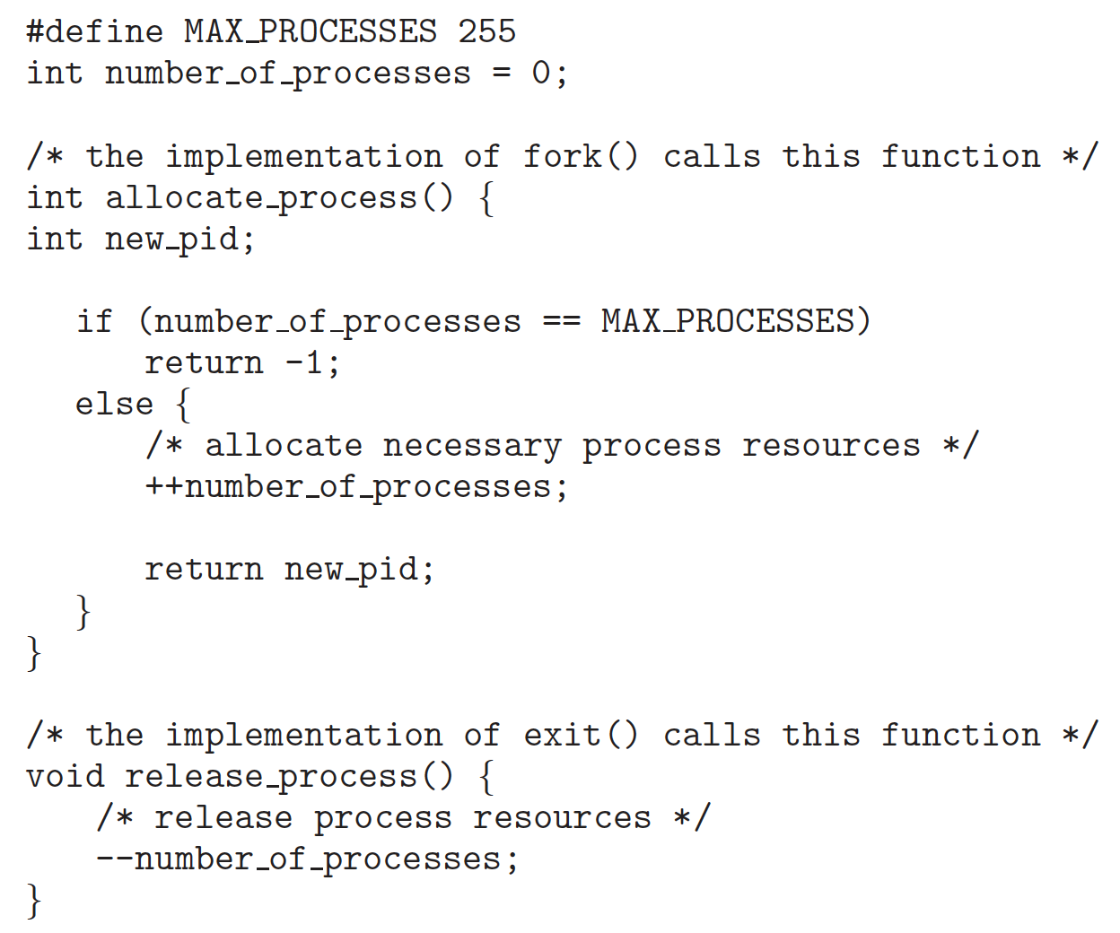
- Identify the race condition(s).
b. Assume you have a mutex lock named mutex_lock with the operations acquire() and release(). Indicate where the locking needs to be placed to prevent the race condition(s).
- We define a semaphore as follows:
typedef struct {
int value;
struct process *list;
} semaphore;
Each semaphore has an integer value and a list of processes list. When a process must wait on a semaphore, it is added to the list of processes. A signal() operation removes one process from the list of waiting processes and awakens that process.
Now, the wait() semaphore operation can be defined as
wait(semaphore *S) {
S->value--;
if (S->value < 0) {
add this process to S->list;
block();
}
}
And the signal() semaphore operation can be defined as
signal(semaphore *S) {
S->value++;
if (S->value <= 0) {
remove a process P from S->list;
wakeup(P);
}
}
The block() operation suspends the process that invokes it. The wakeup(P) operation resumes the execution of a blocked process P. These two operations are provided by the operating system as basic system calls.
Identify race conditions in the above implementation of wait() and signal(), and illustrate how to resolve the problem using the mutex lock mechanism.

Consider a system consisting of four resources of the same type that are shared by three processes, each of which needs at most two resources. Show that the system is deadlock free.

请在下方给出所有问题的解答。
1.
void acquire(boolean *lock) {
while(test_and_set(lock)) ;
}

void release(boolean *lock) {
*lock = false;
}
（default boolean lock = false）
2.
a.竞争条件：在创建进程的时候，变量number_of_processes可能被多个进程同时修改，例如当该变量=254时，有两个新建的进程都已经判断完if条件进入修改变量部分的代码，然后就会使得进程数超出最大值
b.在allocate_process函数的if条件语句前加一个acquire()，然后在if-else条件语句结束后加一个release()
release()应该加两处，在if和else的两个return语句之前

3.
竞争条件：多个进程同时执行wait()并减少value值时，可能导致value变成负值，然后多个进程同时进入if的分支，导致对同一个信号量来说有多个进程在同时对它进行修改；执行signal()时也可能出现类似的结果。
解决：
typedef struct {
int value;
struct process *list;
mutex lock; // 向信号量添加一个互斥锁
} semaphore;

void wait(semaphore *S) {
acquire(&S->lock); // 在修改共享数据之前获取锁
S->value--;
if (S->value < 0) {
add_to_list(S->list);
release(&S->lock); // 在block()之前释放锁
block();
} else {
release(&S->lock); // 如果不进行block()，则释放锁
}
}

void signal(semaphore *S) {
acquire(&S->lock); // 在修改共享数据之前获取锁
S->value++;
if (S->value <= 0) {
remove_from_list(S->list);
release(&S->lock); // 在wakeup()之前释放锁
wakeup(P);
} else {
release(&S->lock); // 如果没有要唤醒的进程，则释放锁
}
}

4.
最坏情况下，每个进程都需要两个资源，如果最坏情况下也不会造成死锁，那么可以认为其他情况下也不会出现死锁。
在这个最坏情况下，每个进程需要2个资源，并且总共只有4个资源，那么至少会有一个进程被分配两个资源，而其它两个进程都只被分配了一个，或是有一个进程被分配两个，另一个进程没有被分配资源；但是不论如何，它们只需要等待被分配了两个资源的进程执行完毕，释放资源，然后就可以获取到足够的资源来执行了，不会出现死锁的情况。

命题教师
签 字

年 月 日

