计算机与信息科学学院 软件学院
课程过程性考核命题记录表
（适用于平时作业等过程性考核）

（ 2023 － 2024 学年第 2 学期）

课程名称 | 操作系统原理 | 任课教师 | 赵恒军
年级/专业 /班级 | 2022级软件工程1-4班 | 考核时间 | 2023.5.14
考核点对应教学内容（如章/节编号、名称） |  | Ch3, ch4, ch8, ch9
本次过程性考核内容（如作业题目、题目序号、调研内容）
- What output will be at line A for Fig.3.30?
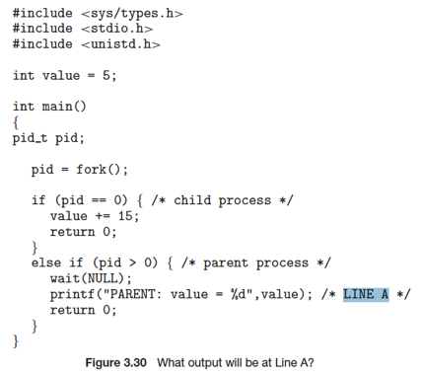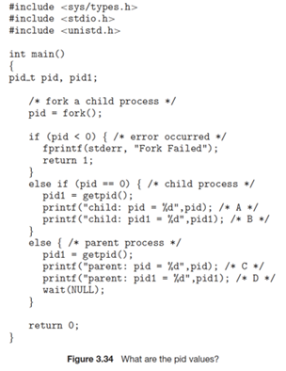
Hint: the return value of fork() is:
- 0, for the child process
- the PID of the child process, for the parent process
- Assume that the pids of parent and child are 2600 and 2603, respectively. Identify the values of pids at lines A, B, C, D for Fig.3.34. Hint: getpid() is a system call that returns the PID of the calling process.
- Which of the following components of program state are shared across threads in a multithreaded process?
a. Register values
b. Heap memory
c. Global variables
d. Stack memory
- The program shown in the following figure uses the Pthreads API. What would be the output from the program at LINE C and LINE P ?
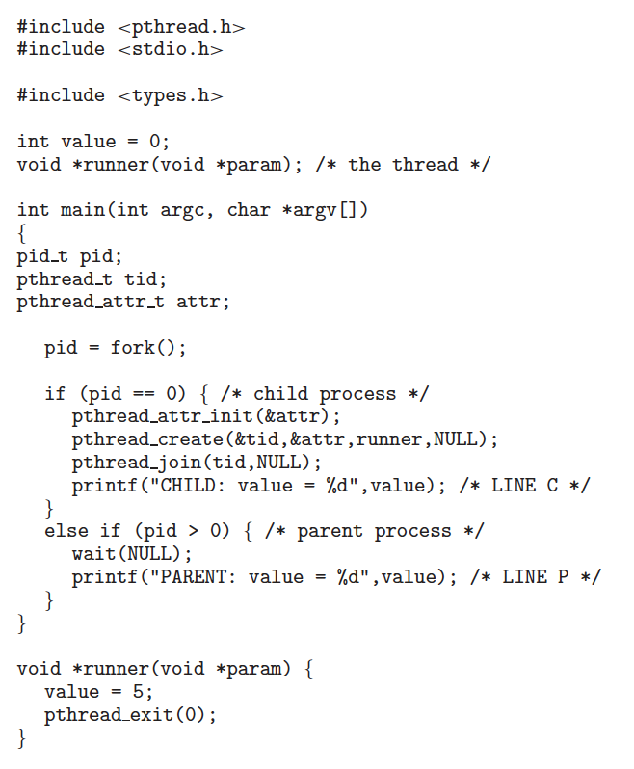

Consider the following segment table (all numbers are in decimal):
Segment Base Limit
0 219 600
1 2300 14
2 90 100
3 1327 580
4 1952 96
What are the physical addresses for the following logical addresses?
a. 0, 430
b. 1, 10
c. 2, 500
d. 3, 400
e. 4, 112

Assuming a 1-KB page size, what are the page numbers and offsets for the following address references (provided as decimal numbers):
a. 3085
b. 42095
c. 215201

Consider a logical address of 256 pages with a 4-KB page size, mapped onto a physical memory of 64 frames.
a. How many bits are required in the logical address?
b. How many bits are required in the physical address?

Consider a computer system with a 32-bit logical address and 4-KB page size. The system supports up to 512 MB of physical memory. How many entries are there in a conventional single level page table?

Consider a paging system with the page table stored in memory.
a. If a memory reference takes 50 nanoseconds, how long does a paged memory reference take?
b. If we add TLBs, and 75 percent of all page-table references are found in the TLBs, what is the effective memory reference time? (Assume that finding a page-table entry in the TLBs takes zero nanoseconds, if the entry is present.)

Assume that a program has just referenced an address in virtual memory. Describe a scenario in which each of the following can occur. (If no such scenario can occur, explain why.)
• TLB miss with no page fault
• TLB miss and page fault
• TLB hit and no page fault
• TLB hit and page fault
Note: here ‘page fault’ means that the physical page is not present
11.
Assume that we have a demand-paged memory. The page table is held in registers. It takes 8 milliseconds to service a page fault if an empty frame is available or if the replaced page is not modified and 20 milliseconds if the replaced page is modified. Memory-access time is 100 nanoseconds. Assume that the page to be replaced is modified 70 percent of the time. What is the maximum acceptable page-fault rate for an effective access time of no more than 200 nanoseconds?
12.
When a page fault occurs, the process requesting the page must block while waiting for the page to be brought from disk into physical memory. Assume that there exists a process with five user-level threads and that the mapping of user threads to kernel threads is one to one. If one user thread incurs a page fault while accessing its stack, would the other user threads belonging to the same process also be affected by the page fault—that is, would they also have to wait for the faulting page to be brought into memory? Explain.
13.
Consider a demand-paging system with a paging disk that has an average access and transfer time of 20 milliseconds. Addresses are translated through a page table in main memory, with an access time of 1 microsecond per memory access. Thus, each memory reference through the page table takes two accesses. To improve this time, we have added an associative memory that reduces access time to one memory reference if the page-table entry is in the associative memory. Assume that 80 percent of the accesses are in the associative memory and that, of those remaining, 10 percent (or 2 percent of the total) cause page faults. What is the effective memory access time?

请将答案写在下方：
1. PARENT: value = 5
2. A:0, B:2603, C:1, D: 2600
3. b&c
4. Line c: CHILD: value = 5
Line p: PARENT: valud = 0
5. a. 649 b. 2310 c. 超出limit，陷入内核，不确定物理地址 d. 1727 e. 超出limit，陷入内核，不确定物理地址
6. a. 页码：3 偏移量：13 b. 页码：41 偏移量：111 c. 页码：210 偏移量：161
7. a. log2(256) = 8 + log2(1024*4) = 8+12 = 20 b. log2(1024*4*64) = 18
8. 2^32/2^12 = 2^20个entry，问的只是页表最大的行数，不用考虑物理空间大小的限制
9. a. 需要花费50*2 = 100ns
b. 0.75*50+0+0.25*50*2 = 62.5ns
10.
TLB miss with no page fault
CPU查看TLB发现找不到，遂访问页表，找到该映射，将该映射更新到TLB中，然后CPU根据映射生成物理地址
TLB miss and page fault
CPU查看TLB发现找不到，访问页表，页表缺页错误找不到该映射，根据页表是否已满分两种情况，若已满则根据相应算法进行页面置换，然后将置换后的映射更新到页表中，再检查一次TLB，仍找不到，访问页表找到了映射，然后将映射存入TLB，由CPU根据映射生成物理地址；若页表未满，则CPU从磁盘中找到页面并读入到内存中，接着更新页表，然后也是查看一次TLB，仍找不到，但访问页表找到了映射，将映射存入TLB，并根据映射生成物理地址
TLB hit and no page fault
CPU查看TLB找到了缓存在TLB中的映射，直接根据该映射生成物理地址
TLB hit and page fault
TLB hit之后不管是否缺页，因为TLB中直接可以找到

依题意，（0.3*8000000+0.7*20000000）p+100（1-p）<= 200(单位：ns)
解得p大约要小于0.00061%
12.
同一进程的其他用户线程不会受到页面错误的影响，因为题目已说明该进程的线程映射模式是一对一映射，那么每一个用户线程都在内核中有对应的、分隔开的内核线程，具有独立的线程上下文，因为页面错误而对线程进行上下文切换时不会使得整个进程都被阻塞；并且同一进程中的不同线程的堆栈、程序计数器PC是独立的，这个用户线程访问其堆栈时导致页面错误，也就是说其PC访问到了错误的地址空间；但其他用户线程具有自己的堆栈和PC，并不会受到这个线程的影响。
13.
依题，EAT = 0.8*1μs+0.9*（1-0.8）*2μs+0.02*20ms+0.02*2μs = 401.2μs

命题教师
签 字

年 月 日

