计算机与信息科学学院 软件学院
课程过程性考核命题记录表
（适用于平时作业等过程性考核）

（ 2023 － 2024 学年第 2 学期）

课程名称 | 操作系统原理 | 任课教师 | 赵恒军
年级/专业 /班级 | 2022级软件工程1-4班 | 考核时间 | 2024.5.27
考核点对应教学内容（如章/节编号、名称） |  | Ch5, ch9, ch12
本次过程性考核内容（如作业题目、题目序号、调研内容）
- Which of the following scheduling algorithms could result in starvation?
a. First-come, first-served
b. Shortest job first
c. Round robin
d. Priority

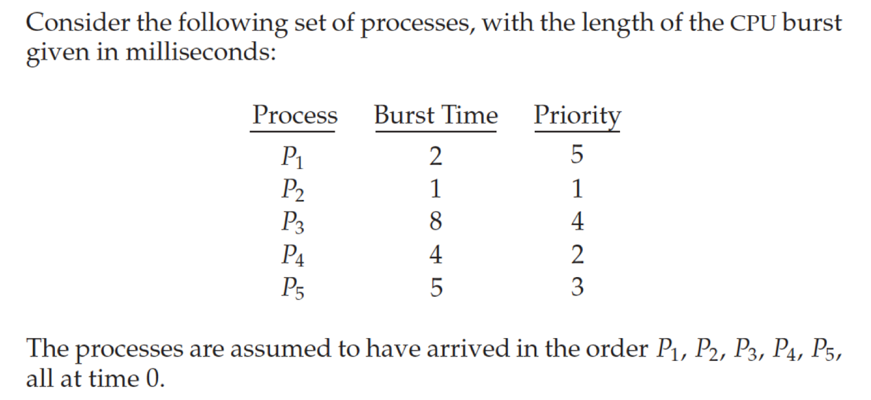
Draw the Gantt charts that illustrate the execution of these processes using the RR algorithm with time slice = 2. What is the waiting time of each process?

Consider the following page reference string:
7, 2, 3, 1, 2, 5, 3, 4, 6, 7, 7, 1, 0, 5, 4, 6, 2, 3, 0, 1.
Assuming demand paging with three frames, how many page faults would occur for the following replacement algorithms?
• LRU replacement
• FIFO replacement
• Optimal replacement

The page table shown in the following figure is for a system with 16-bit virtual and physical addresses and with 4,096-byte pages. The reference bit is set to 1 when the page has been referenced. Periodically, a thread zeroes out all values of the reference bit. A dash for a page frame indicates the page is not in memory. The page-replacement algorithm is localized LRU, and all numbers are provided in decimal.
a. Convert the following virtual addresses (in hexadecimal) to the equivalent physical addresses. You may provide answers in either hexadecimal or decimal. Also set the reference bit for the appropriate entry in the page table.
• 0xE12C
• 0x3A9D
• 0xA9D9
• 0x7001
• 0xACA1
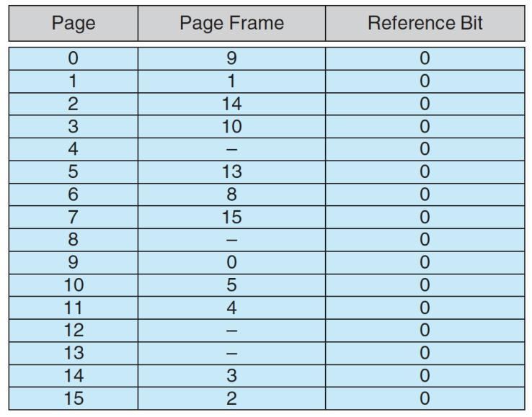
b. Using the above addresses as a guide, provide an example of a logical address (in hexadecimal) that results in a page fault.
c. From what set of page frames will the LRU page-replacement algorithm choose in resolving a page fault?
- Suppose that a disk drive has 5,000 cylinders, numbered 0 to 4,999. The drive is currently serving a request at cylinder 2,150, and the previous request was at cylinder 1,805. The queue of pending requests, in FIFO order, is:
2,069, 1,212, 2,296, 2,800, 544, 1,618, 356, 1,523, 4,965, 3681
Starting from the current head position, what is the total distance (in cylinders) that the disk arm moves to satisfy all the pending requests for each of the following disk-scheduling algorithms?
a. FCFS
b. SSTF
c. SCAN
6. Consider a file system that uses index blocks for space allocation. Disk blocks are 8 KB in size, and a pointer to a disk block requires 4 bytes. This file system has 12 direct disk blocks, as well as single, double, and triple indirect disk blocks. What is the maximum size of a file that can be stored in this file system?

请将答案写在下方：

- B、D

2.进程调度的Gantt图如下
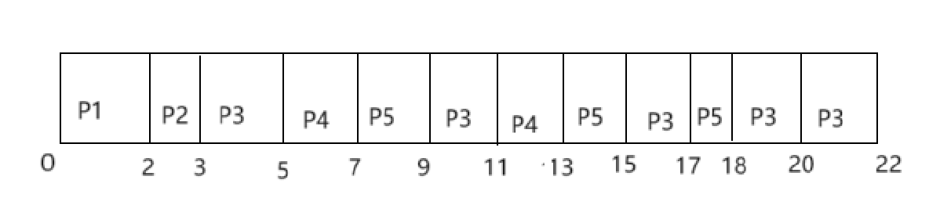
每个进程的等待时间：
P1：0
P2：2 ms
P3：3+4+4+1=12 ms
P4：5+4=9 ms
P5：7+4+2=13 ms

3.对于如下页引用顺序：
7, 2, 3, 1, 2, 5, 3, 4, 6, 7, 7, 1, 0, 5, 4, 6, 2, 3, 0, 1.
帧数为3个的情况下
- 采用LRU算法：
7-2-3-1(对7页面置换)-2-5(对3页面置换)-3(对1页面置换)-4(对2页面置换)-6(对5页面置换)-7(对3页面置换)-7-1(对4页面置换)-0(对6页面置换)-5(对7页面置换)-4(对1页面置换)-6(对0页面置换)-2(对5页面置换)-3(对4页面置换)-0(对6页面置换)-1(对2页面置换)
则缺页次数=15
- 采用FIFO算法：
7-2-3-1(7)-2-5(2)-3-4(3)-6(1)-7(5)-7-1(4)-0(6)-5(7)-4(1)-6(0)-2(5)-3(4)-0(6)-1(2)
缺页次数=14
- 采用Opt算法：
7-2-3-1(7)-2-5(2)-3-4(3)-6(4)-7(6)-7-1-0(1)-5-4(7)-6(5)-2(4)-3(6)-0-1(2)
缺页次数=11

4.
- 单个页面大小为4096字节，即2^12bytes，而逻辑地址空间为2^16bit，那么逻辑地址的高(16-12=4)位表示页表的页码，低12位表示页偏移量，那么下列逻辑地址对应物理地址为
• 0xE12C ---> V.A. 14：0x12C 根据页表计算，物理地址为3：0x12C
• 0x3A9D ---> V.A. 3：0xA9D 物理地址为10：0xA9D
• 0xA9D9 ---> V.A. 10：0x9D9 物理地址为5：0x9D9
• 0x7001 ---> V.A. 7：0x1 物理地址15：0x001
• 0xACA1 ---> V.A. 10：0xCA1 物理地址为5：0xCA1
则将页码为3、7、10、14的引用位设为1
- 例如0x4001，对应的页码为4，但页表显示页码为4的帧不存在内存中，那么就会导致缺页错误
- 由页表可知，页码为4、8、12、13的页都还没有将对应的帧存在内存中，那么当缺页错误的时候，就会优先从这几个页里选择一个进行请求调页，将所需的帧写入内存，然后更新页表

5.
依题，The queue of pending requests, in FIFO order, is:
2,069, 1,212, 2,296, 2,800, 544, 1,618, 356, 1,523, 4,965, 3681
当前磁臂所在柱面为2150，上一次磁臂所在柱面为1805
那么以下三种磁盘调度算法对应的磁臂需要移动的距离为：
- FCFS：
(2150-2069)+(2069-1212)+(2296-1212)+(2800-2296)+(2800-544)+(1618-544)+(1618-356)+(1523-356)+(4965-1523)+(4965-3681) = 13011
- SSTF：
从2150开始，依次移动到距离最近的柱面，则总的移动距离为
2150-2069+2296-2069+2800-2296+3681-2800+4965-3681+4965-1618+1618-1523+1523-1212+1212-544+544-356 = 7586
- SCAN：
从2069的柱面开始，由于上一次磁臂所在柱面为1805，在2069的前面，说明应该继续向后扫描，直到4999柱面后再转而向前扫描到为0的柱面
则磁臂总的移动距离为2849+4999 = 7848

6.在题述的索引分配文件系统中，每个索引块的最大长度为8KB/4B = 2048，则single indirect disk block索引条数为2048条，最多指向2048个磁盘块，则最大空间大小为2048*8KB = 16MB；double indirect disk block最多指向2048*2048个磁盘块，最大空间大小为2048*2048*8KB = 32GB；triple indirect disk block最多指向2048*2048*2048个磁盘块，最大空间大小为2048*2048*2048*8KB = 64TB，则最大总空间大小为12*8KB+16MB+32GB+64TB = 64TB32GB16MB96KB

命题教师
签 字

年 月 日

