OTA CONTROL

Firmware deployment user guide

Product | OTA Control
Version | Application v0.2
Audience | Administrators and deployment operators
Date | 22 October 2026
Scope | PHYTEC targets with RAUC and hawkBit DDI v1

1 Prepare the server PC
Run the Python OTA server on the host PC. Run the existing RAUC updater on the PHYTEC board. The dashboard is opened in a browser on the host PC or another computer on the same reachable network. Cloning the project copies application source; it does not start the server or copy the old database, user accounts, tokens, or firmware files.

Choose where the server will run
The commands in this guide use Linux and Bash, matching the project setup. On a Windows workstation, use a Linux host or a correctly configured WSL2 environment for these commands. Do not paste Bash commands into Command Prompt. A normal Windows browser can open a reachable Linux server address. For a PHYTEC board to reach a server inside WSL2, the WSL and Windows network/firewall configuration must also permit incoming connections; the physical Linux host procedure below avoids that extra network boundary.

Check prerequisites before cloning
git --version
python3.11 --version
python3.11 -m venv --help
node --version
npm --version
Install Git, Python 3.11 with venv and pip support, and Node.js 22 or newer with npm if any check fails. Use the installation method supported by your Linux distribution. Docker Engine is an alternative for building the dashboard when Node/npm are absent; that command is included later. Python and its virtual environment are still required for the direct server launch.

Prepare network and storage
Keep the server PC and target on a network where they can communicate. Ensure TCP port 8081 is free and reachable. Have storage for the database and uploaded bundles; the server normally accepts files up to 2048 MB. The board separately needs free download space for its bundle. Prepare an administrator password of at least 12 characters.
These startup instructions describe the controlled HTTP lab. Production deployment requires PostgreSQL and trusted HTTPS as described in docs/deployment-guide.md. Do not change the target bootloader, partitions, RAUC keyring, or updater executable to start this host application.

2 Clone and install the backend

Clone the project
Open a terminal on the server PC. Choose a writable work directory, then run:
git clone https://github.com/MrDevaNagalingam/RAUC-python-server.git
cd RAUC-python-server
pwd
The new repository directory is RAUC-python-server. Commands marked repository root are run here, where backend/, frontend/, docs/, and scripts/ are located. The directory may have another name if you already checked out the project elsewhere; use your actual path.

Create a private Python environment
Run from the repository root:
python3.11 -m venv .venv
.venv/bin/pip install -r backend/requirements.lock
.venv/bin/pip install --no-deps -e backend
The .venv directory contains this project’s Python packages and commands. The commands below use its explicit executable paths, so activating the environment is optional. Wait for each installation command to finish successfully before continuing.

Create the local settings file
cp backend/.env.example backend/.env
nano backend/.env
Use another text editor if nano is unavailable. Create .env this way only for a fresh installation. If this checkout already has a working backend/.env, edit the existing file instead of overwriting it. Configure the actual server IP as shown on the next page, save the file, and exit the editor.

Know what a fresh clone does not contain
Git excludes .venv/, frontend/node_modules/, frontend/dist/, backend/.env, the database, artifact storage, and private token files. Recreate dependencies and build output, then initialize a new database or privately restore the existing database and artifact storage together. An empty first dashboard is expected for a new database.
Do not delete an existing database or recreate working targets merely because you cloned a newer copy of the application. For an existing installation, use the upgrade and backup procedure in README.md.

3 Configure the server IP address

Find the address of the server PC
On the Linux server PC, inspect its interface addresses:
hostname -I
ip -4 addr
Choose the LAN address that is reachable from the board and the computer opening the dashboard. A PC may list multiple addresses, including VPN and Docker interfaces. Do not select a container-only address. In this guide, 192.168.11.17 is an example from the lab; use it only if it is actually assigned to your server PC.

Set the public origin and trusted host
For the example server address, set these lines in backend/.env:
APP_ENV=development
DATABASE_URL=sqlite:///./ota.db
ARTIFACT_STORAGE_PATH=./storage/artifacts
PUBLIC_BASE_URL=http://192.168.11.17:8081
ALLOWED_HOSTS=["localhost","127.0.0.1","192.168.11.17"]
FRONTEND_PATH=../frontend/dist
Keep the remaining settings from .env.example unless your deployment needs a change. PUBLIC_BASE_URL includes the scheme and port, with no trailing slash. ALLOWED_HOSTS is a JSON list of hostname/IP strings without schemes or ports. The public origin hostname must appear in that list. Save your actual IP rather than a placeholder.

Use each address in the right place
Address | Where to use it | Meaning
0.0.0.0 | Server bind option | Listen on the server interfaces; not a browser URL
127.0.0.1 | Browser on server PC | This computer only; not the server from a different device
Server LAN IP | Browser on another PC or board config | Reach the host across the lab network

The example board setting is hawkbit_server = 192.168.11.17:8081, without http://. Its ssl flag selects HTTP or HTTPS. If the PC’s IP or port changes, update PUBLIC_BASE_URL, ALLOWED_HOSTS, the server launch port when necessary, and the board’s server address consistently, then restart the affected services.

4 Build the dashboard and initialize access

Build the dashboard
From the repository root, run:
cd frontend
npm ci
npm run build
cd ..
The build creates frontend/dist/. A fresh clone needs this build before the dashboard can open. Wait for a successful result. The API can exist without the frontend build, but the dashboard then reports that its build is missing.

Alternative build using Docker
If Docker Engine is available and Node/npm are absent, use this block instead of the preceding build commands. Run it from the repository root:
docker run --rm --user "$(id -u):$(id -g)" \
-v "$PWD/frontend:/app" -w /app node:22-alpine \
sh -c 'npm ci && npm run build'

Apply migrations and create an administrator
From the repository root, enter backend/ and run:
cd backend
../.venv/bin/alembic upgrade head
../.venv/bin/ota admin-create admin
Enter and confirm a private password of at least 12 characters when prompted. The password is not shown while typing. There is no default password. Create the administrator once for a fresh database; do not run admin-create again on every launch. If the username already exists, sign in with that account or use the administrator recovery command below.

Recover a local administrator password
Run from backend/ only when you need to reset an existing administrator:
../.venv/bin/ota admin-password-reset admin
This resets the password and invalidates that user’s existing sessions. Keep the database and backend/.env in place so the next launch uses the same installation.

5 Start the server and open the dashboard

Start from the backend directory
Keep the terminal in backend/ and run:
../.venv/bin/uvicorn app.main:create_app --factory \
--host 0.0.0.0 --port 8081 \
--no-proxy-headers --no-access-log
Keep this terminal running. Closing it or pressing Ctrl+C stops this direct server process. Do not start a second copy on the same port. On later launches, change to your checkout’s backend/ directory and run this same command; you do not need to reinstall packages or recreate the administrator.

Open the address in a browser
1. On the server PC, open http://127.0.0.1:8081/.
2. On another computer on the same reachable network, open http://192.168.11.17:8081/ using the server’s actual LAN IP. Enter the address in the browser address bar.
3. Sign in with admin and the password created on the previous page. A new database has no targets or firmware yet; continue with the operational workflow.

Check that the server is ready
In a second terminal on the server PC:
curl --fail http://127.0.0.1:8081/health
curl --fail http://127.0.0.1:8081/ready
Expect status ok from /health and status ready from /ready. The dashboard is at /. The separate /docs address is the API explorer. If localhost works but the LAN address does not, check the selected IP, --host 0.0.0.0, routing, and the host/network firewall. Permit the configured TCP port on the intended lab network; do not disable the firewall globally.

Restart after changes
For backend or .env changes, stop the running Uvicorn process with Ctrl+C and restart it from backend/. For frontend changes, rebuild frontend/ and refresh the browser; restarting the backend also ensures newly built assets are mounted. After a schema upgrade, back up the existing data and apply alembic upgrade head before restarting.

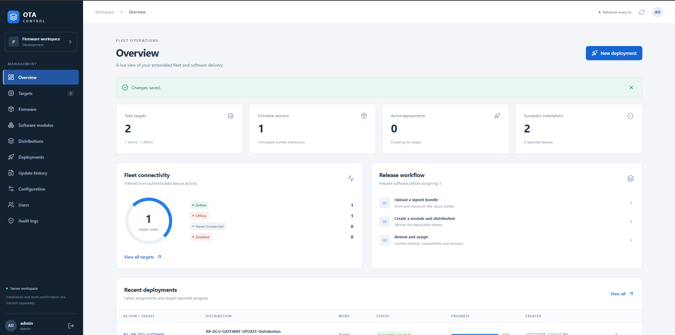

6 Use the dashboard
Use this guide to register a PHYTEC device, connect its existing updater, prepare a firmware release, and follow a deployment in OTA Control. Complete device enrollment before assigning firmware. Uploading a file or creating a release does not start installation.

What you need
Have the dashboard address and a user account, access to the target terminal, a signed .raucb bundle approved for the exact board, and a recovery procedure. The target must reach the server over the network. Keep the existing RAUC service, bootloader, partitions, keyring, and updater executable in place.

Open the dashboard
1. Open the configured server address in a browser. For the illustrated lab, the example address is http://192.168.11.17:8081/. Use your actual server address if different.
2. Sign in with the account issued by your administrator. There is no built-in default password.
3. Use the left menu to move between Targets, Firmware, Software modules, Distributions, Deployments, and Update history.
Role | Use | Administrative access
Viewer | Read fleet and update information | No changes
Operator | Upload and assign firmware | Cannot manage target identities or users
Admin | Full operational workflow | Targets, credentials, users and audit logs

Order of work
Add target → configure updater → confirm communication → upload firmware → create software module → create distribution → review deployment → monitor feedback.
The dashboard refreshes every five seconds. Device polling is separate; the default device interval is 60 seconds unless overridden. Opening a deployment timeline refreshes its details every three seconds.
Related procedures: README.md covers setup and upgrades; docs/deployment-guide.md covers hosting; docs/hardware-testing.md covers installation and reboot checks; docs/code-flow.md explains the implementation.

7 Add and enable a target
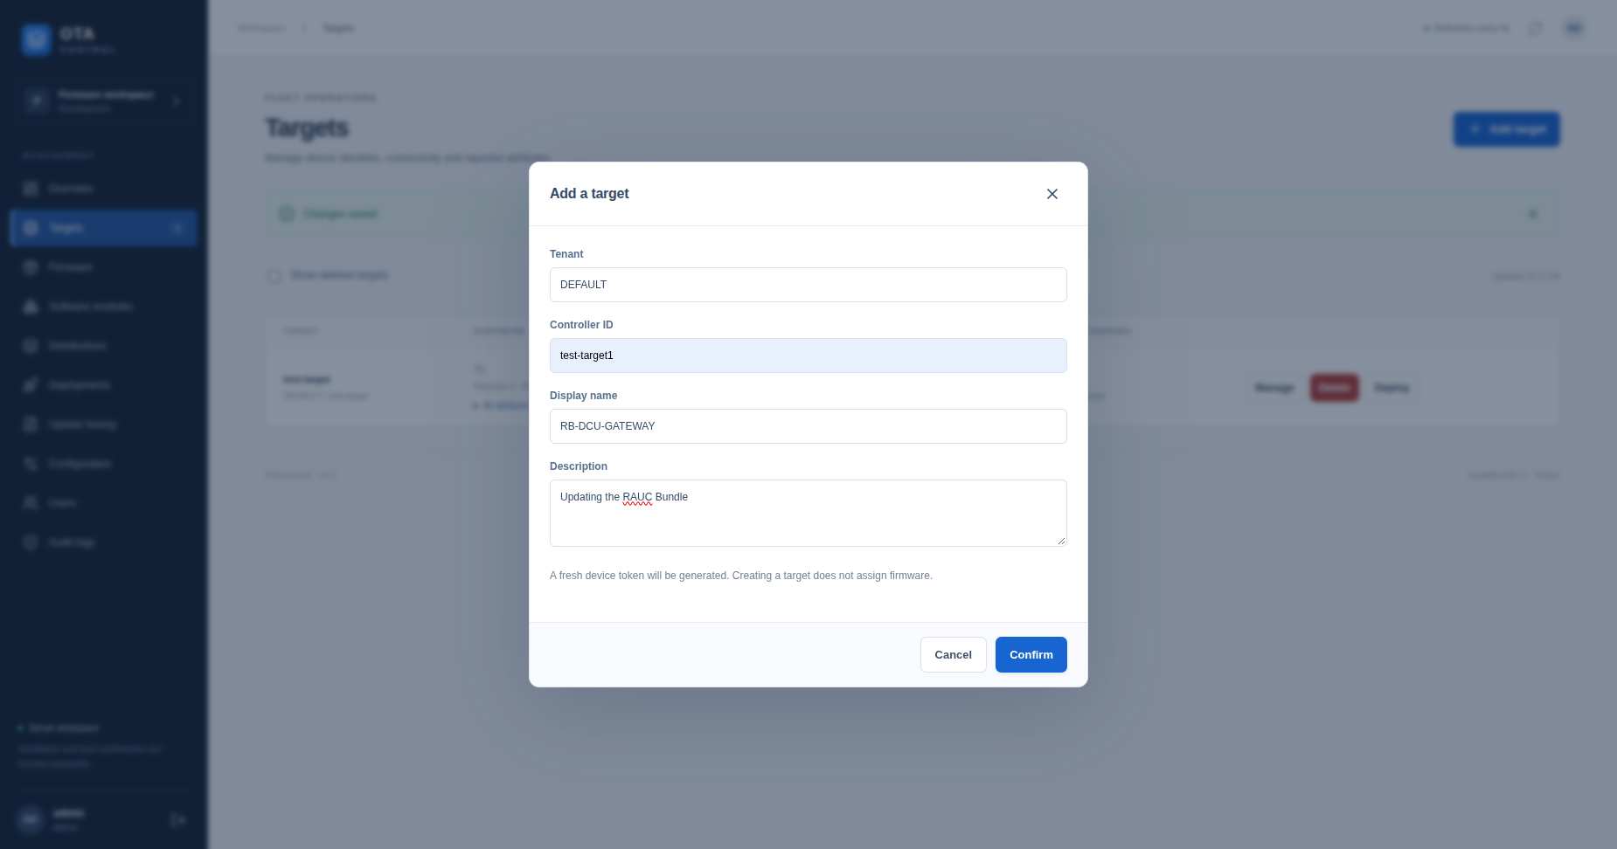

1. Sign in as an administrator and open Targets. Select Add target.
2. Enter the fields below and select Confirm.
3. Copy the generated device token immediately and store it privately. The plaintext token is shown only once. It belongs to this specific target.
4. Find the new row. Open Manage and confirm Target enabled is checked. Save if you change it.
5. Configure the updater with the matching tenant, controller ID, and token as described on the next page.
Field | Example | Meaning
Tenant | DEFAULT | Must match tenant_id on the target
Controller ID | test-target1 | Must match target_name on the target
Display name | RB-DCU-GATEWAY | Friendly label shown in the dashboard
Description | Gateway firmware updates | Optional operator note

Check the correct identity
The display name is not the controller ID. In this example the dashboard name is RB-DCU-GATEWAY, while the updater must send test-target1. The combination DEFAULT / test-target1 identifies the device. A different tenant may use the same controller ID.

Understand the status
Never Connected means no authenticated activity has been recorded. Online means recent authenticated activity. Offline means the last activity is older than the configured threshold; it does not by itself disable deployment. Disabled means access is turned off. Deleted means the record was removed from the normal fleet list.

If the device is missing from deployment selection
Open Targets → Manage and enable it. Deleted targets and targets with an active deployment cannot be selected. Finish the existing action, or cancel it only if it has not been discovered. Close and reopen New deployment after saving. An enabled offline target can be assigned an update, but it must reconnect and poll to receive it.

8 Configure the target updater
Perform these steps on the PHYTEC target, not on the server PC. Before reconnecting a device, check that it has no unintended active deployment. Keep a private backup of its existing configuration.
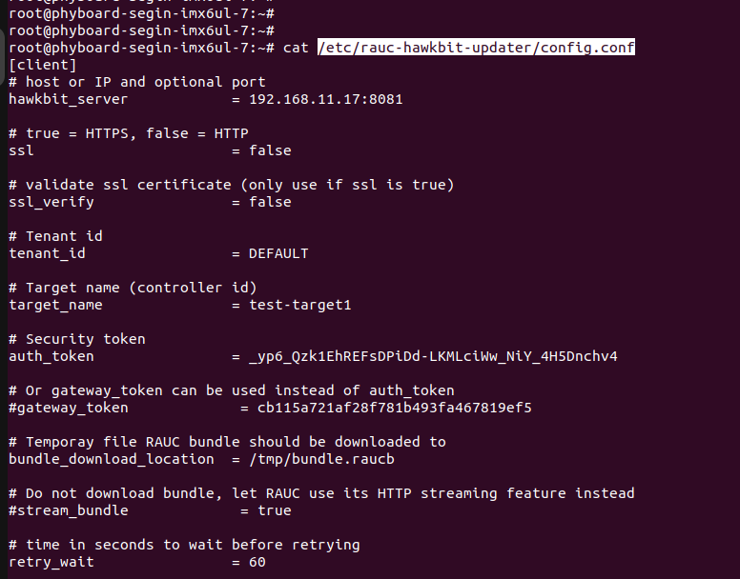
1. Edit /etc/rauc-hawkbit-updater/config.conf using your usual terminal editor.
2. Set the server, tenant, controller ID, and the newly generated token. Preserve other board-specific settings unless your approved procedure requires a change.
3. For the illustrated HTTP lab, use the example below. Replace REPLACE_WITH_DEVICE_TOKEN with the actual token and use the correct server address.
[client]
hawkbit_server = 192.168.11.17:8081
ssl = false
ssl_verify = false
tenant_id = DEFAULT
target_name = test-target1
auth_token = REPLACE_WITH_DEVICE_TOKEN
bundle_download_location = /tmp/bundle.raucb
retry_wait = 60
Use the target token generated by this dashboard. Gateway-token authentication is not implemented by this server. Leave gateway_token unused. The HTTP settings above are for the illustrated lab; use the configured HTTPS server and certificate validation for production. Do not copy an exposed token from a screenshot.

Start communication and check it
After checking the assigned actions, restart the existing updater service. If your image uses a different unit name, use that installed service name.
systemctl restart rauc-hawkbit-updater
systemctl status rauc-hawkbit-updater
journalctl -u rauc-hawkbit-updater --since '5 minutes ago'
Wait for a polling cycle, then check Targets. Last seen should update and the status should become Online. Confirm several polling cycles. Unknown model or MAC means the expected attributes have not been reported; do not treat a display name alone as hardware verification.
The download location needs enough free space for the bundle. Leave streaming disabled for this download-to-file workflow. Keep post_update_reboot=false when a controlled reboot is required by your lab procedure.

9 Upload and manage firmware
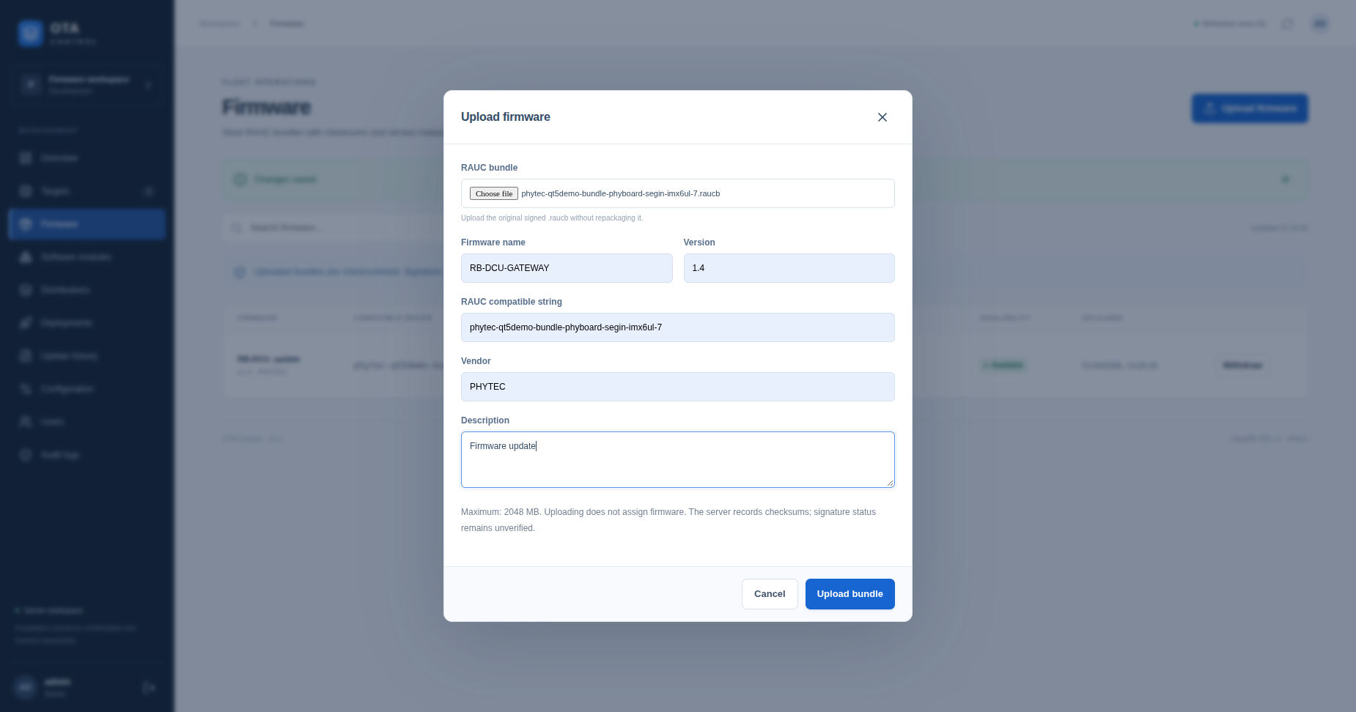

1. Open Firmware and select Upload firmware.
2. Choose the original signed .raucb file. Do not rename internal files or repackage the bundle.
3. Enter firmware name and version, the actual RAUC compatible string, vendor if needed, and a description.
4. Select Upload bundle and wait for the result. A 100% progress bar means file transfer has finished; server processing must still complete.
5. Confirm that the firmware row is Available. Expand Checksums to inspect the SHA-256, SHA-1, and signature-status information.

Choose accurate metadata
Use the compatible value from the approved bundle manifest and the target RAUC configuration. Do not infer it from the filename or copy it from an unrelated example. Your release preparation process should verify the intended hardware, signature trust, and firmware version before upload.
For example, a filename ending in phyboard-segin-imx6ul-7.raucb does not establish the exact compatible value. The server records the compatible text you enter and does not verify the manifest or signature. RAUC on the device performs its trust and compatibility checks.

Resolve a duplicate upload
Identical artifact already exists means the SHA-256 checksum matches a stored artifact. Filename, firmware name, and form version do not change this check. Close the dialog and use the existing firmware. If it is Withdrawn, select Restore on its row and confirm. Build a new signed bundle when the actual firmware contents or embedded metadata must change.

Withdraw or restore a bundle
Select Withdraw to stop new assignments from using the bundle. The server retains the bytes and history. Withdrawal is blocked while an active deployment requires that artifact. Select Restore to make a withdrawn artifact available again with its original metadata and checksums. Restoration does not deploy it.
The normal maximum upload size is 2048 MB; use the value shown in your dashboard if configured differently. A signature status of not verified by server is expected and does not replace target-side verification.

10 Prepare a deployable distribution

Create a software module

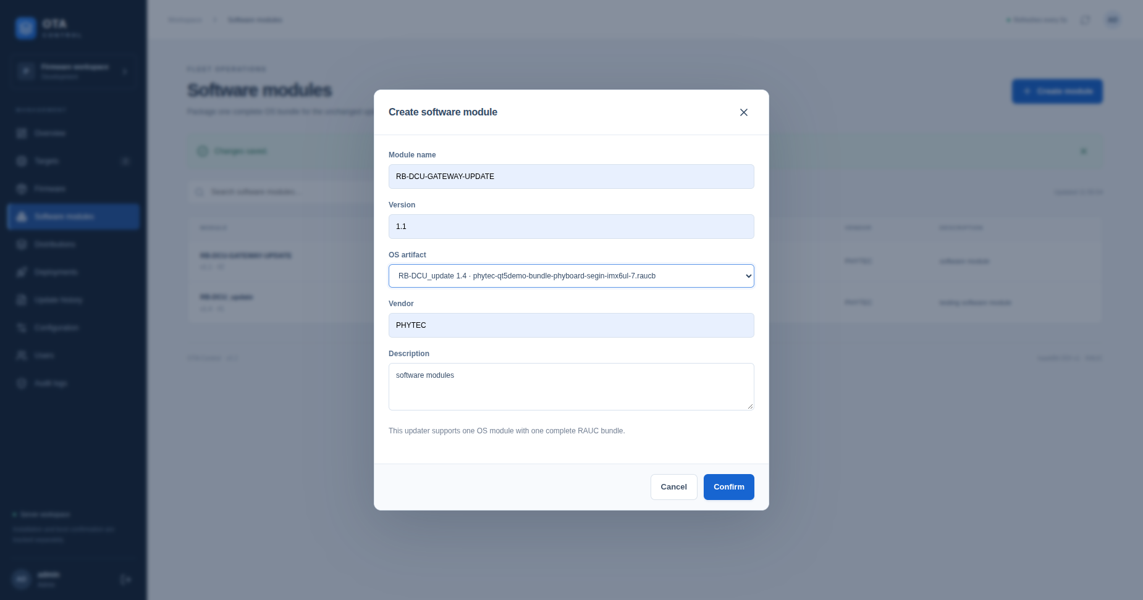

1. Open Software modules and select Create module.
2. Enter Module name and Version. For a consistent example, use RB-DCU-GATEWAY-UPDATE and 1.1.
3. Select the intended available firmware in OS artifact. Check its filename and version before continuing.
4. Enter Vendor and Description if required, then select Confirm. Verify the new row and its linked artifact.
This workflow packages one OS module with one complete RAUC bundle. A module name/version pair must be unique. Creating a module does not transfer or install firmware.

Create a distribution
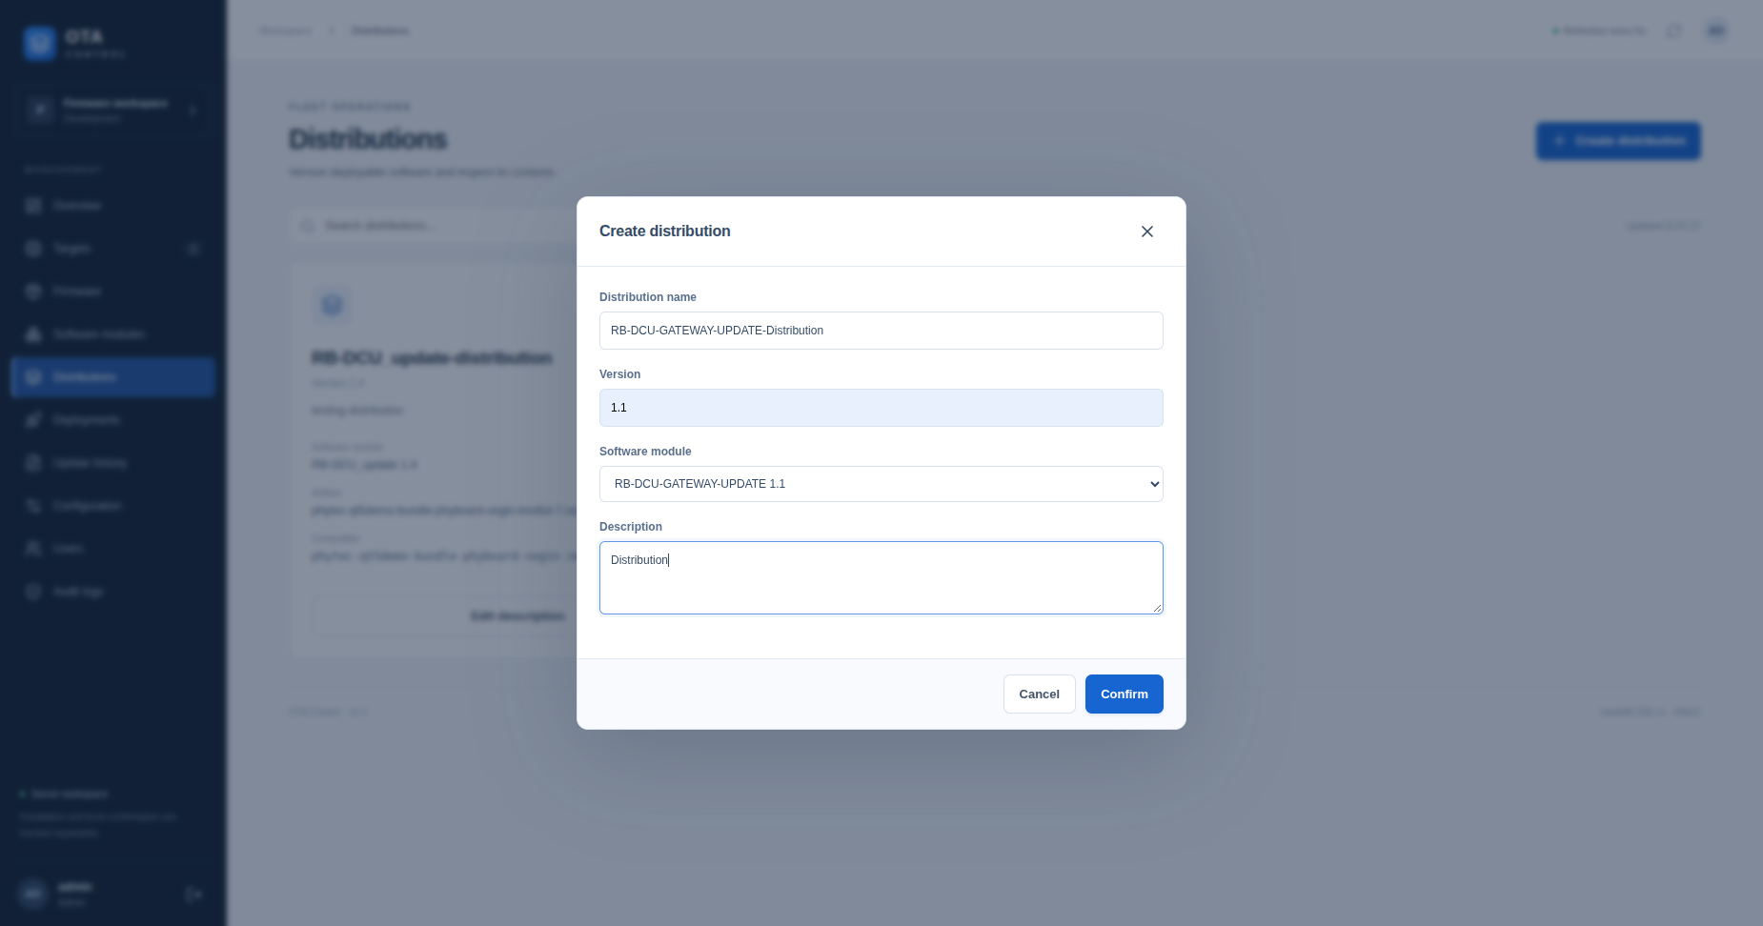

1. Open Distributions and select Create distribution.
2. Enter Distribution name, such as RB-DCU-GATEWAY-UPDATE-Distribution, and its release Version, such as 1.1.
3. Choose the software module created above. Add a useful description and select Confirm.
4. Inspect the new distribution card. Confirm its software module, artifact filename, compatible value, and Available status.

Understand the three version labels
Version | Where it is entered | How it is used
Firmware | Upload firmware | Metadata describing the stored file
Module | Create software module | Version sent in the updater OS chunk
Distribution | Create distribution | Release version typed during assignment review

Keep these versions consistent with your release process. For example, a module/distribution labeled 1.1 can reference firmware labeled 1.4. Changing these labels does not alter the signed bundle or turn it into a new firmware build. Verify the real bundle version before choosing what to install.
A distribution becomes unavailable when its linked artifact is withdrawn. Restore the artifact before assigning it. Edit description updates the operator note only; it does not change bundle contents.

11 Assign a deployment
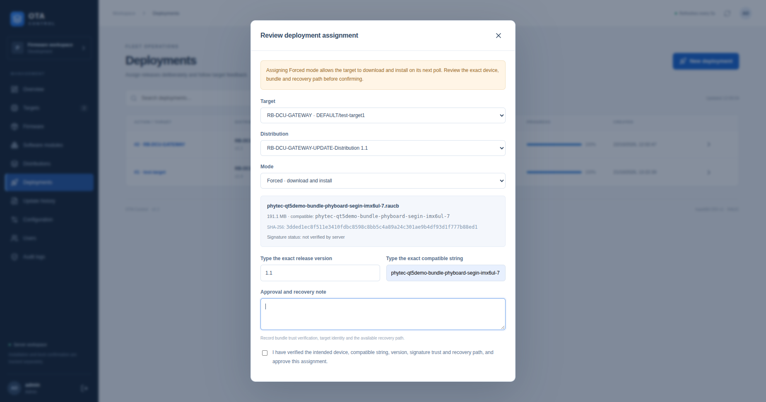

An assignment in Forced mode can trigger installation on the device’s next poll. Complete your device, bundle, trust, and recovery checks before confirming.
1. Open Deployments → New deployment, or choose Deploy beside the intended target.
2. Select the exact Target and Distribution. Check tenant and controller ID as well as the display name.
3. Choose Download Only to transfer and verify the file without installation, or Forced to download and install through RAUC.
4. Inspect the artifact summary, including filename, size, compatible value, and checksum.
5. Type the exact release version shown for the selected distribution. If the distribution is version 1.1, enter 1.1.
6. Type the exact compatible string shown in the selected artifact summary. Independently confirm that it matches the bundle and device.
7. Write an Approval and recovery note. Record the checks actually performed and the available recovery method; do not confirm checks you have not completed.
8. Tick the approval checkbox, then select Confirm assignment. Note the new action ID and monitor it in Deployments.

An example approval note
Use a note specific to the actual work, for example: “Verified DEFAULT/test-target1 against the physical lab device; checked approved bundle signature trust and compatible value; recovery console available; controlled reboot planned separately.” Only use this wording when those checks have been performed.

What happens after confirmation
The server stores the assignment and waits for the device to poll. It does not push the update immediately. The first poll advertising the action marks it Discovered. The target then requests metadata, downloads its assigned bytes, and reports progress. Only one active deployment per target is allowed.
Download Only should finish as Download Succeeded. Forced can finish as Install Succeeded or a failure state. Neither mode changes target enrollment. If a network error leaves the outcome uncertain, check the deployment list before creating another assignment.

12 Monitor progress and verify the result
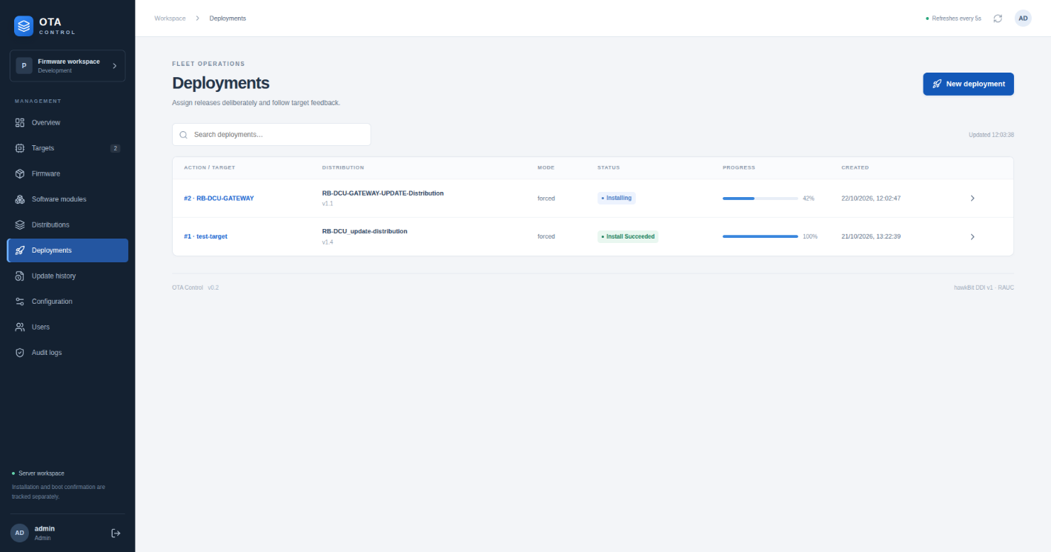

1. Open Deployments and locate the action ID and target.
2. Review its distribution, mode, status, progress, and creation time.
3. Select the action/target link or row detail control to open the event timeline. Read the reported messages and timestamps.
4. On the target, inspect updater and RAUC logs if progress stops or a failure is reported.
5. After a reported installation success, verify the target’s RAUC status. Perform reboot and post-boot checks through your approved hardware procedure.
Status | Meaning | Operator action
Waiting for Target | Assignment exists; no discovery yet | Check connectivity and updater polling
Discovered | Target received the action link | Follow metadata and download activity
Downloading or Downloaded | Transfer or verification stage | Follow feedback and available disk space
Installing | Target reports installation activity | Monitor RAUC and preserve error messages
Download Succeeded | Download-only completion reported | No installation is implied
Install Succeeded | Client reported installation success | Verify boot separately
Install Failed or Rejected | Terminal failure or refusal | Investigate before a deliberate retry

Use target evidence
journalctl -u rauc-hawkbit-updater --since '15 minutes ago'
journalctl -u rauc --since '15 minutes ago'
rauc status
The illustrated 42% Installing value is reported progress, not a completion estimate. Install Succeeded at 100% does not prove the new firmware is currently running, that reboot succeeded, or that a rollback did not occur. Running: Unknown and unknown boot confirmation remain valid until independently checked.
Update history lists completed actions. Keep the action ID, target identity, distribution version, outcome, and relevant target logs with the release record. Sanitize logs before sharing because HTTP traces may contain tokens.

===== END OF THE DOCUMENTATION =====

