<html>

<title>1st Practical</title>

<body>

<body background="C:\HTML\ras.jpg">

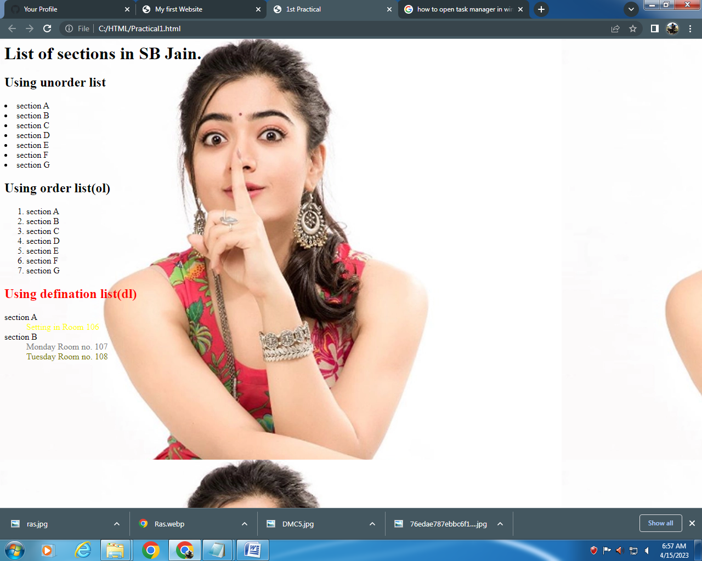<h1>List of sections in SB Jain.</h1>

<h2>Using unorder list</h2>

<li>section A</li>

<li>section B</li>

<li>section C</li>

<li>section D</li>

<li>section E</li>

<li>section F</li>

<li>section G</li>

<h2>Using order list(ol)</h2>

<ol>

<li>section A</li>

<li>section B</li>

<li>section C</li>

<li>section D</li>

<li>section E</li>

<li>section F</li>

<li>section G</li>

</ol>

<h2 style="color:red">Using defination list(dl)</h2>

<dl>

<dt>section A</dt>

<dd style="color:yellow">Setting in Room 106</dd>

<dt>section B</dt>

<dd style="color:gray">Monday Room no. 107</dd>

<dd style="color:olive">Tuesday Room no. 108</dd>

</dl>

</body>

</html>