Foundation
- $f\left(x\right)=x+2$.
Find the values of:
- $f\left(f\left(0\right)\right)$  4 | - $f\left(f\left(3\right)\right)$  7 | - $f\left(f\left(-1\right)\right)$  3 | - $f\left(f\left(-8\right)\right)$  $$-4$$
  - Find an expression for $f\left(f\left(x\right)\right)$

$$x+4$$
  - Check your answers for a – d, how do they relate to your expression for $f\left(f\left(x\right)\right)$?

The composite function is to add 4 to the value of $x$, which reflect the answers to part a – d.
  - Find a value of $x$ where $f\left(f\left(x\right)\right)=0$.

$$x=-4$$
- $f\left(x\right)=2x$
Find the values of:
- $f\left(f\left(0\right)\right)$  0 | - $f\left(f\left(7\right)\right)$  28 | - $f\left(f\left(-3\right)\right)$  $$-12$$ | - $f\left(f\left(-11\right)\right)$  $$-44$$
  - Find an expression for $f\left(f\left(x\right)\right)$

$$4x$$
  - Check your answers for a – d, how do they relate to your expression for $f\left(f\left(x\right)\right)$?

The composite function is to multiply the value of $x$ by 4, which reflect the answers to parts a – d.
  - Find a value of $x$ where $f\left(f\left(x\right)\right)=32$.

$$x=8$$

- $g\left(x\right)=2-x$. Show that $g\left(g\left(x\right)\right)=x$.

$$g\left(x\right)=2-x$$
$$g\left(2-x\right)=2-\left(2-x\right)$$
$$∴g\left(2-x\right)=x$$
- $h\left(x\right)=3x-5$. Find an expression for $h\left(h\left(x\right)\right)$.

$$9x-20$$

- Let $f\left(x\right)=3x+4$ and $g\left(x\right)=3-2x$.
- Find $f\left(g\left(2\right)\right)$  1 | - Find $g\left(f\left(2\right)\right)$  $$-17$$
- Show that $f\left(g\left(x\right)\right)=-6x+13$  $f\left(x\right)=3x+4$  $f\left(g\left(x\right)\right)=f\left(3-2x\right)$  $=3\left(3-2x\right)+4$  $=-6x+13$ | - Show that $g\left(f\left(x\right)\right)=-6x-5$  $g\left(x\right)=3-2x$  $$g\left(f\left(x\right)\right)=g(3x+4)$$  $=3-2\left(3x+4\right)$  $=-6x-5$

- $f\left(x\right)=x+1$ and $g\left(x\right)=2x-3$
Find the values of:
- $f\left(g\left(7\right)\right)$  12 | - $g\left(f\left(7\right)\right)$  13 | - $f\left(f\left(7\right)\right)$  9 | - $g\left(g\left(7\right)\right)$  19
Find expressions for
- $f\left(g\left(x\right)\right)$  $$2x-2$$ | - $g\left(f\left(x\right)\right)$  $$2x-1$$ | - $f\left(f\left(x\right)\right)$  $$x+2$$ | - $g\left(g\left(x\right)\right)$  $$4x-9$$

Development
- $\text{Given }f(x)=2x+7 \text{and} g(x)=5x-3\text{, find:}$
- $f(g(x))$  $$10x+1$$ | - $g(f(x))$  $$10x+32$$
- $f(f(x))$  $$4x+21$$ | - $g(g(x))$  $$25x-18$$

- $f\left(x\right)=\sqrt{x}$ and $g\left(x\right)=x+4$
- Find $f\left(g\left(x\right)\right)$  $$\sqrt{x+4}$$ | - Find $g\left(f\left(x\right)\right)$  $$\sqrt{x}+4$$
- Find $g\left(g\left(x\right)\right)$  $$x+8$$ | - What composite function would produce $\sqrt{x+8}$?  $$f\left(g\left(g\left(x\right)\right)\right)$$

- $\text{Given }p(x)=x^{2}-4 \text{and} q(x)=2x+3\text{, simplify}$:
- $p(q(x))$  $$4x^{2}+12x+5$$ | - $q(p(x))$  $$2x^{2}-5$$
- $p(p(x))$  $$x^{4}-8x^{2}+12$$ | - $q(q(x))$  $$4x+9$$

- $\text{Given }h(x)=\frac{2}{x+3} \text{and} m(x)=4x-1\text{, find:}$
- $h(m(x))$  $$\frac{1}{2x+1}$$ | - $m(h(x))$  $$\frac{5-x}{x+3}$$ | - $h(h(x))$  $$\frac{2x+6}{3x+11}$$

- Find $f\left(g\left(x\right)\right)$ and $g\left(f\left(x\right)\right)$ for each of these function pairs.
- $f\left(x\right)=x-2$, $g\left(x\right)=2x+5$  $f\left(g\left(x\right)\right)$  $$2x+3$$  $g\left(f\left(x\right)\right)$  $$2x+1$$ | - $f\left(x\right)=2x$, $g\left(x\right)=3x$  $f\left(g\left(x\right)\right)$  $$6x$$  $g\left(f\left(x\right)\right)$  $$6x$$
- $f\left(x\right)=x^{2}$, $g\left(x\right)=x^{3}$  $f\left(g\left(x\right)\right)$  $$x^{6}$$  $g\left(f\left(x\right)\right)$  $$x^{6}$$ | - $f\left(x\right)=$ $\frac{1}{x}$, $g\left(x\right)=\sqrt{x}$  $f\left(g\left(x\right)\right)$  $$\frac{1}{\sqrt{x}}$$  $g\left(f\left(x\right)\right)$  $$\frac{1}{\sqrt{x}}$$

- $f\left(x\right)=$ $\frac{x}{x+1}$, find $f\left(f\left(x\right)\right)$.

$$\frac{x}{2x+1}$$
- HSC Sample Question Band 4
Given $f\left(2\right)=5, f\left(3\right)=4, g\left(2\right)=5, g\left(3\right)=2,g\left(4\right)=1.$
What is the value of $f\left(g\left(3\right)\right)$?

$$f\left(g\left(3\right)\right)=f\left(2\right)=5$$

- HSC Sample Question Band 4
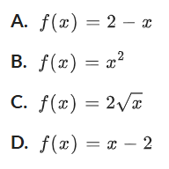
Which of these functions satisfies $f\left(f\left(x\right)\right)=x$?

A
- HSC Sample Question Band 4
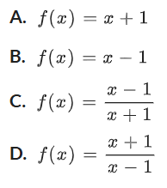
Which of these functions satisfies $f\left(f\left(x\right)\right)=x$?

D

- Consider the graphs of $f\left(x\right)$ and $g\left(x\right)$ below.
  - Evaluate $g\left(3\right)$.
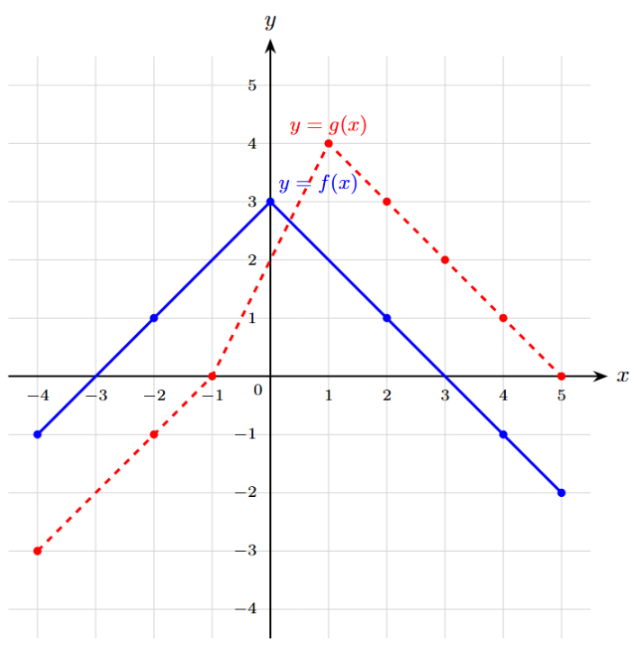
2
  - Hence evaluate $f\left(g\left(3\right)\right)$.
1
  - Evaluate $g\left(f\left(0\right)\right)$.
2
  - $f\left(f\left(1\right)\right).$
1
  - $g\left(g\left(4\right)\right)$.
4
  - $f\left(g\left(3\right)\right)$
1
  - $g\left(f\left(3\right)\right)$
2
  - $f\left(g\left(5\right)\right)$
3
  - $g\left(f\left(5\right)\right)$
$$-1$$
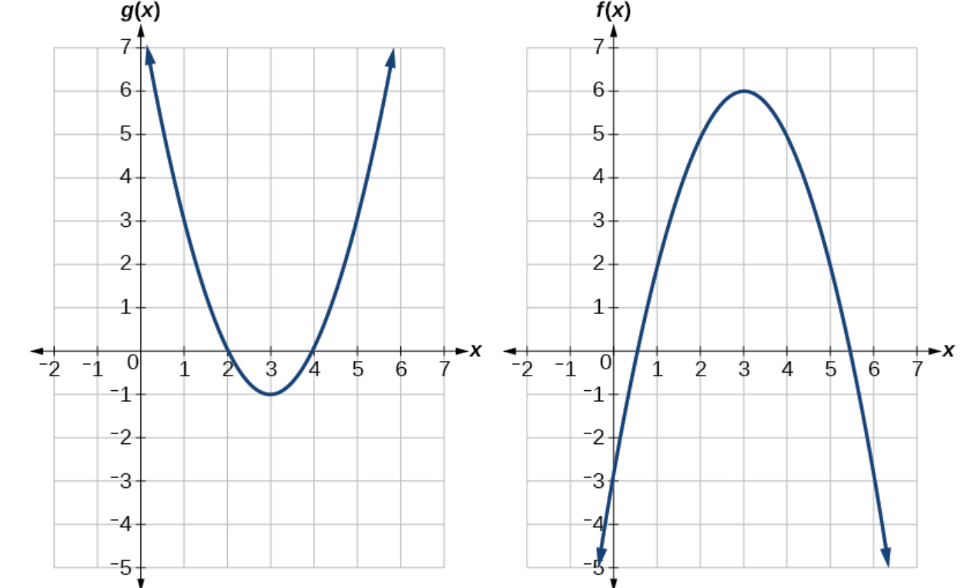
- Using the graphs below, evaluate $f\left(g\left(1\right)\right)$ and $g\left(f\left(2\right)\right)$

$f\left(g\left(1\right)\right): g\left(1\right)=3$, $f\left(3\right)=6$
$$g\left(f\left(2\right)\right): f\left(2\right)=5, g\left(5\right)=3$$

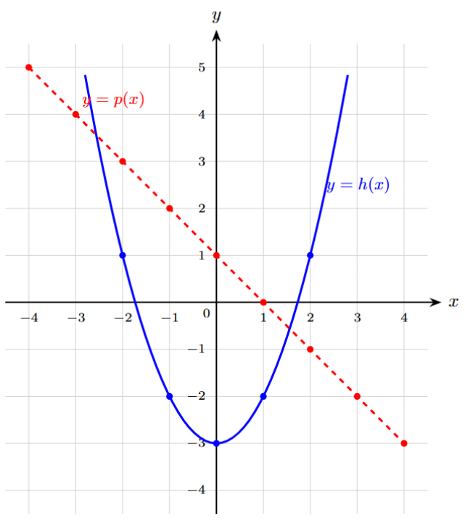
- Consider the graphs of $p\left(x\right)$ and $h\left(x\right)$ below. Evaluate:
  - $h\left(p\left(2\right)\right)$

$$-2$$
  - $p\left(h\left(2\right)\right)$

$$0$$
  - $h\left(h\left(1\right)\right)$

$$1$$
  - $p\left(p\left(-3\right)\right)$

$$-3$$

- 2022 HSC Advanced Band 5
The graphs of $y=f\left(x\right)$ and $y=g\left(x\right)$ are shown.
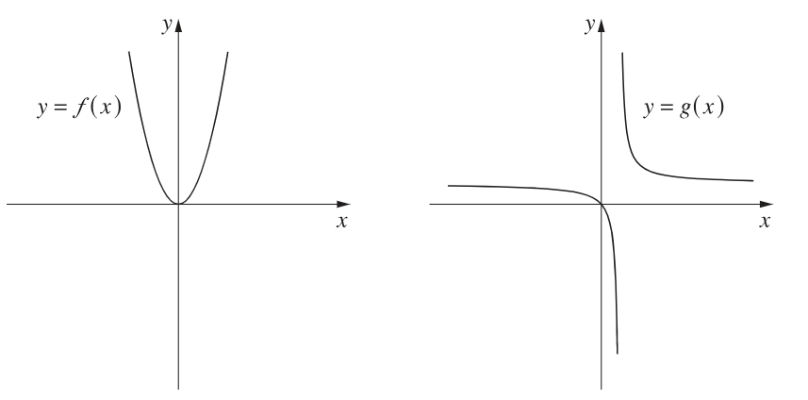

Which graph best represents $y=g\left(f\left(x\right)\right)$?
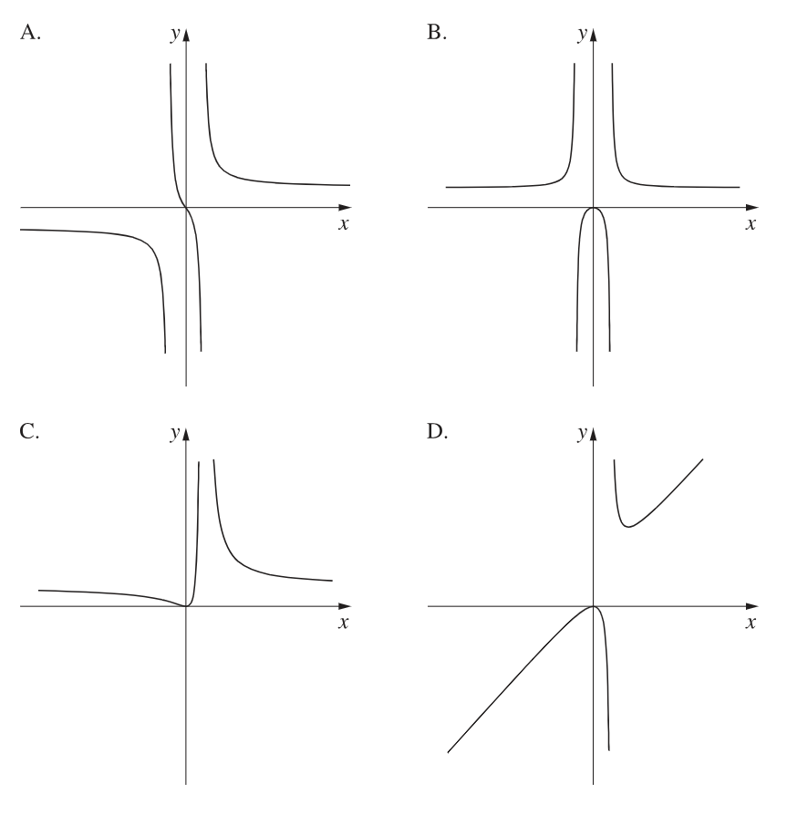

Since $f\left(x\right)$ is even, $g\left(f\left(x\right)\right)$ will also be even.
B
- Consider once again the graph of $f\left(x\right)$ and $g\left(x\right)$ below.
  - Find all values of $x$ in the domain $\left[-4,5\right]$ that satisfy $f(g(x))=3$.

Consider $f\left(g(x)\right)=3$
$$\text{Look for points where graph }f\text{ reaches height }y=3.$$
$$\text{From the grid, }f\left(g\left(x\right)\right)=3\text{ only when }g\left(x\right)=0.$$
Solve $g\left(x\right)=0:$
$$x=-1, 5$$
  - [2-cycle fixed points]
    - Evaluate $ffff\left(x\right)$ for $x=0$.
    - Evaluate $ffff\left(x\right)$ for $x=3$.
    - Explain geometrically why the pair $\{0,3\}$ forms an alternating cycle under composition by $f$, and state other alternating cycles for $f$.

Repeated compositions of $x=0$ and $x=3$ keep alternating between $0$ and $3$.
An alternating cycle occurs when $f\left(a\right)=b$ and $f\left(b\right)=a$
Geometrically, this means $\left(a,b\right)$ and $\left(b,a\right)$ must lie on the graph of $y=f\left(x\right)$
These two points are mirror reflections across the line $y=x$
Therefore, all points with symmetry across $y=x$ on the graph of $f\left(x\right)$ will have this property, such as $\left\{1,2\right\}$ and $\left\{0.5,2.5\right\}$
By considering the graph, the solution set is all $\left(x,y\right)$ pairs satisfying $y=3-x$ in the domain $x∈\left[0,3\right]$

Development
- For each function, find its inverse $f^{-1}\left(x\right)$ then verify $f\left(f^{-1}\left(x\right)\right)=x$ and $f^{-1}\left(f\left(x\right)\right)=x$.
- $f\left(x\right)=x^{3}+1$  $$f^{-1}\left(x\right)=\sqrt[3]{x-1}$$  Verify $f\left(f^{-1}\left(x\right)\right)=x$  Verify $f^{-1}\left(f\left(x\right)\right)=x$ | - $f\left(x\right)=$ $\frac{1-x}{3+x}$  $$f^{-1}\left(x\right)=\frac{1-3x}{1+x}$$  Verify $f\left(f^{-1}\left(x\right)\right)=x$  Verify $f^{-1}\left(f\left(x\right)\right)=x$ | - $f\left(x\right)=\sqrt[3]{x-7}$  $$f^{-1}\left(x\right)=x^{3}+7$$  Verify $f\left(f^{-1}\left(x\right)\right)=x$  Verify $f^{-1}\left(f\left(x\right)\right)=x$

- $f(x)=3x+4$ and $g(x)=ax^{2}$
  - Work out an expression for $f^{-1}(x)$
  - Given that $fg(3)=85$, find the value of $a$.

$$f^{-1}(x)=\frac{x-4}{3}$$
$$g\left(3\right)=9a$$
$$f\left(9a\right)=27a+4=85$$
$$a=3$$
- $f\left(x\right)=ax+8$ and $g\left(x\right)=2x-3$
  - Work out an expression for $f^{-1}(x)$
  - Given $fg(2)=13$, find the value of $a$.

$$f^{-1}\left(x\right)=\frac{x-8}{a} \\ g\left(2\right)=1$$
$$f\left(1\right)=a+8=13$$
$$a=5$$
- $f(x)=x^{2}-1$ and $g(x)=4x+5$
  - Work out an expression for $f^{-1}(x)$
  - Work out an expression for $g^{-1}(x)$
  - Given that $fg(x)=3gf(x)$, show that $4x^{2}+40x+21=0$
$$f^{-1}(x)=\sqrt{x+1}, g^{-1}(x)=\frac{x-5}{4}$$

$$fg\left(x\right)={\left(4x+5\right)}^{2}-1=16x^{2}+40x+24$$
$$gf\left(x\right)=4\left(x^{2}-1\right)+5=4x^{2}+1$$
$$16x^{2}+40x+24=3\left(4x^{2}+1\right) \\ 4x^{2}+40x+21=0$$
- $f(x)=2x+4$ and $g(x)=3x-8$
  - Find $f^{-1}(x)$ and $g^{-1}(x)$
  - Find an expression for $fg(x)$
  - Find an expression for the inverse of $fg\left(x\right)$
  - Is $(fg)^{-1}(x)$ the same as $f^{-1}g^{-1}(x)$?
  - Is $(fg)^{-1}(x)$ the same as $g^{-1}f^{-1}(x)$?

$$f^{-1}(x)=\frac{x-4}{2}, g^{-1}(x)=\frac{x+8}{3} \\ fg\left(x\right)=2\left(3x-8\right)+4=6x-12 \\ {\left(fg\right)}^{-1}(x)=\frac{x+12}{6} \\ f^{-1}g^{-1}(x)=\frac{x-4}{6} not the same as {\left(fg\right)}^{-1}(x) \\ g^{-1}f^{-1}(x)=\frac{x+12}{6} yes, the same as {\left(fg\right)}^{-1}(x)$$

Mastery

  - Let $f\left(x\right)$ be the function “increase $x$ by 50%”. Write the equation for $f\left(x\right)$.
$$f\left(x\right)=1.5x$$

  - A student in Year 8 says:
If you increase by 50%, then you can get back to the original by decreasing by 50%.

Let $g\left(x\right)$ be “decrease $x$ by 50%.”
    - Write the equation for $g\left(x\right)$.
$$g\left(x\right)=0.5x$$
    - Show that she is incorrect by finding $g\left(f\left(x\right)\right)$.

$$g\left(1.5x\right)=0.5\left(1.5x\right)=0.75x$$
Since $g\left(f\left(x\right)\right)≠x$, $g\left(x\right)$ is not the inverse of $f\left(x\right)$
Therefore, a decrease of 50% will not undo an increase of 50%
  - What is the inverse function $f^{-1}\left(x\right)$?

$$f^{-1}\left(x\right)=\frac{x}{1.5}=\frac{2x}{3}$$
  - Therefore, to undo a 50% increase, what percentage do you need to decrease by?

$f^{-1}\left(x\right)=$ $\frac{2}{3}$ $x$, we need to decrease $x$ by a third,
so $33.\dot{3}\%$decrease

  - Show that $\frac{x^{2}+x}{x^{2}+4x+3}$ can be written as $\frac{x}{x+a}$ where $a$ is a positive integer.

$$\frac{x(x+1)}{(x+1)(x+3)}=\frac{x}{x+3}, a=3$$
  - Hence, given $f\left(x\right)=\frac{x^{2}+x}{x^{2}+4x+3}$, find an expression for $f^{-1}\left(x\right)$

$$f^{-1}\left(x\right)=\frac{3x}{1-x}$$

Development
- Sketch the derivative function for each curve.
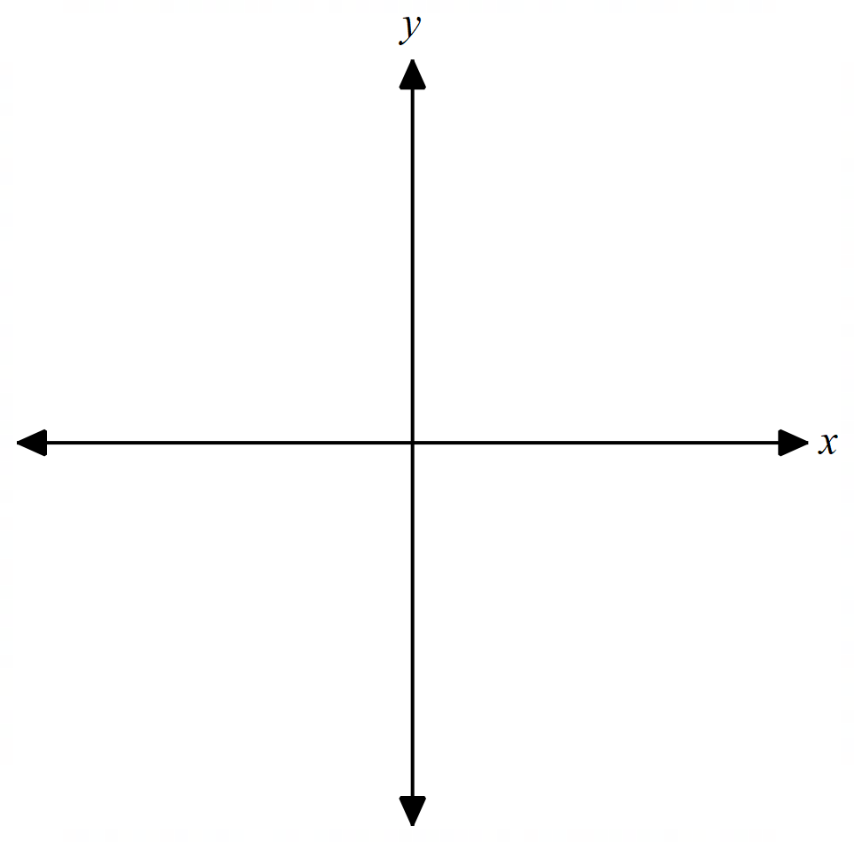
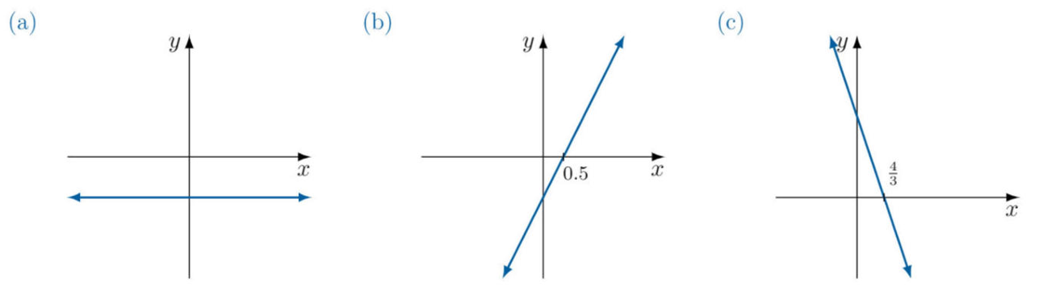
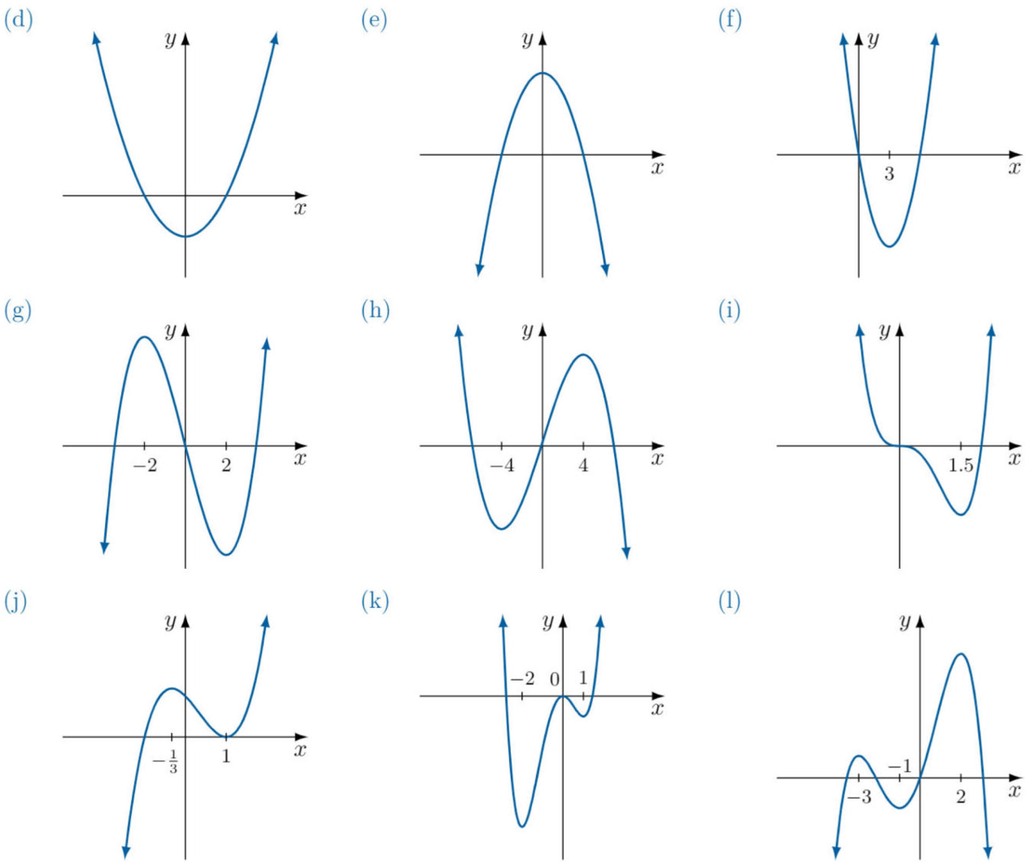
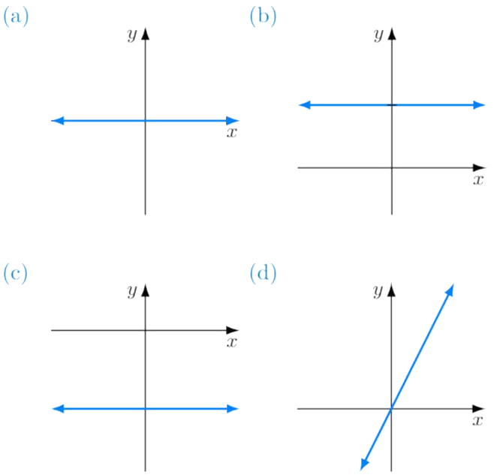
 | 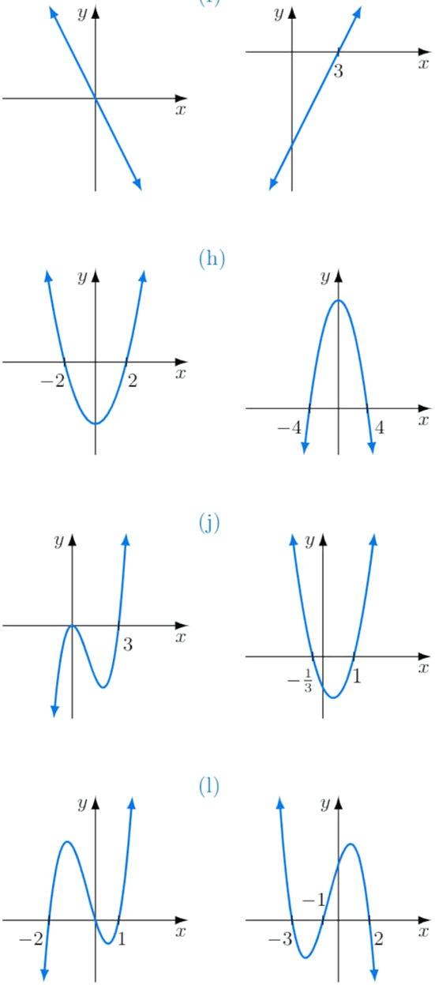
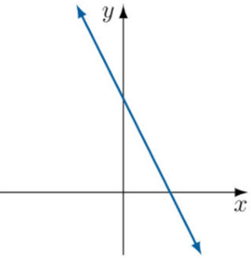  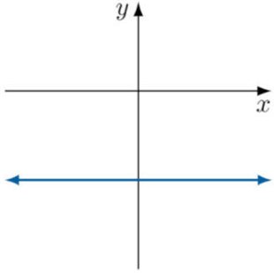 | 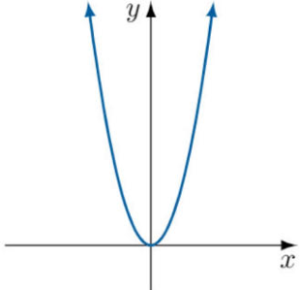  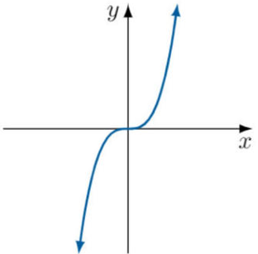 | 