Name

Stage 4
Volume

Book 1 |  | Version: 260912  Feedback:  https://MrDingMaths.com
Contents
Syllabus Content 2
Learning Intention 3

Syllabus Content
MA4-VOL-C-01 applies knowledge of volume and capacity to solve problems involving right prisms and cylinders
Describe the different views of prisms and solids that have been formed from prism combinations
- Represent prisms from different views in 2 dimensions, including top, side, front and back views
- Describe and illustrate solids formed from prism combinations from different views in 2 dimensions, including top, side, front and back views
- Identify and illustrate the cross-sections of different prisms
- Examine the idea that prisms have a uniform cross-section that is equal to the base area
- Determine if a particular solid has a uniform cross-section
Develop and apply the formula to find the volume of a prism to solve problems
- Develop the formula for the volume of a prism: $V=base area×height$, leading to $V=Ah$
- Apply the formula for the volume of a prism to prisms with uniform cross-sections to solve problems
Develop the formula for finding the volume of a cylinder and apply the formula to solve problems
- Develop and apply the formula to solve problems involving the volume of cylinders: $V=πr^{2}h$, where $r$ is the length of the radius of the base and ℎ is the perpendicular height
Choose appropriate units of measurement for volume and capacity and convert between units
- Recognise that 1000 L is equal to 1 kilolitre (kL) and use the abbreviation
- Recognise that 1000 kL is equal to 1 megalitre (ML) and use the abbreviation
- Choose an appropriate unit to measure the volume or capacity of different objects and justify the choice
- Convert between metric units of volume and capacity
(1 cm³ = 1000 mm³, 1 cm³ = 1 mL, 1 m³ = 1000 L = 1 kL)
- Solve practical problems involving the volume and capacity of right prisms and cylinders

Drawing Prisms

- Example Draw the top, side, front, and back view of a simple prism
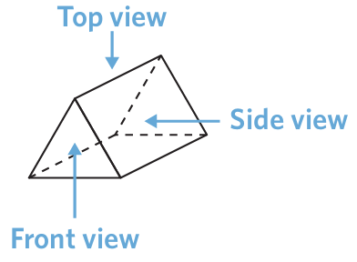

Front  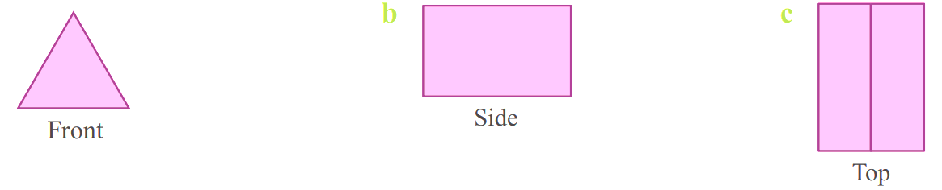 | Back | Side | Top

- Guided Practice
Sketch the front, back, side, and top views of these prisms.
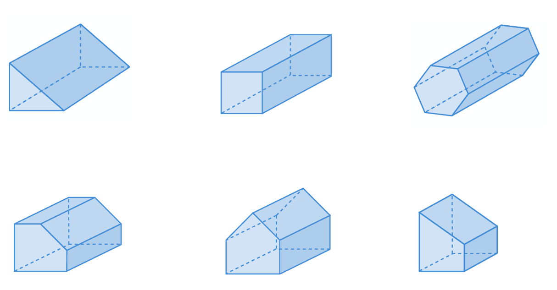

Front | Back | Side | Top

Front | Back | Side | Top

Foundation
- Sketch the front, back, side, and top views of these prisms.

Front | Back | Side | Top

Front | Back | Side | Top
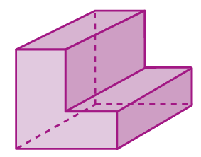

Front | Back | Side | Top

Front | Back | Side | Top

Front | Back | Side | Top
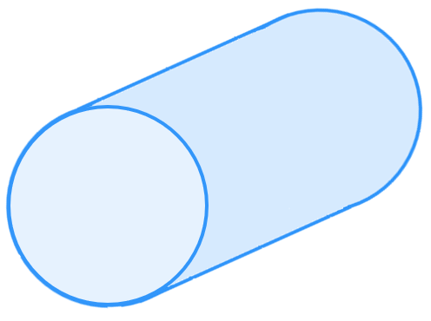

Front | Back | Side | Top
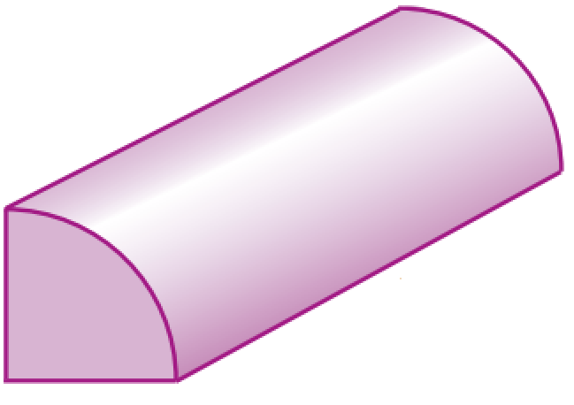

Front | Back | Side | Top

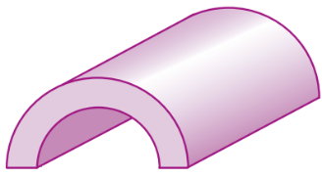

Front | Back | Side | Top

Development
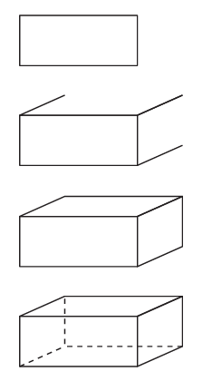
- Consider the example of how to sketch a rectangular prism and sketch these prisms.

- Triangular Prism | - Cube

- Pentagonal Prism | - Hexagonal Prism

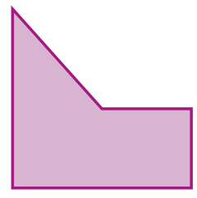
- Sketch a prism with the following front and back faces:
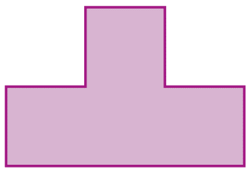

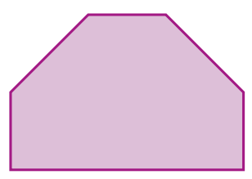
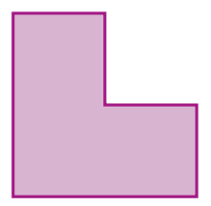

Mastery
- Sketch these prisms using the given faces.
- Front /Back Side Top
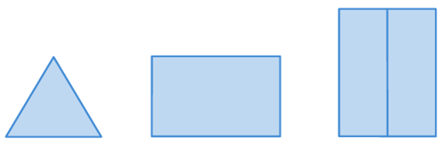

- Front /Back Side Top
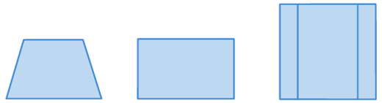

- Front /Back Right-side Left-side Top
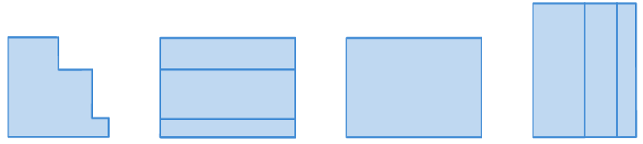

- Sketch these prisms using the given faces and label the dimensions.
- Front /Back Side Top
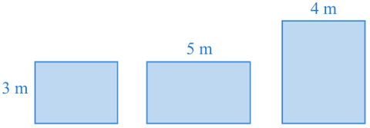

- Front /Back Side Top
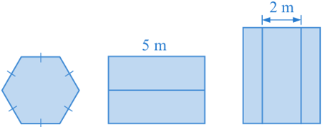

- Front /Back Right-side Left-side Top
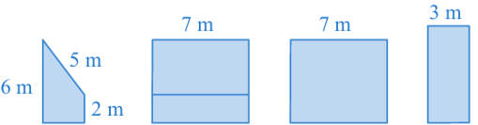

Cross-Section of a Prism

- Prisms
- A prism is a type of 3D solid with identical opposite end faces connected by rectangular sides.
- The base of a prism is the identical opposite end faces.
- The height of a prism is the perpendicular distance between the bases.
- We name prisms based on the shape of their base.
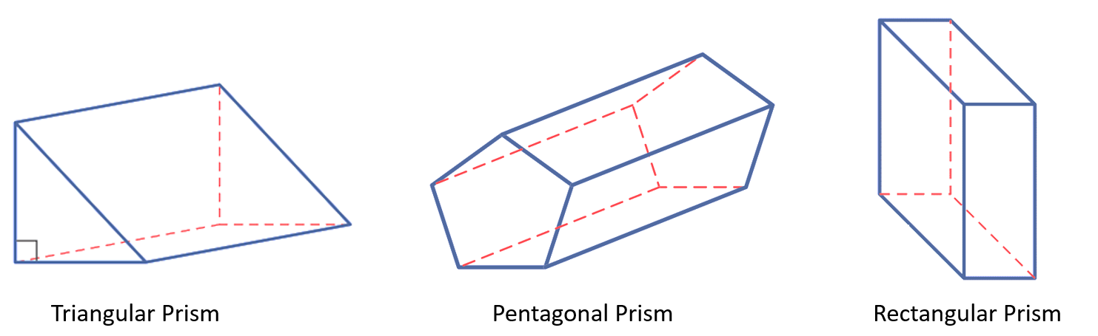  Triangular Prism | Pentagonal Prism | Rectangular Prism

- Identify prisms
 |  |  |  |  | 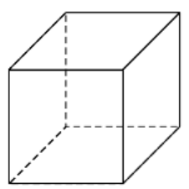
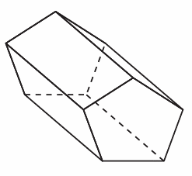 |  |  |  |  | 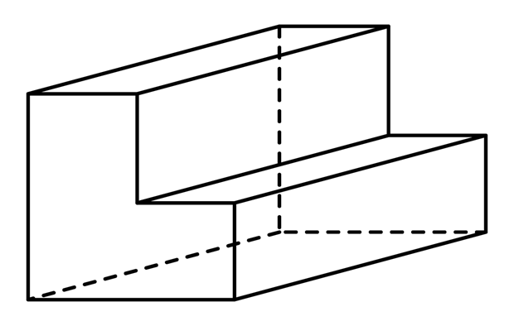  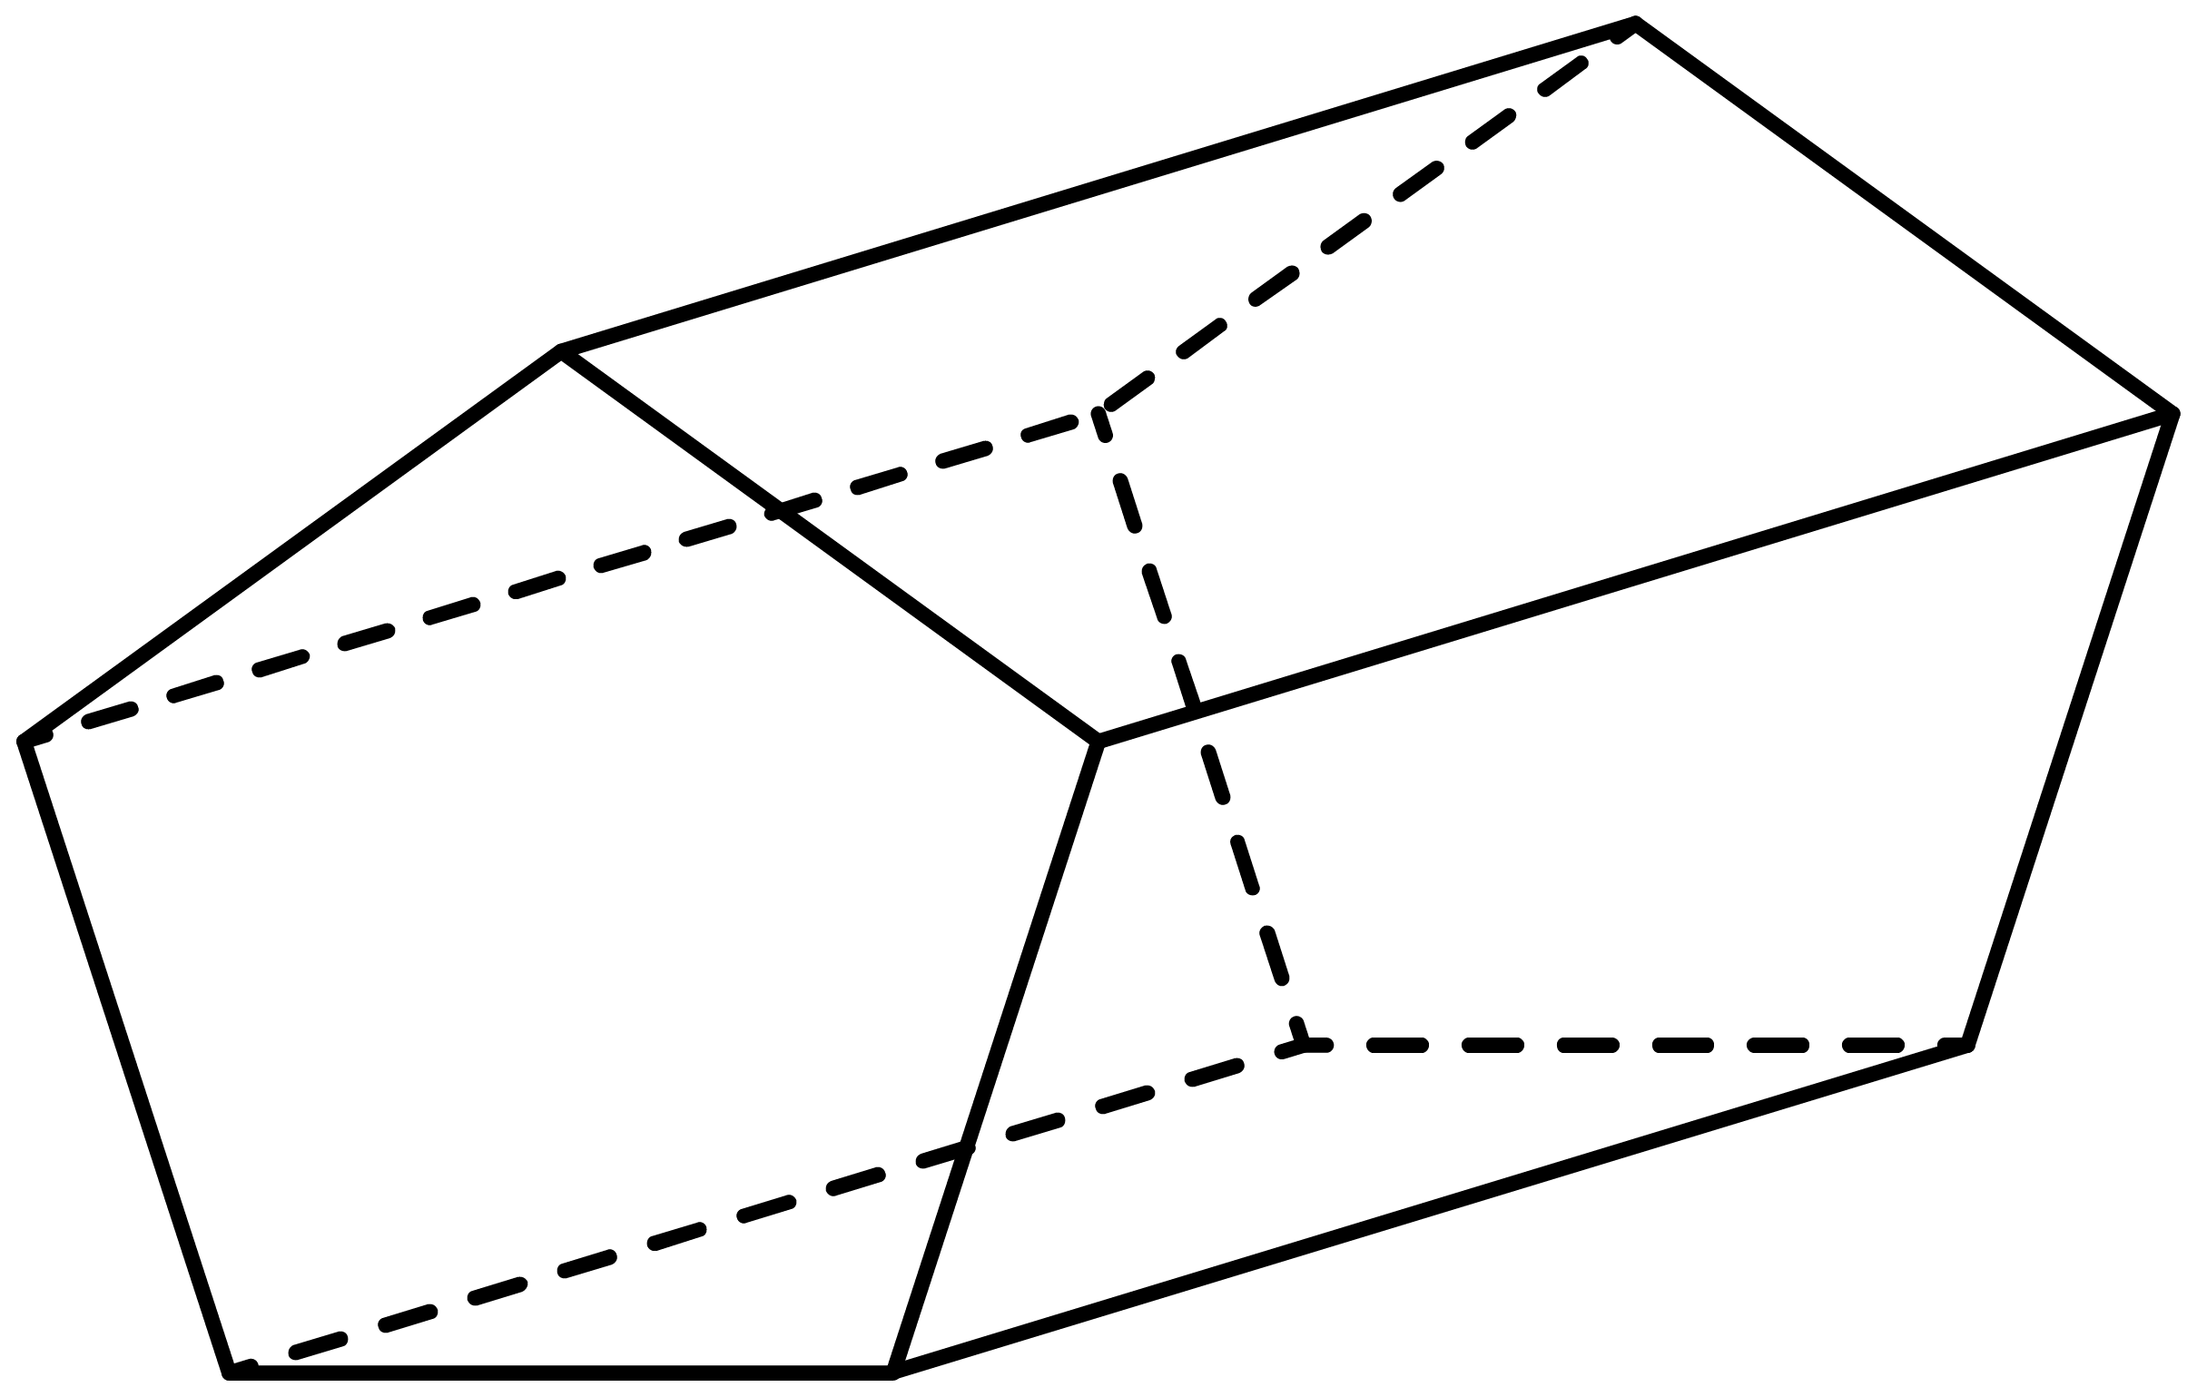  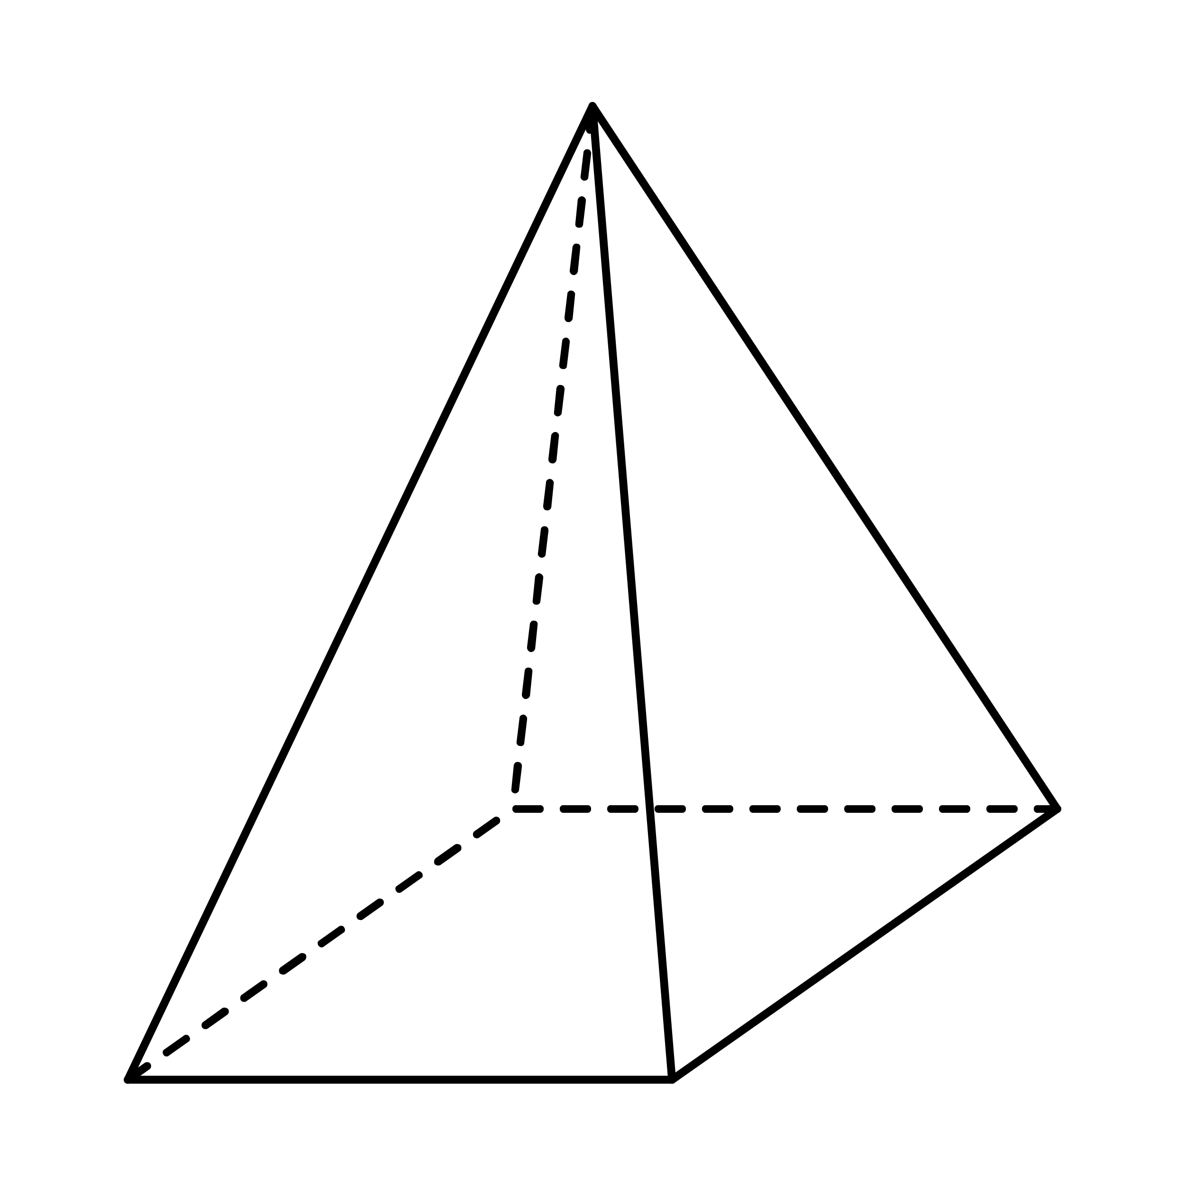
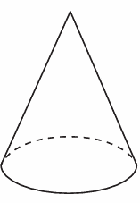 |  |  | 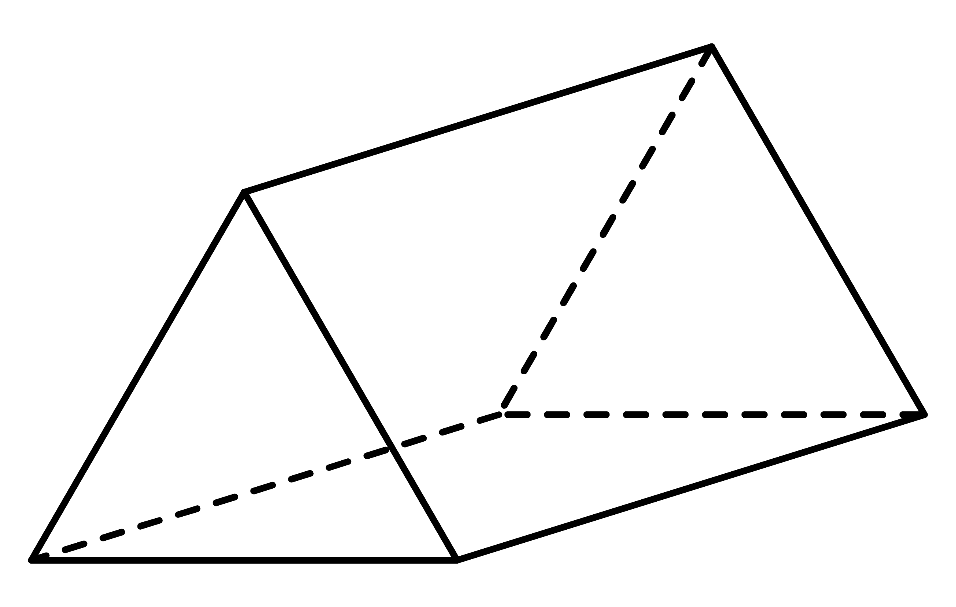 |  | 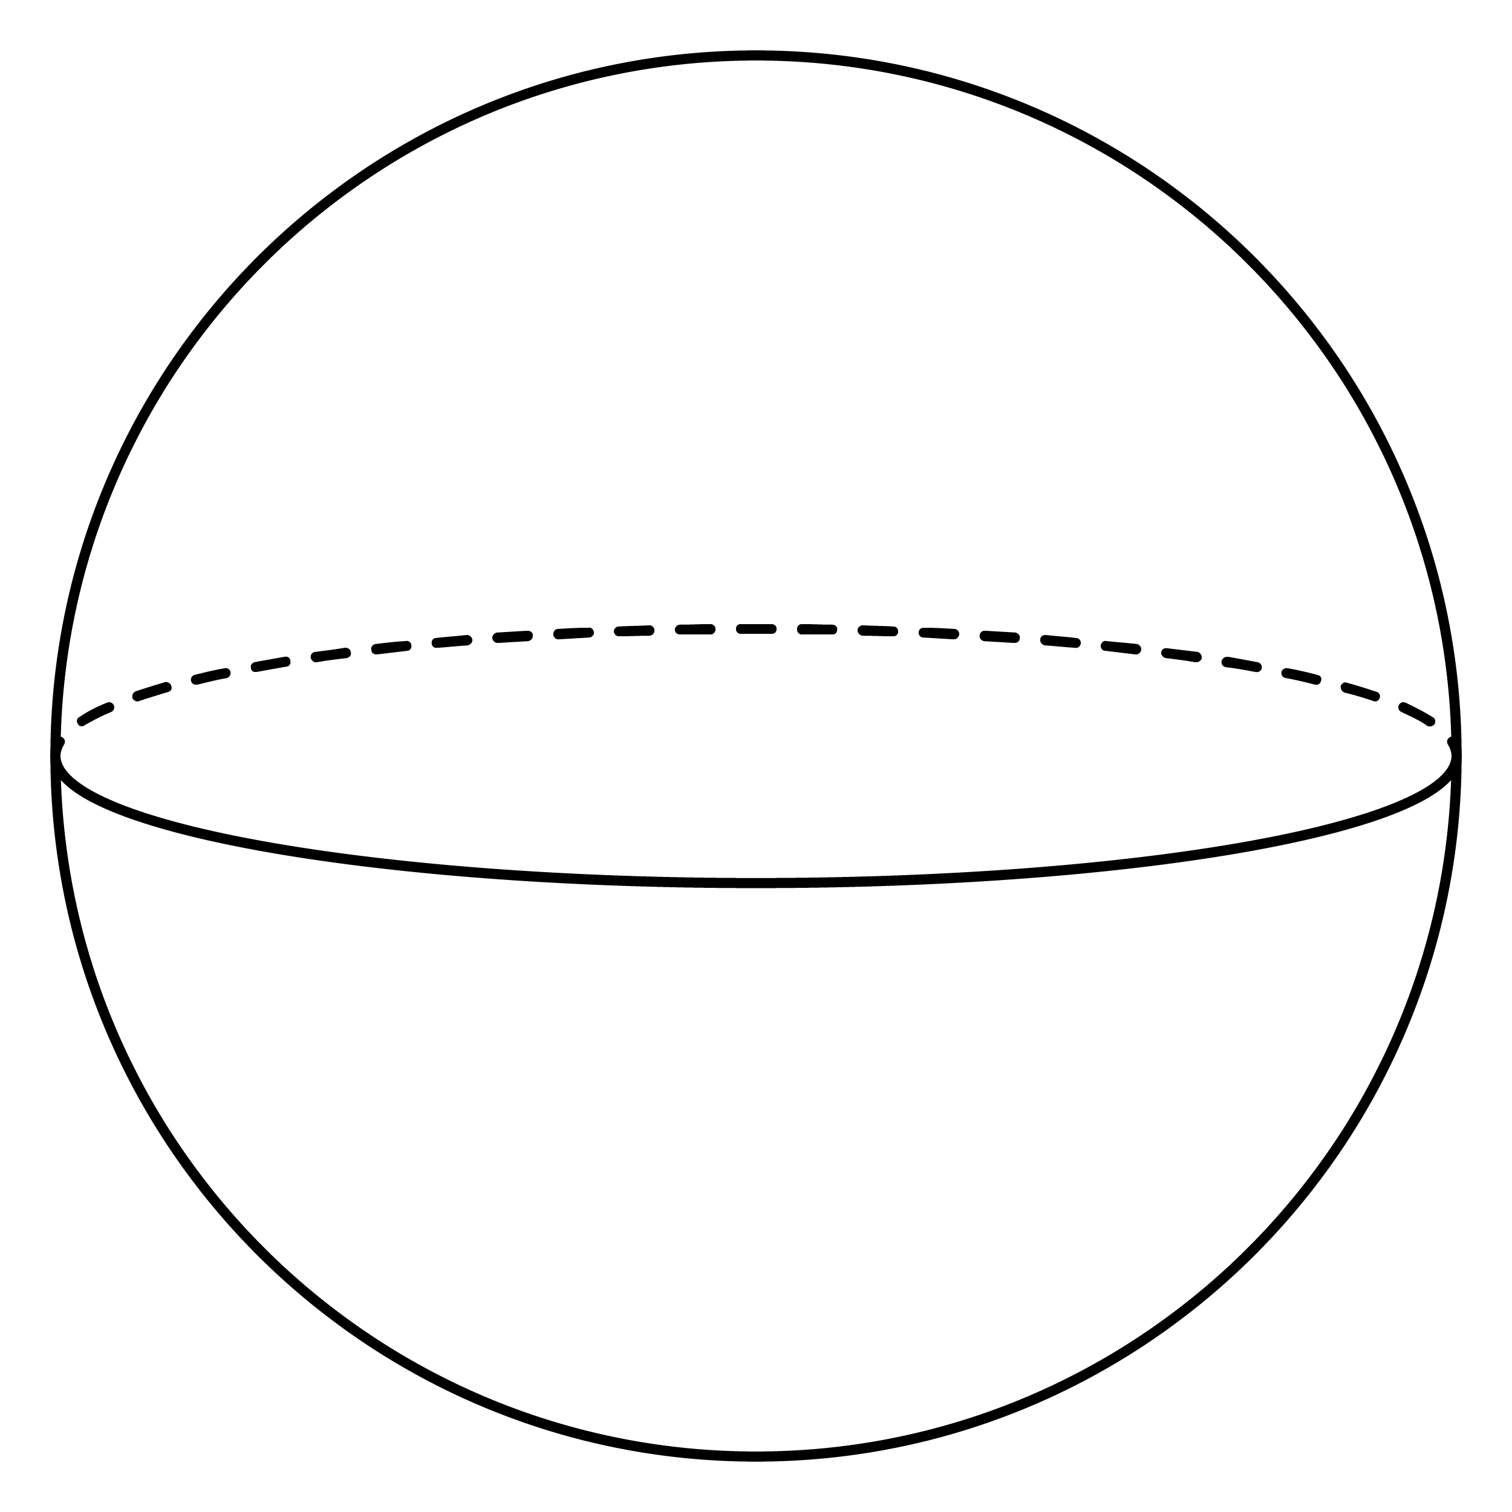  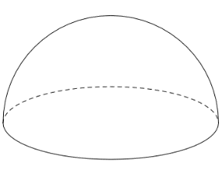
- The base of a prism must be a polygon; a polygon has straight sides.
Explain why a cylinder is not a prism.
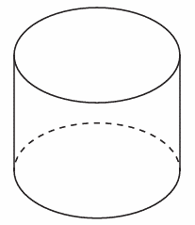

- Identify base and height of solids with uniform cross-section
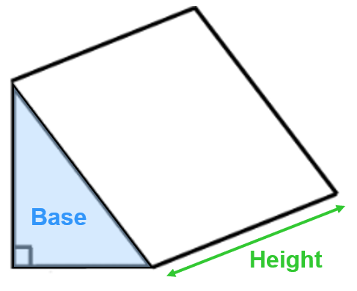 |  | 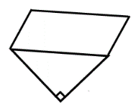 |  | 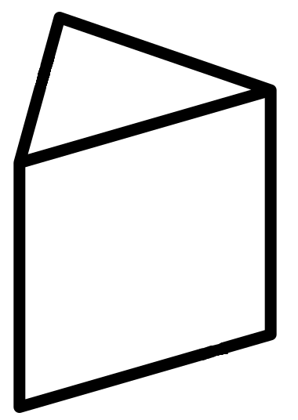
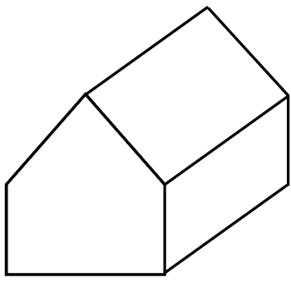 |  | 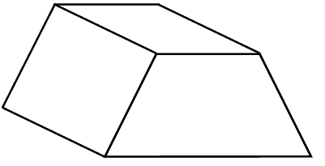 |  | 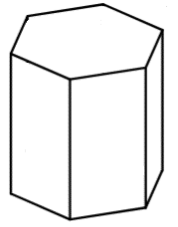
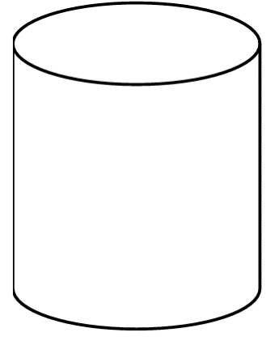  - cylinders are not prisms. |  | 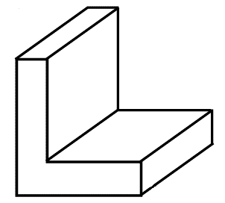 |  | 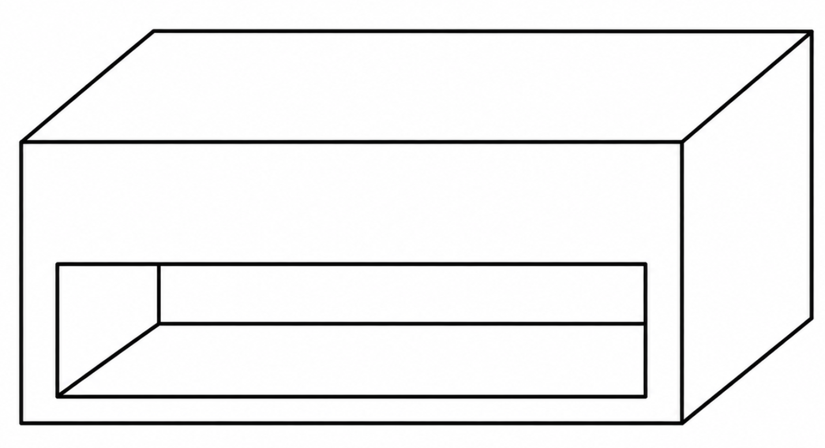

- Cross-Section of a Prism
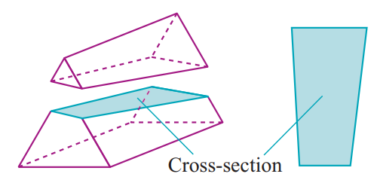
- A cross-section shows the shape formed when we ‘slice’ a solid.

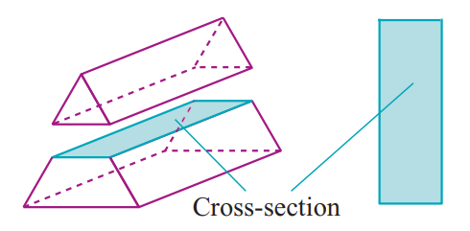

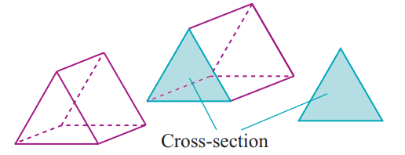
- A prism has uniform cross section;
any cross section parallel to the base is identical to the base.
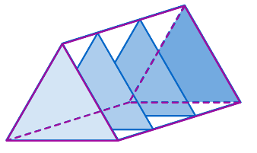

- Example Draw the cross section of a solid
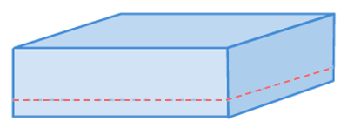  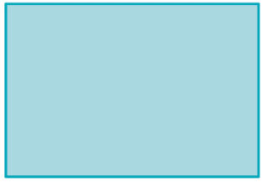  Explain why this is a prism. | 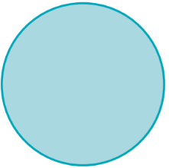  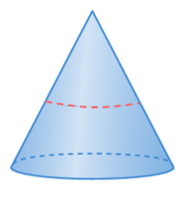  Explain why this is not a prism.

- Guided Practice
 | Solid | Cross-section parallel to base | Prism?
 | 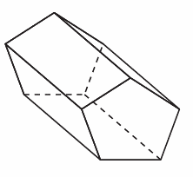
 | 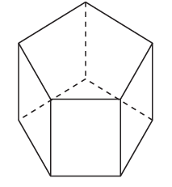
 | 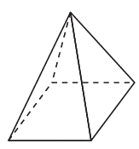
 | 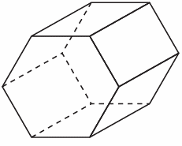
 | 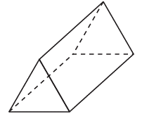
 | 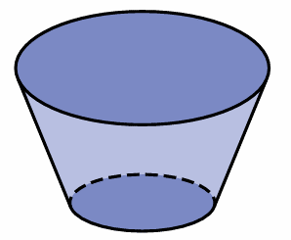
 | 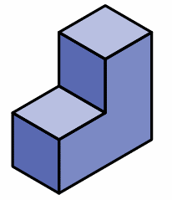

- Key Ideas
- A prism is a ……-dimensional solid with identical ………………… faces connected by ………………… sides.
- A …………… - ……………… is the shape formed from “…………………” the object.
- A prism has ………………… cross-section; slices ………………… to the base are identical to the base.

Foundation
- Draw the cross-section along the dotted line.
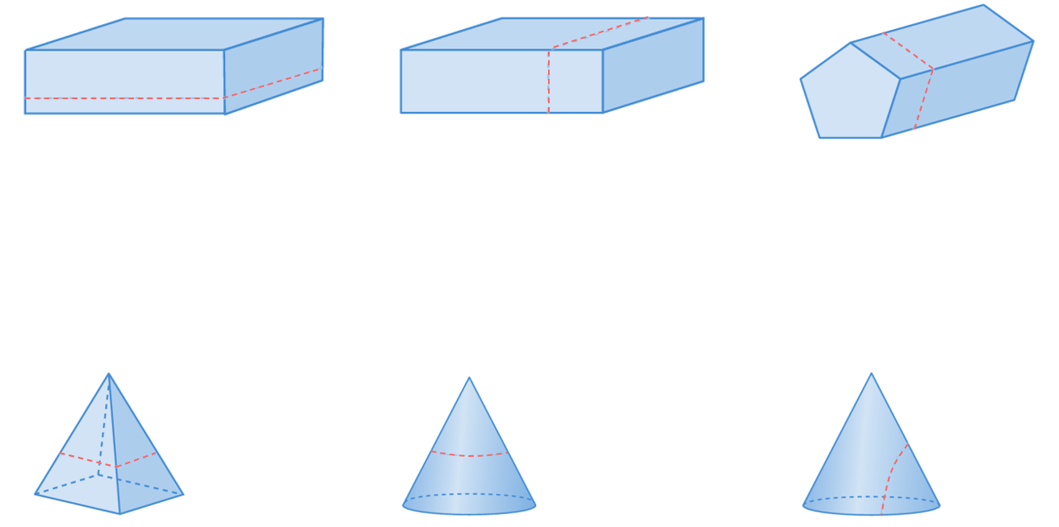

- Decide whether these solids have uniform cross-section parallel to the base.
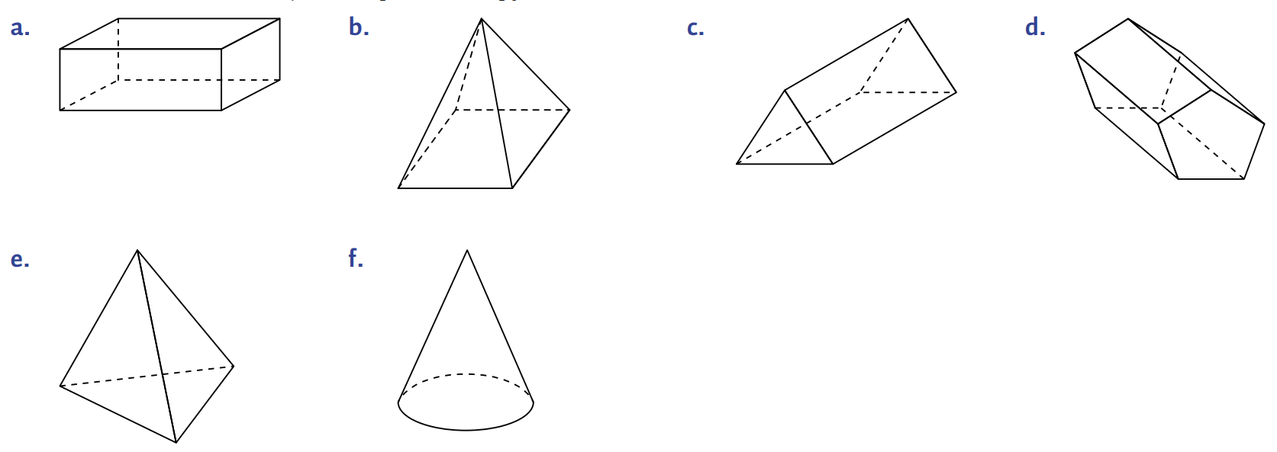  yes | no | yes
no | no | 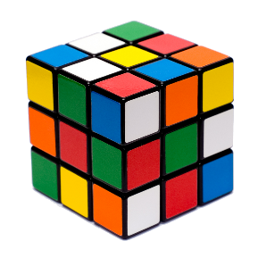  yes
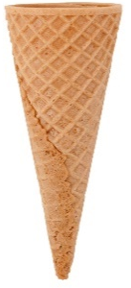  no | 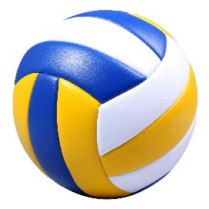  no | 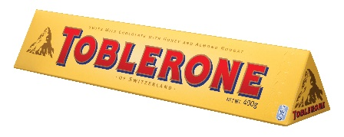  yes
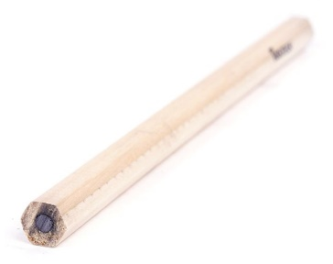  yes |   yes | 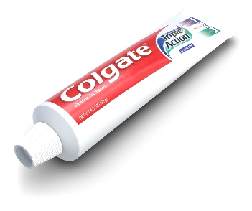  no

Volume of a Prism (Base Area Given)

- Review
- Calculate volume by counting cubes. Each cube is $1$ cm³.
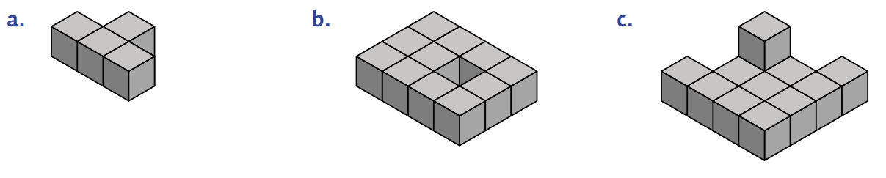

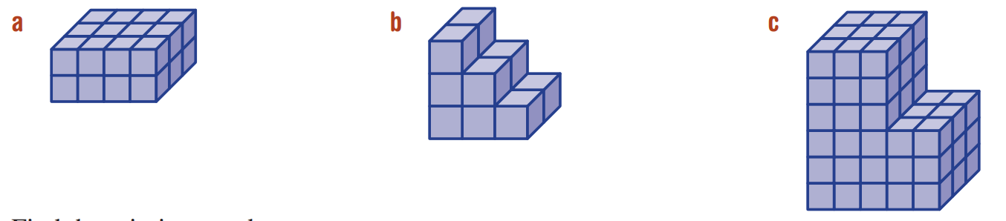

- Volume
- Volume is the amount of space taken up by a 3-dimensional object.
- Volume is measured in cubic units.
cubic centimetre (cm³)  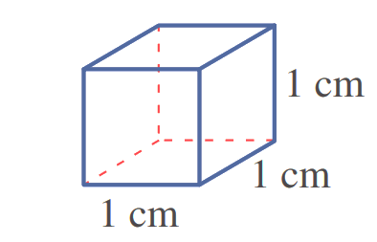 | 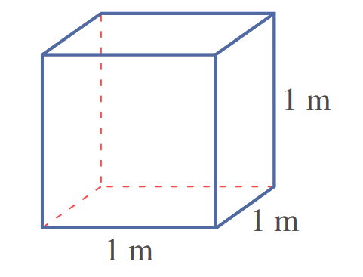  cubic metre (m³)

- Volume of a Prism
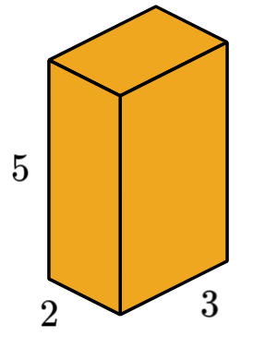
Suppose we want to find how many unit cubes can fit in this box.

The box is a special type of 3D solid called a
………………… ………………, because it has
……………… …………-………………………

The number of unit cubes that can fit in the box is called the ………………………

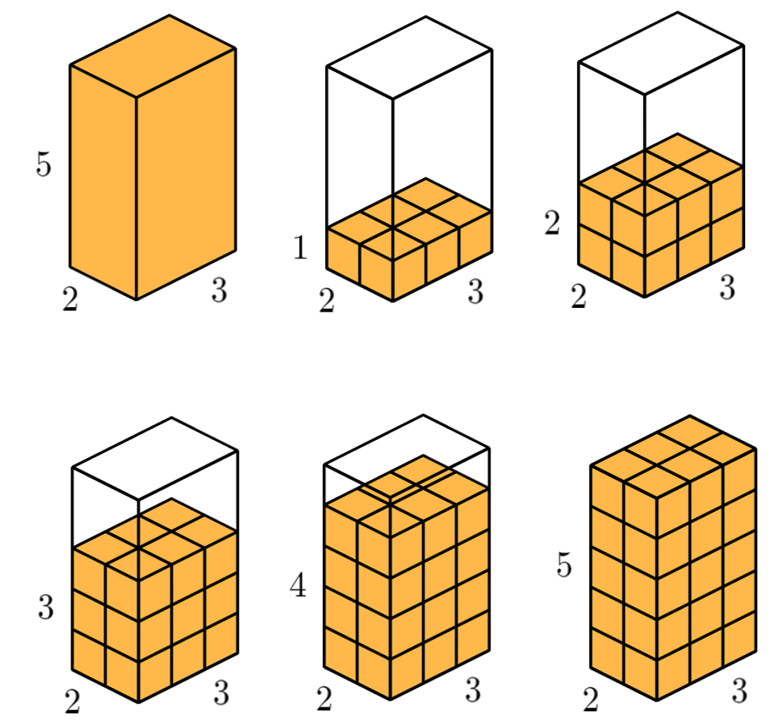
We will begin by considering the bottom layer, or base, of the shape.

The number of cubes that can fit in the bottom layer is

…… $×$ …… $=$ ………

If there are two layers, then the number of cubes is:

……… $×$ …… $×$ …… $=$ ………

So, if there are 5 layers, then the number of cubes is:

……… $×$ …… $×$ …… $=$ ………

The volume of any prism can be found using the formula:

$Volume=$ Area of the b…………… $×$ number of l………………

https://www.geogebra.org/m/rqnd3khf
- Volume of a Prism
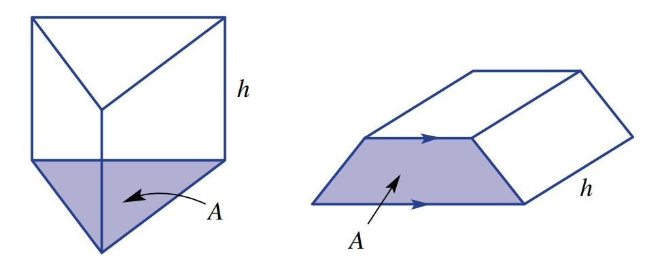

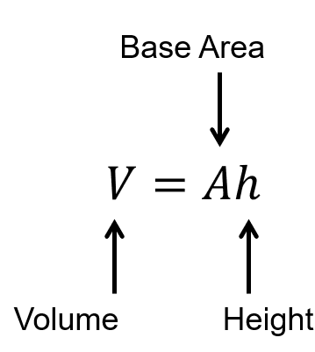
- Example Calculate volume of a prism (base area given)
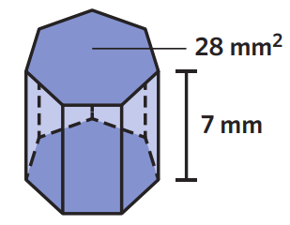
$V=Ah$
$=28 mm^{2}×7 mm$
$=196 {mm}^{3}$

- Guided Practice
Calculate the volume of these prisms
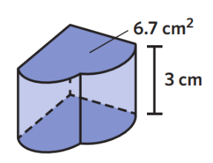  $V=Ah$  $=$ ……………………  $=$ ……………………  20.1 cm³ | 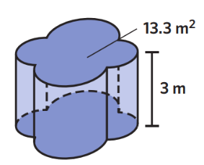  $V=Ah$  $=$ ……………………  $=$ ……………………  39.9 m³
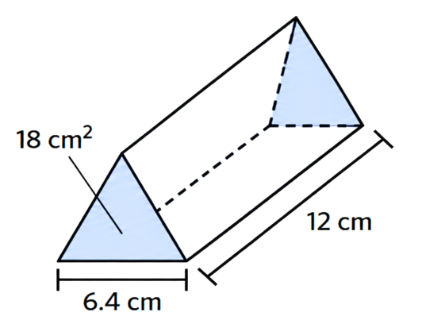  $V=Ah$  $=$ ……………………  $=$ ……………………  216 cm³ | 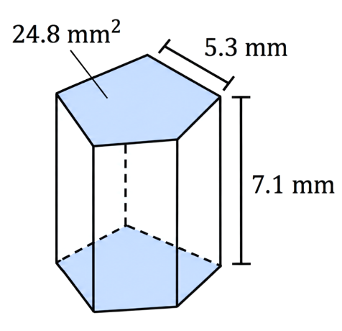  $V=Ah$  $=$ ……………………  $=$ ……………………  176.08 m³

- Key Ideas
- Volume is how much ………………… a 3D solid takes up.
- Volume is measured using …………… units.
- Calculate the volume of a prism by multiplying the base ……………… by the ………………

Foundation
- The area of the base is given. Calculate the volume of these prisms.
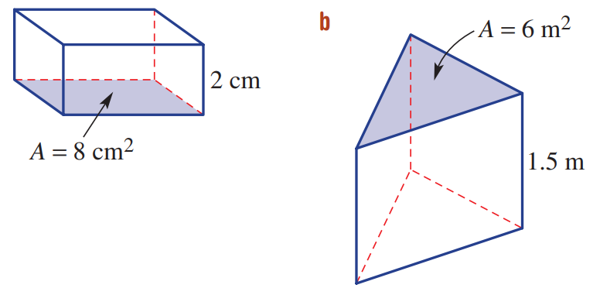  $V=Ah$  $=$ ……………………………  $=$ ……………………………  16 cm³ | $V=Ah$  $=$ ……………………………  $=$ ……………………………  9 m² | 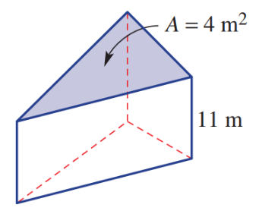  $V=Ah$  $=$ ……………………………  $=$ ……………………………  44 m³
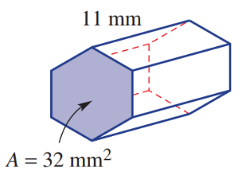  352 mm³ | 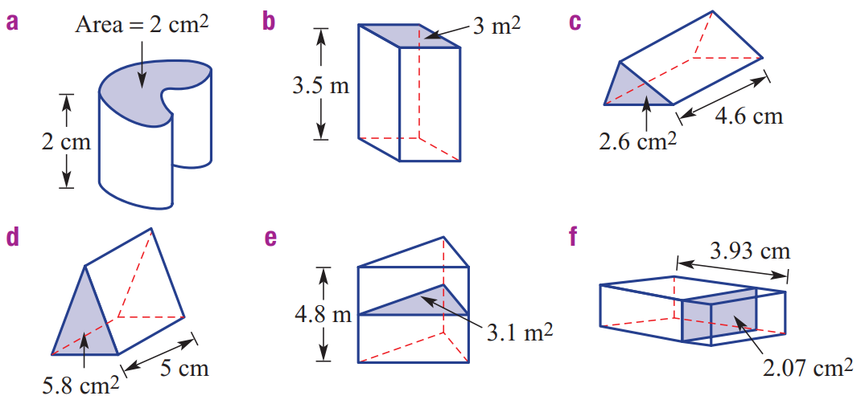  4 cm³ | 14.88 m³
8.1351 cm² | 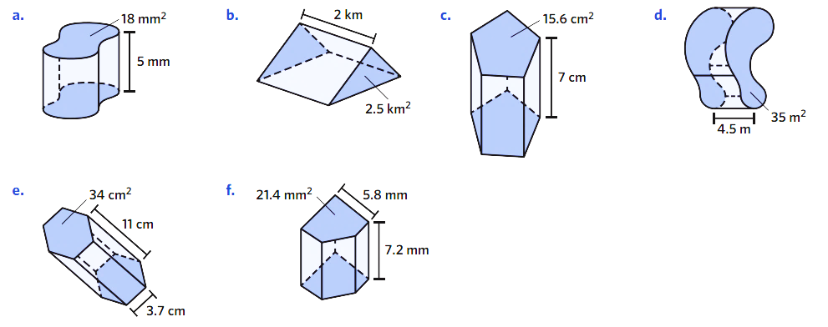  374 cm³ | 154.08 mm³

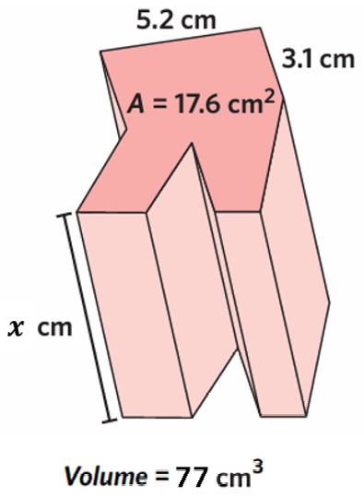
- Find the missing value for each pronumeral.
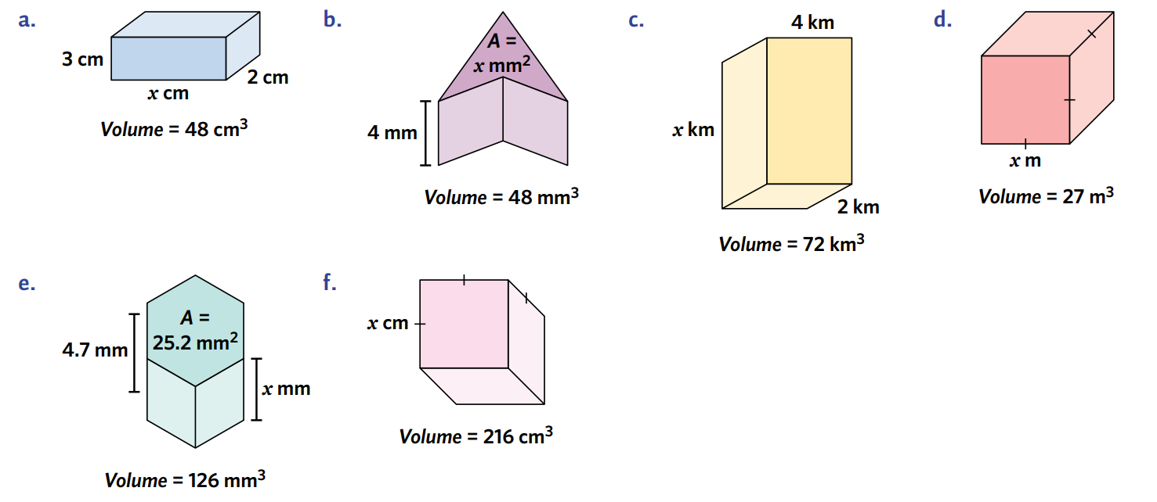  $V=Ah$  $48=4x$  …… $=x$  12 mm | 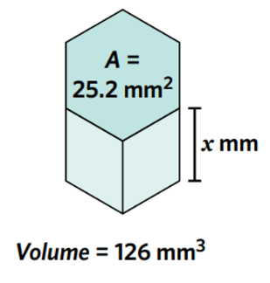  5 mm | 0.4375 cm³

Volume of a Prism

- Review
- Calculate area of simple shapes
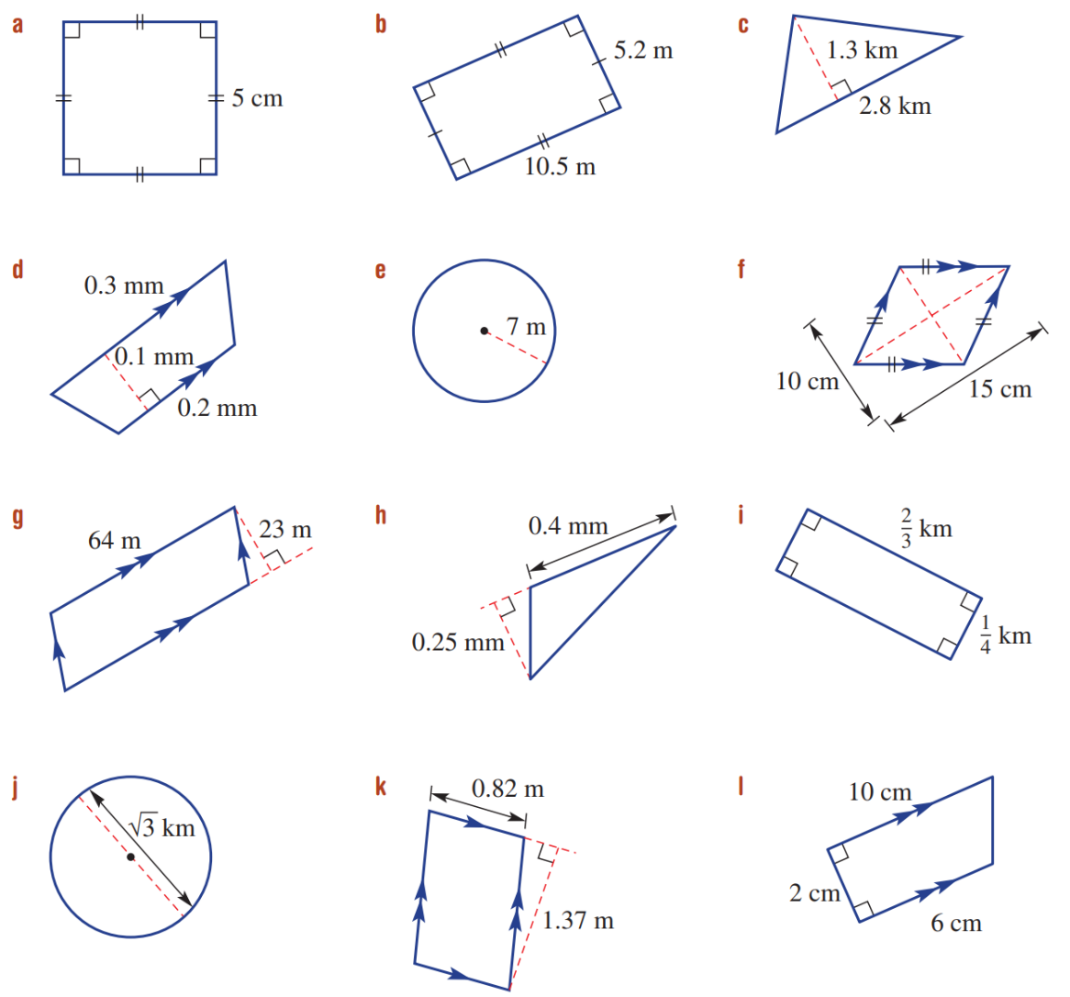 |  | 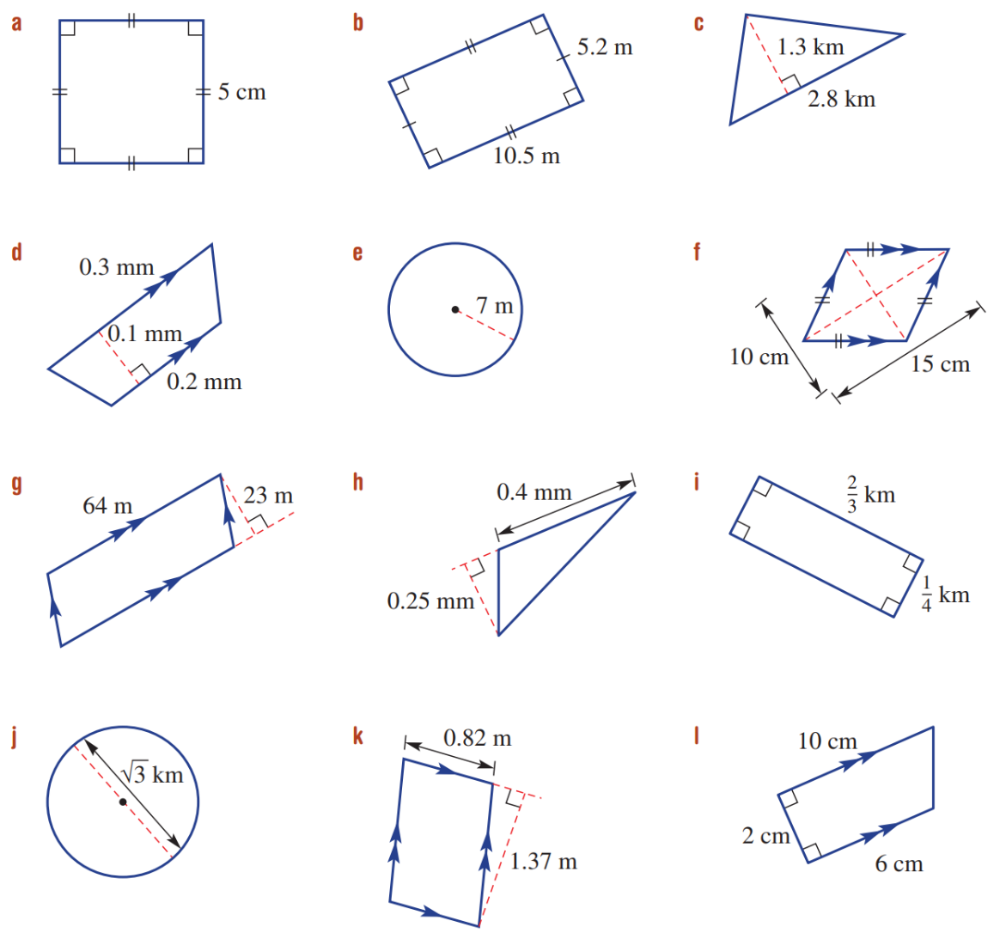
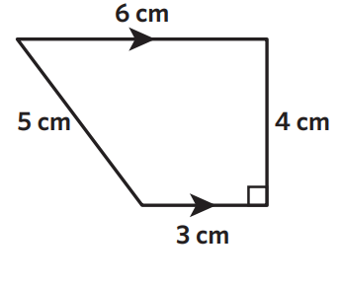 | 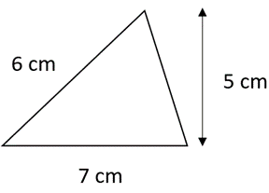 | 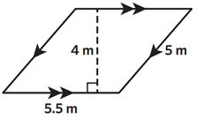

- Volume of a Prism
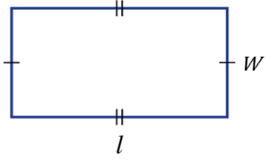  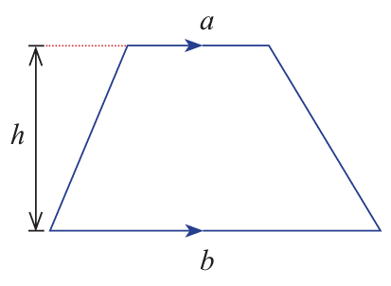  Rectangle  $$A=lw$$ | 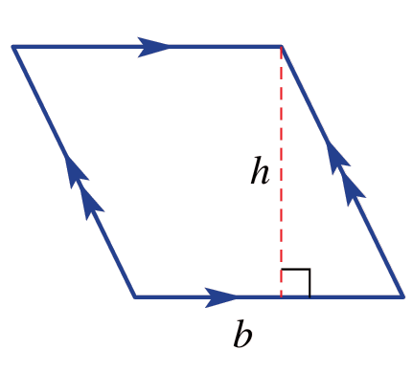  Parallelogram  $$A=bh$$ | Triangle  $$A=\frac{bh}{2}$$  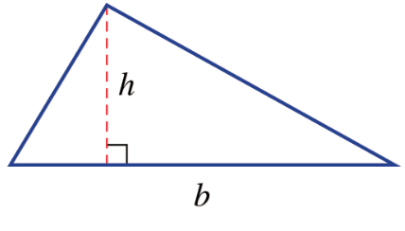 | Trapezium  $$A=\frac{h\left(a+b\right)}{2}$$

- Example Calculate volume of a prism
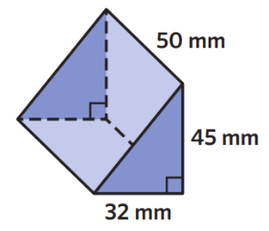  $V=Ah$  $=$ $\left(\frac{45×32}{2}\right)$ $×50$  $=36 000$ mm³ | The base of this prism is a ………………… because that is the face with uniform …………… - ………………  The height of this prism is ………………, it is ……………… to the height of the triangle.

- Guided Practice
Calculate the volume of these prisms.
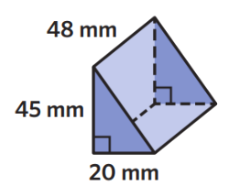  $V=$ $Ah$  $=$ $\left(\frac{ × }{2}\right)$ $×$ ……  $=$ ……………………  21600 m³ | 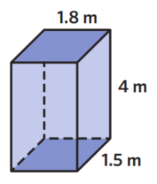  $V=$ $Ah$  $=$ ( … $×$ … ) $×$ ……  $=$ ……………………  10.8 m³

- Volume of a Rectangular Prism
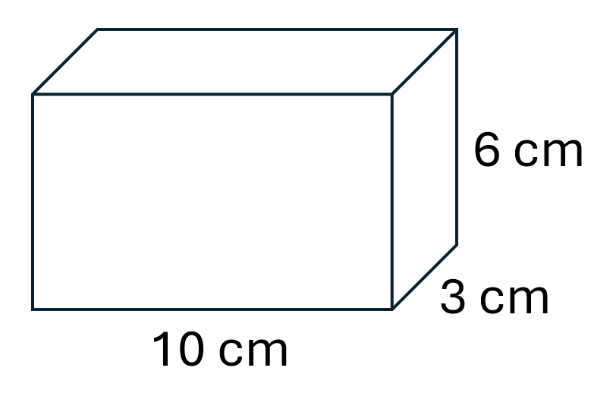
A rectangular prism is special because you can choose any of the three faces as the base of the prism.

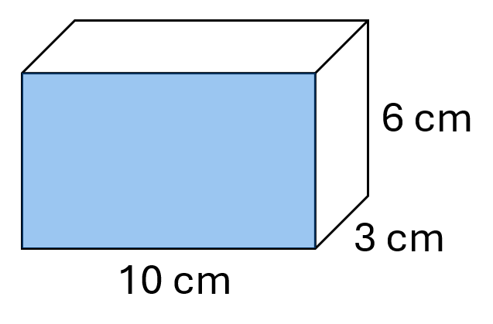  $V=$ $Ah$  $=$ (…… $×$ ……) $×$ ……  $=$ ……… cm² | 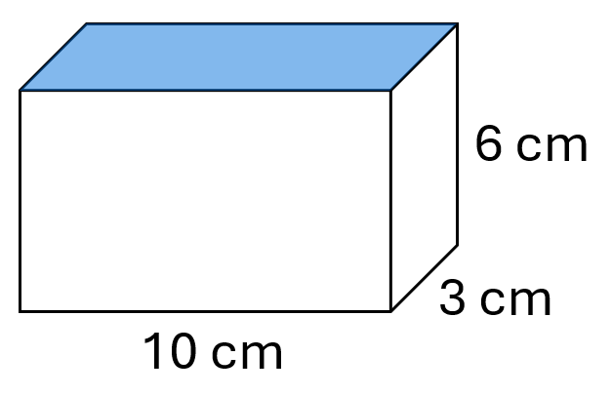  $V=$ $Ah$  $=$ (…… $×$ ……) $×$ ……  $=$ ……… cm² | 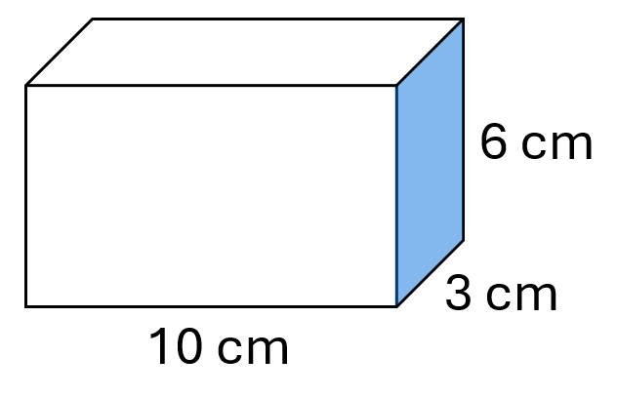  $V=$ $Ah$  $=$ (…… $×$ ……) $×$ ……  $=$ ……… cm²
So, for a rectangular prism, you can the volume is the product of the three dimensions:

$$V=length×width×height \\ =lwh$$

For any other type of prism, there is only one way to choose the base area, so there isn’t a nice shortcut.

Foundation
- Calculate the volumes of these solids.
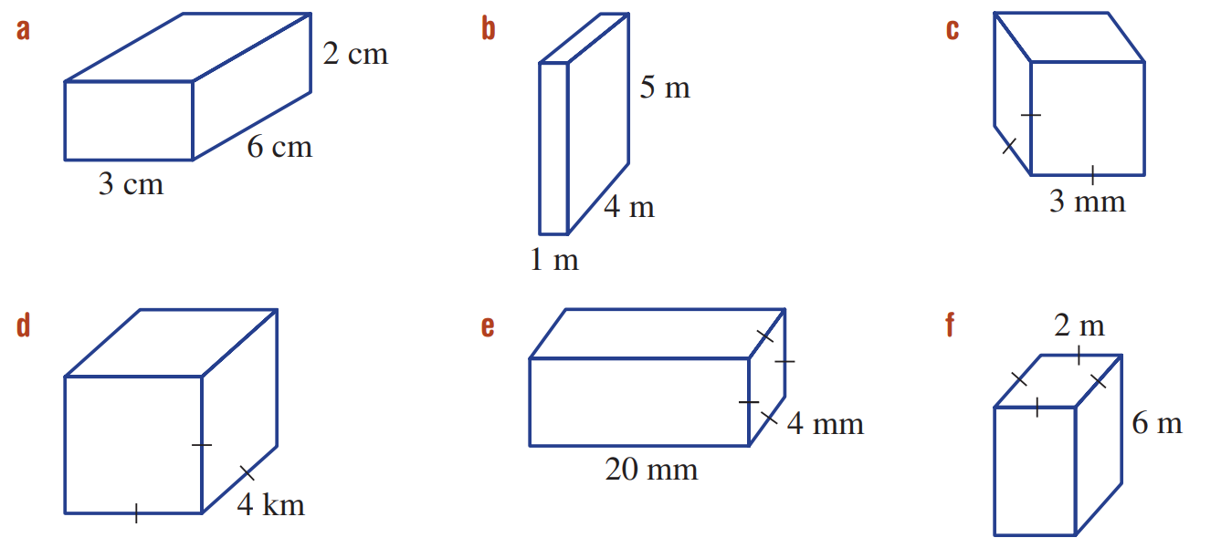  $V=Ah$  $=$ ……………  $=$ ……………  36 cm³ | $V=Ah$  $=$ ……………  $=$ ……………  27 cm³ | 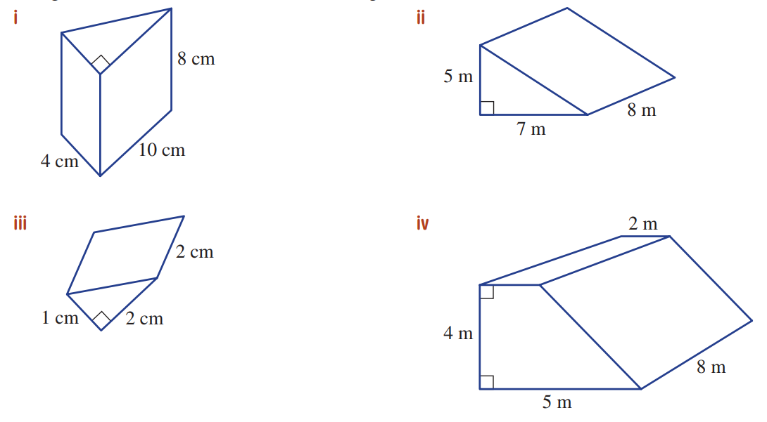  $V=Ah$  $=$ ……………  $=$ ……………  2 cm³
160 cm³ | 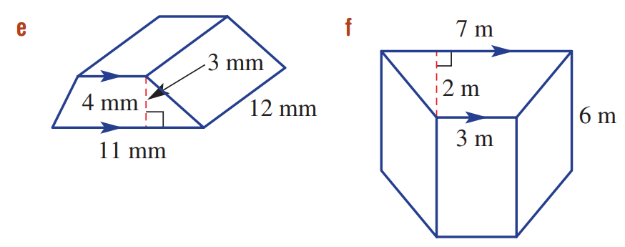  270 mm³ | 320 mm³
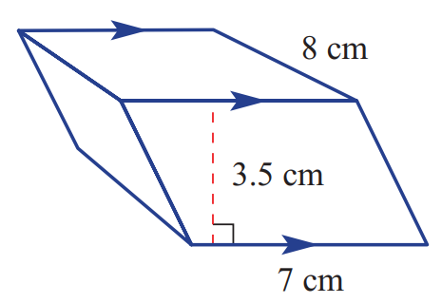  196 cm³ | 140 m³ | 60 m³
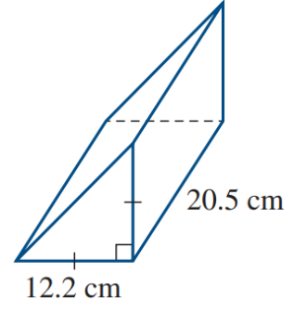  1525.61 cm³ | 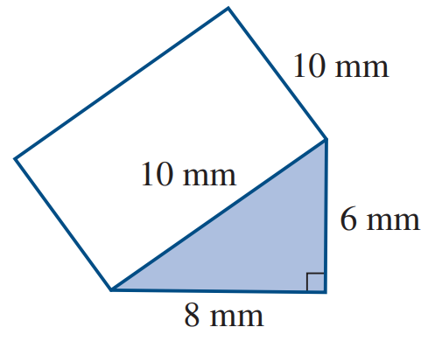  240 mm³ | 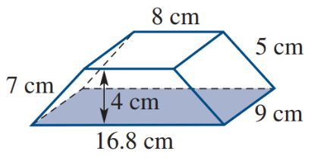  446.4 cm³

Development
- Charya is going to make 100 doorstops for his school with recycled plastic.
The doorstops will be in the shape of a triangular prism with these dimensions.
What volume of plastic will he need to make all 100 door stops?
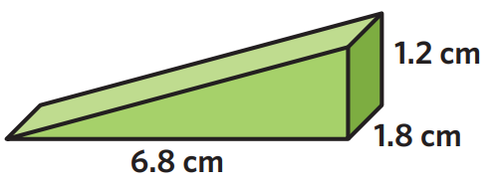

734.4 cm³
- Find the missing value for each pronumeral.
9 km | 8 cm
6 cm | 3 m

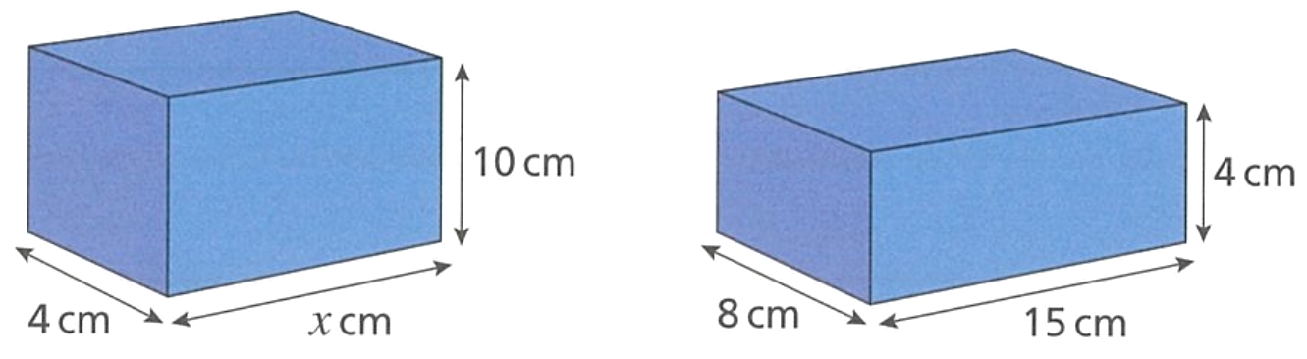
- Both rectangular prisms have the same volume. Work out the value of $x$.

12 cm
- The volume of the rectangular prism is double the volume of the cube.
Work out the value of $x$to 2 d.p.
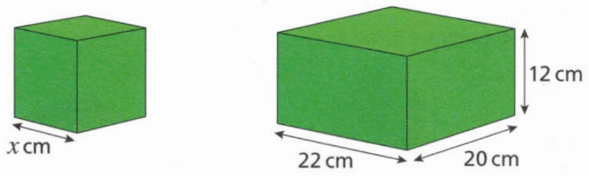

13.82 cm
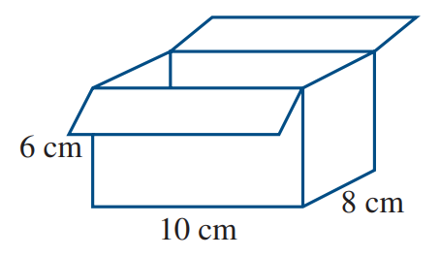
- A vase with a volume of 200 cm³ is packed into the cardboard box shown below.
The space around the vase is filled with packing foam. What is the volume of the foam?

280 cm³

Mastery
- A cube measures 5 cm by 5 cm by 5 cm.
  - Work out the volume of the cube.
125 cm³
  - The length of all the sides is increased by 10%.
Calculate the percentage increase in the volume of the cube.
$${1.1}^{3}=1.331$$
33.1%

- The cube and triangular prism have the same volume. Work out the value of $x$ to 2 d.p.
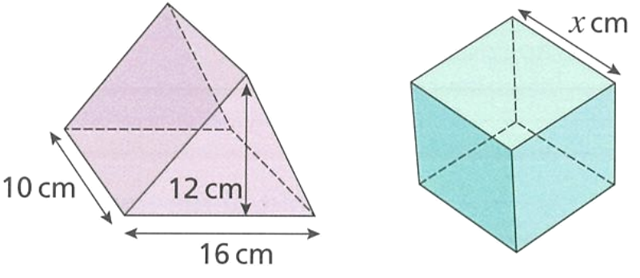

9.86 cm
- Find the volume of each of the following solids.
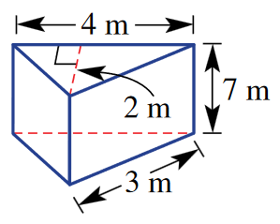  28 m³ | 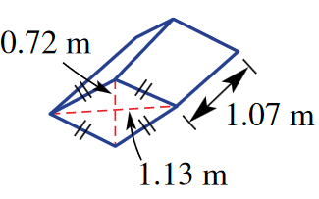  0.435276 m³ | 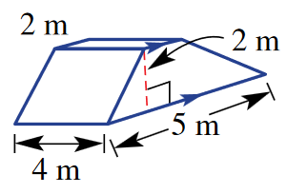  28 m³

- Determine the volume of this equilateral triangular prism. Answer to 1 d.p.
(hint: you need to use Pythagoras’ theorem)
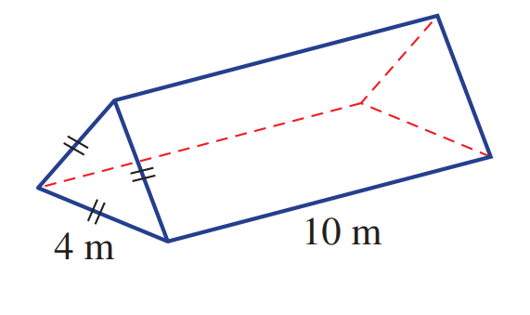

69.3 m³

Volume of a Cylinder

- Review
- Calculate the volume of these prisms.
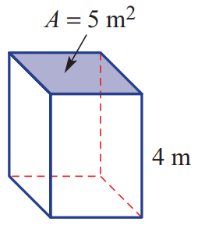 | 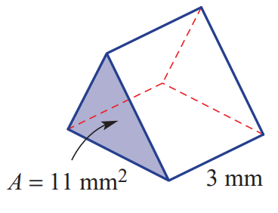 | 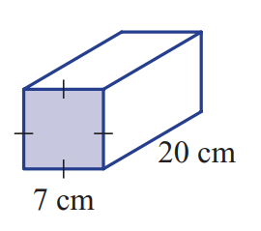
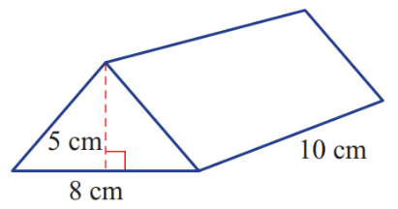 | 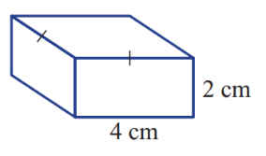 | 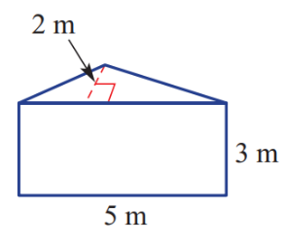

- Calculate area of these circles.
Give your answer in terms of $π$ and rounded to two decimal places.
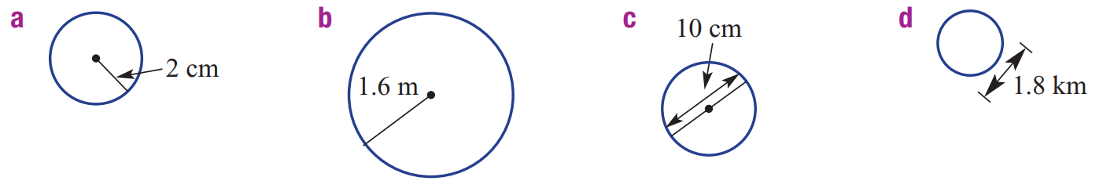

$A=πr^{2}$
$=$
$=$

- Volume of a Cylinder
- A cylinder is a 3D solid with uniform cross-section of a circle.
- The volume of a cylinder is calculated using $V=Ah$, where $A=πr^{2}$
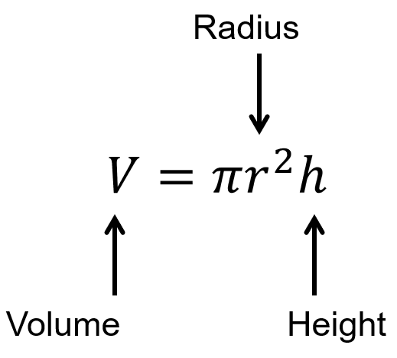
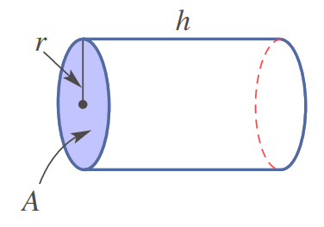

- Example Calculate volume of a cylinder
Calculate the volume of these cylinders, round your answer to 2 d.p.
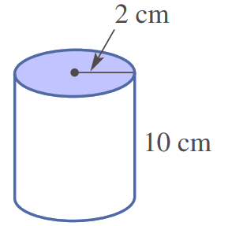  $V=πr^{2}h$  $=π×2^{2}×10$  $=125.66$ cm³ | 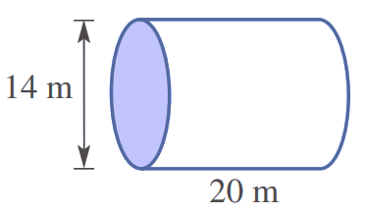  $V=πr^{2}h$  $=π×7^{2}×20$  $=3078.76$ m³

- Guided Practice
Calculate the volume of these cylinders. Round your answer to 2 decimal places.
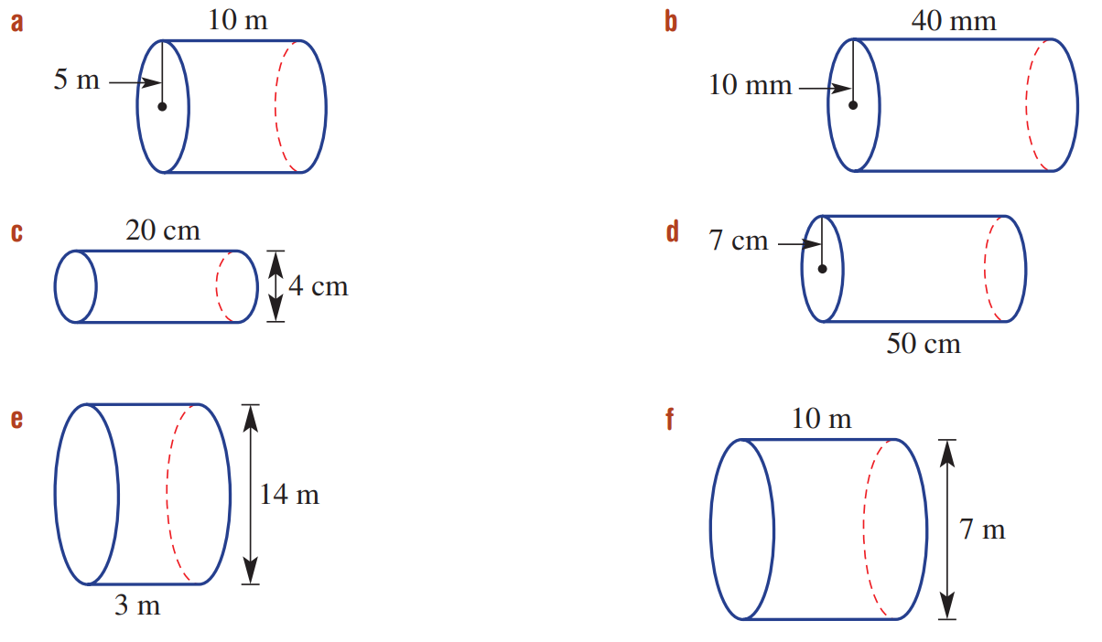  $V=Ah$  $=$ ……………………  $=$ ……………………  785.40 m³ | $V=Ah$  $=$ ……………………  $=$ ……………………  461.81 m³
251.33 cm³ | 12566.37 mm³

- Key Ideas
- A cylinder is similar to a prism because it has …………… …………-………………
- The volume of any solid with uniform cross section is $V=$ ………………
- The volume of a cylinder is $V=πr^{2}h$ because the area of the base is ……………

Foundation
- The area of the base is given. Calculate the volume of these cylinders.
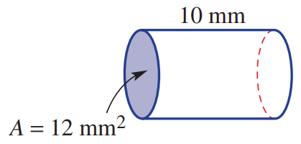  $V=Ah$  $=$ ………………  $=$ ………………  120 mm³ | 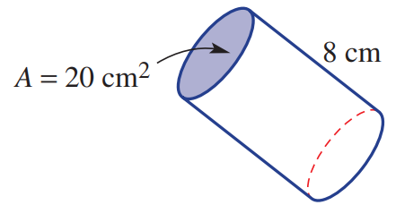  $V=$ ………………  $=$ ………………  $=$ ………………  160 cm³

- Complete to calculate the volume of the cylinder to the nearest cubic cm.
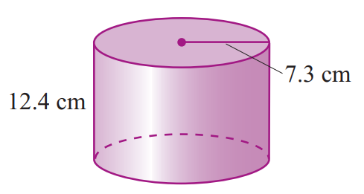  $V=πr^{2}h$  $=π×{____}^{2}×_____$  $= ____________$ cm³  2076 cm³ | 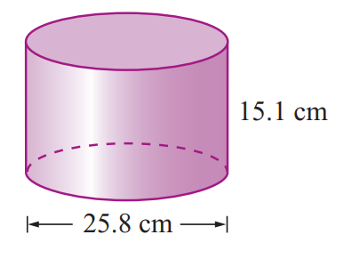  $V=πr^{2}h$  $=π×{____}^{2}×_____$  $= ____________$ cm³  7894 cm³

- Calculate the volume of these cylinders. Give your answer in exact form in terms of $π$.
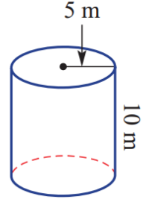  250π m³ | 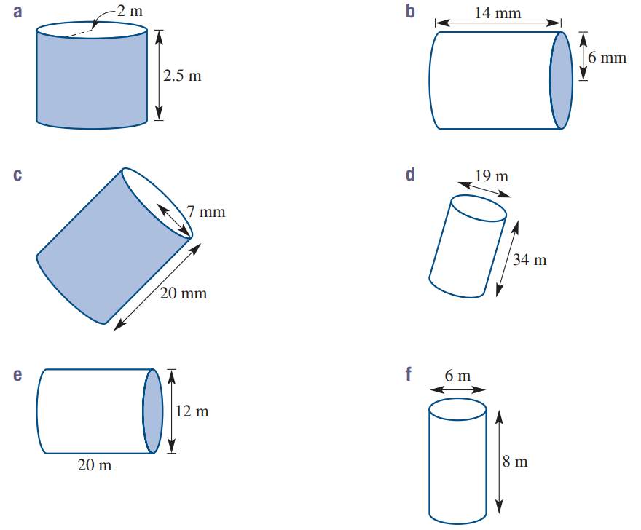  504π mm³ | 980π mm³
720π m³ | 3068.5π m³ | 10π m³
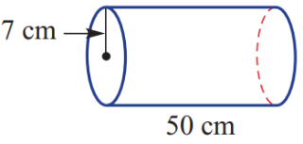  2450π cm³ | 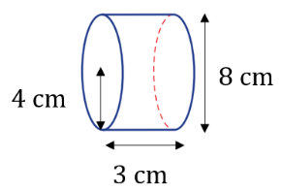  48π cm³ | 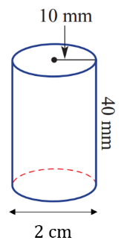  4000π mm³

Development
- A cylindrical tank has a diameter of 3 m and height 2 m.
Calculate the volume in cubic metres (m³), answer to 1 d.p.

14.1 cm³
- Calculate the volume of these fractions of a cylinder. Answer to 2 d.p.
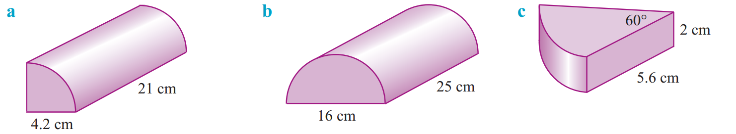  290.94 cm³ | 2513.27 cm³ | 32.84 cm³
- A cylindrical tin of beans has radius 4 cm and a height of 10 cm.
The can contains 400 cm³ of beans. How much empty space is there inside the tin?

102.65 cm³
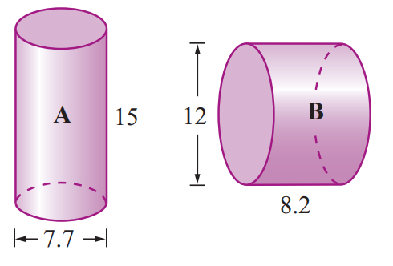
- Determine which of these prisms has the largest volume.

Cylinder A: 698.5
Cylinder B: 927.4
Cylinder B is larger.
- Determine the unknown dimension of the cylinder.
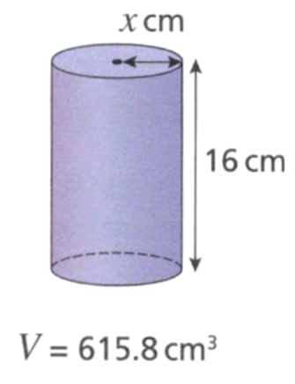  $x=3.5$ cm | 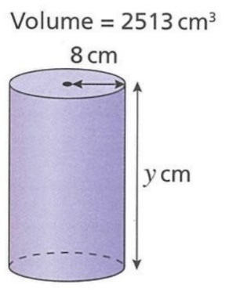  $y=12.5$cm

- Concrete sewer pipes are 5 m long with an outer diameter of 1.3 m.
The walls of the pipes are 10 cm thick. What volume of concrete is required to make each pipe? Express your answer in m³ correct to 2 decimal places.
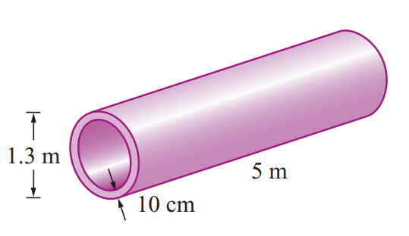

Large cylinder – small cylinder = $π{\left(0.65\right)}^{2}\left(5\right)-π{\left(0.55\right)}^{2}\left(5\right)=1.88$m³
- A cylindrical wheat hopper is 8 m in diameter and 10 m high.
  - Calculate its volume correct to two decimal places.

$V=π{\left(4\right)}^{2}\left(10\right)=502.65$ m³
  - Grain pours out at 48 000 cm³ per second. How long would it take a full hopper to empty? Answer correct to the nearest minute. 1 000 000 cm³ = 1 m³

175 minutes.
- A cube has every single one of its sides doubled.
How many times is the new volume compared to the original?

8 times

Mastery
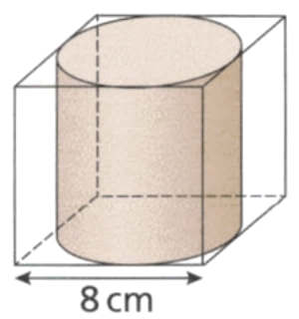
- Express the volume of the cylinder as a percentage of the volume of the cube. Answer to 1 d.p.

$$\frac{V_{Cyl}}{V_{cube}}×100=\frac{π{\left(4\right)}^{2}\left(8\right)}{8^{3}}×100=78.5\%$$
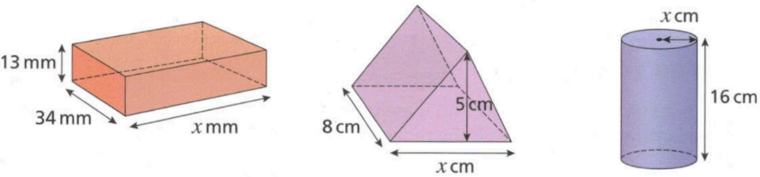
- Find the missing length in each of these shapes.
- $V=22 100 {mm}^{3}$  50 mm | - $V=180 cm^{3}$  9 cm | - $V=615.8 cm^{3}$  3.5 cm

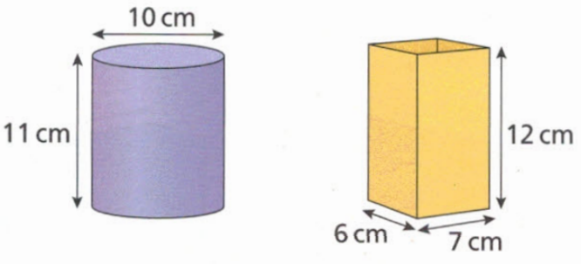
- Marta fills the cylindrical container with water.
She then pours the water into the rectangular prism-shaped container.
Will all of the water fit into the rectangular prism?
Justify your answer with mathematical reasoning.

Volume of cylinder: 863.94 cm³
Volume of rectangular prism: 504 cm³
No, the volume of the prism is less than the cylinder.
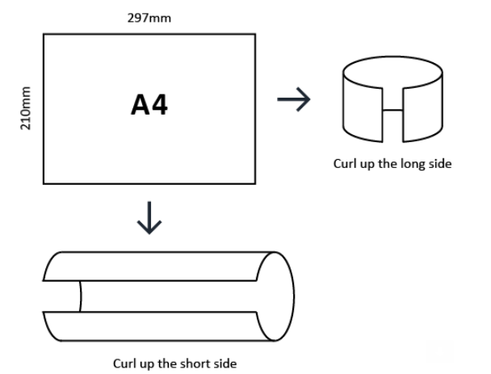
- Which cylinder would have a greater volume? Justify your answer with mathematical reasoning.

Short side: $C=2πr=210, r=$ $\frac{210}{2π}$
$$V_{curl short side}=π{\left(\frac{210}{2π}\right)}^{2}\left(297\right)≈1042282 {cm}^{3}$$
Long side: $C=2πr=297, r=$ $\frac{297}{2π}$
$$V_{curl long side}=π{\left(\frac{297}{2π}\right)}^{2}\left(210\right)≈1474084 {cm}^{3}$$
$∴$ cylinder curled up long side has larger volume.

Converting Units of Volume

- Review
- Convert these units of length.
- 5 cm to mm | - 2 m to cm | - 3.5 km to m
- 2.1 m to mm | - 400 mm to m | - 500 cm to km

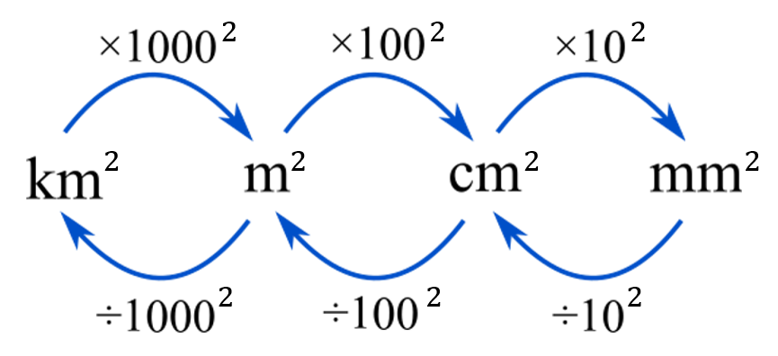
- Convert these units of area

- 5 cm² to mm² | - 2 m² to cm² | - 3.5 km² to ha
- 2.1 m² to mm² | - 400 mm² to m² | - 500 cm² to ha

- Calculate the volume of these solids. Answer in the smaller unit.
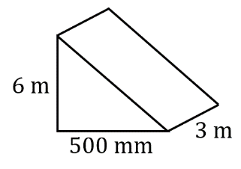  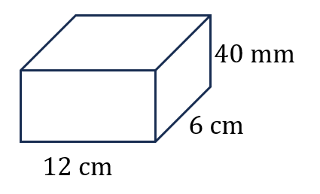 |  | 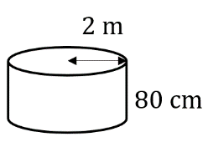

- Converting Units of Volume
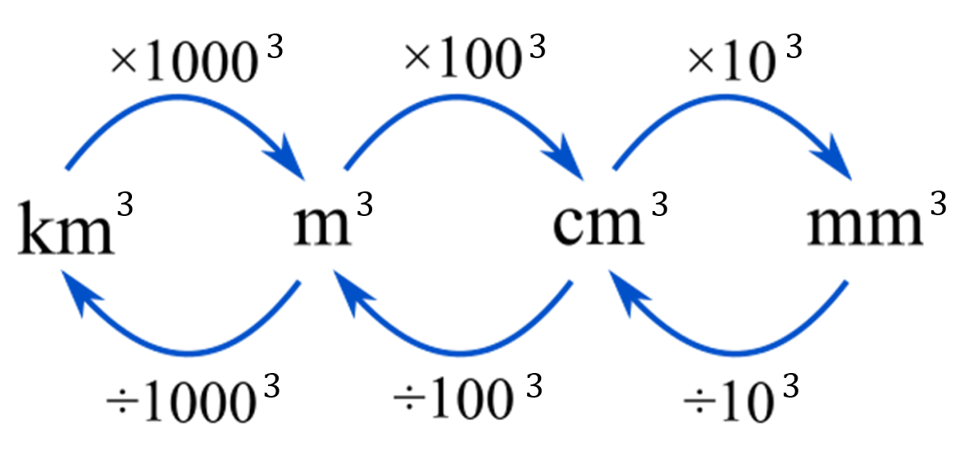

- Example Convert units of volume
20 m³ to cm³  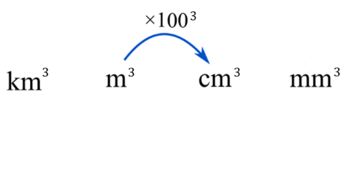  $20 m^{3}×{100}^{3}$  $=20 000 000$cm² | 5000 mm³ to cm³  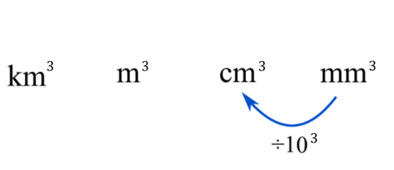  $5000 {mm}^{3}÷{10}^{3}$  $=5$ cm² | 150 000 mm³ to m³  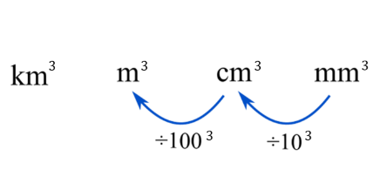  $150 000 {mm}^{3}÷{10}^{3}÷{100}^{3}$  $=0.00015$ m³

- Guided Practice
Convert these units of volume.
- 5 cm³ to mm³  5000 mm³ | - 2 m³ to cm³  2 000 000 cm³ | - 40 000 mm³ to m³  0.000 04 m³
- 0.15 m³ to mm³  150 000 000 mm³ | - 35 000 m³ to km³  0.000 035 km³ | - 5 500 000 cm³ to m³  5.5 m³

- Key Ideas
- Volume is measured using ……………… units;
5 m³ means the volume that 5 cubes of side length …………… would cover.
- To convert between metres and centimetres, the conversion factor is ……
- To convert between square metres and square centimetres, the conversion factor is ……
- To convert between cubic metres and cubic centimetres, the conversion factor is ……

Foundation
- Express these volumes in cm³
- 2.5 m³  2 500 000 cm³ | - $\frac{3}{4}$ m³  750 000 cm³ | - 5000 mm³  5 cm³
- 100 mm³  0.1 cm³ | - 62 m³  62 000 000 cm³

- Express these volumes in m³
- 2 000 000 cm³  2 m³ | - 50000 cm³  0.05 m³ | - 850 000 cm³  0.85 m³

- Convert these units of volume.
- 8 cm³ to mm³  8000 mm³ | - 3000 mm³ to cm³  3 cm³ | - 90 000 000 cm³ to m³  90 m³
- 18 m³ to cm³  18 000 000 cm³ | - 30 mm³ to cm³  0.03 cm³ | - 0.02 m³ to cm³  20 000 cm³

- Convert these units of volume.
- $2 cm^{3} to {mm}^{3}$  2000 mm³ | - $0.002 {km}^{3} to m^{3}$  2 000 000 m³ | - $0.04 m^{3} to mm^{3}$  40 000 000 mm³
- $2 mm^{3} to{ cm}^{3}$  0.002 cm³ | - $0.00002 {cm}^{3} to {mm}^{3}$  0.02 mm³ | - $0.0016 km^{3} to{ m}^{3}$  1 600 000 m³
- $2 m^{3} to{ cm}^{3}$  2 000 000 cm³ | - $0.4 m^{3} to cm^{3}$  400 000 cm³ | - $0.00016 km^{3} to{ m}^{3}$  160 000 m³
- $2 {km}^{3} to m^{3}$  2 000 000 000 m³ | - $0.04 m^{3} to cm^{3}$  40 000 cm³ | - $0.1km^{3} to{ m}^{3}$  100 000 000 m³

Units of Capacity

- Converting Units of Capacity
- Volume is the amount of space a solid takes up
- Capacity is the amount of liquid/gas that an object can hold.
  - A solid block of wood has volume but no capacity.
It takes up space but cannot hold anything inside it.
  - A plastic bottle has volume and capacity.
It takes up space and can hold liquid or gas.
- Metric units for capacity are millilitres (mL), litres (L), kilolitres (kL), and megalitres (ML).
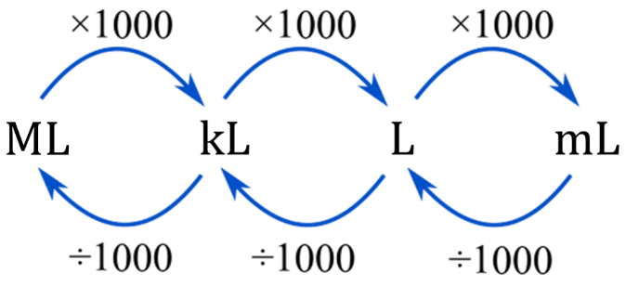

- Example Convert units of capacity
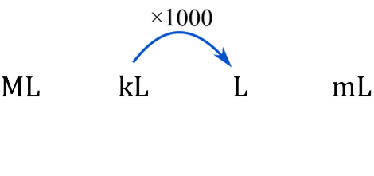  5.7 kL to L  $5.7 kL×1000$  $=5700 L$ | 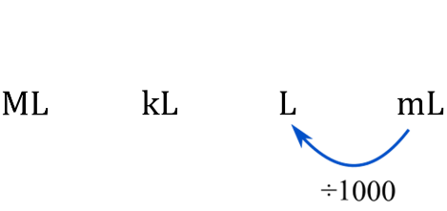  450 mL to L  $450 mL÷1000$  $=0.45 L$ | 920 000 L to ML  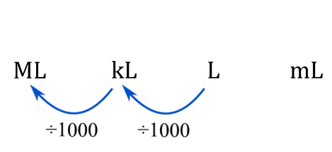  $920 000 L÷1000÷1000$  $=0.92 ML$

- Guided Practice
Convert these units of capacity.
- 60.42 kL to L  60420 L | - 45 mL to L  0.045 L | - 0.42 kL to mL  420 000 mL
- 0.0304 L to mL  30.4 mL | - 5.43 ML to kL  5430 kL | - 670 400 L to ML  0.6704 ML
- Converting Volume and Capacity
$$1 {cm}^{3} = 1 mL \\ 1000 {cm}^{3} = 1 L \\ 1 m^{3} = 1 kL$$

- Example Convert units of capacity
Convert 257 cm³ to mL  $$257 mL$$ | Convert 32.5 m³ to kL  $32.5 kL$ | Convert 4500 cm³ to L  $4.5 L$

- Guided Practice
Convert these units of capacity.
- 5 cm³ to mL  5 mL | - 2 m³ to kL  2 kL | - 40 000 cm³ to L  40 L
- 2.34 m³ to L  2340 L | - 8920 cm³ to kL  0.00892 kL | - 0.023 cm³ to mL  0.023 mL

- Key Ideas
- 1 mL is the amount of fluid/gas that can fit in …… ………
- 1 …… is the amount of fluid/gas that can fit in 1 m³.

Foundation
- Convert these units of capacity
- 2000 mL to L  2 L | - 1500 L to kL  1.5 kL | - 900 L to kL  0.9 kL
- 6 L to mL  6000 mL | - 1.25 L to mL  1250 mL | - 0.8 kL to L  800 L
- 1375 mL to L  1.375 L | - 505 L to kL  0.505 kL | - 10 mL to L  0.01 L
- 0.01 kL to L  10 L | - 3.05 kL to L  3050 L | - 5.03 L to mL  5030 mL
- 4070 L to kL  4.07 kL | - 60 mL to L  0.06 L | - 0.07 L to mL  70 mL
- 3.5 ML to L  3 500 000 L | - 890 ML to kL  0.89 kL | - 0.0087 kL to L  8.7 L

- 1 litre = 1000 cm³. Express the following in litres.
- 45 000 cm³  45 L | - 800 cm³  0.8 L | - 1 m³  1000 L
- $\frac{1}{2}$ cm³  0.0005 L | - 600 000 mm³  0.6 L

- Convert these units.
- 4 cm³ to mL  4 mL | - 2000 cm³ to L  2 L | - 70 cm³ to mL  70 mL
- 34 000 m³ to L  34 000 000 L | - 900 cm³ to mL  900 mL | - 55 m³ to L  55 000 L
- 43 m³ to kL  43 kL | - 3.52 m³ to L  3520 L | - 79 m³ to kL  79 kL
- A pint is an imperial unit for measuring capacity. Five pints is approximately 3 L.
Approximately how many mL is one pint?

Around 600 mL

Converting Volume and Capacity

- Converting Volume and Capacity
If you are asked to calculate the capacity of a container:
- Calculate the volume.
- Convert to capacity.

- Example Calculate capacity of a container
The milk carton has base dimensions 6 cm by  9 cm and height 21 cm.  What is its capacity in litres?  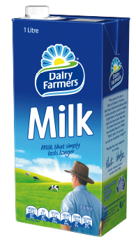  1. Calculate volume  $$V=Ah$$  $=\left(21\right)\left(9\right)\left(6\right)$  $=1134 {cm}^{3}$  2. Convert to capacity  $=1134 mL$  $=1.134 L$ | A cylindrical tank has a radius of 2 m and height of 3 m.  What is its capacity to the nearest whole L?  1. Calculate volume  $$V=πr^{2}h$$  $=π{\left(2\right)}^{2}\left(3\right)$  $=37.69911184…$ m³  2. Convert to capacity  $=37.69911184…$ kL  $=37 699$ L

- Guided Practice
Calculate the capacity for these containers.
- A plastic takeaway container measuring 12 cm by 17.5 cm by 6.5 cm  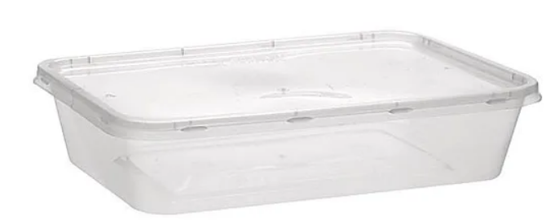  1. Volume  1365 cm³  2. Capacity  1.365 L | 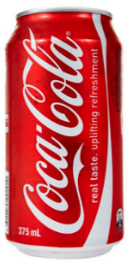  - A soft drink can with a 3.25 cm radius and 12.3 cm height.  1. Volume  408.15 cm³  2. Capacity  408.15 mL

Foundation
- Calculate the volume of these solids, then convert to capacity. Answer in an appropriate unit.
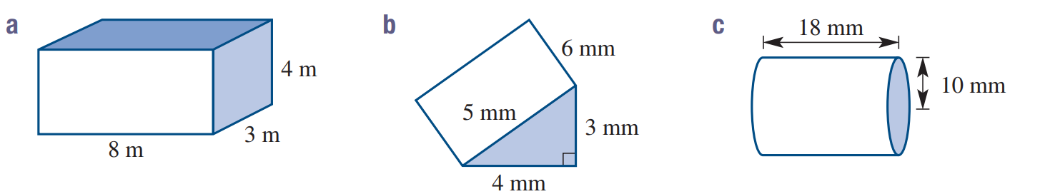  Volume:  96 m³  Capacity:  96 kL | 36 mm³ = 0.036 mL | 5.655 cm³ = 5.655 mL
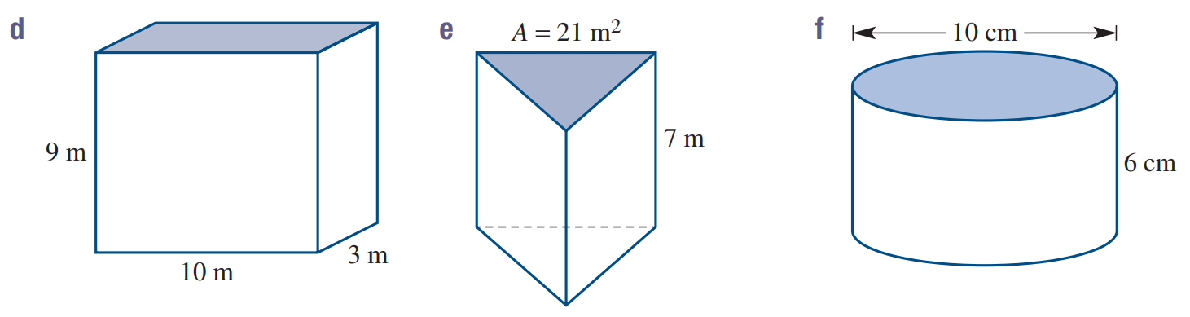  270 m³ = 270 kL | 147 m³ = 147 kL | 471.24 cm³ = 471.24 mL

- A fish tank measures 80 cm by 60 cm by 50 cm.
Find, in litres, the volume of the fish tank.

240 L
- How many litres of fuel can a tanker carry if its tank is cylindrical with a 2 m diameter and is
12 m in length? Round to the nearest litre.

37 700 L
- Which has a bigger volume and what is the difference in volume to 2 decimal places:
a cube with side length 1 m, or a cylinder with radius 1 m and height 0.5 m?

0.57 m³

Development
- Samantha is inviting 18 friends to a party.
She estimates that each person will drink 700 mL of soft drink.
  - How many litres of soft drink does she need to buy?
  - If each large bottle of soft drink is 2.5 L, how many bottles does she need?

$$19×700=13300 mL=13.3 L$$
$$13.3÷2.5=5.32$$
$∴$ 6 bottles
- Samira has a 2-litre bottle of cola.
She pours the cola into cylindrical glasses with radius 3 cm and a height of 11 cm.
  - What is the capacity of each cylindrical glass?
  - How many full glasses can be filled from the bottle of cola?

V = πr²h = π(3)²(11) = 99π ≈ 311 cm³
Number of glasses = 2000 ÷ 311 ≈ 6.4
6 full glasses
- A juice carton measures 8 cm by 8 cm by 15 cm. It is 80% full.
Abby uses the juice to fill some cups. Each cup holds 230ml.
How many full cups of juice will Abby be able to fill?
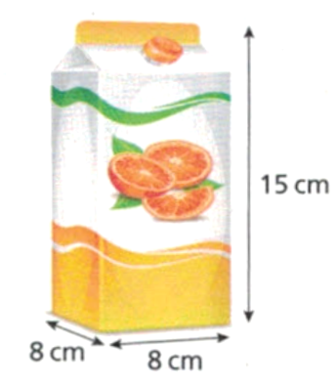

Carton volume = 8 × 8 × 15 = 960 cm³
Juice available = 960 × 0.8 = 768 cm³
Number of cups = 768 ÷ 230 = 3.34
Abby can fill 3 cups
- A swimming pool is a prism with a cross-section that is a trapezium.
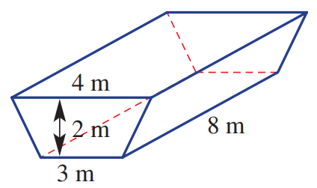
  - Find the capacity of the pool in litres.
  - The pool is being filled at a rate of 1000 litres per hour.
How long will it take to fill the pool?

$$Trapezium area = \left(\frac{2}{2}\right)\left(3 + 4\right)= 7 m^{2}$$
Pool volume = Ah = 7 × 8 = 56 m³
= 56,000 L
Time = 56 000 ÷ 1000 = 56 hours
- Jakub fills an empty flowerpot with soil. The flowerpot is a prism.
Its cross-section is a trapezium. Jakub has 2.5 litres of soil.
Does Jakub have enough soil to fill the flowerpot?
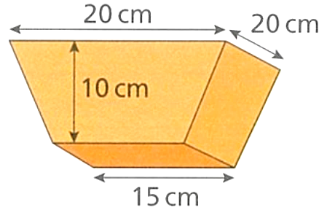

$$Trapezium area = \left(\frac{10}{2}\right)\left(15 + 20\right)= 175 {cm}^{2}$$
Volume needed = 175 × 20 = 3500 cm³ = 3.5 L
Jakub has 2.5 L, so not enough soil.
- 2016 HSC Standard 2 Band 4
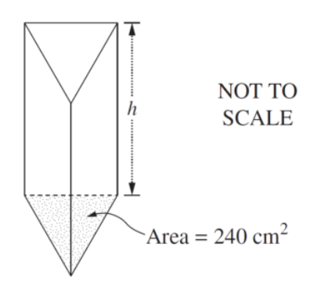
A container is in the shape of a triangular prism that has a capacity of 12 litres.
The area of the base is 240 cm². What is the distance, $h$, between the ends of the container?

V = Base area × height
12 L = 240 cm² × h
12000 cm³ = 240h
h = 50 cm
- 2010 HSC Standard 2 Band 5
During a flood 1.5 hectares of land was covered by water to a depth of 17 cm.
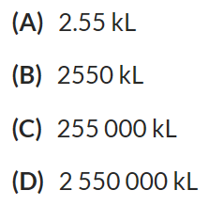
How many kilolitres of water covered the land? (1 hectare = 10 000 m²)

Area = 1.5 ha × 10000 ha/m² = 15000 m²
Volume = 15000 m² × 0.17 m = 2550 m³ = 2550 kL
B

- 2018 HSC Standard 2 Band 5
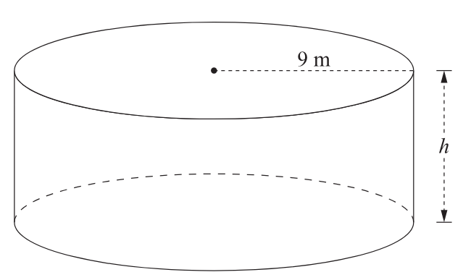
A cylindrical water tank has a radius of 9 metres and a capacity of 1.26 megalitres.
What is the height of the water tank? Give your answer in metres, correct to two decimal places.

V = πr²h
1.26 ML = π(9)²h
1 260 000 L = 81πh
$$h =\frac{1260000}{81π}= 4.95 m$$

Mastery
- Warragamba Dam is filled by runoff from a catchment area of 9050 square kilometres.
In a storm, 40 mm of rain fell. What is the increase in the volume of the dam?

Volume = area × depth = 9050 km² × 0.04 m
= (9050 × 1 000 000) m² × 0.04 m = 362 000 000 m³
- Water is being poured into a fish tank at a rate of 2 L every 10 seconds.
The tank is 1.2 m long by 1 m wide by 80 cm high.
How long will it take to fill the tank? Give the answer in minutes.

Tank volume = 1.2 × 1 × 0.8 = 0.96 m³ = 960 L
Rate = 2 L per 10 seconds = 0.2 L/s = 12 L/min
Time = 960 ÷ 12 = 80 minutes
- A saltwater swimming pool requires 2 kg of salt to be added for every 10 000 litres of water. Joan’s pool is a rectangular prism 1.5 metres deep, 5 metres wide and 15 metres long.
How much salt will she need to add to her pool? (Hint: 1 m³ = 1000 L)

Pool volume = 1.5 × 5 × 15 = 112.5 m³ = 112500 L
Salt needed = (112500 ÷ 10000) × 2 = 22.5 kg
- Each day a factory produces 5000 litres of soft drink in their 13 vats.
The soft drink is distributed in cans 13 centimetres high with diameter 6.5 centimetres.
How many cans does one vat produce each day?

Can volume = π(3.25)²(13) = 433.7 cm³
Daily production per vat = 5000 L ÷ 13 = 384.6 L = 384615 cm³
Cans per vat = 384615 ÷ 433.7 = 887 cans
- A rectangular container is partially filled with 2.4 litres of water.
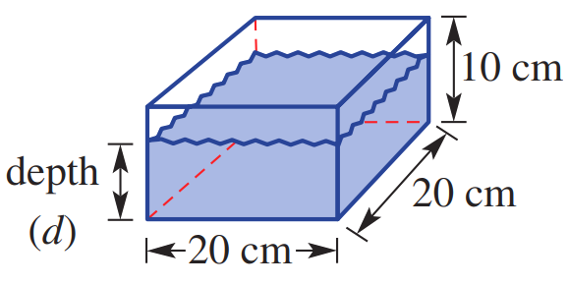
  - Calculate the base area of the container, in square cm.

$$A=20 m×20 m=400 cm^{2}$$
  - Calculate the depth of the water using $V=Ah$, where the height is $d$.

$$2400 cm^{3}=\left(400 cm^{2}\right)h$$
$h=6$ cm
- Use the same method as the previous question to calculate the depth of water in these prisms.
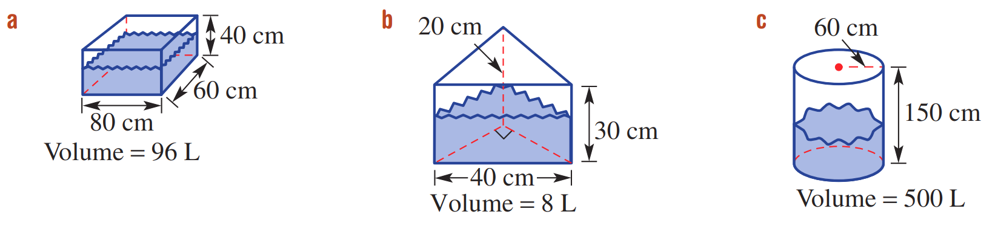  20 cm | 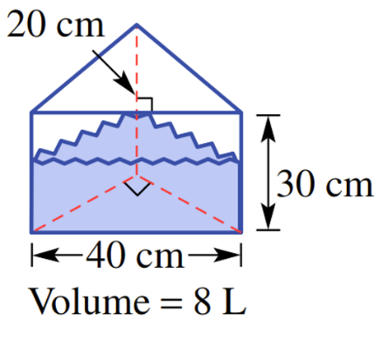  20 cm | 44.2 cm

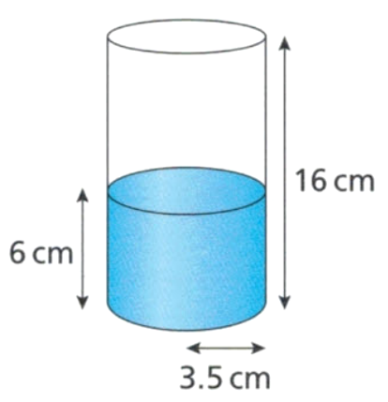
- A cylindrical vase is filled with water to the height shown. Sven pours in another 200 ml of water. Calculate the new depth of the water.

First figure out how high 200 mL would be
$$V=Ah$$
$$200=\left(π{\left(3.5\right)}^{2}\right)h$$
$$h=5.2$$
$5.2+6=11.2$ cm
- A pool is 50 metres long, 25 metres wide, 1 m deep at one end and 2 m deep at the other.
  - Draw a diagram of the pool. What 3D solid is this?

Trapezoidal prism
  - Calculate the capacity of the pool in kilolitres.
$$V=Ah$$
$$V=\frac{50}{2}\left(1+2\right)\left(25\right)=1875 m^{3}=1875 kL$$
  - If the level of the pool dropped by 75 cm on a hot day, calculate how much water is needed to replace the evaporated water, answer in kilolitres.

$$V=Ah=\left(25\right)\left(50\right)\left(0.75\right)=937.5 m^{3}$$
937.5 kL

