**MAT248 – Applied Linear Algebra**

**Programming Assignment – 1**

**AU2140150 – Solanki Dipesh A.**

**AU2140152 – Razdan Vinayak R.**

**AU2140055 - Ved Nayi**

**AU2140180 – Petal Parv**

**AU2140212 – Priyansh Yadav**

**AU2140216 – Krish Patel**

**-----------------------------------------------------------------------------------------------------------------------**

**3x3 Matrix**

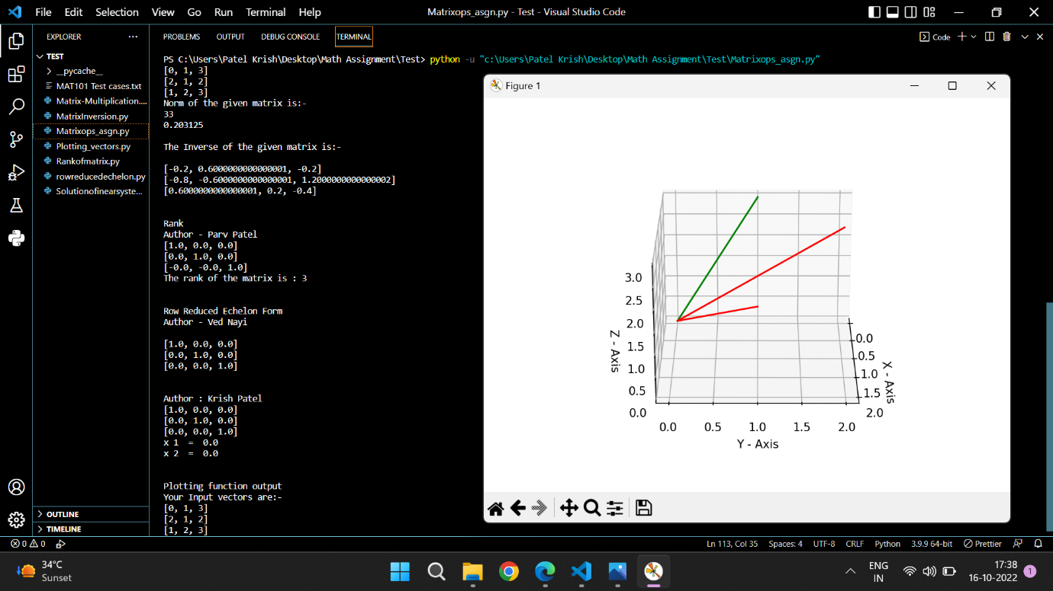

**-----------------------------------------------------------------------------------------------------------------------**

**4x4 Matrix**

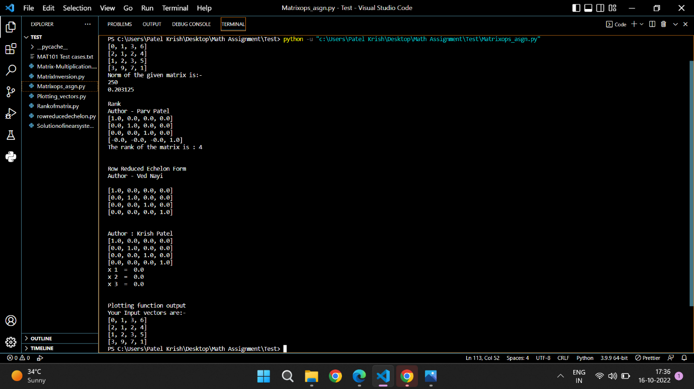

**-----------------------------------------------------------------------------------------------------------------------**

**5x5 Matrix**

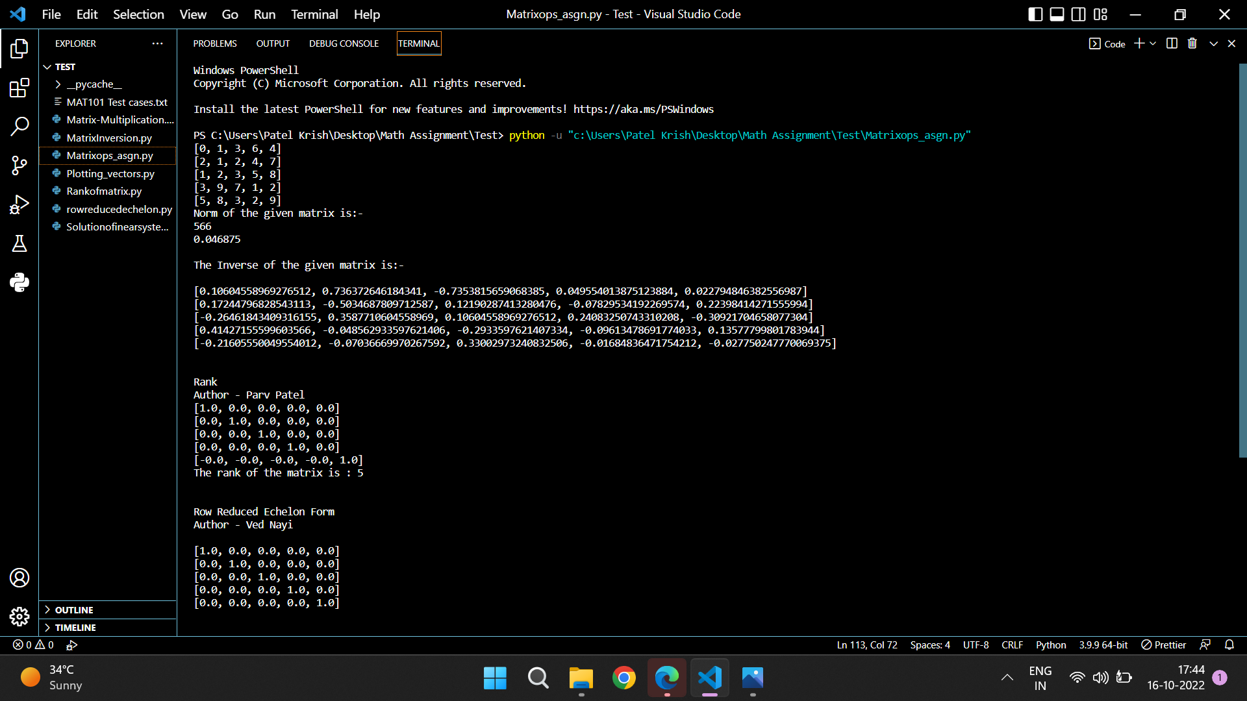

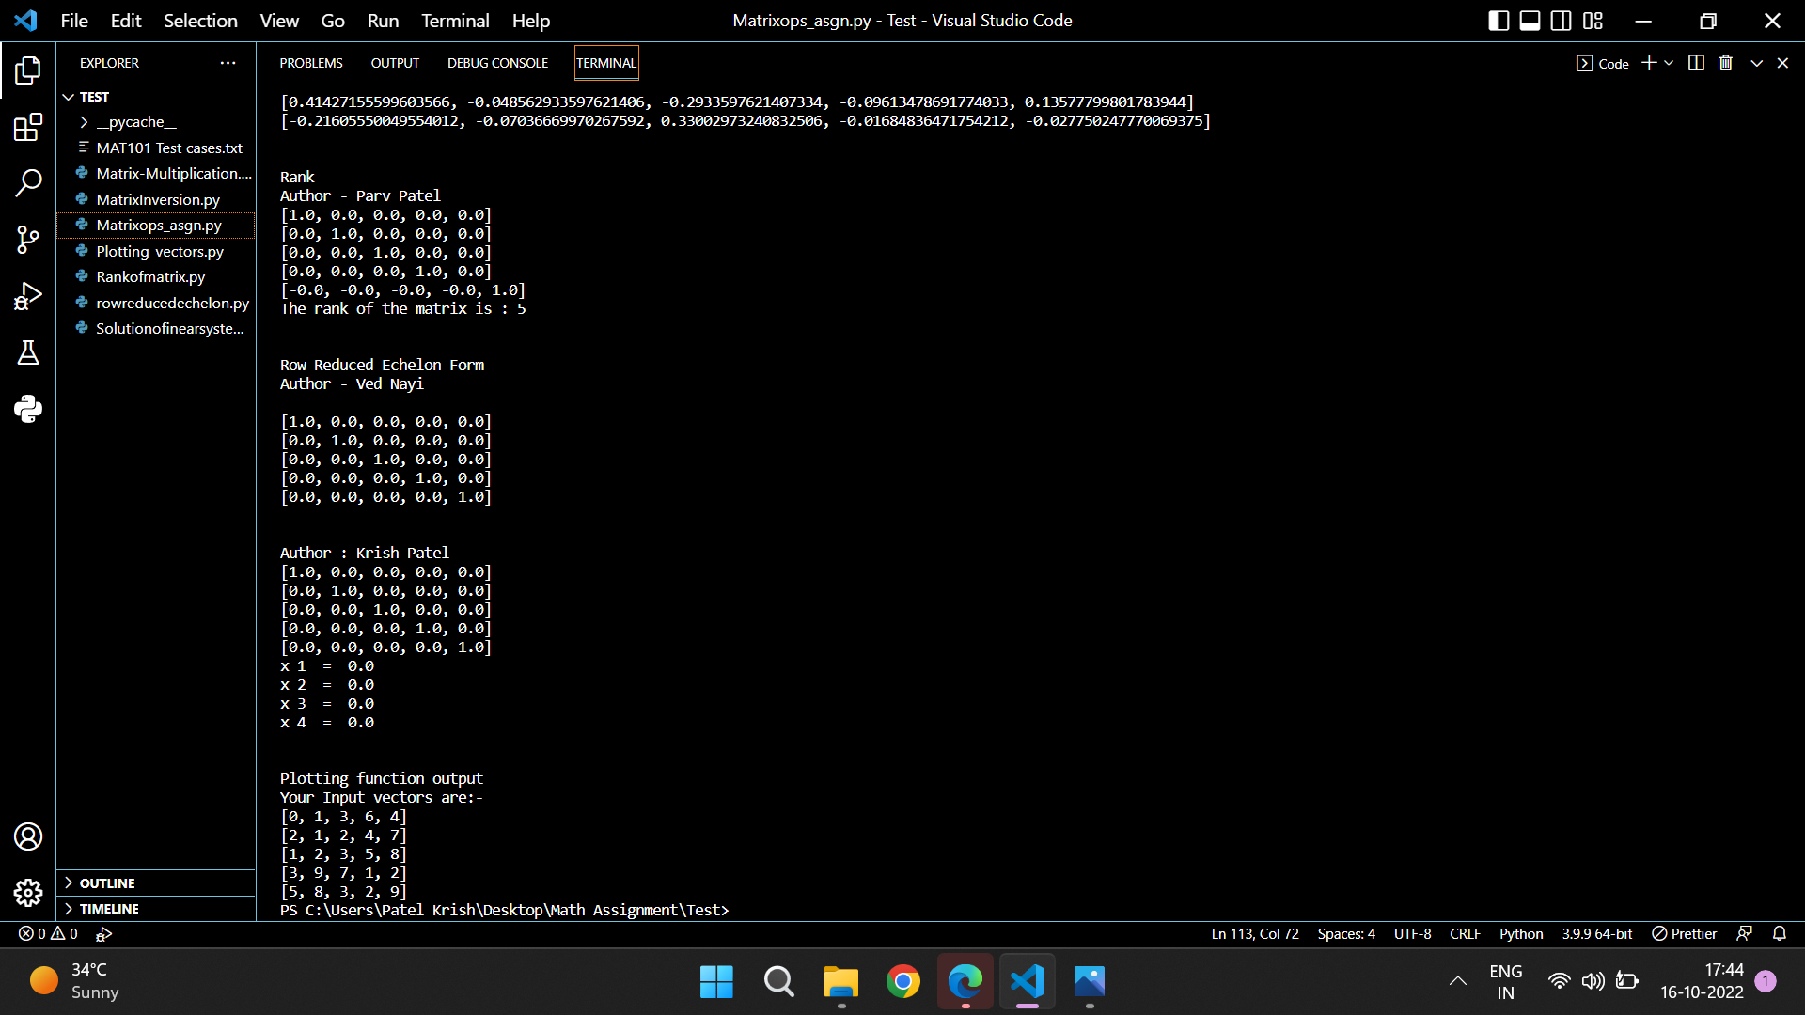

**-----------------------------------------------------------------------------------------------------------------------**

**Contribution:**

* Priyansh - Norm of matrix
* Dipesh - Inverse of Matrix
* Parv - Rank of a Matrix
* Ved - Row Reduced Echelon Form + Echelon form
* Vinayak - Matrix Multiplication
* Krish – Solve a system of linear equations – Homogenous and Non-Homogenous
* Represent the vectors (Plotting the vectors in 2-D and 3-D Plane and demonstrating it) – Dipesh + Priyansh