BKHD-2049NP-6L-15 155H V1.0
User Manual
English Translation
Translated from the supplied Chinese-language original manual.
All original images from the source manual are embedded in this version.

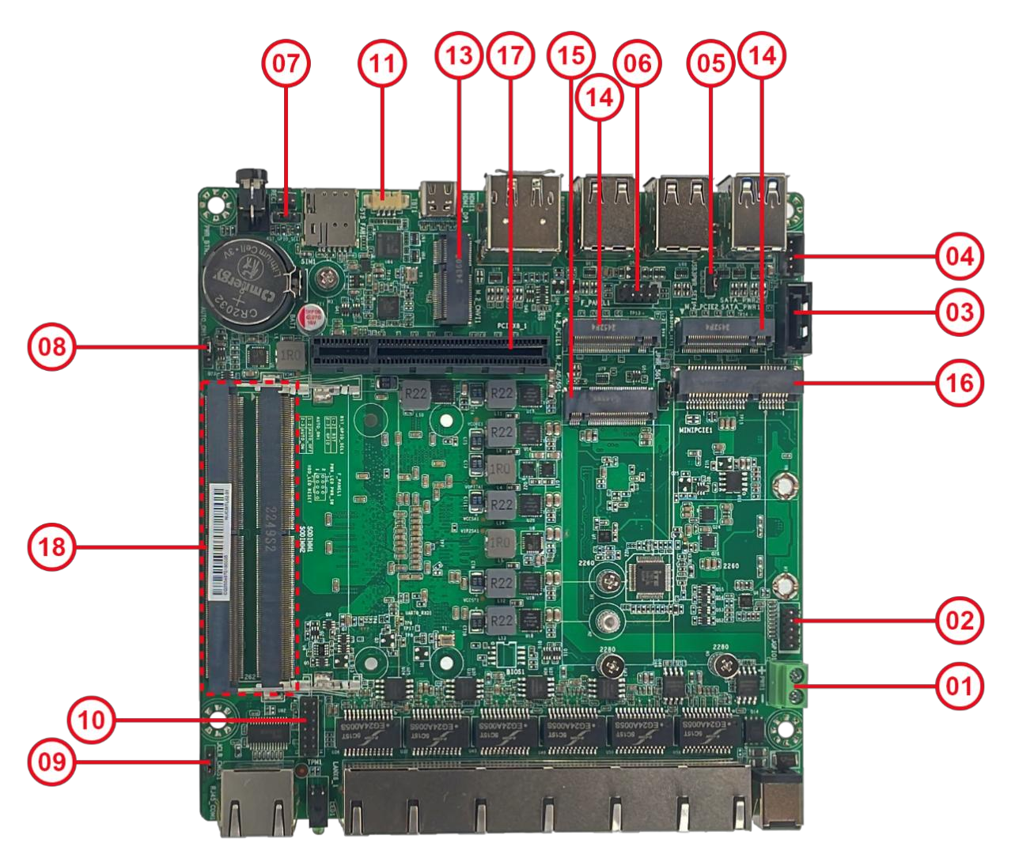
Prepared as a practical English replacement manual for the original document.

Safety Guidance

General Safety Tips
1. Before using this product, please read the manual carefully.
2. Store any board that is not yet ready for installation in an anti-static protective bag.
3. Before removing a board from its anti-static bag, touch a grounded metal object for several seconds, for example about 10 seconds, to discharge static electricity from your body and hands.
4. Wear anti-static gloves when handling the board and, whenever possible, touch only the board edges.
5. To avoid electric shock or product damage, switch off AC power before inserting, removing, or reconfiguring the board.
6. Switch off AC power before moving either the board or the complete system.
7. For complete systems, always switch off AC power before adding or removing boards.
8. Before connecting or disconnecting any device, switch off AC power first.
9. To avoid unnecessary wear caused by frequent power cycling, wait at least 30 seconds after shutdown before powering the system on again.

Revision History
Revision | Date | Description | Author
V1.0 | 2025-07-15 | Initial release

Contents
Safety Guidance 2
Chapter 1 Introduction 5
1.1 Packing List 5
1.2 Motherboard Specifications 6
1.3 Motherboard Layout 7
1.3.1 Rear I/O Interfaces 9
1.3.2 Front I/O Interfaces 10
Chapter 2 Motherboard Installation 11
2.1 Memory Installation 11
2.2 Jumper Description 12
2.3 Header and Jumper Settings 12
1. PWR1 Phoenix Terminal 12
2. GPIO Internal GPIO Header 13
3. SATA Internal SATA Connector 13
4. SATA_PWR SATA Power Header 14
5. JUSB3PWR_SET1 USB 3.0 Port Power-Source Selection Jumper 14
6. F_PANEL Front-Panel Switch Header 14
7. RST_GPIO_SEL1 SW Button Function Selection Jumper 15
8. AUTO_ON1 Automatic Power-On Jumper 15
9. CLR_CMOS CMOS Clear Jumper 16
10. TPM1 TPM Header 16
11. SYS_FAN1/2 System Fan Headers 17
12. CPU_FAN CPU Fan Header 17
Chapter 3 BIOS Setup 18
3.1 BIOS Overview 18
3.2 Entering BIOS Setup 18
3.2.1 Main 19
3.2.2 Connectivity Configuration 19
3.2.3 CPU Configuration 20
3.2.4 Power & Performance 21
3.2.5 System Agent Configuration 23
3.2.6 PCIe Configuration 23
3.2.7 PCH-IO Configuration 24
3.2.8 PCH-FW Configuration 27
3.2.9 Trusted Computing 27
3.2.10 ACPI Settings 28
3.2.11 IT8613 Super I/O Configuration 29
3.2.12 Hardware Monitor 29
3.2.13 Serial Port Console Redirection 30
3.2.14 USB Configuration 31
3.2.15 Network Configuration 31
3.2.16 NVMe Configuration 32
3.2.17 Security 33
3.2.18 Boot 33
3.2.19 Save & Exit 34

Chapter 4 Troubleshooting 36
4.1 System Does Not Power On 36
4.2 No VGA Display After Power-On 36
4.3 BIOS Setup Settings Cannot Be Saved 36
4.4 Cannot Boot the Operating System or the Drive Is Not Detected 36
4.5 Blue Screen or System Freeze During Boot 36
4.6 System Stuck at the BIOS Screen 36
4.7 System Restarts Automatically 36
4.8 USB Device Cannot Be Detected 37

Chapter 1 Introduction

1.1 Packing List
Thank you for choosing our product. After receiving the product, please confirm that the outer packaging is intact. If the package shows visible damage or any accessories are missing, please contact your dealer.
• Motherboard x 1
• Cables, add-in boards, and other accessories (contents vary by order; please contact sales if needed)
• Warranty card
• Certificate of conformity
Included accessories are for reference only. Actual bundled items are determined by the shipped product.
Motherboard specifications and BIOS software are continuously updated. The contents of this manual are subject to change without notice. Please refer to the actual product or any updated version published online.
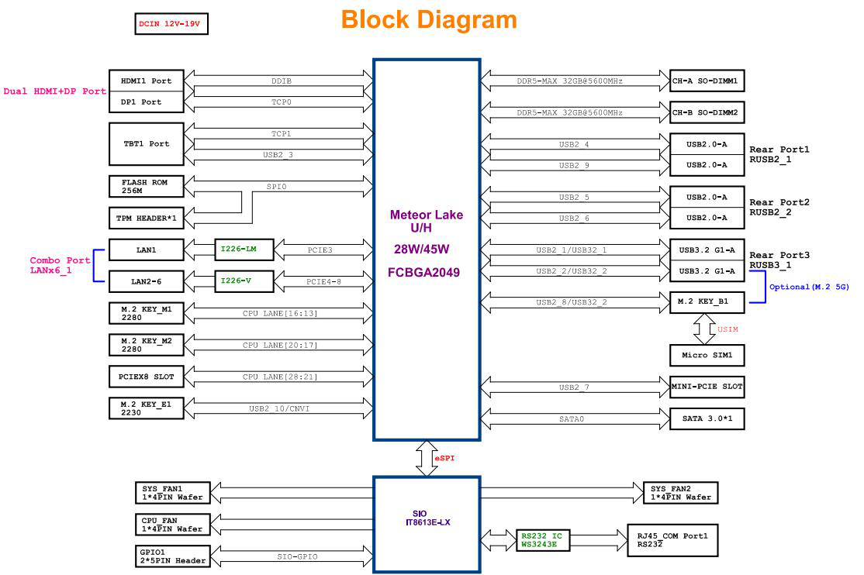
Original block diagram from the source manual.

1.2 Motherboard Specifications
Item | Specification
Motherboard size | 150 mm x 145 mm
Processor | Intel Core Ultra Meteor Lake processors (125H / 155H / 185H)
Memory | 2 x 262-pin DDR5 SO-DIMM slots, up to 5600 MHz, maximum 96 GB
Expansion | 1 x M.2 E Key for Wi-Fi module expansion (CNVi Wi-Fi only); 1 x M.2 B Key for 4G, optional 5G hardware variant; 1 x Mini PCIe slot for 4G; 1 x PCIe x8 expansion slot
Storage | 2 x M.2 M Key supporting PCIe x4; 1 x SATA 3.0 interface
Rear panel interfaces | 1 x RJ45_COM, 1 x LED (power / drive), LAN1-6, 1 x DC_IN power input
Front interfaces | 2 x USB 3.0 ports; 4 x USB 2.0 ports (two dual-port groups); 1 x stacked DP + HDMI; 1 x Type-C port (Thunderbolt); 2 x SIM slots; 1 x REC button (reset or optional GPIO); 1 x PWR button
Internal headers | 1 x Phoenix terminal; 1 x GPIO header; 1 x SATA header; 1 x SATA_PWR header; 1 x F_PANEL header; 1 x TPM header; 2 x SYS_FAN headers; 1 x CPU_FAN header
BIOS | AMI BIOS
Power management | ACPI supported; Wake-on-LAN for S4 and S5; automatic power-on after power restore supported
Display | HDMI + DP + Type-C triple-display output, synchronous or asynchronous
Network | Onboard 6 x Intel i226V 2.5G NICs; LAN1 can optionally use i226-LM with vPro support
I/O controller | IT8613
Power input | DC 19 V
Operating environment | Operating temperature 0 C to 60 C; humidity 0% to 95%
Supported operating systems | Windows 10, Windows 11, Linux

1.3 Motherboard Layout
The diagrams below are for reference only. Please use the actual product as the final reference.

Top-side motherboard layout.
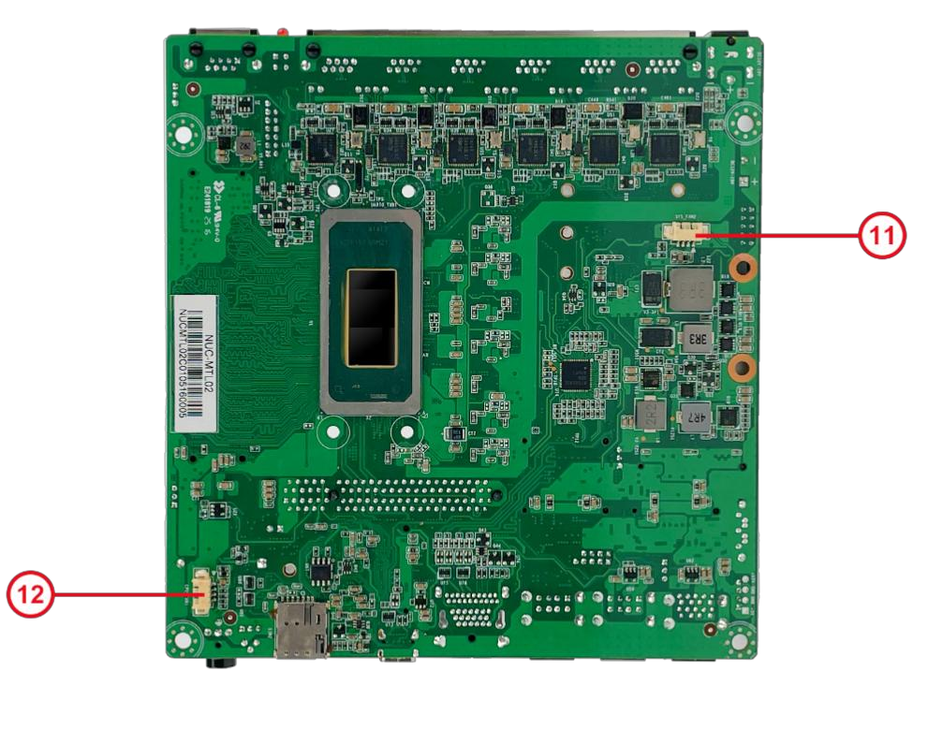
Bottom-side motherboard layout.
Item | Description
1 | PWR1 Phoenix terminal
2 | JGPIO Internal GPIO header
3 | SATA Internal SATA connector
4 | SATA_PWR SATA power header
5 | JUSB3PWR_SET1 USB 3.0 power-source selection jumper
6 | F_PANEL Front-panel switch header
7 | RST_GPIO_SEL1 SW button function selection jumper
8 | AUTO_ON Automatic power-on selection jumper
9 | CLR_CMOS CMOS clear jumper
10 | TPM Internal TPM header
11 | SYS_FAN1/2 System fan headers (FAN1 front side / FAN2 rear side)
12 | CPU_FAN1 CPU fan header (rear side)
13 | M.2_CNVI M.2 E Key slot for Wi-Fi
14 | M.2_PCIE M.2 M Key slot supporting PCIe x4
15 | M.2_4G/5G M.2 B Key slot for 4G or optional 5G
16 | MINIPCIE Mini PCIe slot for 4G
17 | PCIEx8 PCIe x8 slot
18 | SODIMM1/2 2 x DDR5 SO-DIMM slots

1.3.1 Rear I/O Interfaces
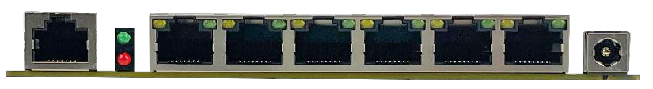
Rear I/O view from the source manual.
Item | Description
RJ45_COM | RJ45 serial port
LED1 | Status LED. Power: green. Drive activity: red.
LANX6 | Six-port LAN block. Link LED: solid green means link established. Activity LED: flashing amber means data transmission.
DCIN | DC 19 V power input

1.3.2 Front I/O Interfaces
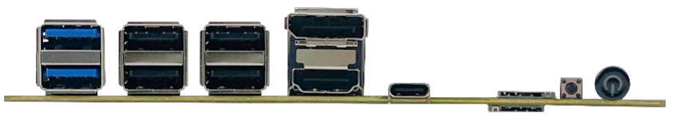
Front I/O view from the source manual.
Item | Description
RUSB3 | 2 x USB 3.2 Gen 2 ports, up to 10 Gbps
RUSB2_1 | 2 x USB 2.0 ports
RUSB2_2 | 2 x USB 2.0 ports
HDMI_DP | Stacked DP + HDMI connector
Type-C | 1 x Type-C connector for Thunderbolt and display
SYS_FAN1 | System fan header
SIM1/2 | 2 x SIM card slots
REC | Default function is reset; optional GPIO function
PWR_BTN1 | Power button

Chapter 2 Motherboard Installation

Installation Safety Notes
 | Read these precautions before installing or servicing the motherboard.
• Do not remove the motherboard serial-number label or distributor warranty label before installation, otherwise warranty validation may be affected.
• Before installing or removing the motherboard or any other hardware device, switch off the power and unplug the power cable from the outlet.
• When connecting other hardware devices to motherboard headers or sockets, make sure each connector is fully and firmly seated.
• When handling the motherboard, avoid touching exposed metal traces or contacts in order to reduce the risk of short circuits.
• When handling the motherboard, processor, or memory modules, it is recommended to wear an anti-static wrist strap. If one is not available, make sure your hands are dry and touch a metal object first to discharge static electricity.
• Before installation, place the motherboard on an anti-static mat or keep it inside an anti-static bag.
• Before disconnecting the motherboard power connector, make sure the power supply is turned off.
• Before powering on the system, confirm that the power-supply input setting matches the local mains standard.
• Before powering on the system, make sure all signal cables and power cables are connected correctly.
• Do not allow screws to touch traces or components on the motherboard.
• Make sure no loose screws or metal objects remain on the motherboard or inside the computer chassis.
• Do not place the computer on an unstable surface.
• Do not place the computer in an excessively hot environment.
• Applying power during installation may damage the motherboard, damage other devices, or cause personal injury.
• If you are unfamiliar with hardware installation or encounter technical issues while using this product, consult a qualified technician.

2.1 Memory Installation
This motherboard provides two 262-pin DDR5 SO-DIMM memory sockets.
Before installing memory, please note the following:
1. Make sure the memory you purchased matches the specifications supported by this motherboard.
2. Before installing or removing memory, confirm that the computer is powered off to prevent damage.
3. The memory module is keyed. If the insertion direction is wrong, it will not fit. Do not force it. Adjust the orientation and try again.
Memory installation steps:
1. Before installing or removing memory, switch off the power and unplug the AC power cord.
2. Hold the memory module gently by both ends. Do not touch the gold contacts.
3. Align the gold fingers with the slot and make sure the notch in the module matches the keyed tab in the socket.
4. Insert the module into the slot at about a 30-degree angle, then press it downward until you hear a click. This indicates that the module is installed correctly. Do not use excessive force.
5. To remove a memory module, push both latches on the DIMM socket outward at the same time, then lift the module out.
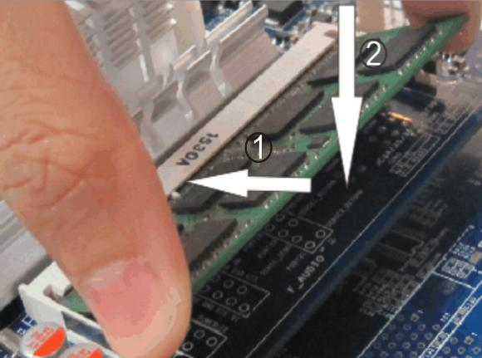 | 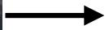 | 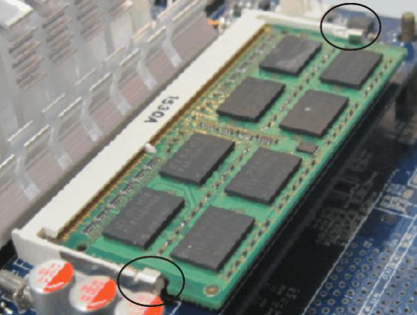
Original memory-installation images from the source manual.

2.2 Jumper Description
2-pin header: placing the jumper cap across both pins closes, or shorts, the header.
3-pin header: placing the jumper cap on pins 1-2 or on pins 2-3 closes the corresponding selection.
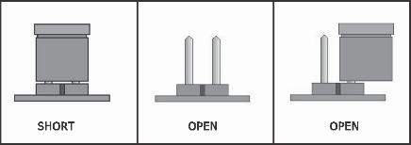 | 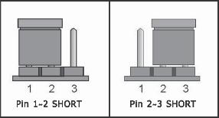
Left: 2-pin header states. Right: 3-pin jumper positions.
How to identify pin 1:
1. On the motherboard, pin 1 is usually marked with a "1" or with a thick white line.
2. On the solder side of the board, the square pad is usually pin 1.

2.3 Header and Jumper Settings

1. PWR1 Phoenix Terminal
The motherboard provides one 1 x 2-pin Phoenix terminal that supports 12 V to 19 V input and output. When used as an input connector, choose either this terminal or the DC input. Do not power the motherboard from both at the same time.
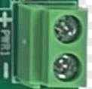
Original connector diagram from the source manual.
Pin | Definition
+ | 12 V to 19 V
- | GND

2. GPIO Internal GPIO Header
The motherboard provides one 2 x 5-pin GPIO header with 2.00 mm pitch.
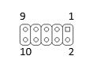
Original connector diagram from the source manual.
Pin | Definition
1 | GPIO
2 | GPIO
3 | GPIO
4 | GPIO
5 | GPIO
6 | GPIO
7 | GPIO
8 | GPIO
9 | GND
10 | +3.3 V

3. SATA Internal SATA Connector
The motherboard provides one 1 x 7-pin SATA connector.
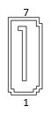
Original connector diagram from the source manual.
Pin | Definition
1 | GND
2 | TX+
3 | TX-
4 | GND
5 | RX-
6 | RX+
7 | GND

4. SATA_PWR SATA Power Header
The motherboard provides one 1 x 4-pin SATA power header with 2.00 mm pitch. An optional 1 x 4-pin header with 2.54 mm pitch may also be used. Both variants use the same pin definition.
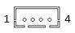 | 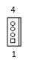
Left: 2.00 mm SATA power header. Right: optional 2.54 mm variant.
Pin | Definition
1 | +5 V
2 | GND
3 | GND
4 | +12 V

5. JUSB3PWR_SET1 USB 3.0 Port Power-Source Selection Jumper
The motherboard provides one 1 x 3-pin selection jumper with 2.00 mm pitch.
Original connector diagram from the source manual.
Pins | Definition
1-2 (Default) | +5VS
2-3 | +5VA

6. F_PANEL Front-Panel Switch Header
The motherboard provides one 2 x 5-pin F_PANEL header with 2.00 mm pitch.
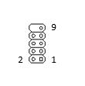
Original connector diagram from the source manual.
Pin | Definition
1 | HDD LED+
2 | PWR LED+
3 | HDD LED-
4 | PWR LED-
5 | GND
6 | POWER-SW
7 | RESET-SW
8 | GND
9 | GND
10 | NC

7. RST_GPIO_SEL1 SW Button Function Selection Jumper
The motherboard provides one 1 x 3-pin selection jumper with 2.00 mm pitch.
Original connector diagram from the source manual.
Pins | Definition
1-2 (Default) | RST
2-3 | GPIO

8. AUTO_ON1 Automatic Power-On Jumper
The motherboard provides one 1 x 3-pin automatic power-on jumper with 2.00 mm pitch.
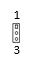
Original connector diagram from the source manual.
Pins | Definition
1-2 (Default) | NORMAL
2-3 | AUTO_ON

9. CLR_CMOS CMOS Clear Jumper
The motherboard provides one 1 x 3-pin CMOS-clear jumper with 2.00 mm pitch.

Original connector diagram from the source manual.
Pins | Definition
1-2 (Default) | NORMAL
2-3 | CLR_CMOS

10. TPM1 TPM Header
The motherboard provides one 2 x 7-pin TPM header with 2.00 mm pitch.
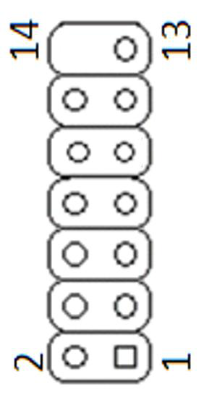
Original connector diagram from the source manual.
Pin | Definition
1 | VCC
2 | S_SPI_TPM_IRQ#
3 | S_PLTRST#
4 | S_SPI_TPM_CS2#
5 | F2_SPI_CS1#_R
6 | F_BOIS_WP#_R
7 | +3V_SPI
8 | GND
9 | F_SPI_CSO#_R
10 | T_SPI_CLK
11 | T_SPI_MISO
12 | T_SPI_MOSI
13 | F_SPI_HOLD#_R
14 | NC

11. SYS_FAN1/2 System Fan Headers
The motherboard provides two 1 x 4-pin SYS_FAN headers with 1.25 mm pitch.
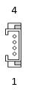
Original connector diagram from the source manual.
Pin | Definition
1 | Ground
2 | +12 V
3 | Sense
4 | Control

12. CPU_FAN CPU Fan Header
The motherboard provides one 1 x 4-pin CPU_FAN header with 1.25 mm pitch.

Original connector diagram from the source manual.
Pin | Definition
1 | Ground
2 | +12 V
3 | Sense
4 | Control

Chapter 3 BIOS Setup

3.1 BIOS Overview
This motherboard uses AMI BIOS. BIOS stands for Basic Input Output System. It is stored in a ROM chip on the motherboard. When the computer is powered on, BIOS is the first program to run and it performs the following main tasks:
• Power-On Self Test, or POST, to check whether the computer hardware is operating correctly.
• Initialization and detection of external devices, followed by loading the operating system.
• Providing the lowest-level and most basic control interface for the system hardware.
• Providing the BIOS Setup utility used to configure the computer.

AMI branding captured in the original manual.
BIOS information is stored in CMOS RAM on the motherboard and maintained by a 3.3 V coin-cell battery. This memory contains important system information and the BIOS Setup program used to configure system parameters. Under normal operation, BIOS settings do not need to be changed. If CMOS data is lost for any reason, the BIOS must be configured again.
Important: Incorrect BIOS settings can damage computer hardware or even the motherboard itself. Users who are unfamiliar with BIOS options should modify settings carefully.
Because the BIOS is continuously updated, the BIOS information shown in this manual is for reference only and may differ slightly from the actual BIOS on your motherboard.

3.2 Entering BIOS Setup
When the motherboard is powered on or the system is restarted, the POST screen displays a prompt. Press DEL to enter BIOS Setup.
Use the arrow keys to move between options, Enter to select, and Page Up or Page Down to change values. Press F1 for help and Esc to exit.
Key | Function
Left / Right | Move between items across the screen
Up / Down | Move between items vertically
+ / - | Increase or decrease values, or change a selection
Enter | Confirm the current option or enter a submenu
Esc | Return to the previous screen or exit CMOS Setup from the main screen
F1 | Display help
F2 | Restore previous values
F9 | Load optimized defaults
F10 | Save CMOS settings and restart

3.2.1 Main
The Main screen displays basic system information such as BIOS version, processor type, memory information, and system date and time.
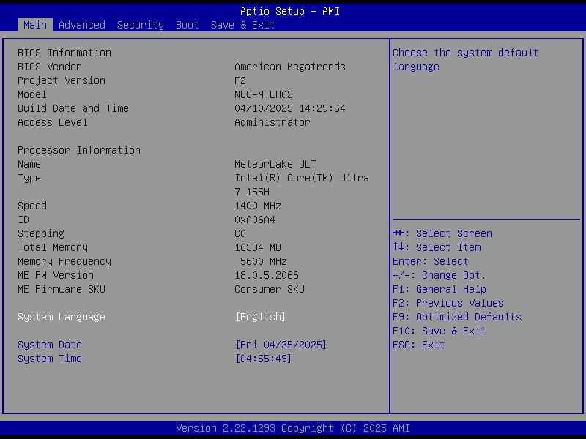

3.2.2 Connectivity Configuration
This menu groups connectivity-related options and provides access to CPU, power, PCIe, USB, network, NVMe, and other platform configuration pages.
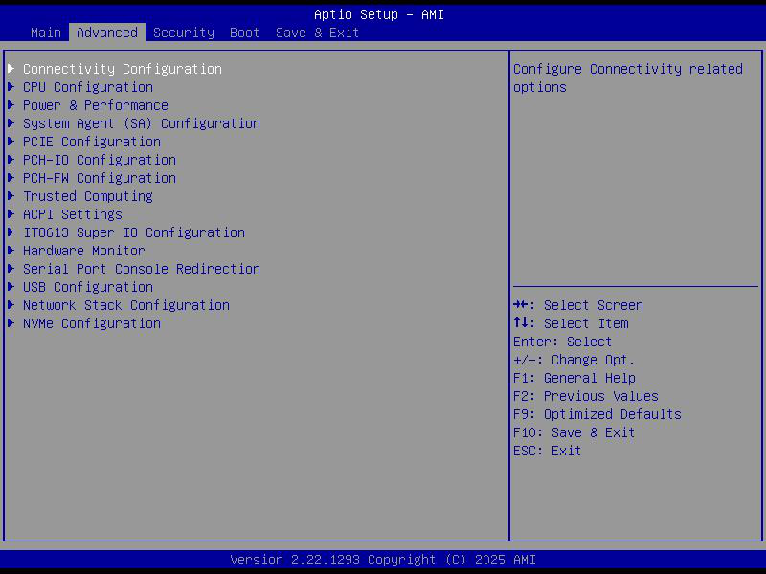

3.2.3 CPU Configuration
This page displays processor information and allows configuration of CPU-specific features and behavior.
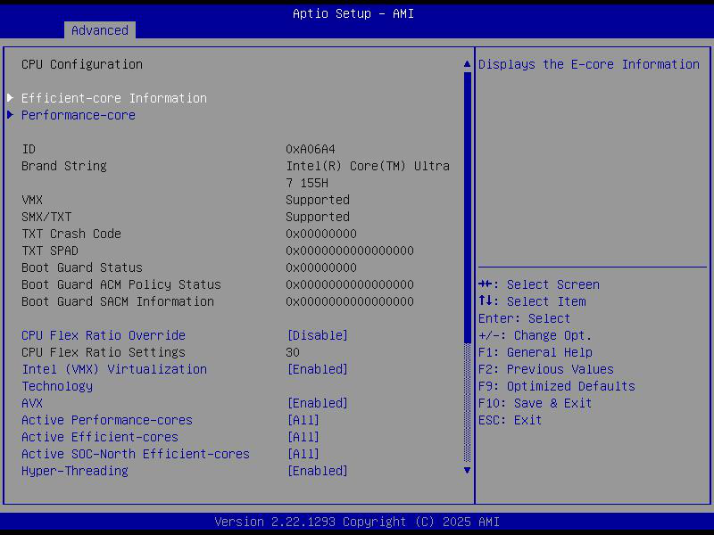

3.2.4 Power & Performance
This screen provides access to CPU and graphics power-management options.
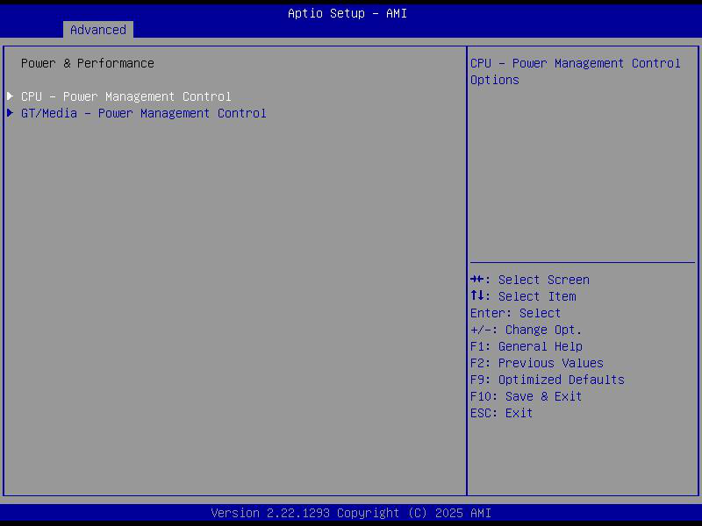

3.2.4 Power & Performance Additional Pages
The original manual also includes the following Power & Performance subpages.
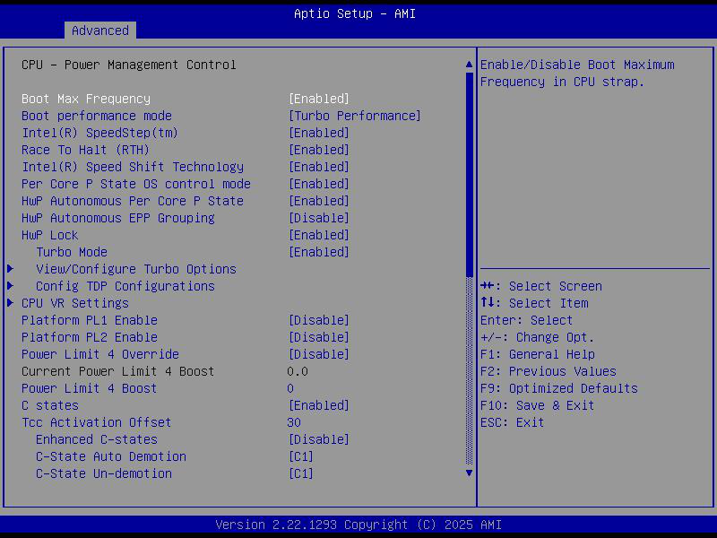
CPU power-management control page.
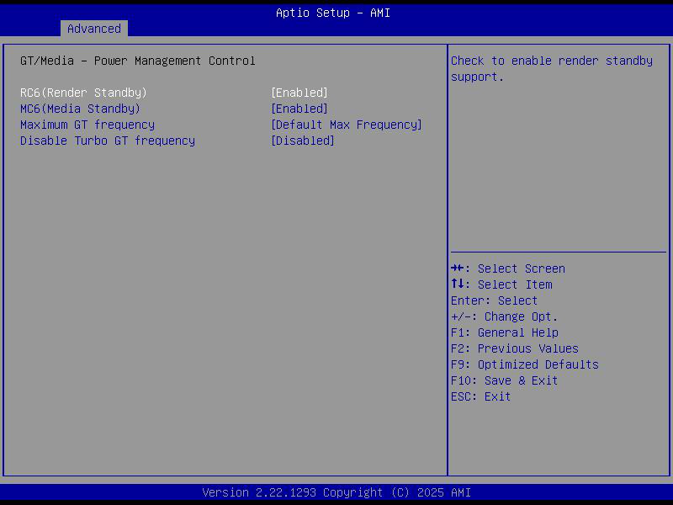
GT / media power-management control page.

3.2.5 System Agent Configuration
System Agent configuration page.
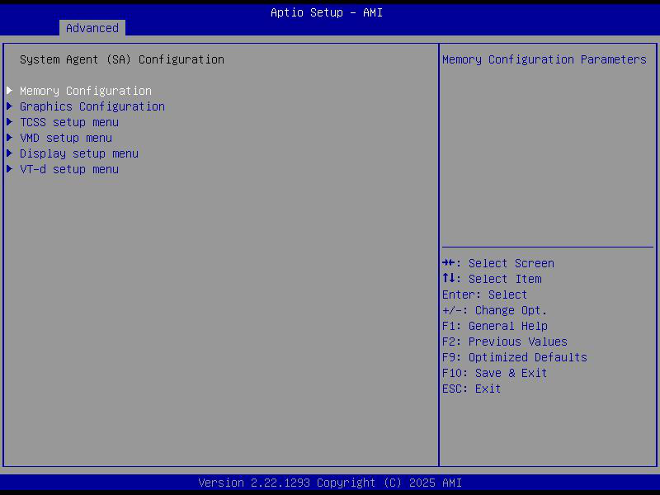

3.2.6 PCIe Configuration
PCIe configuration and root-port options.
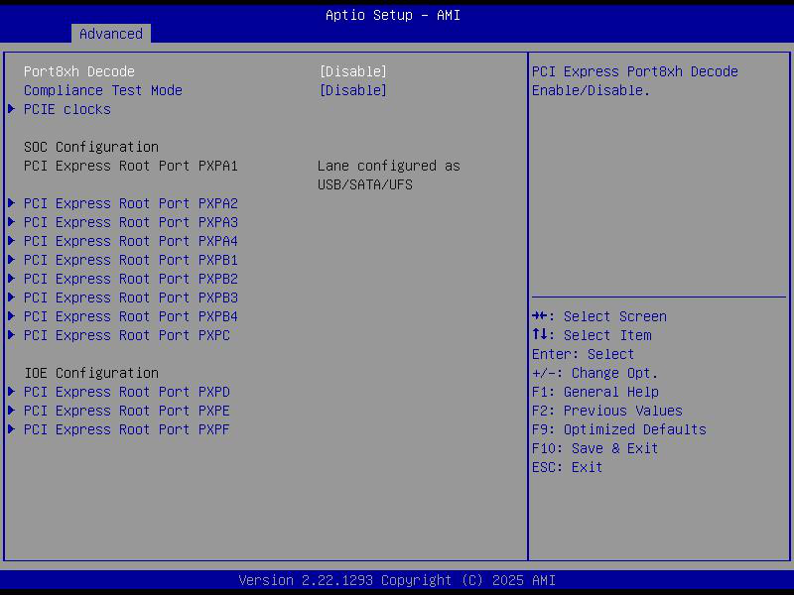

3.2.7 PCH-IO Configuration
PCH-IO parent menu.
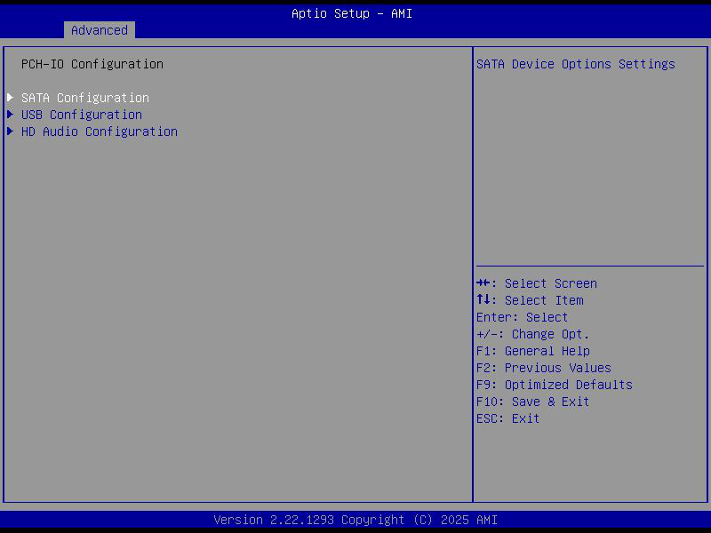

3.2.7 PCH-IO Configuration Device Subpages
The PCH-IO section in the original manual includes additional SATA, USB, and HD Audio configuration pages.
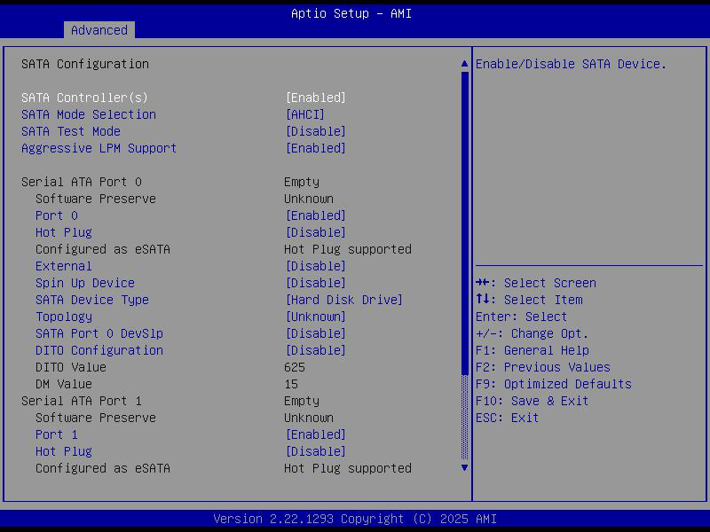
SATA configuration page.
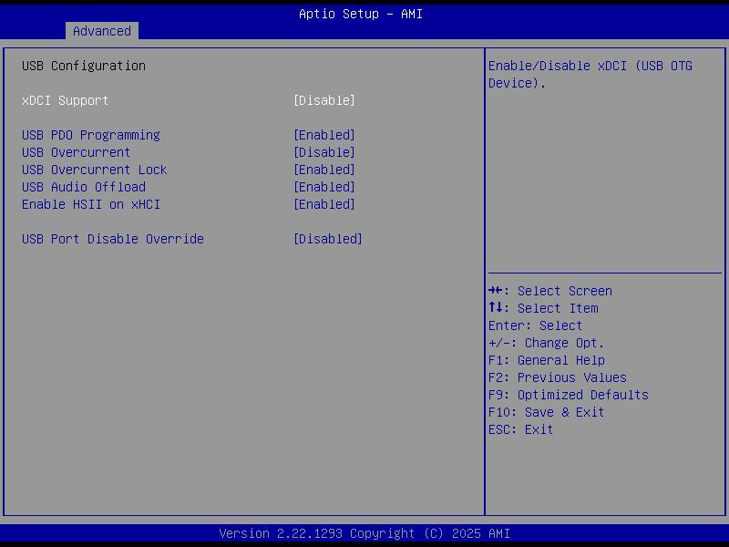
USB configuration subpage.
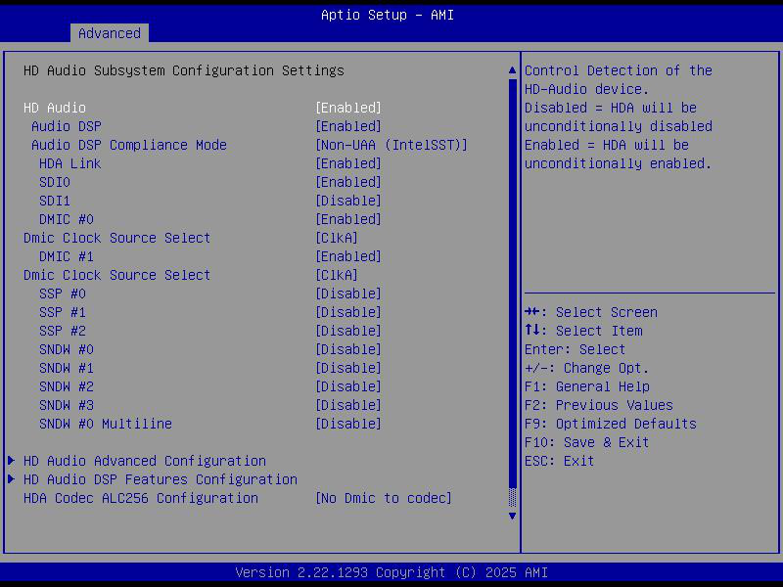
HD Audio configuration page.

3.2.8 PCH-FW Configuration
Firmware-related platform configuration page.
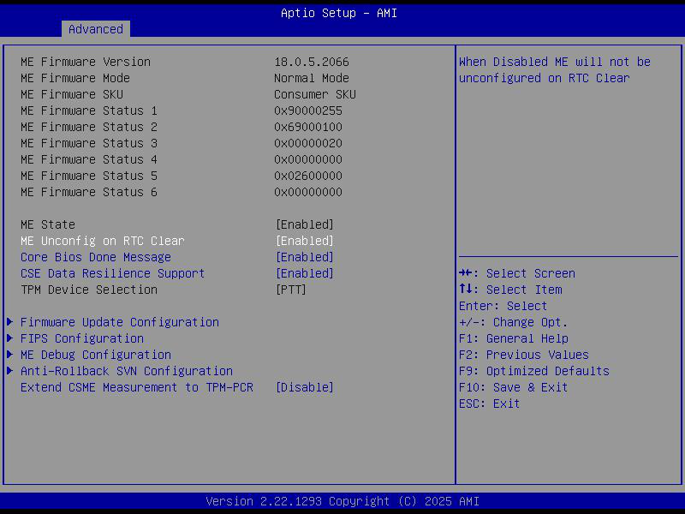

3.2.9 Trusted Computing
TPM and trusted-computing settings.
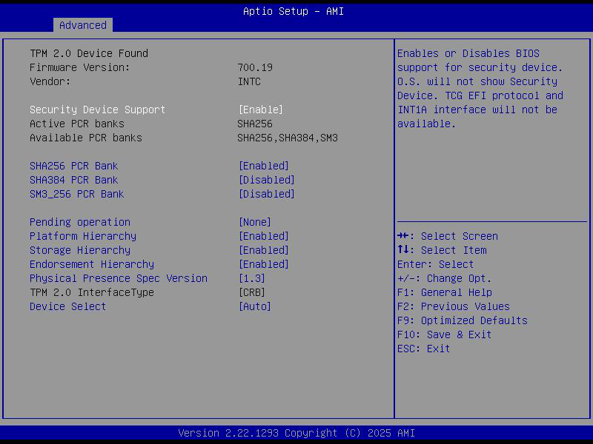

3.2.10 ACPI Settings
ACPI and power-management behavior settings.
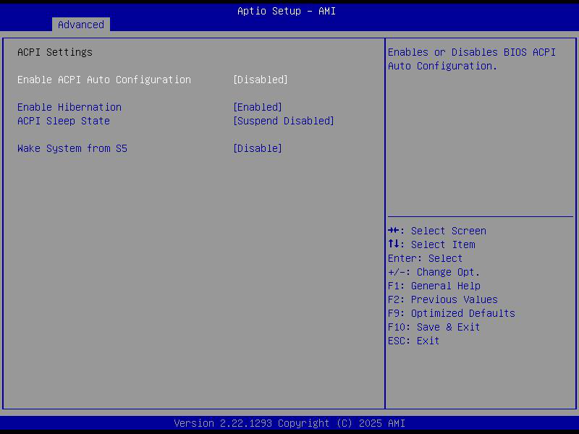

3.2.11 IT8613 Super I/O Configuration
Super I/O and restore-AC-power-loss behavior.
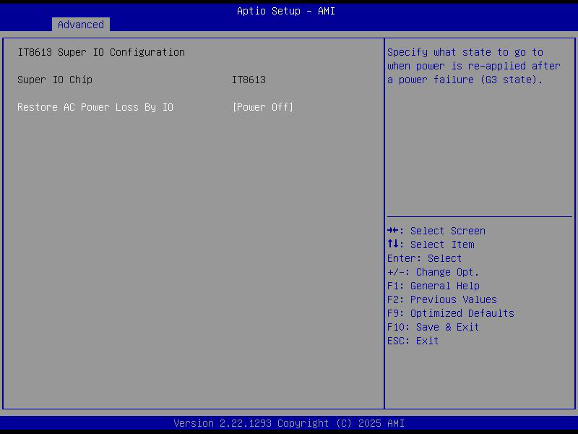

3.2.12 Hardware Monitor
Hardware monitoring page for temperatures, voltages, and fan status.
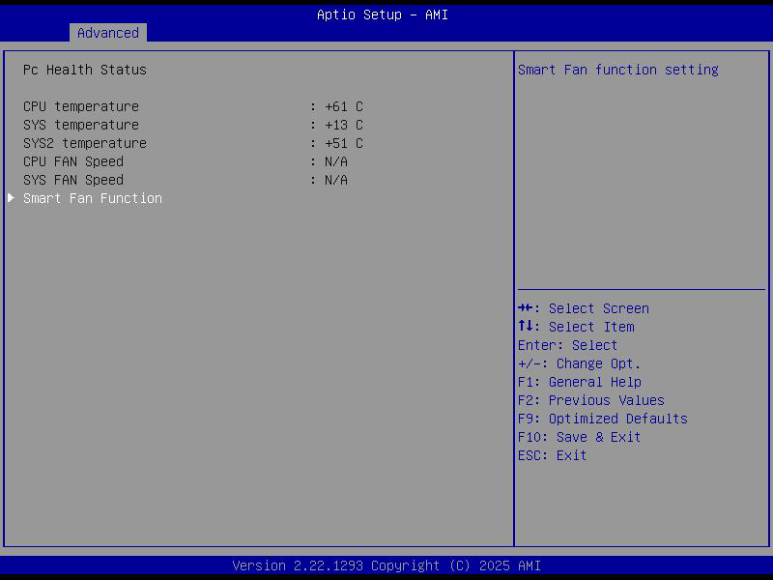

3.2.13 Serial Port Console Redirection
Serial-port and console-redirection settings.
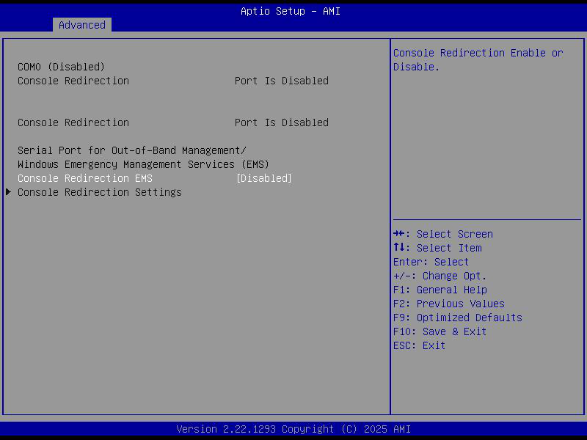

3.2.14 USB Configuration
USB controller and USB boot support configuration.
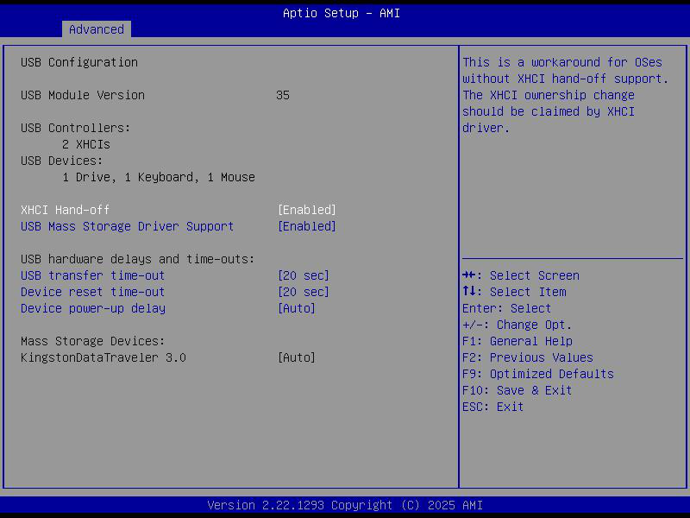

3.2.15 Network Configuration
UEFI network stack configuration.
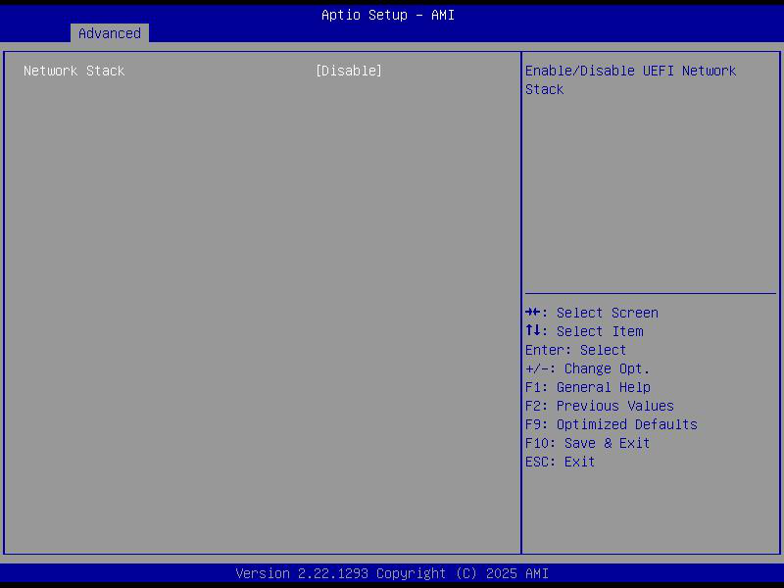

3.2.16 NVMe Configuration
NVMe device information page.
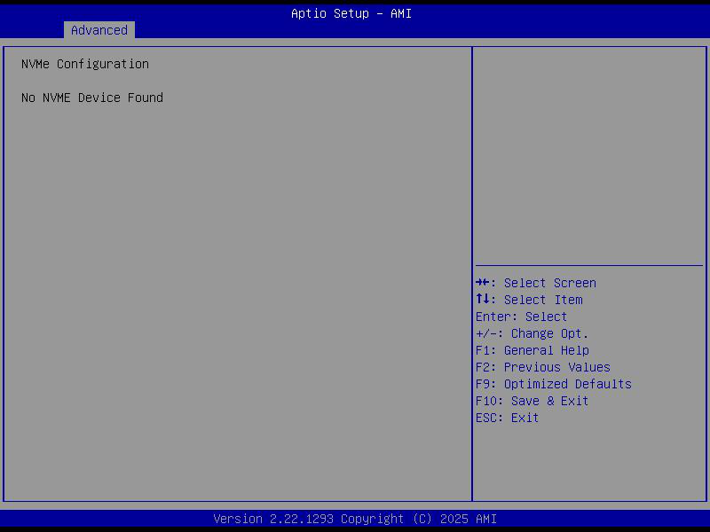

3.2.17 Security
Administrator password, user password, and secure-boot related settings.
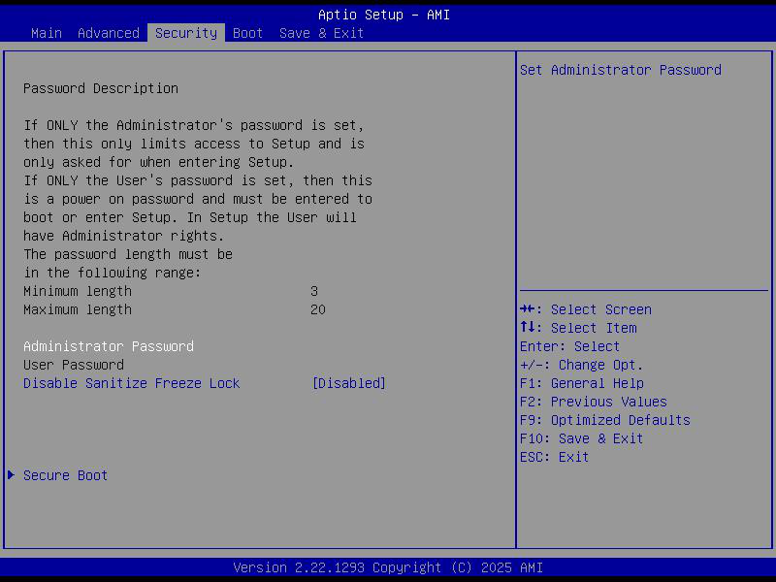

3.2.18 Boot
The Boot page controls startup-related options such as POST prompt delay, NumLock behavior after boot, boot priorities, and Fast Boot.
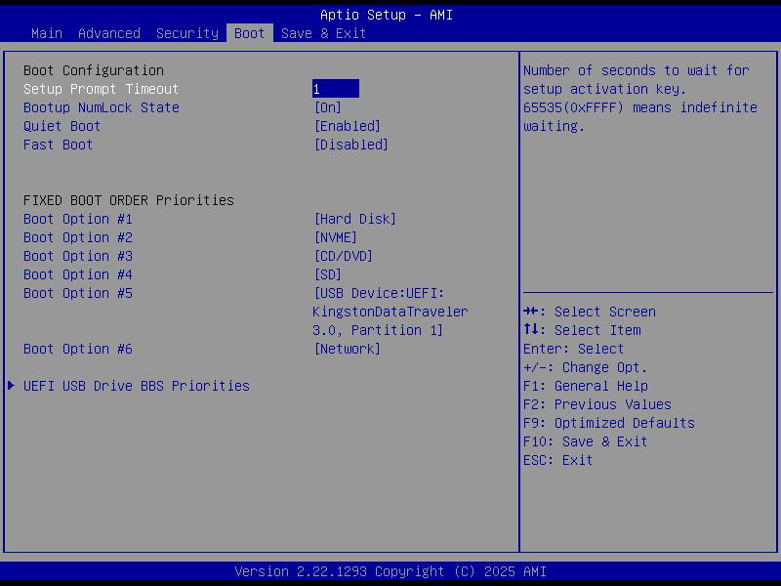
• Setup Prompt Timeout: sets how long the POST screen remains visible.
• Bootup NumLock State: controls the NumLock state after boot. When set to On, the numeric keypad enters number-input mode. When set to Off, the keypad behaves as directional keys.
• Fast Boot: enables or disables fast startup. Available options are Disabled and Enabled.

3.2.19 Save & Exit
This page contains the standard commands used to save or discard BIOS changes.
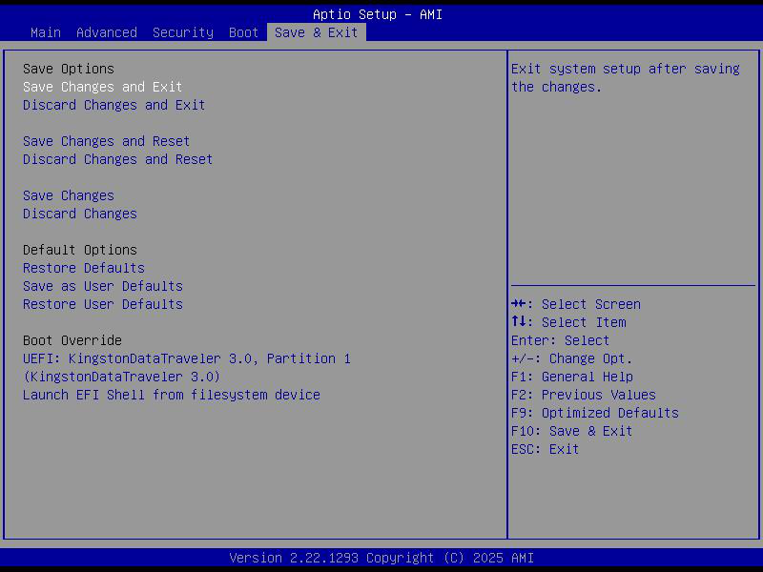
• Save Changes and Exit: save the current changes and leave BIOS Setup.
• Discard Changes and Exit: leave BIOS Setup without saving changes.
• Save Changes and Reset: save changes and restart the motherboard.
• Discard Changes and Reset: restart without saving changes.
• Save Changes: save current changes without leaving the page.
• Discard Changes: discard current unsaved changes.
• Restore Defaults: restore default settings.
• Save as User Defaults: save the current settings as user defaults.
• Restore User Defaults: restore the previously saved user defaults.

Chapter 4 Troubleshooting
The following common motherboard issues and simple solutions are compiled from customer feedback and the original manual.

4.1 System Does Not Power On
• Confirm that the power adapter is connected correctly.
• Confirm that the power supply specifications meet the motherboard requirements.
• Clean and reseat the memory modules, or try different memory modules.
• Clear CMOS according to the motherboard manual.

4.2 No VGA Display After Power-On
• Confirm that the monitor is powered on.
• Confirm that the display cable is functioning correctly.
• Check whether LVDS or eDP has been set as the primary display output in BIOS.
• If additional display modules are used, make sure the required drivers are installed.

4.3 BIOS Setup Settings Cannot Be Saved
• Measure the CMOS battery voltage. If it is below 2.8 V, replace the battery and reconfigure the BIOS.
• Reflash the same BIOS version.

4.4 Cannot Boot the Operating System or the Drive Is Not Detected
• Confirm that the drive power cable and data cable are connected correctly.
• Confirm that the drive is not damaged.
• Confirm that the operating system is properly installed on the drive.
• Check whether the drive is connected to the correct socket.
• Check whether the motherboard supports the selected drive mode.

4.5 Blue Screen or System Freeze During Boot
• Confirm that the memory modules and any add-in cards are securely installed.
• Remove newly installed hardware, then uninstall any related driver or software.
• Try different memory modules.

4.6 System Stuck at the BIOS Screen
• Try different memory modules.
• The system may have identified a peripheral as a boot device. Remove all external peripherals and test again, ideally with another monitor.

4.7 System Restarts Automatically
• Confirm that the CPU cooling fan is rotating normally.
• Confirm that the memory modules and add-in cards are securely installed.
• Check whether the power supply capacity is sufficient for operation; if necessary, try a different power supply.

4.8 USB Device Cannot Be Detected
• Check whether the USB device requires its own external power source.
• Confirm that the USB port does not have a poor or intermittent contact.
• Confirm that the USB controller is enabled in BIOS Setup.
If users encounter additional issues during operation, please contact the manufacturer's FAE team. Once verified, new solutions can be added to future revisions of this problem-resolution section.
User feedback is welcome.

