ТЕХНИЧЕСКИЙ УНИВЕРСИТЕТ МОЛДОВЫ
Факультет Информатики,
Вычислительной техники и Микроэлектроники

Web технологии
ОТЧЕТ
Лабораторная работа №4

Тема: Использование PHP для генерации динамического контента для веб-приложения. Подключение к базе данных MySQL. Работа с файлами.

Выполнил | ст.гр. TI-242 F/R Cunev Valentin
Проверила | конф. унив. Rusu Viorel

Задание
Цель: Трансформация статических страниц в динамические с использованием PHP. Проектирование и создание базы данных MySQL (таблицы, связи). Реализация взаимодействия PHP и MySQL (CRUD операции: создание, чтение, удаление). Использование сессий для аутентификации пользователей (панель администратора). Работа с файловой системой сервера (чтение/запись логов).

- Продолжение темы из лабораторной работы 1, некоторые страницы преобразованы таким образом, чтобы они создавались динамически.
- Должна содержать такие функции, как подключение к БД, управление информацией из нескольких таблиц (чтение, запись, изменение, удаление).
- Использование сессий для хранения данных аутентификации для пользовательских страниц с привилегированными функциями.
- Практика чтения/записи в файлах путем реализации нескольких примеров, даже если это не требуется в логике сайта.
Отчет загружается в электронном виде на адрес elese.fcim.utm.md для соответствующего задания.
Веб-страница будет представлена на компьютере, и выполненная лабораторная работа будет защищена.

Листинг кода
`config/db.php `
<?php
mysqli_report(MYSQLI_REPORT_ERROR | MYSQLI_REPORT_STRICT);

function loadEnv($path) {
if (!file_exists($path)) {
die("Ошибка: Файл .env не найден! Создайте его в корне проекта.");
}

$lines = file($path, FILE_IGNORE_NEW_LINES | FILE_SKIP_EMPTY_LINES);

foreach ($lines as $line) {
if (strpos(trim($line), '#') === 0) {
continue;
}

list($name, $value) = explode('=', $line, 2);

$_ENV[trim($name)] = trim($value);
}
}

loadEnv(__DIR__ . '/../db.env');

$servername = $_ENV['DB_HOST'];
$username = $_ENV['DB_USER'];
$password = $_ENV['DB_PASS'];
$dbname = $_ENV['DB_NAME'];

try {
$conn = new mysqli($servername, $username, $password, $dbname);
$conn->set_charset("utf8mb4");

} catch (mysqli_sql_exception $e) {
die("Ошибка подключения к БД: " . $e->getMessage());
}
?>

`js/main.js`
// Ждем, пока вся страница загрузится
document.addEventListener("DOMContentLoaded", function () {
console.log("JavaScript Lab 3 is loaded!");

function updateClock() {
const now = new Date();
// Форматируем время чч:мм:сс
const timeString = now.toLocaleTimeString('ro-MD');
const dateString = now.toLocaleDateString('ro-MD');

const clockElement = document.getElementById('digital-clock');
if (clockElement) {
clockElement.innerText = `${dateString} | ${timeString}`;
}
}
setInterval(updateClock, 1000);
updateClock();

// Реализуем простой ротатор баннеров
const banners = [
"Upgrade Your Power",
"Best Prices in Moldova",
"Official Warranty 3 Years"
];
let bannerIndex = 0;

function rotateBanner() {
const bannerElement = document.getElementById('custom-banner');
if (bannerElement) {
bannerElement.style.opacity = 0; // Эффект исчезновения

setTimeout(() => {
bannerElement.innerText = banners[bannerIndex];
bannerElement.style.opacity = 1; // Эффект появления

bannerIndex++;
if (bannerIndex >= banners.length) {
bannerIndex = 0;
}
}, 500); // Ждем 0.5 сек пока исчезнет
}
}
setInterval(rotateBanner, 3000);

const contactForm = document.querySelector('form');

if (contactForm) {
contactForm.addEventListener('submit', function (event) {
event.preventDefault();

let isValid = true;

const nameInput = document.getElementById('nume');
if (nameInput.value.length < 3) {
alert("Eroare: Numele trebuie să aibă cel puțin 3 caractere!");
nameInput.style.border = "2px solid red";
isValid = false;
} else {
nameInput.style.border = "1px solid #ced4da";
}

const emailInput = document.getElementById('email');
const emailRegex = /^[a-zA-Z0-9._%+-]+@[a-zA-Z0-9.-]+\.[a-zA-Z]{2,}$/;

if (!emailRegex.test(emailInput.value)) {
alert("Eroare: Email-ul nu este valid! (Ex: user@domain.com)");
emailInput.style.border = "2px solid red";
isValid = false;
} else {
emailInput.style.border = "1px solid #ced4da";
}

if (isValid) {
alert("Succes! Mesajul a fost trimis.");
contactForm.reset();
}
});
}

// Создаем кнопку динамически
const navBar = document.querySelector('.navbar .container');
const btnDark = document.createElement('button');
btnDark.className = "btn btn-outline-light ms-3 btn-sm";
btnDark.innerText = "Dark Mode";
btnDark.id = "darkModeBtn";

if(navBar) {
navBar.appendChild(btnDark);
}

// Логика переключения
btnDark.addEventListener('click', function() {
document.body.classList.toggle('bg-dark');
document.body.classList.toggle('text-white');

if (document.body.classList.contains('bg-dark')) {
btnDark.innerText = "Light Mode";
const cards = document.querySelectorAll('.card');
cards.forEach(card => {
card.classList.add('bg-secondary', 'text-white');
});
} else {
btnDark.innerText = "Dark Mode";
document.body.style.backgroundColor = "#f8f9fa";
const cards = document.querySelectorAll('.card');
cards.forEach(card => {
card.classList.remove('bg-secondary', 'text-white');
});
}
});
});

`admin.php`
<?php
session_start();
require_once 'config/db.php';

if (!isset($_SESSION['admin_logged_in'])) {
header("Location: login.php");
exit();
}

if (isset($_GET['delete'])) {
$id = $_GET['delete'];
$conn->query("DELETE FROM products WHERE id=$id");
header("Location: admin.php");
}

if ($_SERVER["REQUEST_METHOD"] == "POST") {
$name = $_POST['name'];
$desc = $_POST['desc'];
$price = $_POST['price'];
$cat = $_POST['cat'];

$sql = "INSERT INTO products (name, description, price, category_id) VALUES ('$name', '$desc', '$price', '$cat')";
$conn->query($sql);

$log = "Produs adaugat: $name la pretul $price (" . date('Y-m-d H:i:s') . ")\n";
$file_path = __DIR__ . '/admin_log.txt';
file_put_contents($file_path, $log, FILE_APPEND);

header("Location: admin.php");
}
?>

<!DOCTYPE html>
<html>
<head>
<title>Admin Panel</title>
<link href="https://cdn.jsdelivr.net/npm/bootstrap@5.3.0/dist/css/bootstrap.min.css" rel="stylesheet">
</head>
<body class="container mt-5">
<div class="d-flex justify-content-between align-items-center mb-4">
<h1>Gestiune Produse</h1>
<a href="logout.php" class="btn btn-danger">Ieșire</a>
</div>

<div class="card p-3 mb-5 bg-light">
<h5>Adaugă Produs Nou</h5>
<form method="POST">
<div class="row">
<div class="col-md-3"><input type="text" name="name" class="form-control" placeholder="Nume" required></div>
<div class="col-md-3"><input type="text" name="desc" class="form-control" placeholder="Descriere"></div>
<div class="col-md-2"><input type="number" name="price" class="form-control" placeholder="Preț" required></div>
<div class="col-md-2">
<select name="cat" class="form-select">
<option value="1">CPU</option>
<option value="2">GPU</option>
<option value="3">RAM</option>
</select>
</div>
<div class="col-md-2"><button type="submit" class="btn btn-success w-100">Adaugă</button></div>
</div>
</form>
</div>

<table class="table table-bordered table-striped">
<thead><tr><th>ID</th><th>Nume</th><th>Preț</th><th>Acțiune</th></tr></thead>
<tbody>
<?php
$result = $conn->query("SELECT * FROM products");
while($row = $result->fetch_assoc()) {
echo "<tr>
<td>{$row['id']}</td>
<td>{$row['name']}</td>
<td>{$row['price']} MDL</td>
<td><a href='admin.php?delete={$row['id']}' class='btn btn-sm btn-danger'>Șterge</a></td>
</tr>";
}
?>
</tbody>
</table>
<a href="index.php">Înapoi la Site</a>
</body>
</html>

`contact.php`
<!DOCTYPE html>
<html lang="ro">

<head>
<meta charset="UTF-8">
<meta name="viewport" content="width=device-width, initial-scale=1.0">
<title>Contacte - PC Master</title>
<link href="https://cdn.jsdelivr.net/npm/bootstrap@5.3.0/dist/css/bootstrap.min.css" rel="stylesheet">
</head>

<body>

<nav class="navbar navbar-expand-lg navbar-dark bg-dark fixed-top">
<div class="container">
<a class="navbar-brand fw-bold text-info" href="index.html">PC MASTER</a>
<button class="navbar-toggler" type="button" data-bs-toggle="collapse" data-bs-target="#navbarNav">
<span class="navbar-toggler-icon"></span>
</button>
<div class="collapse navbar-collapse" id="navbarNav">
<ul class="navbar-nav ms-auto">
<li class="nav-item"><a class="nav-link" href="index.html">Acasă</a></li>
<li class="nav-item dropdown">
<a class="nav-link dropdown-toggle" href="#" data-bs-toggle="dropdown">Categorii</a>
<ul class="dropdown-menu">
<li><a class="dropdown-item" href="#">Procesoare</a></li>
<li><a class="dropdown-item" href="#">Plăci Video</a></li>
<li>
<hr class="dropdown-divider">
</li>
<li><a class="dropdown-item" href="#">RAM</a></li>
</ul>
</li>
<li class="nav-item"><a class="nav-link" href="despre.html">Despre Noi</a></li>
<li class="nav-item"><a class="nav-link active" href="contact.html">Contacte</a></li>
</ul>
</div>
</div>
</nav>

<div class="container" style="margin-top: 100px;">
<div class="row justify-content-center">
<div class="col-12 col-md-8 col-lg-6">

<div class="card shadow">
<div class="card-header bg-primary text-white text-center py-3">
<h3 class="mb-0">Formular de Contact</h3>
</div>

<div class="card-body p-4">
<form novalidate>
<div class="mb-3">
<label for="nume" class="form-label">Nume și Prenume</label>
<input type="text" class="form-control" id="nume" placeholder="Ex: Ion Popescu"
required>
</div>

<div class="mb-3">
<label for="email" class="form-label">Email</label>
<input type="email" class="form-control" id="email" placeholder="email@exemplu.md"
required>
</div>

<div class="mb-3">
<label for="dept" class="form-label">Departament</label>
<select class="form-select" id="dept">
<option selected>Alegeți departamentul...</option>
<option value="1">Vânzări</option>
<option value="2">Suport Tehnic</option>
<option value="3">Garanție</option>
</select>
</div>

<div class="mb-3">
<label for="msg" class="form-label">Mesaj</label>
<textarea class="form-control" id="msg" rows="4"
placeholder="Scrieți mesajul aici..."></textarea>
</div>

<div class="d-grid">
<button type="submit" class="btn btn-primary btn-lg">Trimite Mesaj</button>
</div>
</form>
</div>
</div>

</div>
</div>
</div>

<footer class="bg-dark text-white text-center py-3 mt-5">
<div class="container">
<p class="mb-0">PC Master &copy; 2026. Elaborat de studentul Cunev.</p>
<p class="small text-info mt-1" id="digital-clock">Loading time...</p>
</div>
</footer>

<script src="https://cdn.jsdelivr.net/npm/bootstrap@5.3.0/dist/js/bootstrap.bundle.min.js"></script>
<script src="js/main.js"></script>
</body>

</html>

`despre.php`
<!DOCTYPE html>
<html lang="ro">

<head>
<meta charset="UTF-8">
<meta name="viewport" content="width=device-width, initial-scale=1.0">
<title>Despre Noi - PC Master</title>
<link href="https://cdn.jsdelivr.net/npm/bootstrap@5.3.0/dist/css/bootstrap.min.css" rel="stylesheet">
</head>

<body>

<nav class="navbar navbar-expand-lg navbar-dark bg-dark fixed-top">
<div class="container">
<a class="navbar-brand fw-bold text-info" href="index.html">PC MASTER</a>
<button class="navbar-toggler" type="button" data-bs-toggle="collapse" data-bs-target="#navbarNav">
<span class="navbar-toggler-icon"></span>
</button>
<div class="collapse navbar-collapse" id="navbarNav">
<ul class="navbar-nav ms-auto">
<li class="nav-item"><a class="nav-link" href="index.html">Acasă</a></li>
<li class="nav-item dropdown">
<a class="nav-link dropdown-toggle" href="#" data-bs-toggle="dropdown">Categorii</a>
<ul class="dropdown-menu">
<li><a class="dropdown-item" href="#">Procesoare</a></li>
<li><a class="dropdown-item" href="#">Plăci Video</a></li>
</ul>
</li>
<li class="nav-item"><a class="nav-link active" href="despre.html">Despre Noi</a></li>
<li class="nav-item"><a class="nav-link" href="contact.html">Contacte</a></li>
</ul>
</div>
</div>
</nav>

<div class="container" style="margin-top: 100px;">
<div class="row align-items-center mb-5">
<div class="col-lg-6">
<h2 class="display-4 text-primary">Cine suntem noi?</h2>
<p class="lead">Lideri pe piața componentelor IT din Moldova din 2020.</p>
<p>Misiunea noastră este să oferim acces la cele mai noi tehnologii (NVIDIA, Intel, AMD) la prețuri
corecte. Avem o echipă de experți gata să te ajute la asamblarea PC-ului de vis.</p>
</div>
<div class="col-lg-6">
<div class="bg-secondary text-white d-flex align-items-center justify-content-center rounded shadow"
style="height: 300px;">
<h3>FOTO OFICIU</h3>
</div>
</div>
</div>

<h3 class="text-center mb-4">Întrebări Frecvente (FAQ)</h3>
<div class="row justify-content-center mb-5">
<div class="col-lg-8">

<div class="accordion" id="faqAccordion">

<div class="accordion-item">
<h2 class="accordion-header" id="headingOne">
<button class="accordion-button" type="button" data-bs-toggle="collapse"
data-bs-target="#collapseOne">
Oferiți garanție la produse?
</button>
</h2>
<div id="collapseOne" class="accordion-collapse collapse show" data-bs-parent="#faqAccordion">
<div class="accordion-body">
<strong>Da, absolut.</strong> Toate produsele noastre vin cu garanție oficială de la
producător, valabilă între 24 și 36 de luni.
</div>
</div>
</div>

<div class="accordion-item">
<h2 class="accordion-header" id="headingTwo">
<button class="accordion-button collapsed" type="button" data-bs-toggle="collapse"
data-bs-target="#collapseTwo">
Livrați în toată țara?
</button>
</h2>
<div id="collapseTwo" class="accordion-collapse collapse" data-bs-parent="#faqAccordion">
<div class="accordion-body">
Livrăm gratuit în Chișinău pentru comenzi de peste 1000 MDL. În restul țării livrarea se
face prin curier rapid în 24-48 ore.
</div>
</div>
</div>

<div class="accordion-item">
<h2 class="accordion-header" id="headingThree">
<button class="accordion-button collapsed" type="button" data-bs-toggle="collapse"
data-bs-target="#collapseThree">
Pot returna produsul?
</button>
</h2>
<div id="collapseThree" class="accordion-collapse collapse" data-bs-parent="#faqAccordion">
<div class="accordion-body">
Conform legii, aveți dreptul de a returna produsul în termen de 14 zile calendaristice,
dacă acesta este în starea inițială.
</div>
</div>
</div>

</div>

</div>
</div>
</div>

<footer class="bg-dark text-white text-center py-3">
<div class="container">
<p class="mb-0">PC Master &copy; 2026. Elaborat de studentul Cunev.</p>
<p class="small text-info mt-1" id="digital-clock">Loading time...</p>
</div>
</footer>

<script src="https://cdn.jsdelivr.net/npm/bootstrap@5.3.0/dist/js/bootstrap.bundle.min.js"></script>
<script src="js/main.js"></script>
</body>

</html>

`index.php`
<?php
ini_set('display_errors', 1);
ini_set('display_startup_errors', 1);
error_reporting(E_ALL);
require_once 'config/db.php';
?>

<!DOCTYPE html>
<html lang="ro">

<head>
<meta charset="UTF-8">
<meta name="viewport" content="width=device-width, initial-scale=1.0">
<title>PC Master - Magazin Componente</title>
<link href="https://cdn.jsdelivr.net/npm/bootstrap@5.3.0/dist/css/bootstrap.min.css" rel="stylesheet">
</head>

<body>

<nav class="navbar navbar-expand-lg navbar-dark bg-dark fixed-top">
<div class="container">
<a class="navbar-brand fw-bold text-info" href="index.html">PC MASTER</a>

<button class="navbar-toggler" type="button" data-bs-toggle="collapse" data-bs-target="#navbarNav">
<span class="navbar-toggler-icon"></span>
</button>

<div class="collapse navbar-collapse" id="navbarNav">
<ul class="navbar-nav ms-auto">
<li class="nav-item">
<a class="nav-link active" href="index.html">Acasă</a>
</li>

<li class="nav-item dropdown">
<a class="nav-link dropdown-toggle" href="#" role="button" data-bs-toggle="dropdown">
Categorii
</a>
<ul class="dropdown-menu">
<li><a class="dropdown-item" href="#">Procesoare (CPU)</a></li>
<li><a class="dropdown-item" href="#">Plăci Video (GPU)</a></li>
<li>
<hr class="dropdown-divider">
</li>
<li><a class="dropdown-item" href="#">Memorii RAM</a></li>
</ul>
</li>

<li class="nav-item"><a class="nav-link" href="despre.html">Despre Noi</a></li>
<li class="nav-item"><a class="nav-link" href="contact.html">Contacte</a></li>
</ul>
</div>
</div>
</nav>

<div id="heroCarousel" class="carousel slide mt-5" data-bs-ride="carousel">
<div class="carousel-indicators">
<button type="button" data-bs-target="#heroCarousel" data-bs-slide-to="0" class="active"></button>
<button type="button" data-bs-target="#heroCarousel" data-bs-slide-to="1"></button>
<button type="button" data-bs-target="#heroCarousel" data-bs-slide-to="2"></button>
</div>

<div class="carousel-inner">
<div class="carousel-item active">
<div class="d-block w-100 bg-secondary d-flex align-items-center justify-content-center text-white"
style="height: 400px;">
<div class="text-center">
<h1>Upgrade Your Power</h1>
<p>Cele mai noi procesoare Intel și AMD</p>
</div>
</div>
</div>
<div class="carousel-item">
<div class="d-block w-100 bg-dark d-flex align-items-center justify-content-center text-white"
style="height: 400px;">
<div class="text-center">
<h1>Gaming Ultimate</h1>
<p>Plăci video RTX seria 4000</p>
</div>
</div>
</div>
<div class="carousel-item">
<div class="d-block w-100 bg-primary d-flex align-items-center justify-content-center text-white"
style="height: 400px;">
<div class="text-center">
<h1>Viteză Maximă</h1>
<p>SSD-uri NVMe de ultimă generație</p>
</div>
</div>
</div>
</div>

<button class="carousel-control-prev" type="button" data-bs-target="#heroCarousel" data-bs-slide="prev">
<span class="carousel-control-prev-icon"></span>
</button>
<button class="carousel-control-next" type="button" data-bs-target="#heroCarousel" data-bs-slide="next">
<span class="carousel-control-next-icon"></span>
</button>
</div>

<div class="container text-center my-3">
<div class="alert alert-warning fw-bold shadow-sm" role="alert">
PROMO: <span id="custom-banner" style="transition: opacity 0.5s;">Welcome to PC Master!</span>
</div>
</div>

<div class="container my-5">
<h2 class="text-center mb-4">Oferte Populare</h2>

<div class="row g-4">
<?php
$sql = "SELECT products.*, categories.name as cat_name
FROM products
LEFT JOIN categories ON products.category_id = categories.id";
$result = $conn->query($sql);

if ($result->num_rows > 0) {
while($row = $result->fetch_assoc()) {
?>
<div class="col-12 col-md-6 col-lg-4">
<div class="card h-100 shadow-sm">
<div class="card-img-top bg-light d-flex align-items-center justify-content-center" style="height: 200px;">
<span class="fs-1 text-muted"><?php echo $row['cat_name']; ?></span>
</div>
<div class="card-body">
<h5 class="card-title"><?php echo $row['name']; ?></h5>
<p class="card-text"><?php echo $row['description']; ?></p>
<h4 class="text-danger"><?php echo $row['price']; ?> MDL</h4>
</div>
<div class="card-footer bg-white border-0">
<button class="btn btn-primary w-100" data-bs-toggle="modal" data-bs-target="#buyModal">
Cumpără Acum
</button>
</div>
</div>
</div>
<?php
}
} else {
echo "<p class='text-center'>Nu sunt produse în baza de date.</p>";
}
?>
</div>
</div>

<div class="modal fade" id="buyModal" tabindex="-1">
<div class="modal-dialog">
<div class="modal-content">
<div class="modal-header">
<h5 class="modal-title">Confirmare Comandă</h5>
<button type="button" class="btn-close" data-bs-dismiss="modal"></button>
</div>
<div class="modal-body">
<p>Produsul a fost adăugat în coș!</p>
<p class="text-muted small">Aceasta este o fereastră modală Bootstrap.</p>
</div>
<div class="modal-footer">
<button type="button" class="btn btn-secondary" data-bs-dismiss="modal">Închide</button>
<button type="button" class="btn btn-success">Spre Coș</button>
</div>
</div>
</div>
</div>

<footer class="bg-dark text-white text-center py-3 mt-5">
<div class="container">
<p class="mb-0">PC Master &copy; 2026. Elaborat de studentul Cunev.</p>
<p class="small text-info mt-1" id="digital-clock">Loading time...</p>
</div>
</footer>

<script src="https://cdn.jsdelivr.net/npm/bootstrap@5.3.0/dist/js/bootstrap.bundle.min.js"></script>
<script src="js/main.js"></script>
</body>

</html>

`login.php`
<?php
session_start();
require_once 'config/db.php';

if ($_SERVER["REQUEST_METHOD"] == "POST") {
$user = $_POST['username'];
$pass = $_POST['password'];

$sql = "SELECT * FROM users WHERE username = '$user' AND password = '$pass'";
$result = $conn->query($sql);

if ($result->num_rows > 0) {
$_SESSION['admin_logged_in'] = true;
header("Location: admin.php");
exit();
} else {
$error = "Login sau parolă greșită!";
}
}
?>

<!DOCTYPE html>
<html lang="ro">
<head>
<title>Login Admin</title>
<link href="https://cdn.jsdelivr.net/npm/bootstrap@5.3.0/dist/css/bootstrap.min.css" rel="stylesheet">
</head>
<body class="bg-light d-flex align-items-center justify-content-center" style="height: 100vh;">
<div class="card p-4 shadow" style="width: 300px;">
<h3 class="text-center mb-3">Admin Panel</h3>
<?php if(isset($error)) echo "<p class='text-danger text-center'>$error</p>"; ?>
<form method="POST">
<div class="mb-3">
<input type="text" name="username" class="form-control" placeholder="Login" required>
</div>
<div class="mb-3">
<input type="password" name="password" class="form-control" placeholder="Password" required>
</div>
<button type="submit" class="btn btn-dark w-100">Intră</button>
</form>
<a href="index.php" class="d-block text-center mt-3">Înapoi la site</a>
</div>
</body>
</html>

`logout.php`
<?php
session_start();
session_destroy();
header("Location: login.php");
?>

Скриншоты сайта
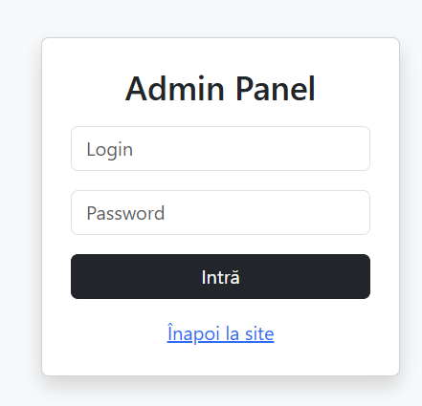
Рисунок 1 Форма входа

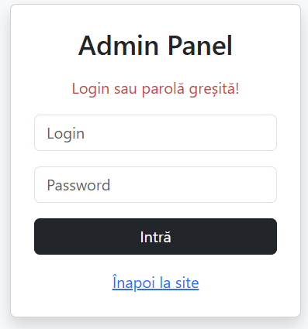
Рисунок 2 Ошибка при вводе неверных данных

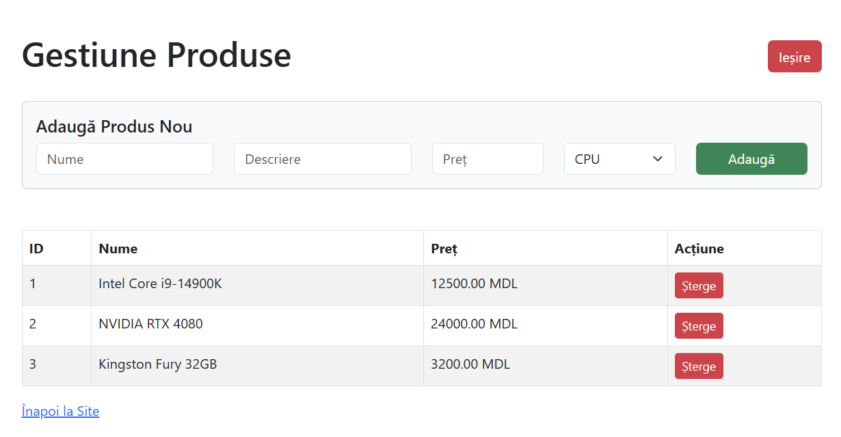
Рисунок 3 Админ панель

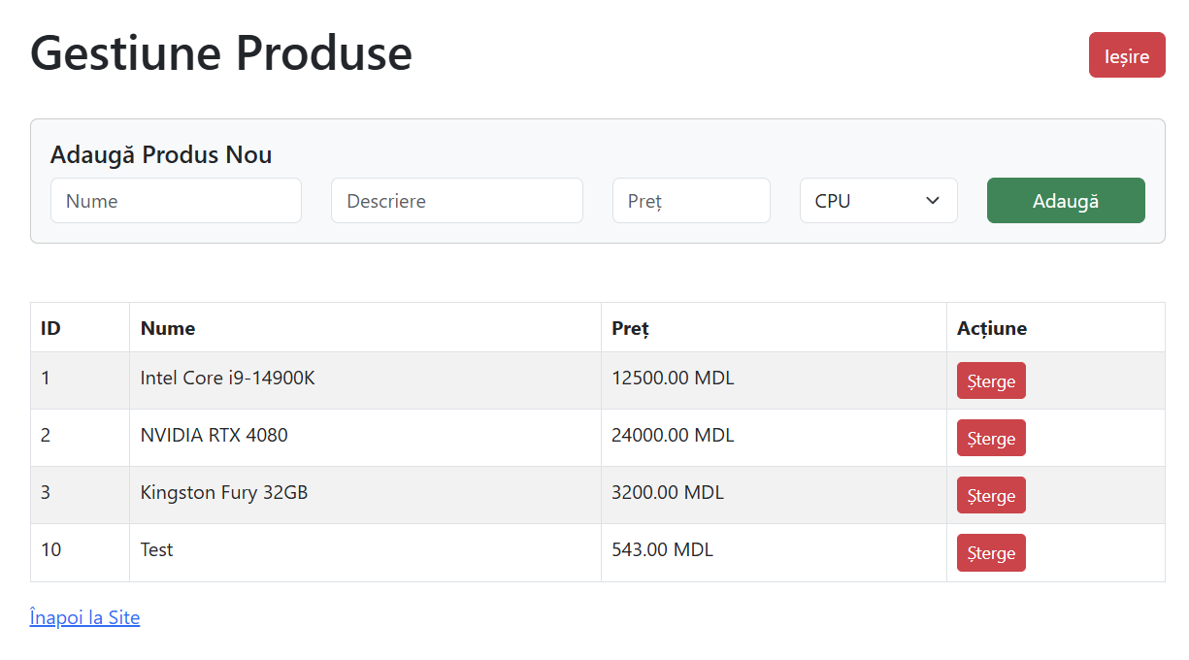
Рисунок 4 Проверка добавления нового товара

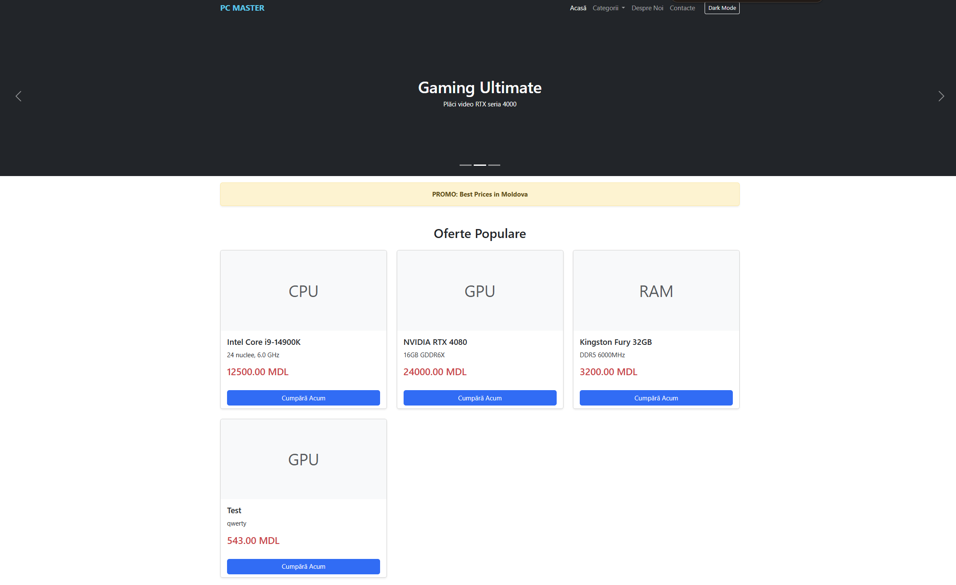
Рисунок 5 Проверка изменений на главной странице

Вывод
В ходе выполнения лабораторной работы я успешно трансформировал статический веб-сайт в полноценное динамическое веб-приложение, использующее архитектуру клиент-сервер.
В процессе работы были освоены и применены следующие технологии и подходы:
- Проектирование БД: Разработана реляционная база данных MySQL pc_master с таблицами для товаров, категорий и пользователей. Настроен отдельный пользователь базы данных с ограниченными правами для повышения безопасности.
- Backend-разработка: Написаны PHP-скрипты для генерации HTML-контента на основе данных из БД, что позволило автоматизировать вывод товаров на главной странице.
- Безопасность и Конфигурация: Реализован собственный парсер файлов конфигурации .env. Это позволило вынести учетные данные базы данных из кода, что соответствует современным стандартам безопасности (Security Best Practices).
- Аутентификация: Внедрен механизм сессий ($_SESSION) для защиты административной панели от несанкционированного доступа.
- Admin панель и Файлы: Создан интерфейс администратора для управления товарами и реализована система логирования действий в текстовый файл.
Таким образом, я прошел полный цикл разработки (Fullstack): от верстки интерфейса до реализации серверной логики и работы с базами данных.

