**Project Title: Axis Bulk Payment Processing System for Retail Customer**

**Project Scope:**

Bulk Module payment system will take input as a file from customer to process payment in bulk.Develop a System which will accept file in csv/xlsx format. File format will be configurable which user will manage via Template Module where user can select the order of expected fields of file.

**Technology Stack:** React**/**Java/kotlin

**Database:** MySql/Postgress

**Tools and Libraries / DevOps.** Java, Oracle/SQL

**How this project helps end Users?**

This project will help end user to settle multiple payment at once via bulk module engine.

**Project Description:**

1. Develop a portal from where user will be able to upload bulk for payment settlement in xlsx or csv format.
2. Format of file will be configurable. This format also called as template will be created by user by selecting master list of field and their order in file. There can be multiple template mapped for user.
3. While uploading file user will select template for upload.
4. Template Management should include
   1. Create Template
   2. Edit Template
   3. Delete Template
5. File upload Module
   1. Upload file by selecting template
   2. Process file by storing records as per field mapping.
   3. List all file uploaded by user
   4. List records in a file by selecting file list.
6. Details of the template screen and file upload screen are attached.
7. Logging should be enabled and should capture details like Date/Time of template management, File upload,Success and Failures etc. These details be used for Debugging/Troubleshooting purpose.

List template

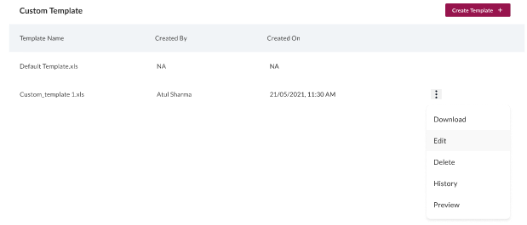

Create Template

