 | Министерство науки и высшего образования Российской Федерации  Федеральное государственное бюджетное образовательное учреждение  высшего образования  «Московский государственный технический университет  имени Н.Э. Баумана  (национальный исследовательский университет)»  (МГТУ им. Н.Э. Баумана)

ФАКУЛЬТЕТ Информатика и системы управления

КАФЕДРА Компьютерные системы и сети (ИУ6)

НАПРАВЛЕНИЕ ПОДГОТОВКИ 09.03.01 Информатика и вычислительная техника

Отчет
по зачетной работе
Название:

Футбольный обозреватель

Дисциплина: Языки интернет-программирования

Студент | ИУ6-32Б |  |  | Э.Э. Джафаров
 | (Группа) |  | (Подпись, дата) | (И.О. Фамилия)
Преподаватель |  |  |  | Д.В. Малахов
 |  |  | (Подпись, дата) | (И.О. Фамилия)

Москва, 2023

Цель работы — продемонстрировать полученные знания в создании собственного веб-приложения.

Задание: Мой футбольный обозреватель предназначен для просмотра прошедших матчей, нахождения матчей по определенным условиям, просмотр статистики матча и информации о команде. На сайте реализован авторизация и регистрация пользователей. Так же на сайте есть профиль пользователя и некоторые его данные, такие как любимый клуб и фото профиля, а также изменение этих параметров.

Решение:
1. Измененные контроллеры
1. Контроллер matches_controller.rb
class MatchesController < ApplicationController
before_action :set_match, only: %i[ show edit update destroy ]

# GET /matches or /matches.json
def index
@db = Match.all
@teams = Team.all
@teams_name = {}
@teams.each do |team|
@teams_name[team[:team_name]] = team[:id]
end
end

# GET /matches/1 or /matches/1.json
def show
@match = Match.find(params[:id])
@match_stat = @match[:statistic].split(", ")
@sop1 = Team.find(@match[:sop1_id])
@sop2 = Team.find(@match[:sop2_id])
@vlad = @match_stat[0].split
@udar_v_stvor = @match_stat[1].split
@udar_mimo = @match_stat[2].split
@ugol_udar = @match_stat[3].split
@shtraf_udar = @match_stat[4].split
end

def filters
@teams = Team.all
@team_id = params[:team]
@team_id = 1 if @team_id
@team_name = Team.find(@team_id)[:team_name] if @team_id
@years = params[:year]
@league = params[:league]
@place = params[:place]
@need_matches = Match.all
right_year if @years
right_league if @league
if @place == 'home'
search_home
else
search_guest
end
end

private

def right_year
@year = @years.split('-')
@year[0] = "#{@year[0]}-01-01"
@year[1] = "#{@year[1]}-01-01"
end

def right_league
leg = @league.split()
@leag = ''
leg.each do |word|
@leag += word[0]
end
end

def search_home
@need_matches = @need_matches.where(sop1_id: @team_id) if @team_id
search
end

def search_guest
@need_matches = @need_matches.where(sop2_id: @team_id) if @team_id
search
end

def search
@need_matches = @need_matches.where(match_date: @year[0]..@year[1]) if @years
@need_matches = @need_matches.where(style: @leag) if @league
end

2. Контроллер teams_controller.rb
class TeamsController < ApplicationController
before_action :set_team, only: %i[ show edit update destroy ]

# GET /teams/1 or /teams/1.json
def show
@team = Team.find(params[:id])
@team_name = @team[:team_name]
@coach = @team[:coach]
@capitan = @team[:capitan]
@year = @team[:year_of_creation]
end

3. Контроллер user_abouts_controller.rb
class UserAboutsController < ApplicationController
before_action :set_user_about, only: %i[ show edit update destroy ]

# GET /user_abouts or /user_abouts.json
def index
@user_abouts = UserAbout.all
end

# GET /user_abouts/1 or /user_abouts/1.json
def show
end

# GET /user_abouts/new
def new
@user_about = UserAbout.new
end

# GET /user_abouts/1/edit
def edit
user_id = params[:user_id]
team_id = params[:team_id]
end

# POST /user_abouts or /user_abouts.json
def create
@user_about = UserAbout.new(user_about_params)

respond_to do |format|
if @user_about.save
format.html { redirect_to user_about_url(@user_about), notice: "User about was successfully created." }
format.json { render :show, status: :created, location: @user_about }
else
format.html { render :new, status: :unprocessable_entity }
format.json { render json: @user_about.errors, status: :unprocessable_entity }
end
end
end

# PATCH/PUT /user_abouts/1 or /user_abouts/1.json
def update
respond_to do |format|
if @user_about.update(user_about_params)
format.html { redirect_to root_path, notice: "User about was successfully updated." }
else
format.html { render :edit, status: :unprocessable_entity }
format.json { render json: @user_about.errors, status: :unprocessable_entity }
end
end
end

# DELETE /user_abouts/1 or /user_abouts/1.json
def destroy
@user_about.destroy

respond_to do |format|
format.html { redirect_to user_abouts_url, notice: "User about was successfully destroyed." }
format.json { head :no_content }
end
end

private
# Use callbacks to share common setup or constraints between actions.
def set_user_about
@user_about = UserAbout.find(params[:id])
end

# Only allow a list of trusted parameters through.
def user_about_params
params.require(:user_about).permit(:fav_club, :image)
end
end

4. Контроллер user_controller.rb
class UserController < ApplicationController
def profile
@curr_user = User.find(params[:id])
@username = @curr_user.email.split('@')[0]
@curr_info = UserAbout.find_by(id: params[:id])
@avatar = @curr_info.image
@fav_club = @curr_info.fav_club
@fav_club_name = Team.find(@fav_club)[:team_name] if @fav_club
@guest = @curr_info.comments
end
end

2. Модели
1.match.rb
class Match < ApplicationRecord
has_many :teams
has_many :comments
end

2. team.rb
class Team < ApplicationRecord
end

3. user.rb
class User < ApplicationRecord
# Include default devise modules. Others available are:
# :confirmable, :lockable, :timeoutable, :trackable and :omniauthable
devise :database_authenticatable, :registerable,
:recoverable, :rememberable, :validatable
has_many :comments
has_one :user_about
after_create :create_user_about

def create_user_about
UserAbout.create!(user_id: self.id)
end
end

4.ures_about.rb
class UserAbout < ApplicationRecord
belongs_to :user
has_one_attached :image
end

3. Представления
1. application.html.erb
<!DOCTYPE html>
<html>
<head>
<title>Zachet</title>
<meta name="viewport" content="width=device-width,initial-scale=1">
<%= csrf_meta_tags %>
<%= csp_meta_tag %>

<%= stylesheet_link_tag "application", "data-turbo-track": "reload" %>
<%= stylesheet_link_tag "drop_down_menu" %>
<%= javascript_importmap_tags %>
</head>

<body>
<% if current_user %>
<nav class="navbar navbar-light">
<li class="nav-item active">
<%= link_to "En", root_path( :locale => 'en' ), class:"btn btn-outline-light"%> /
</li>
<li class="nav-item active">
<%= link_to "Ru", root_path( :locale => 'ru' ), class:"btn btn-outline-light"%>
</li>
<p class='user_username'><%= current_user.email.split('@')[0] %></p>
<div class="dropdown">
<button class="dropbtn"><%= image_tag "ampbil.jpeg", class: "image_inside_btn"%></button>
<div class="dropdown-content">
<%= link_to "#{t('profile')}", "/user/profile?id=#{current_user.id}", method: :get %>
<%= link_to "#{t('matches')}", root_path%>
<%= button_to "#{t('exit')}", destroy_user_session_path, data: { turbo: false }, method: :delete, class: "exit_btn" %>
</div>
</div>
</nav>
<% end %>
<%= yield %>
</body>
</html>

2. sessions/new.html.erb
<div class='login_form container'>
<h2 class='login_text'><%= t('log_in') %></h2>

<%= stylesheet_link_tag "login.css" %>

<%= form_for(resource, as: resource_name, url: session_path(resource_name)) do |f| %>
<div class="field mb-3">
<%= f.label t('email'), class: 'login_text form-label' %><br />
<%= f.email_field :email, autofocus: true, autocomplete: "email", class: 'form-control' %>
</div>

<div class="field mb-3">
<%= f.label t('pass_word'), class: 'login_text form-label' %><br />
<%= f.password_field :password, autocomplete: "current-password", class: 'form-control' %>
</div>

<% if devise_mapping.rememberable? %>
<div class="field mb-3 form-check">
<%= f.check_box :remember_me, class: 'form-check-input login-text'%>
<%= f.label t('remember_me'), class: 'login_text', class: 'form-check-label' %>
</div>
<% end %>

<div class="actions">
<%= f.submit t('log_in'), class: 'btn btn-primary' %>
</div>

<%# <div class="video_with_link">
<input type="button" value="Бонус" class="PlayPauseVideo btn btn-primary">
<video class="video" width="380px" height="250px" src="/video/Ankara_Messi.mp4" class="PlayPauseVideo"></video>
</div> %>
<% end %>

<%= render "devise/shared/links" %>
</div>

3. reqistrations/new.html.erb
<%= stylesheet_link_tag "signup.css" %>
<div class='login_form container'>
<h2 class='login_text'><%= "#{t('sign_up')}" %></h2>

<%= form_for(resource, as: resource_name, url: registration_path(resource_name), data: {turbo: false}) do |f| %>
<div class="field mb-3">
<%= f.label "#{t('email')}", class: 'login_text form-label' %><br />
<%= f.email_field :email, autofocus: true, autocomplete: "email", class: 'form-control' %>
</div>

<div class="field mb-3">
<%= f.label "#{t('pass_word')}", class: 'login_text form-label'%>
<% if @minimum_password_length %>
<em>(<%= @minimum_password_length %> characters minimum)</em>
<% end %><br />
<%= f.password_field :password, autocomplete: "new-password", class: 'form-control' %>
</div>

<div class="field mb-3">
<%= f.label "#{t('pass_conf')}", class: 'login_text form-label' %><br />
<%= f.password_field :password_confirmation, autocomplete: "new-password", class: 'form-control' %>
</div>

<%= render "devise/shared/links" %>

<div class="actions">
<%= f.submit "#{t('sign_up')}", class: 'btn btn-primary' %>
</div>
<% end %>

</div>

<%= render "devise/shared/error_messages", resource: resource %>

4. registrations/edit.html.erb
<div class='login_form container'>
<h2 class='login_text'>Редактирование пользователя</h2>
<%= stylesheet_link_tag "edit_user.css" %>

<%= form_for(resource, as: resource_name, url: registration_path(resource_name), html: { method: :put, data: {turbo: false} }) do |f| %>

<div class="field mb-3">
<%= f.label "Почта", class: 'login_text form-label' %>Почта<br />
<%= f.email_field :email, autofocus: true, autocomplete: "email", class: 'form-control' %>
</div>

<% if devise_mapping.confirmable? && resource.pending_reconfirmation? %>
<div>Currently waiting confirmation for: <%= resource.unconfirmed_email %></div>
<% end %>

<div class="field">
<%= f.label "Пароль", class: 'login_text form-label'%> <br />
<%= f.password_field :password, autocomplete: "new-password", class: 'form-control' %>
<% if @minimum_password_length %>
<br />
<em><%= @minimum_password_length %> characters minimum</em>
<% end %>
</div>

<div class="field mb-3">
<%= f.label "Подтвердите пароль", class: 'login_text form-label' %>Подтвердите пароль<br />
<%= f.password_field :password_confirmation, autocomplete: "new-password", class: 'form-control' %>
</div>

<div class="field mb-3">
<%= f.label "Текущий пароль", class: 'login_text form-label' %> <i>Старый пароль</i><br />
<%= f.password_field :current_password, autocomplete: "current-password" %>
</div>
<% end %>
</div>

<div class='error'>
<%= render "devise/shared/error_messages", resource: resource %>
</div>

5. matches/index.html.erb
<h1><%="#{t('matches')}"%></h1>

<%= stylesheet_link_tag "show_match.css" %>

<div class="filters">
<%= form_tag("/match/filters", :method => :get) do %>
<select name="team">
<option value='' disabled selected><%="#{t('team')}"%></option>
<%= options_for_select(@teams_name)%>
</select>
<select name="year">
<option value="" disabled selected><%="#{t('season')}"%></option>
<option value='2018-2019'>18/19</option>
<option value='2019-2020'>19/20</option>
<option value='2020-2021'>20/21</option>
<option value='2021-2022'>21/22</option>
<option value='2022-2023'>22/23</option>
</select>
<select name="league">
<option value='' disabled selected><%="#{t('league')}"%></option>
<option value='Бауманская Футбольная Лига'><%="#{t('league_b')}"%></option>
<option value='Измайловская Футбольная Лига'><%="#{t('league_i')}"%></option>
</select>
<select name="place">
<option value='home'><%="#{t('place_home')}"%></option>
<option value='guest'><%="#{t('place_guest')}"%></option>
</select>
<%= submit_tag( "#{t('search')}", class: 'btn btn-success') %>
<% end %>
</div>

<div class='today_matches'>
<% @db.each do |zap| %>
<% id = zap.id %>
<div class='one_match' id='<%= zap.id %>'>
<p class='sop'><%= @teams.find(zap[:sop1_id])[:team_name] %> - <%= @teams.find(zap[:sop2_id])[:team_name] %></p>
<p class='style'><%= zap.style %></p>
<p class='schet'><%= "#{t('schet')}" %>: <%= zap.schet%></p>
<p class='date'><%= "#{t('date')}" %>: <%= zap.match_date %></p>
<button><%= link_to "#{t('statistic')}", match_path(locale, id), method: :get, id: 'stat_button', :style=>'color: black; text-decoration: none' %></button>
</div>
<% end %>
</div>

6. matches/show.html.erb
<%= stylesheet_link_tag "show_stat.css" %>
<%= stylesheet_link_tag "comments.css" %>

<div class='match container-sm'>
<div class='statistic'>
<div class='sop'>
<span class='sop'><%= link_to @sop1[:team_name], team_path(locale, @sop1) %> <%= link_to @sop2[:team_name], team_path(locale, @sop2) %></span>
</div>
</div>
<div class='statistic'>
<div class='schet'>
<p class='text-center st'><%= "#{t('schet')}" %> <%= @match[:schet]%></p>
</div>
</div>
<div class='statistic'>
<p class='text-center st_title'><%= "#{t('statistic')}" %> </p>
<p class='text-center'><%= "#{t('possession')}" %> </p>
<span class='statik'><%= @vlad[0] %><span>
<span class='statik'><%= @vlad[1] %><span>
</div>
<div class='statistic'>
<p class='text-center'><%= "#{t('udar_v_stvor')}" %></p>
<span class='statik'><%= @udar_v_stvor[0] %><span>
<span class='statik'><%= @udar_v_stvor[1] %><span>
</div>
<div class='statistic'>
<p class='text-center'><%= "#{t('udar_mimo')}" %></p>
<span class='statik'><%= @udar_mimo[0] %><span>
<span class='statik'><%= @udar_mimo[0] %><span>
</div>
<div class='statistic'>
<p class='text-center'><%= "#{t('ugol_udar')}" %></p>
<span class='statik'><%= @ugol_udar[0] %><span>
<span class='statik'><%= @ugol_udar[1] %><span>
</div>
<div class='statistic'>
<p class='text-center'><%= "#{t('shtraf_udar')}" %></p>
<span class='statik'><%= @shtraf_udar[0] %><span>
<span class='statik'><%= @shtraf_udar[1] %><span>
</div>
<%= button_to "#{t('exit')}", root_path, class: "back_to_all btn btn-outline-primary", method: :get %>
</div>

7. matches/filters.html.erb
<h1><%="#{t('matches')}"%></h1>
<%= stylesheet_link_tag "show_match.css" %>
<%= stylesheet_link_tag "filters.css" %>

<h1></h1>
<% if @team_name %>
<h1><%= "#{t('team_name')}" %>: <%= @team_name %> </h1>
<% end %>
<% if @year %>
<h1><%= "#{t('season')}" %>: <%= @years %></h1>
<% end %>
<% if @league %>
<h1><%= "#{t('league')}" %>: <%= @league %> </h1>
<% end %>
<%= button_to "#{t('back')}", root_path, method: :get %>

<% if @array < 180 %>
<div class='today_matches'>
<% @need_matches.each do |zap| %>
<% id = zap.id %>
<div class='one_match' id='<%= zap.id %>'>
<p class='sop'><%= @teams.find(zap[:sop1_id])[:team_name] %> - <%= @teams.find(zap[:sop2_id])[:team_name] %></p>
<p class='style'><%= zap.style %></p>
<p class='schet'><%= "#{t('schet')}" %> <%= zap.schet%></p>
<p class='date'><%= "#{t('date')}" %> <%= zap.match_date %></p>
<button><%= link_to "#{t('statistic')}", match_path(locale, id), method: :get, id: 'stat_button', :style=>'color: black; text-decoration: none' %></button>
</div>
<% end %>
</div>
<% else %>
<h1><%= "#{t('no_matches')}"%> </h1>
<% end %>

8. teams/show.html.erb
<h1><%= "#{t('team_info')}" %></h1>

<%= stylesheet_link_tag "show_team.css" %>

<div class='today_matches'>
<div class='one_match'>
<p class='name'><%= "#{t('team_name')}" %>: <%= @team_name %></p>
<p class='coach'> <%= "#{t('coach')}" %>:<%= @coach %></p>
<p class='cap'><%= "#{t('cap')}" %>: <%= @capitan %></p>
<p class='year'><%= "#{t('year_of_creation')}" %>: <%= @year %></p>
<%= button_to "#{t('exit')}", root_path, class: "back_to_all btn btn-outline-primary", method: :get %>
</div>
</div>

9. user/profile.html.erb
<%= stylesheet_link_tag "profile.css" %>
<h1><%= @username %></h1>
<div class='about'>
<table class="table table-hover" style="width: 540px">
<tr>
<td>
<%= "#{t('fav_club')}"%>:
</td>
<td>
<span class='favsb'><%= @fav_club_name %></span>
</td>
</tr>
<tr>
<td>
<%= "#{t('comments_count')}"%>:
</td>
<td>
<span class='guest'> <%= @guest %></span>
</td>
</tr>
</table>
<% if @curr_info.image.attached? %>
<div class='image'>
<%= image_tag @avatar, class: "image", width: "40%" %>
</div>
<% else %>
<div class='image'>
<%= image_tag 'ampbil.jpeg', class: "image", width: "40%" %>
</div>
<% end %>

</div>
</br>
<%= button_to "#{t('update')}", edit_user_about_path(locale, current_user.id), method: :get %>

10. user/edit_profile.html.erb
<%= render "form", user_about: @user_about %>

<%= stylesheet_link_tag "signup.css" %>
<div class='login_form container'>
<h2 class='login_text'><%= "#{t('fav_club')}"%></h2>

<%= form_with(model: @user_dop_info, url: user_about_path) do |f| %>
<div class="field mb-3">
<%= f.label "#{t('fav_club')}", class: 'login_text form-label' %>
<% teams = Team.all %>
<% teams_name = {} %>
<% teams.each do |team| %>
<% teams_name[team[:team_name]] = team[:id] %>
<% end %>

<%= f.select(:favorsb, ["Клуб", *teams_name]) %>
</div>

<div class="field mb-3">
<%= f.label "#{t('picture')}", class: 'login_text form-label' %><br />
<%= f.file_field :image, class: 'add_image_url' %>
</div>

<div class="actions">
<%= f.submit "#{t('submit')}", class: 'btn btn-primary' %>
</div>
<% end %>
</div>

4. Марщруты
Rails.application.routes.draw do
scope '(:locale)', locale: /#{I18n.available_locales.join("|")}/ do
resources :user_abouts
resources :matches do
resources :comments
end
get 'team/show'
resources :team
get 'user/profile'
get 'match/show_stat'
root 'matches#index'
get 'match/filters'
devise_for :users
get 'user/edit_info'
end
# Define your application routes per the DSL in https://guides.rubyonrails.org/routing.html

# Defines the root path route ("/")
# root "articles#index"
end

5. Локали
1. en.yml
en:
email: 'Email'
log_in: "Login"
log_in1: "Login"
pass_word: "Password"
remember_me: "Remember"
sign_up: "Register"
sign_up1: "Register"
forgot_password: "Forgot password?"
confirm_instr: "Didn't receive confirmation instructions?"
unlock_instr: "Didn't receive unlock instructions?"
user_name: "Username"
pass_conf: "Confirm password"
characters_minimum: "minimum characters"
resend_conf_instr: "Resend confirmation instructions"
edit_user: "Change profile"
curr_pass: "Current password"
update: "Edit"
back: "Back"
submit: "Confirm"
show_button: "Open"
schet: "Score"
date: "Date"
statistic: "Statistics"
match: "Match"
team: 'Team'
season: 'Season'
league: 'League'
league_b: 'BFL'
league_i: 'IFL'
league_ch: 'WC'
place_home: 'Home'
place_guest: 'Guest'
search: 'Search'
profile: 'Profile'
matches: 'Matches'
exit: 'Exit'
fav_club: 'Favorite club'
comments_count: 'Comments count'
edit_user_about: 'Edit user_about'
possession: 'Possession'
udar_v_stvor: 'Shots on target'
udar_mimo: 'Shots off-target '
ugol_udar: 'Corner kicks'
shtraf_udar: 'Free kick'
team_name: 'Team name'
coach: 'Coach'
cap: 'Capitan'
year_of_creation: 'Year of creation'
team_info: 'Info about team'
no_matches: "No matches"
picture: "Picture"
advanced: 'Advanced options'

2. ru.yml
ru:
email: 'Почта'
log_in: "Войти"
log_in1: "Вход"
pass_word: "Пароль"
remember_me: "Запомнить"
sign_up: "Зарегистрироваться"
sign_up1: "Регистрация"
forgot_password: "Забыли пароль?"
confirm_instr: "Не получили инструкции по подтверждению?"
unlock_instr: "Не получили инструкции по разблокировке?"
user_name: "Имя пользователя"
pass_conf: "Подтвердите пароль"
characters_minimum: "6 символов минимум"
resend_conf_instr: "Повторно отправить инструкции по подтверждению"
edit_user: "Изменить профиль"
curr_pass: "Текущий пароль"
update: "Изменить"
cancel_account: "Удалить аккаунт"
back: "Назад"
schet: "Счет"
date: "Дата"
statistic: "Статистика"
match: "Матчи"
team: 'Команда'
season: 'Сезон'
league: 'Лига'
league_b: 'БФЛ'
league_i: 'ИФЛ'
league_ch: 'ЧМ'
place_home: 'Дома'
place_guest: 'В гостях'
search: 'Искать'
profile: 'Профиль'
matches: 'Матчи'
exit: 'Выход'
fav_club: 'Любимый клуб'
comments_count: 'Всего комментариев'
edit_user_about: 'Изменение дополнительных настроек пользователя'
possession: 'Владение мячом'
udar_v_stvor: "Удары в створ"
udar_mimo: "Удары мимо"
ugol_udar: "Угловые удары"
shtraf_udar: "Штрафные удары"
team_name: 'Название команды'
coach: 'Тренер'
cap: 'Капитан'
year_of_creation: 'Год создания'
team_info: 'Информация о команде'
no_matches: "Нет матчей, удовлетворяющих данным требованиям ;("
picture: "Картинка"
advanced: 'Продвинутые изменения'

6. Интерфейс:
1. Входа
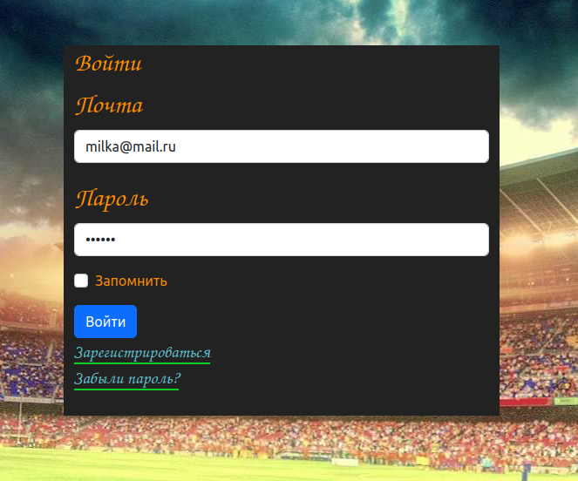

2. Регистрации
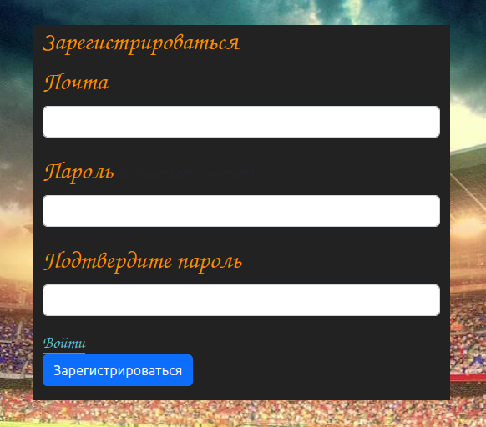
3. Все матчи
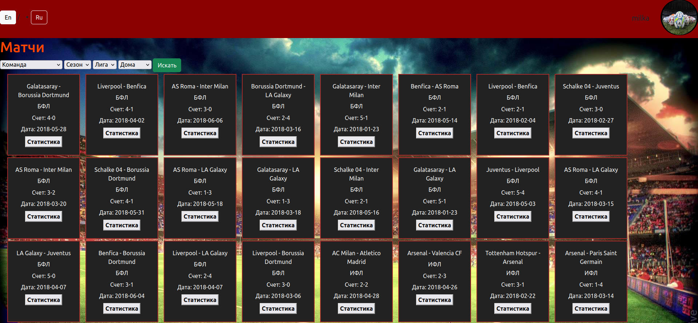

4. Статистика матча
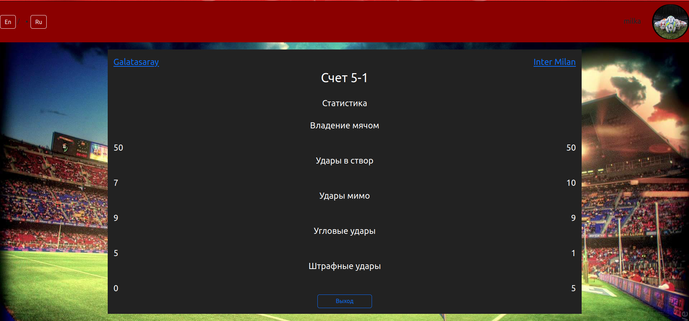
5. Информация о команде
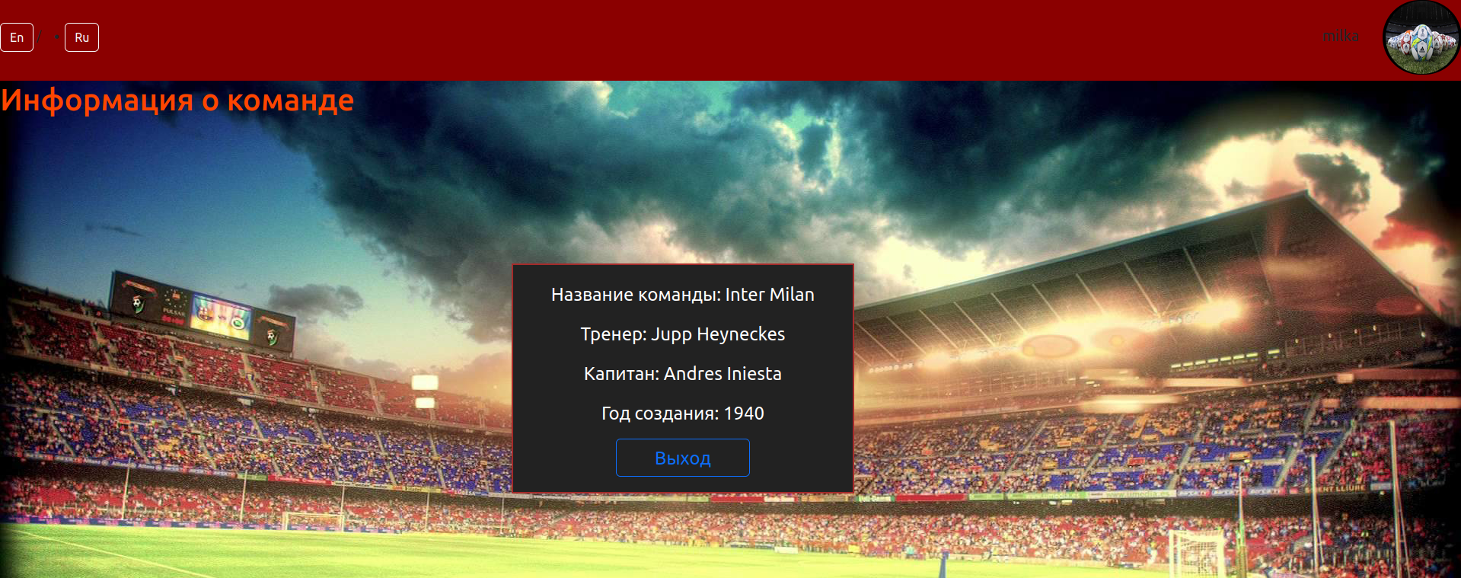
6. Фильтры
а) Устанавливаем фильтры
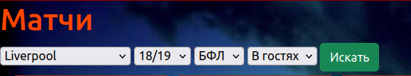

б) Результат
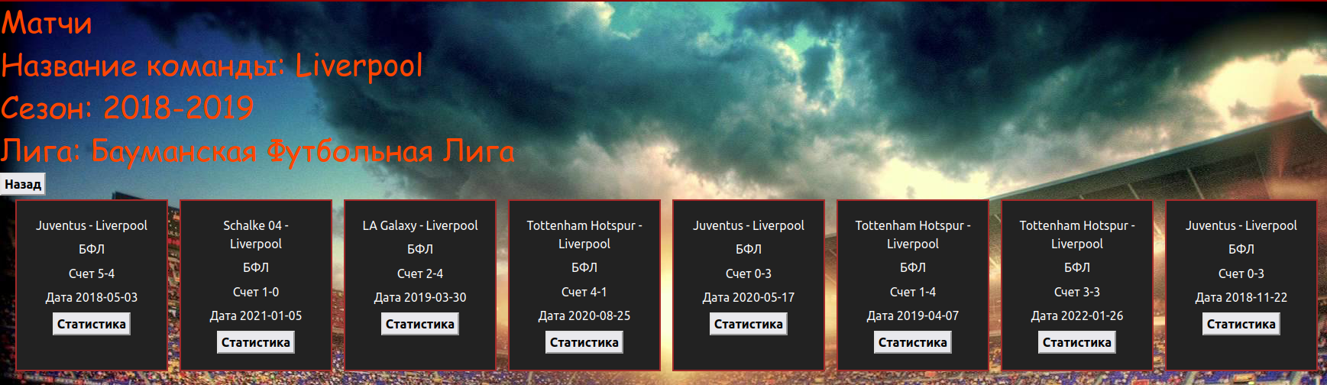
7. Профиль пользователя
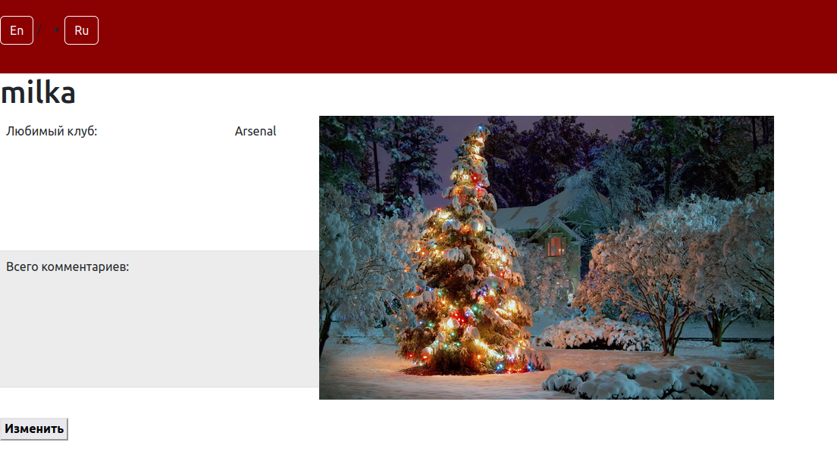

8. Изменение профиля пользователя
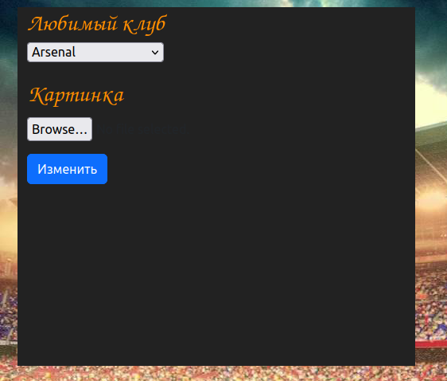

7. Тесты
а) Функциональные
1) Контроллеры
require_relative '../rails_helper'

RSpec.describe "Matches", type: :request do
describe "GET / without login" do
it "returns unauthorized" do
get "/"
expect(response).to have_http_status(302)
end
end

describe "GET matches/filters without login" do
it "returns unauthorized" do
get "/matches/filters"
expect(response).to have_http_status(302)
end
end

describe "GET matches/show without login" do
it "returns unauthorized" do
get "/matches"
expect(response).to have_http_status(302)
end
end
end

RSpec.describe "Teams", type: :request do
describe "GET /show" do
it "returns unauthorized" do
get "/team/show"
expect(response).to have_http_status(302)
end
end

end

RSpec.describe "User", type: :request do
describe "GET /profile" do
it "returns unauthorized" do
get "/user/profile"
expect(response).to have_http_status(302)
end
end

end

2) Модели
require_relative '../rails_helper'

RSpec.describe Team, type: :model do
describe "adding" do
it 'without arguments' do
expect{Match.create!}.to raise_error(ActiveRecord::NotNullViolation)
end

it 'with arguments' do
expect((Match.create!(sop1_id:1, sop2_id:2))[:id]).to eq(1)
end
end
end

RSpec.describe Team, type: :model do
describe "adding" do
it 'without team_name' do
expect{Team.create!}.to raise_error(ActiveRecord::NotNullViolation)
end
end
end

RSpec.describe UserAbout, type: :model do
describe 'adding user_about' do
it 'without arguments' do
expect{UserAbout.create!}.to raise_error(ActiveRecord::RecordInvalid)
end

it 'without user' do
expect{UserAbout.create!(user_id:100)}.to raise_error(ActiveRecord::RecordInvalid)
end

it 'with user' do
User.create!(email: 'a@d.com', password: '1234567')
expect((UserAbout.create!(user_id:1))[:user_id]).to eq(1)
end
end
end

б) Интеграционные
1) Регистрация
require 'selenium-webdriver'
require 'json'
describe 'Registrations' do
before(:each) do
@driver = Selenium::WebDriver.for :firefox
@driver.manage.window.maximize
end
after(:each) do
sleep(2)
@driver.quit
end
it 'visit root_path before authorizing' do
sleep(1)
@driver.get('localhost:3000/')
expect(@driver.find_element(:css, '.alert').text).to eq("translation missing: ru.devise.failure.user.unauthenticated")
end

it 'reg with incorrect passwords' do
@driver.get('localhost:3000/ru')
@driver.find_element(:css, ".sign_in").click
sleep(1)
@driver.find_element(:id, 'user_email').send_keys('gav@example.com')
@driver.find_element(:id, 'user_password').send_keys('897654')
@driver.find_element(:id, 'user_password_confirmation').send_keys('8976547')
@driver.find_element(:name, 'commit').click
expect(@driver.find_element(:xpath, '//li').text).to eq("Password confirmation не совпадает со значением поля Password")
end

it 'reg with taken email' do
@driver.get('localhost:3000/ru')
@driver.find_element(:css, '.sign_in').click
sleep(1)
@driver.find_element(:id, 'user_email').send_keys('gav2@example.com')
@driver.find_element(:id, 'user_password').send_keys('8976')
@driver.find_element(:id, 'user_password_confirmation').send_keys('8976')
@driver.find_element(:name, 'commit').click
expect(@driver.find_element(:xpath, '//li').text).to eq("Email уже существует")
end

it 'reg succesfull' do
@driver.get('localhost:3000/ru')
@driver.find_element(:css, '.sign_in').click
sleep(1)
@driver.find_element(:id, 'user_email').send_keys('gav100@example.com')
@driver.find_element(:id, 'user_password').send_keys('123456')
@driver.find_element(:id, 'user_password_confirmation').send_keys('123456')
@driver.find_element(:name, 'commit').click
sleep(4)
expect(@driver.find_element(:css, 'h1').text).to eq("Матчи")
end
end

2) Проверка функций матчей
describe 'Authorization and other' do
before(:each) do
@driver = Selenium::WebDriver.for :firefox
@driver.manage.window.maximize
end
after(:each) do
sleep(1)
@driver.quit
end
it 'show_all_matches' do
@driver.get('localhost:3000/ru')
@driver.find_element(:id, 'user_email').send_keys('milka@mail.ru')
@driver.find_element(:id, 'user_password').send_keys('123456')
@driver.find_element(:name, 'commit').click
sleep(4)
expect(@driver.find_element(:xpath, '//h1').text).to eq("Матчи")
end

it 'show match_stat' do
@driver.get('localhost:3000/ru')
@driver.find_element(:id, 'user_email').send_keys('milka@mail.ru')
@driver.find_element(:id, 'user_password').send_keys('123456')
@driver.find_element(:name, 'commit').click
sleep(4)
@driver.find_element(:xpath, "(//a[contains(text(),'Статистика')])[2]").click
sleep(1)
expect(@driver.find_element(:css, '.st_title').text).to eq("Статистика")
end

it 'show match_filters' do
@driver.get('localhost:3000/ru')
@driver.find_element(:id, 'user_email').send_keys('milka@mail.ru')
@driver.find_element(:id, 'user_password').send_keys('123456')
@driver.find_element(:name, 'commit').click
sleep(4)
@driver.find_element(:css, 'select:nth-child(1) > option:nth-child(2)').click
sleep(2)
@driver.find_element(:name, "commit").click
sleep(1)
expect(@driver.find_element(:xpath, '//h1[3]').text).to eq("Название команды: Liverpool")
end

it 'show team' do
@driver.get('localhost:3000/ru')
@driver.find_element(:id, 'user_email').send_keys('milka@mail.ru')
@driver.find_element(:id, 'user_password').send_keys('123456')
@driver.find_element(:name, 'commit').click
sleep(4)
@driver.find_element(:xpath, "(//a[contains(text(),'Статистика')])[2]").click
sleep(2)
@driver.find_element(:xpath, "//span/a[2]").click
sleep(1)
expect(@driver.find_element(:xpath, '//h1').text).to eq("Информация о команде")
end

it 'show user profile' do
@driver.get('localhost:3000/ru')
@driver.find_element(:id, 'user_email').send_keys('milka@mail.ru')
@driver.find_element(:id, 'user_password').send_keys('123456')
@driver.find_element(:name, 'commit').click
sleep(5)
@driver.find_element(:css, ".image_inside_btn").click
@driver.find_element(:xpath, "//a[contains(text(),'Профиль')]").click
sleep(2)
@driver.find_element(:xpath, "//body/form/button").click
sleep(2)
expect(@driver.find_element(:xpath, "//h2[contains(.,'Любимый клуб')]").text).to eq("Любимый клуб")
end
end

8. Отчет Rubocop по всем контроллерам


