Франчука Єгора, гр.5, маг., біоінформатики
Лабораторна робота №1.
Distributed version-control system Git
Мета роботи: ознайомитися системами керування версіями. Дослідити та отримати практичні навики щодо створення найпростішої програми та власного репозиторію.
Завдання на лабораторну роботу:
` Ознайомитись з теоретичними відомостями, ретельно опрацювати матеріал. Вміти давати пояснення термінам та поняттям: система керування версіями; централізовані та розподілені системи контролю версіями; репозиторій; приватні та відкриті репозиторії; GitHub.
Виконання практичної частини
Попередньо було завантажено Git за посиланням https://git-scm.com .
Налаштування Git:
1. Yehor@MrEgorin MINGW64 /c/docs/2sem/engineering/labs/lab1Franchuk
$ git init
Initialized empty Git repository in C:/docs/2sem/engineering/labs/lab1Franchuk/.git/
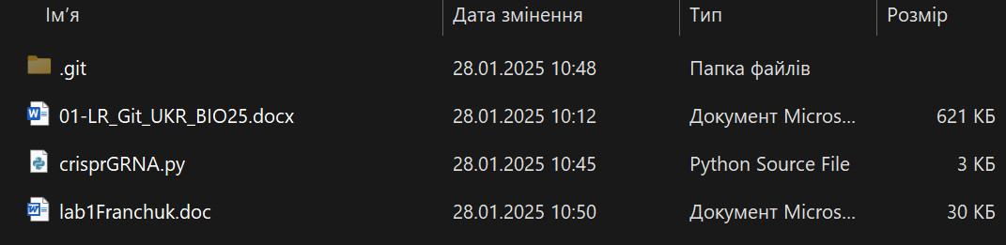
2. Yehor@MrEgorin MINGW64 /c/docs/2sem/engineering/labs/lab1Franchuk (master)
$ git config username "Yehor Franchuk"
error: key does not contain a section: username

Yehor@MrEgorin MINGW64 /c/docs/2sem/engineering/labs/lab1Franchuk (master)
$ git config user.name "Yehor Franchuk"

Yehor@MrEgorin MINGW64 /c/docs/2sem/engineering/labs/lab1Franchuk (master)
$ git config user.email egorushkasuper12@gmail.com

Yehor@MrEgorin MINGW64 /c/docs/2sem/engineering/labs/lab1Franchuk (master)
$ git config --global user.name "Yehor Franchuk"

Yehor@MrEgorin MINGW64 /c/docs/2sem/engineering/labs/lab1Franchuk (master)
$ git config --global user.email egorushkasuper12@gmail.com
Yehor@MrEgorin MINGW64 /c/docs/2sem/engineering/labs/lab1Franchuk (master)
$ git config --list
diff.astextplain.textconv=astextplain
filter.lfs.clean=git-lfs clean -- %f
filter.lfs.smudge=git-lfs smudge -- %f
filter.lfs.process=git-lfs filter-process
filter.lfs.required=true
http.sslbackend=openssl
http.sslcainfo=C:/Program Files/Git/mingw64/etc/ssl/certs/ca-bundle.crt
core.autocrlf=true
core.fscache=true
core.symlinks=false
pull.rebase=false
credential.helper=manager
credential.https://dev.azure.com.usehttppath=true
init.defaultbranch=master
user.name=Yehor Franchuk
user.email=egorushkasuper12@gmail.com
core.repositoryformatversion=0
core.filemode=false
core.bare=false
core.logallrefupdates=true
core.symlinks=false
core.ignorecase=true
user.name=Yehor Franchuk
user.email=egorushkasuper12@gmail.com

Yehor@MrEgorin MINGW64 /c/docs/2sem/engineering/labs/lab1Franchuk (master)
$ git help
usage: git [-v | --version] [-h | --help] [-C <path>] [-c <name>=<value>]
[--exec-path[=<path>]] [--html-path] [--man-path] [--info-path]
[-p | --paginate | -P | --no-pager] [--no-replace-objects] [--no-lazy-fetch]
[--no-optional-locks] [--no-advice] [--bare] [--git-dir=<path>]
[--work-tree=<path>] [--namespace=<name>] [--config-env=<name>=<envvar>]
<command> [<args>]

These are common Git commands used in various situations:

start a working area (see also: git help tutorial)
clone Clone a repository into a new directory
init Create an empty Git repository or reinitialize an existing one

work on the current change (see also: git help everyday)
add Add file contents to the index
mv Move or rename a file, a directory, or a symlink
restore Restore working tree files
rm Remove files from the working tree and from the index

examine the history and state (see also: git help revisions)
bisect Use binary search to find the commit that introduced a bug
diff Show changes between commits, commit and working tree, etc
grep Print lines matching a pattern
log Show commit logs
show Show various types of objects
status Show the working tree status

grow, mark and tweak your common history
backfill Download missing objects in a partial clone
branch List, create, or delete branches
commit Record changes to the repository
merge Join two or more development histories together
rebase Reapply commits on top of another base tip
reset Reset current HEAD to the specified state
switch Switch branches
tag Create, list, delete or verify a tag object signed with GPG

collaborate (see also: git help workflows)
fetch Download objects and refs from another repository
pull Fetch from and integrate with another repository or a local branch
push Update remote refs along with associated objects

'git help -a' and 'git help -g' list available subcommands and some
concept guides. See 'git help <command>' or 'git help <concept>'
to read about a specific subcommand or concept.
See 'git help git' for an overview of the system.
3. Yehor@MrEgorin MINGW64 /c/docs/2sem/engineering/labs/lab1Franchuk (master)
$ touch .gitignore
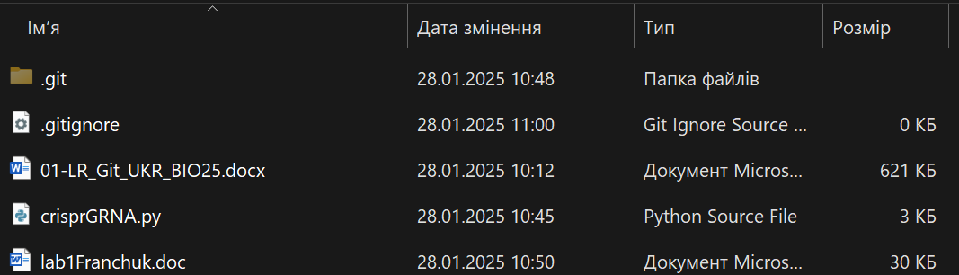
Yehor@MrEgorin MINGW64 /c/docs/2sem/engineering/labs/lab1Franchuk (master)
$ nano .gitignore
Після додавання необхідних виключень і збереження змін (ctrl+o, ctrl+x) маємо:
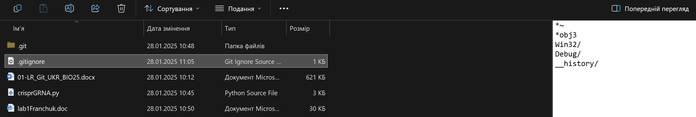
Символ «*» заменює будь яку кількість символів, а символ «/» після імені означає папку.
4. Yehor@MrEgorin MINGW64 /c/docs/2sem/engineering/labs/lab1Franchuk (master)
$ git init
Reinitialized existing Git repository in C:/docs/2sem/engineering/labs/lab1Franchuk/.git/

Yehor@MrEgorin MINGW64 /c/docs/2sem/engineering/labs/lab1Franchuk (master)
$ git status
On branch master

No commits yet

Untracked files:
(use "git add <file>..." to include in what will be committed)
.gitignore
01-LR_Git_UKR_BIO25.docx
crisprGRNA.py
lab1Franchuk.doc
~$b1Franchuk.doc
~WRL0003.tmp

nothing added to commit but untracked files present (use "git add" to track)
Yehor@MrEgorin MINGW64 /c/docs/2sem/engineering/labs/lab1Franchuk (master)
$ git add *

Yehor@MrEgorin MINGW64 /c/docs/2sem/engineering/labs/lab1Franchuk (master)
$ git status
On branch master

No commits yet

Changes to be committed:
(use "git rm --cached <file>..." to unstage)
new file: 01-LR_Git_UKR_BIO25.docx
new file: crisprGRNA.py
new file: lab1Franchuk.doc
new file: ~$b1Franchuk.doc
new file: ~WRL0003.tmp

Untracked files:
(use "git add <file>..." to include in what will be committed)
.gitignore

Yehor@MrEgorin MINGW64 /c/docs/2sem/engineering/labs/lab1Franchuk (master)
$ nano crisprGRNA.py
Додано коментарій про те, що Cas12a-нуклеаза не підтримується.

Yehor@MrEgorin MINGW64 /c/docs/2sem/engineering/labs/lab1Franchuk (master)
$ git status
On branch master

No commits yet

Changes to be committed:
(use "git rm --cached <file>..." to unstage)
new file: 01-LR_Git_UKR_BIO25.docx
new file: crisprGRNA.py
new file: lab1Franchuk.doc
new file: ~$b1Franchuk.doc
new file: ~WRL0003.tmp

Changes not staged for commit:
(use "git add <file>..." to update what will be committed)
(use "git restore <file>..." to discard changes in working directory)
modified: crisprGRNA.py

Untracked files:
(use "git add <file>..." to include in what will be committed)
.gitignore
Yehor@MrEgorin MINGW64 /c/docs/2sem/engineering/labs/lab1Franchuk (master)
$ git add crisprGRNA.py

Yehor@MrEgorin MINGW64 /c/docs/2sem/engineering/labs/lab1Franchuk (master)
$ git status
On branch master

No commits yet

Changes to be committed:
(use "git rm --cached <file>..." to unstage)
new file: 01-LR_Git_UKR_BIO25.docx
new file: crisprGRNA.py
new file: lab1Franchuk.doc
new file: ~$b1Franchuk.doc
new file: ~WRL0003.tmp

Untracked files:
(use "git add <file>..." to include in what will be committed)
.gitignore
Yehor@MrEgorin MINGW64 /c/docs/2sem/engineering/labs/lab1Franchuk (master)
$ git commit -m "first modification"
[master (root-commit) b9a2659] first modification
5 files changed, 62 insertions(+)
create mode 100644 01-LR_Git_UKR_BIO25.docx
create mode 100644 crisprGRNA.py
create mode 100644 lab1Franchuk.doc
create mode 100644 ~$b1Franchuk.doc
create mode 100644 ~WRL0003.tmp

Після цього було додано файл README.txt через файловий провідник Windows.
5. Зареєстровано та створено account на github.
Yehor@MrEgorin MINGW64 /c/docs/2sem/engineering/labs/lab1Franchuk (master)
$ git remote add origin https://github.com/mregorin/labs2025.git

Yehor@MrEgorin MINGW64 /c/docs/2sem/engineering/labs/lab1Franchuk (master)
$ git push -u origin master
info: please complete authentication in your browser...
Enumerating objects: 7, done.
Counting objects: 100% (7/7), done.
Delta compression using up to 12 threads
Compressing objects: 100% (6/6), done.
Writing objects: 100% (7/7), 676.01 KiB | 20.48 MiB/s, done.
Total 7 (delta 0), reused 0 (delta 0), pack-reused 0 (from 0)
remote: This repository moved. Please use the new location:
remote: https://github.com/MrEgorin/labs2025.git
To https://github.com/mregorin/labs2025.git
* [new branch] master -> master
branch 'master' set up to track 'origin/master'.
Yehor@MrEgorin MINGW64 /c/docs/2sem/engineering/labs/lab1Franchuk (master)
$ git clone https://github.com/mregorin/labs2025
Cloning into 'labs2025'...
remote: Enumerating objects: 7, done.
remote: Counting objects: 100% (7/7), done.
remote: Compressing objects: 100% (6/6), done.
remote: Total 7 (delta 0), reused 7 (delta 0), pack-reused 0 (from 0)
Receiving objects: 100% (7/7), 676.00 KiB | 3.91 MiB/s, done.
Yehor@MrEgorin MINGW64 /c/docs/2sem/engineering/labs/lab1Franchuk (master)
$ git remote -v
origin https://github.com/mregorin/labs2025.git (fetch)
origin https://github.com/mregorin/labs2025.git (push)

Yehor@MrEgorin MINGW64 /c/docs/2sem/engineering/labs/lab1Franchuk (master)
$ git remote add download https://github.com/MrEgorin/inytdown

Завдання 1
Виконано клонування репозитарію коду космічної місії польоту на місяць.
а) на локальному SSD-сховищі:

Yehor@MrEgorin MINGW64 /c/docs/2sem/engineering/labs/lab1Franchuk/mission (master)
$ git clone https://github.com/chrislgarry/Apollo-11.git
Cloning into 'Apollo-11'...
remote: Enumerating objects: 3834, done.
remote: Counting objects: 100% (152/152), done.
remote: Compressing objects: 100% (124/124), done.
remote: Total 3834 (delta 112), reused 28 (delta 28), pack-reused 3682 (from 3)
Receiving objects: 100% (3834/3834), 3.36 MiB | 4.08 MiB/s, done.
Resolving deltas: 100% (2615/2615), done.

Yehor@MrEgorin MINGW64 /c/docs/2sem/engineering/labs/lab1Franchuk/mission (master)
$ cd Apollo-11

Yehor@MrEgorin MINGW64 /c/docs/2sem/engineering/labs/lab1Franchuk/mission/Apollo-11 (master)
$ ls -la
total 176
drwxr-xr-x 1 Yehor 197121 0 Jan 28 12:15 ./
drwxr-xr-x 1 Yehor 197121 0 Jan 28 12:15 ../
-rw-r--r-- 1 Yehor 197121 212 Jan 28 12:15 .editorconfig
drwxr-xr-x 1 Yehor 197121 0 Jan 28 12:15 .git/
drwxr-xr-x 1 Yehor 197121 0 Jan 28 12:15 .github/
-rw-r--r-- 1 Yehor 197121 25 Jan 28 12:15 .gitignore
-rw-r--r-- 1 Yehor 197121 155 Jan 28 12:15 .markdownlint.yml
-rw-r--r-- 1 Yehor 197121 6414 Jan 28 12:15 CONTRIBUTING.md
drwxr-xr-x 1 Yehor 197121 0 Jan 28 12:15 Comanche055/
-rw-r--r-- 1 Yehor 197121 1170 Jan 28 12:15 LICENSE.md
drwxr-xr-x 1 Yehor 197121 0 Jan 28 12:15 Luminary099/
-rw-r--r-- 1 Yehor 197121 6040 Jan 28 12:15 README.md
drwxr-xr-x 1 Yehor 197121 0 Jan 28 12:15 Translations/
-rwxr-xr-x 1 Yehor 197121 34445 Jan 28 12:15 bun.lockb*
-rw-r--r-- 1 Yehor 197121 361 Jan 28 12:15 package.json
б) на github:
Yehor@MrEgorin MINGW64 /c/docs/2sem/engineering/labs/lab1Franchuk/mission/Apollo-11 (master)
$ git remote remove origin

Yehor@MrEgorin MINGW64 /c/docs/2sem/engineering/labs/lab1Franchuk/mission/Apollo-11 (master)
$ git remote add origin https://github.com/mregorin/Apollo_copy.git

Yehor@MrEgorin MINGW64 /c/docs/2sem/engineering/labs/lab1Franchuk/mission/Apollo-11 (master)
$ git push -u origin master
Enumerating objects: 3805, done.
Counting objects: 100% (3805/3805), done.
Delta compression using up to 12 threads
Compressing objects: 100% (1183/1183), done.
Writing objects: 100% (3805/3805), 3.35 MiB | 2.16 MiB/s, done.
Total 3805 (delta 2611), reused 3805 (delta 2611), pack-reused 0 (from 0)
remote: Resolving deltas: 100% (2611/2611), done.
remote: This repository moved. Please use the new location:
remote: https://github.com/MrEgorin/Apollo_copy.git
To https://github.com/mregorin/Apollo_copy.git
* [new branch] master -> master
branch 'master' set up to track 'origin/master'.
Посилання на репозитарій-копію: https://github.com/MrEgorin/Apollo_copy
Основні команди Git
5. Yehor@MrEgorin MINGW64 /c/docs/2sem/engineering/labs/lab1Franchuk (master)
$ git status
On branch master
Your branch is up to date with 'origin/master'.

Changes not staged for commit:
(use "git add <file>..." to update what will be committed)
(use "git restore <file>..." to discard changes in working directory)
modified: lab1Franchuk.doc

Untracked files:
(use "git add <file>..." to include in what will be committed)
.gitignore
README.txt
labs2025/
mission/

no changes added to commit (use "git add" and/or "git commit -a")
6. Yehor@MrEgorin MINGW64 /c/docs/2sem/engineering/labs/lab1Franchuk (master)
$ git add README.txt
7. Yehor@MrEgorin MINGW64 /c/docs/2sem/engineering/labs/lab1Franchuk (master)
$ git add *py
Yehor@MrEgorin MINGW64 /c/docs/2sem/engineering/labs/lab1Franchuk (master)
$ git commit -m 'Ver 1.0'
[master 3d81b5c] Ver 1.0
1 file changed, 2 insertions(+)
create mode 100644 README.txt
Збережено знімок поточного стану файлів, що відслідковується.
9. Yehor@MrEgorin MINGW64 /c/docs/2sem/engineering/labs/lab1Franchuk (master)
$ git log
commit 3d81b5c39c4b57e881edf72ea1ebaef89e6083ac (HEAD -> master)
Author: Yehor Franchuk <egorushkasuper12@gmail.com>
Date: Tue Jan 28 12:41:12 2025 +0200

Ver 1.0

commit b9a2659f398ef5bc1ed66c02a2c3287c4aecee81 (origin/master)
Author: Yehor Franchuk <egorushkasuper12@gmail.com>
Date: Tue Jan 28 11:25:38 2025 +0200

first modification

Yehor@MrEgorin MINGW64 /c/docs/2sem/engineering/labs/lab1Franchuk (master)
$ git log --pretty=oneline
3d81b5c39c4b57e881edf72ea1ebaef89e6083ac (HEAD -> master) Ver 1.0
b9a2659f398ef5bc1ed66c02a2c3287c4aecee81 (origin/master) first modification

Yehor@MrEgorin MINGW64 /c/docs/2sem/engineering/labs/lab1Franchuk (master)
$ git log -p -3
commit 3d81b5c39c4b57e881edf72ea1ebaef89e6083ac (HEAD -> master)
Author: Yehor Franchuk <egorushkasuper12@gmail.com>
Date: Tue Jan 28 12:41:12 2025 +0200

Ver 1.0

diff --git a/README.txt b/README.txt
new file mode 100644
index 0000000..25ff7ba
--- /dev/null
+++ b/README.txt
@@ -0,0 +1,2 @@
+Hello!
+This Python script, developed by Yehor Franchuk, is designed to assist biotechnologists in selecting the most suitable gRNA for efficient and accurate genome editing.
\ No newline at end of file

commit b9a2659f398ef5bc1ed66c02a2c3287c4aecee81 (origin/master)
Author: Yehor Franchuk <egorushkasuper12@gmail.com>
Date: Tue Jan 28 11:25:38 2025 +0200

first modification

diff --git a/01-LR_Git_UKR_BIO25.docx b/01-LR_Git_UKR_BIO25.docx
new file mode 100644
index 0000000..a81ed25
--- /dev/null
+++ b/01-LR_Git_UKR_BIO25.docx
@@ -0,0 +1,387 @@
+ Deadline - 10 лютого 2025 р.
10.
Yehor@MrEgorin MINGW64 /c/docs/2sem/engineering/labs/lab1Franchuk (master)
$ git branch testing

Yehor@MrEgorin MINGW64 /c/docs/2sem/engineering/labs/lab1Franchuk (master)
$ git log
commit 3d81b5c39c4b57e881edf72ea1ebaef89e6083ac (HEAD -> master, testing)
Author: Yehor Franchuk <egorushkasuper12@gmail.com>
Date: Tue Jan 28 12:41:12 2025 +0200

Ver 1.0

commit b9a2659f398ef5bc1ed66c02a2c3287c4aecee81 (origin/master)
Author: Yehor Franchuk <egorushkasuper12@gmail.com>
Date: Tue Jan 28 11:25:38 2025 +0200

first modification

Yehor@MrEgorin MINGW64 /c/docs/2sem/engineering/labs/lab1Franchuk (master)
$ git checkout testing
M lab1Franchuk.doc
Switched to branch 'testing'

Yehor@MrEgorin MINGW64 /c/docs/2sem/engineering/labs/lab1Franchuk (testing)
$ git log --oneline
3d81b5c (HEAD -> testing, master) Ver 1.0
b9a2659 (origin/master) first modification
11. Yehor@MrEgorin MINGW64 /c/docs/2sem/engineering/labs/lab1Franchuk (testing)
$ git branch
master
* testing

Yehor@MrEgorin MINGW64 /c/docs/2sem/engineering/labs/lab1Franchuk (testing)
$ nano crisprGRNA.py

Yehor@MrEgorin MINGW64 /c/docs/2sem/engineering/labs/lab1Franchuk (testing)
$ nano README.txt

Yehor@MrEgorin MINGW64 /c/docs/2sem/engineering/labs/lab1Franchuk (testing)
$ git add README.txt crisprGRNA.py

Yehor@MrEgorin MINGW64 /c/docs/2sem/engineering/labs/lab1Franchuk (testing)
$ git commit -a -m "ver 1.0.0.1"
[testing c2e944d] ver 1.0.0.1
3 files changed, 5 insertions(+), 3 deletions(-)

Yehor@MrEgorin MINGW64 /c/docs/2sem/engineering/labs/lab1Franchuk (testing)
$ git log --oneline
c2e944d (HEAD -> testing) ver 1.0.0.1
3d81b5c (master) Ver 1.0
b9a2659 (origin/master) first modification
12. Yehor@MrEgorin MINGW64 /c/docs/2sem/engineering/labs/lab1Franchuk (testing)
$ git checkout master
Switched to branch 'master'
Your branch is up to date with 'origin/master'.
13. Yehor@MrEgorin MINGW64 /c/docs/2sem/engineering/labs/lab1Franchuk (testing)
$ git merge testing
Already up to date.

Yehor@MrEgorin MINGW64 /c/docs/2sem/engineering/labs/lab1Franchuk (testing)
$ log --graph --oneline
bash: log: command not found

Yehor@MrEgorin MINGW64 /c/docs/2sem/engineering/labs/lab1Franchuk (testing)
$ git log --graph --oneline
* c2e944d (HEAD -> testing) ver 1.0.0.1
* 3d81b5c (master) Ver 1.0
* b9a2659 (origin/master) first modification

14.
15.

